18521

CHEN Zi Yuan

Springwood High School

18521

Practical Programming Project

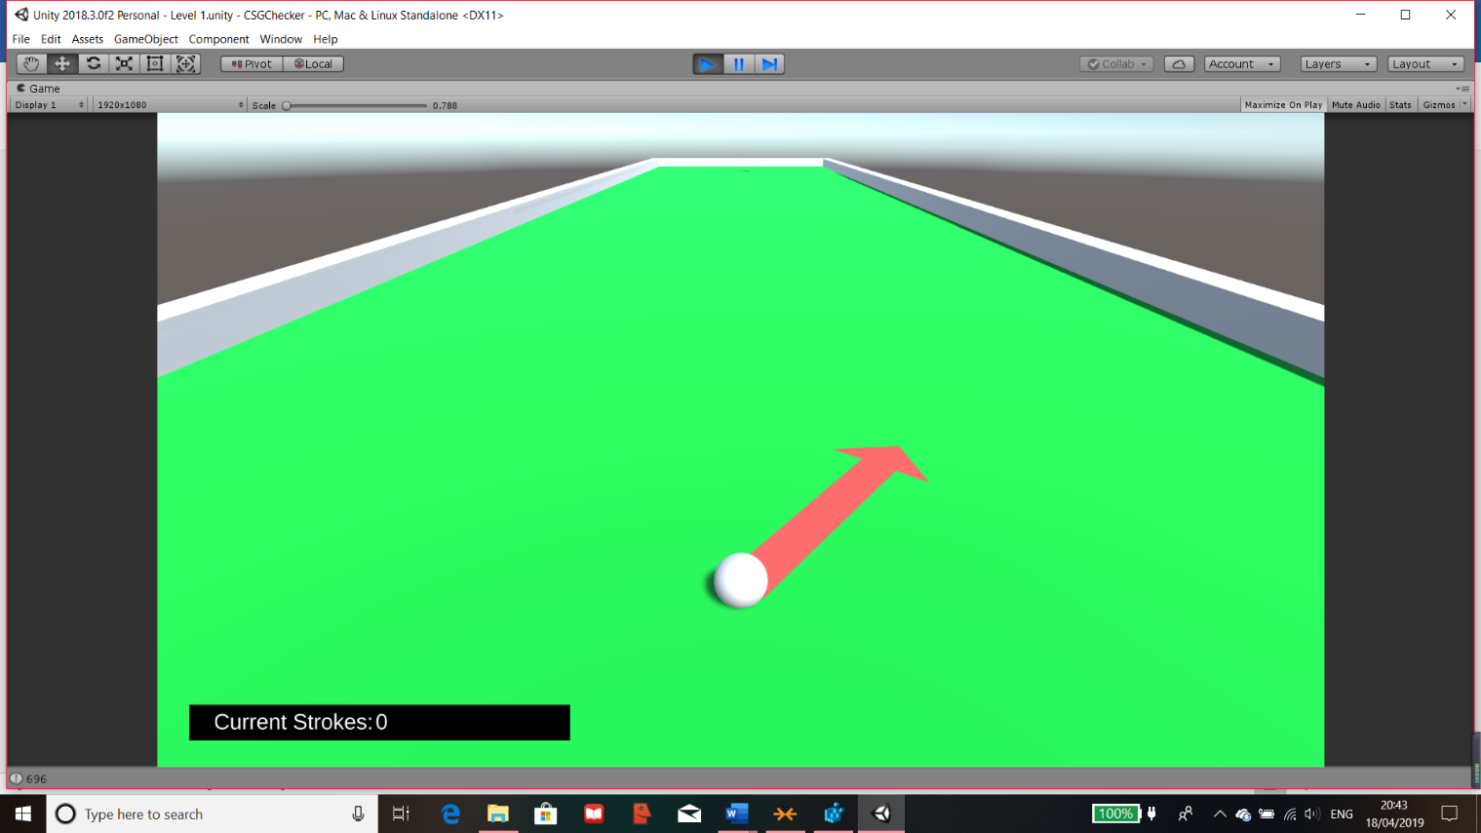

SUVAT Golf

Contents

Analysis 4

Problem Identification 4

Stakeholders 6

Client 6

Client Transcript 6

Client Summary 7

Focus Group 7

Questionnaire 8

Focus Group Questionnaire 8

Results 9

Graphs 10

Focus Group Summary 12

Maths Questions 13

Limitations 14

Hardware & Software 14

Graphical and Audio Design 14

Conditions 15

Time Scale 15

Similar Solutions 17

Integral 17

Exam Solutions 18

Popular Solutions (GOLF IT) 19

Similar Code 20

Requirements Specification 22

Design requirements: 22

Input requirements 22

Processing requirements 22

Output requirements 22

Storage requirements 23

Success Criteria 23

Design 24

Top Down Design 24

Explanation of each strand 25

Justification 25

Strands and Modules 25

Menu 26

Levels 28

Questions 32

Scoring 34

Data Structures 37

Simple Data Structures 37

Buttons 37

Dynamic Lists 37

Player Prefs 38

Classes/Scripts 38

Unity Modules 39

Unity Engine 39

System Collection and System Collection Generic 39

Unity Engine Scene Manager 39

Unity Engine UI 40

System Linq 40

TMPro 40

Data Dictionary 41

Usability features 47

Using Clear English and Easy Instructions 47

Features for Epilepsy 47

Features for Colour Blindness 48

User Interface Design 49

Main Menu 49

Quiz 51

Post Development Test Table 54

Development 57

Menu 57

Menu and Levels Testing 60

Level Design 61

Components 62

Lighting 63

Camera Control 64

Putter/Arrow 66

Arrow Reset 70

Arrow Effects 72

Stroke Counter 75

Level Completion 79

Difficulty 79

Buttons 82

Quiz 84

Timer 87

Final UI 94

Leaderboard 98

Questions and Scoring Testing 104

Prototype Product for Testing Code 106

Final Product UI’s 120

Final Product Code 124

Testing 141

Alpha Testing 141

Beta Testing 142

Maths Questionnaire 144

Final Test Table 145

Evaluation 157

Success of the Criteria 157

Success of Usability features 159

Maintenance 160

Future improvements 161

Project Evaluation 162

Table of figures 163

Bibliography 166

# Analysis

## Problem Identification

Students seem to require a software to help them revise for topic tests and their exams as they may struggle in certain areas. They would need a quiz like software that is also entertaining so they would want to revise and expand on their knowledge and progress through the year. The quiz style will ask them relevant questions and score them so that there is also a competitive nature to this. This will be done for the maths department as maths tend to require practice rather than revising from a book.

By using Unity, I am developing a game which holds attributes from a variety of games to make a game that’s modernised and audience friendly because some games are specified to a certain age range. The game that I will be designing will include friction and forces on a visual display so that the users can view the physics involved, it will also help my target group be familiarised with SUVAT equations because in my project they will have to hit objects with certain force to move them to a target area.

The Game that I will be developing will have a 2D/3D view where the user will click and control an object to project an amount of force so that it will travel to the desired target. This mechanic is similar to golf games. The objects will be interacting with other objects such as the floor and friction along with the force the user will apply. The SUVAT will be implemented as questions after they have completed the game mechanics so that they will be able to answer the question and depending on their answer, it will either increase or decrease their overall score. The level will have obstacles so it will stop the characters from moving in that direction.

There will be a round by round system where the rounds will alternate between the Player and the AI team as they try to aim to attack each other. At the end of rounds, it will detect if there will be any damage done to any charters and detect if any will die, which will remove the character from the current level.

There will be problem solving tasks for the clients to solve and help them advance in the game and in their skill. The problem can be solved by using computational thinking such as abstraction, simulation and algorithms.

* By using simulation within the game, it can help solve the problem by giving the client visual guides on the objects movements and forces that will have an effect on the objects. They will also be able to visualise the force that they entered and the effect it has on the object. Simulation is a good way for people to see and understand SUVAT and friction in an environment rather than on pen and paper which will help some people remember and understand the effects of friction and the uses for SUVAT equations.

This means that the game will use logical mechanics similar to the real world so that the users will get a visualisation of the problem involved.

* The problem is also suitable by abstraction as the only information they will need is variables for the SUVAT equations which they will need to identify and change to get the desired outcome that they would want. The game will not include other variable that may affect friction and SUVAT equations such as wind, density, weather and other variables that would not be of use. The only variables that will be affected and changed will be the basic needs for friction and SUVAT equations like gravity, speed, time, velocity, distance etc.

This means the users will only see what they need to so that they can focus on the key elements that are needed in SUVAT.

* Decomposition and Algorithms, the problem can be broken down into smaller algorithms so that the jobs will be easier to complete and will not be too complicated to understand. The equations can be split up so that each algorithm will only focus on a certain aspect which will mean less errors are likely to occur. The algorithm will be able to be reused for multiple purposes along the way so that there won’t be any unnecessary code that doesn’t need to be repeated.

This helps in the making of the game meaning that everything will work as intended when they are pieced together to form the overall product to help the users with SUVAT.

* Theoretical approach is also useful because there is a use of prediction of how speed the ball is going and how far you would have to travel. I.E. If the ball was x distance away, then there would need a y force to get it into the target area for it to be successful so theoretical approach for games will be suitable for my project.

This means that the game that I will make will use logical mechanics and physics so that the user can physically see how certain forces react which should give them a deeper understanding of the problem which is SUVAT meaning that it will help them in their tests and/or exams.

These computational methods help me in my overall problem by making sure that I will structure and split up the code that will be needed for the game, the use of logical reasoning and forces within the game and focusing on the main aspects so that the final product can help users understand SUVAT.

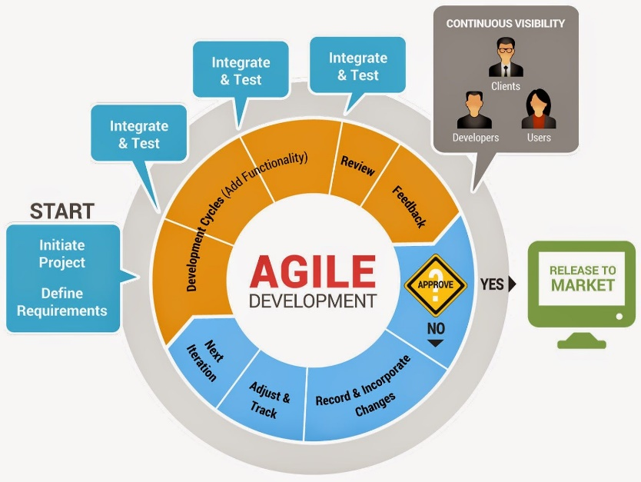Agile life cycle is the system life cycle that I’ll be using for the project as it will have regular inputs by the clients and focus group which will allow me to make adjustments and improvements along the way so that the final product will satisfy the stakeholders (client and focus group). Agile is also useful due to a limited time frame for the project. Figure 1[1]

Figure 1 Agile Life Cycle

## Stakeholders

My stakeholders will be physics or maths students who are struggling with the understanding of Mechanics and memorising the equations. They would be the focus and will have an input to the project along with the teacher who is my client. They will be able to have input to help suit the project to their needs which will assist them in their subject. There will also be a scoreboard system within the project so the students and teachers can view their progress throughout.

To collect information, I will be interviewing and questioning both the client and focus group throughout the project to get their involvement and any additions/change they would like.

### Client

My client is a maths teacher (Mr Levy, Age Group 25-35) who teaches both the high school students and A-level including teaching mechanics which I aim to provide support. I have asked him a series of questions to help me find the main problems that people struggle with and what I should involve within the project so I can adapt my project to these ideas and any additional ideas he may like to see within my project.

### Client Transcript

**What do you see your students struggling with in mechanics?**

Most of them understand the basic use of the questions with the equations. But some do struggle with memorising the equations and more complex use of them.

**What method of teaching did you use for this?**

I teach them by using examples and giving them worksheets to progress through so that I can see their progress throughout.

**What would you like to see within the game?**

A game should be fun and entertaining but, in this case, it should also have parts of education.

**Should it be multiple choice answers?**

Yes, it should as it wouldn’t be too difficult for them to solve and it gets them use to the questions**.**

**How should the quiz be laid out?**

With a question and at least 3 multiple choice answers.

**How many questions would you recommend for each level within the project?**

At least 3 which are similar to the actual solution so guess work wouldn’t be possible and it would require them to actually think.

**How focused on the questions should the game be?**

They should be relatively focused so after each turn or something similar but they shouldn’t be bombarded by questions.

**What your views of a point system and maybe a teacher’s section?**

Point system is a great idea as it would be competitive which will encourage some to get better scores so they will be revising more. A teacher’s section would be useful so we can check on their progress and add additional, maybe personalised questions for each student individually.

**Is music a good idea for the game?**

It would be nice for the students as it wouldn’t be too stressful for them but it would have to be lyric less music and calming so it doesn’t distract them too much.

**What other resources have you used for revision purposes for the students?**

Mostly Worksheets and I demonstrate the question and how it’s done. I allow students to find me and work through areas they’re stuck in.

**How difficult should the questions be?**

Should have a range of questions for different level students.

### Client Summary

From the client interview, I have concluded that I should use a quiz style setup to ask questions and the format to be multiple choice so it wouldn’t be too frustrating for the students which was retrieved from questions 4 and 5 of the interview. I should therefore have a question for each round so it’s not too common and a leaderboard so teachers and students can compare scores and see if they have improved throughout the use of the game. I’ve gathered that there should be a bank of questions for each difficulty so that it will be more beneficial for different levels of students. This was from question 11. The points for these will change relative to the difficulty of the questions which was retrieved from question 8.

Therefore, from this first interview I have gathered how my questions should be laid out, features such as leaderboards and difficulty for the levels and questions for the students. Also, I will have to include a way for the teachers/parents to access the questions and view progress so they can check on them or add more questions.

### Focus Group

My Focus group consists of 17-18 aged physics/maths students who do mechanics in either of their chosen subjects. Most of the people within my focus group also study Computer Science and a variety of other subjects such as Chemistry, Further Maths, Phycology and French. The male to female percentage in my group is 90% Male and 10% female which may cause some data to be biased to one end of the spectrum. The people that I’ve chosen mostly have a competent knowledge of SUVAT but also struggle. I also included people who has only heard about it but haven’t done any practice with this. This is done to ensure that my program could actually help a wide range of ability and knowledge within this subject.

They will be testing and using the game to see if their scores will improve from the effect of the game. It will help them learn and develop their understanding of mechanics from the use of my project. Their performance can be recorded and they will have an input to the project by giving me feedback and any pros and cons that they may want adjusted.

The project will be designed for their use out of lessons most of the time on a computer or tablet as it will provide them with support outside of lesson if they would need help. This could be set as homework by the teachers so that they can check on their progression and the questions can be tailored to each student. I don’t believe this should be set in lessons as the software doesn’t teach them how SUVAT works but only how to apply it. As it will be used outside lessons, it will provide extra help to those who need it and a competitive way for them to play and improve with.

### Questionnaire

### Focus Group Questionnaire

This Questionnaire will ask questions on SUVAT and Games, please answer sensibly and circle the answers intended for the categorical questions.

**Are you confident with the use of Friction and SUVAT equations?**

Great / Good / Alright / Needs improvement / Bad

**What method do you find best for learning this? (Can circle more than one)**

Worded Examples / Diagrams / Practice / Explanation

**What do you struggle with most about this?**

Input response here

**Do you revise school work, if so, how many hours a week?**

Less than 2 / 2-5 / 5-8 / 8-10 / More than 10

**Do you actively play Computer Games, if so, how many hours a week?**

Less than 12 / 12-18 / 18-24 / 24-30 / More than 30

**What genre is your favourite? E.g. Simulation, Action, Adventure, Survival, and Indie. (Name up to 3)**

Input response here

**What resolution do you like a game in?**

1600x900 / 1024x768 / 1280x720 / 1920x1080 / Other _______

**What do you like within a game, e.g. art style, music, characters?**

Input response here

**What do you dislike within a game?**

Input response here

**What features do you like within a game? (E.g. Multiplayer, a Workshop etc.)**

Input response here

This is the end, thank you for finishing this questionnaire.

The questions I have asked to my focus group will be used to help me decide what people would most want as a revision resource and it’ll be more tailored to the focus group which are A-level mechanics students. I have chosen questions such as the time of gaming and revision so that I can compare the amount on average students do and if their gaming may affect this amount.

The first few questions are used to figure out what they’re stuck on in mechanics and what they prefer to learn by. The last few questions are used to find out what kind of games are preferred and what my project should be tailored towards. Also, it will give me ideas and suggestions of what to include within the game.

### Results

**Are you confident with the use of Friction and SUVAT equations?**

Great – 2 Good – 4 Alright – 2 Needs Improvement – 3

**What method do you find best for learning this?**

Worded Examples – 6 Diagrams – 0 Practice – 4 Explanation - 4

**What do you struggle with most about this?**

The response has ranged from nothing to everything with some being more specific like rearranging or memorising the equations and which to use in certain questions.

**Do you revise school work, if so, how many hours a week?**

4 people do less than 2 hours, 4 people does between 2-5 hours, 2 do between 5-8 and 1 does more than 10.

**Do you actively play Computer Games, if so, how many hours a week?**

2 play less than 12 hours a week, 2 play between 12-18 hours, 1 play between 18-24 hours and 6 people play more than 30 hours a week.

**What genre is your favourite, e.g. Simulation, Action, Adventure, Survival, and Indie?**

RPG – 1 Adventure – 3 Strategy – 6 Action – 3 FPS – 3 Survival – 1 Platformer – 1 Other – 4

**What resolution so you like a game in?**

1920x1080 – 6 1280x720 – 2 2560x1440 – 1 Other- 2

**What do you like within a game, e.g. art style, music, characters?**

Music – 1 Good Art Style – 6 Character Design – 2 Challenge – 3 Combat – 1 Other - 7

**What do you dislike within a game?**

Lag/Ping – 3 Loading Times – 2 Bad Music – 1 Bad Characters – 1 Cut Scenes – 1 Other – 6

**What features do you like within a game? E.g. Multiplayer, a Workshop etc.**

Customisation – 5 Multiplayer – 5 Optional Mouse – 1 Secrets – 1 Leaderboards – 1 Other – 4

### Graphs

The majority of the features pie chart suggests that from my focus group they would like customisation and multiplayer with other suggestions like leaderboards and secrets/Easter eggs in the game. There are no mentions of other ways of controlling like a joystick or controller so the focus groups preference are mouse and keyboard. This suggests that the game should be able to work in tablets, laptops and PCs.

The trend to the data between revision and gaming is that the more revision people do (multiplied by 5) the less games they play. This graph suggests that more people are focused on gaming rather than revising. This means that my project in theory should be helpful as it creates a game for revision so the more, they use it, the more they’ll also revise which should be able to help them through their lessons and work.

Figure 2 Gaming Hours Against Revision Hours

Figure 3 Features Pie Chart

Figure 4 Resolution Pie Chart

Figure 5 Genre Pie Chart

Figure 6 Dislikes Pie Chart

There seems to be lots of dislikes my focus group have within a game which I will have to try to avoid and/or fix. The major things that could have an effect to my project would be the lag/ping, music and loading times as these are most likely to be problems in my game so I will have to work on these so that the problems won’t appear. Other dislikes like characters and cut scenes are irrelevant to my game as they will either not be included within the game or kept to a minimal.

In this pie chart, it shows that most people have different tastes in genres and some don’t mind what genre the game is as long as it’s playable and fun. However there does seem to be a larger amount of people preferring strategy, action and adventure. Within these, strategy links in with their option choices and most of my focus groups has picked maths, physics and/or IT so there are lots of problem solving. Therefore, as they seem to enjoy problem solving then strategy is the best options for this.

The majority of the resolution pie chart suggests that most people would prefer a 1920x1024 resolution for the game and not the others. This seems reasonable as most screens should be able to run 1920x1080 for this game. Screen size like 1280x720 would work however there is less demands for it and larger screen sizes like 2560x1440 wouldn’t work as it will need a high spec pc to be able to work and detailing within the game will need to be high. Therefore, a 1920x1080 is most fitting.

### Focus Group Summary

From the questionnaires I have gathered that the basic must need requirements for my game should be:

* Screen size of 1920x1080 from question 7 as a majority of 6/11 wanted this
* Menu settings to help my focus group navigate through the program
* Good Art style as 6/11 voted for this on question 8
* Challenging strategy game which was the highest liked genre in question 6
* Leaderboards was a feature that was asked for in the last question
* Mouse and keyboard input as a basic was of navigating through everything

Then preferable requirements for the game are:

* Background music as it was suggested in question 8
* Easter eggs to add secrets into the program, this was suggested in the last question

### Maths Questions

I have given out a questionnaire for my focus group about SUVAT equations to see what they currently can achieve. I will use this data to compare it to a final exam after they’ve used the program to see if their results have improved. The questions that I will be asking are:

**A particle is accelerated uniformly from rest, so that after 10 seconds it has achieved a speed of 15 m/s. Find its acceleration and the distance it has covered.**

Answer: 1.5m/s-2 and 75m

**A car accelerates uniformly from rest and after 12 seconds has covered 40m. What are its acceleration and its final velocity?**

Answer: 0.55m/s-2 and 6.67m/s-1

**A car accelerates from 10 m/s-1 to 30 m/s-1 in 5 seconds. What is its acceleration?**

Answer: 4m/s-2

**An aircraft was travelling at a speed of 60 m/s-1 when it landed on a runway. It took 2 minutes to stop. Calculate the acceleration of the aircraft when coming to a stop.**

Answer: -0.5m/s-2

**A train is uniformly retarded from 35m/s-1 to 21m/s-1 over a distance of 350m. Calculate the retardation and the time taken to come to rest from the 35m/s.**

Answer: -1.12m/s-2 and 31.25 seconds

**A particle moves with uniform acceleration 0.5m/s2 in a horizontal line ABC. The speed of the particle at C is 80m/s and the times taken from A to B and from B to C are 40 and 30 s respectively. Calculate   
(a) Velocity at A**

Answer: 45m/s-1

**(b) Displacement BC**

Answer: 2175m

#### Maths Questions Results

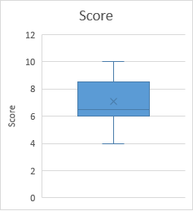The results that I have gotten from this test from highest to lowest was 10, 10, 8, 8, 8, 7, 6, 6, 6 and 4.

The average score was 7.3 and through my program I hope to increase the average score after they have used my program by testing them again with another maths questionnaire in the future. This will test if the program does help them in SUVAT because if it does then their score should’ve increased.

Figure 7 Maths Box Plot

## Limitations

### Hardware & Software

The requirements to be able to run Unity may not be reached by some computers. The computers at most school uses windows 7 and are linked to the school’s network so the hardware and software that will be needed to run unity well is listed below[2]:

Hardware needed:

* Windows 7 or higher so there can be an OS and visuals for people.
* Graphics card with DirectX 10 shader model 4.0 capabilities. Needed for the OS.
* CPU with SSE2 instruction set support
* 250GB Hardware or better, so space is provided to store the project and other required software.
* At least 1 GB RAM, so software and the OS can run quickly.
* At least 1 GHz Processor, instructions can be executed efficiently.
* Monitor to be able to display the software and graphical parts of the project.
* Mouse to control camera and allow user to input data.
* Keyboard allows users to input data and keys needed.
* Speakers for feedback and music within the project.

Software needed:

* Windows 7 OS+, to provide operating system to run all required programs.
* Unity 3D, used to create program and test the program.

These are the minimum hardware and software requirements that are needed so that the overall program will be able to run. The hardware that the school has are:

* Windows 7 with some computers as windows 8
* CPU as Inter Core i5-6500
* Has DirectX 10 capabilities
* 3.2 GHz processor
* A personal storage space of 3.5GB but a large server for subjects and departments
* 8GB Ram
* Monitor at 720p, mouse, keyboard and speakers for each computer

Expected Limitations for hardware and software:

* Storage as it’s needed to download the program and software listed but this should only require a maximum of 3.5GB if only the required files are downloaded and the school doesn’t opt into extras[3]. This also means that it would have to be installed as a department program because students only have 3.5GB of space so this wouldn’t be enough.
* RAM is needed so the program calls resources quickly and if this isn’t reached then it will cause lag as resources won’t be retrieved fast enough which may cause the program or even the PC to crash. This is the same for the processor so that the data and instructions can be passed.
* The CPU and Graphics card will need to be up to date because the CPU would cause crashes if not up to requirements and the graphics card can cause major frame drops to the program which could render it unusable. The CPU that the school has is fine however even though the computers can run DirectX 10, a dedicated GPU would be much better. On the other hand this doesn’t restrict too much of the program, it just may cause some frame drops.

Therefore, these are the major hardware that will cause most issues but it is still best to have everything up to what’s needed. Luckily the computers at most schools already reach these requirements apart from downloading Unity which is easy to install.

### Client

The client will be a major role in my project because he will provide the guidelines and expectations that the program must have that would mostly benefit the students he teaches where some are part of my focus group. However this also means that the client may want different parts to the program than what I thought was beneficial. Their guidelines may also be too difficult to follow and manage which will be limitations for me if I struggle with time or if it will be too difficult to implement.

### Graphical and Audio Design

Due to my project being a game, I will need art and textures so it’s visual attractive for people to play whilst learning. The textures I will use will be from within Unity as they have some free textures, non-copyrighted textures and designs and some custom art made from modelling software and pixel software like voxel. Also, a good layout is needed for the questions on mechanics within the game.

There will also be the need of music so that the user will enjoy the game more and be more focused. The music will be difficult to create and will be lyric less, therefore I will be using royalty free music for my project.

Overall this isn’t likely to affect any of the coding for the program but will affect the users of the program as it will need to be visually intriguing for them to play and learn from. So, I will need time to import art and designs in the program but this will be after all the basis of the program is complete so it runs well.

### Conditions

Time may be a major condition for the project as I will need to layout a timeline of what to do by when as there is a deadline for the project. I will be setting everything that will need to be done in order of what to do and when it should be done with some flexibility in case of bugs or difficulty with some parts. Funding will not be a limitation as the programs are free. The software on the school system and the one that I will be using must be the same versions or issues and bugs may cause delays and problems.

The main condition that will affect the overall product is time management as it needs to be effective and efficient for the program to be finished and refined.

### Time Scale

|  |  |  |  |  |  |
| --- | --- | --- | --- | --- | --- |
| Activity | Expected time taken (days) | Start Date | End Date | Actual time taken (days) | Comment |
| Analysis |  |  |  |  |  |
| Identify problem and First Draft | 2 | 17/05/18 | 19/05/18 | 3 | Research took longer |
| Find suitable clients and stakeholder | 2 | 20/05/18 | 21/05/18 | 2 | As expected |
| Hand Out  Questionnaires and Interview Client | 2 | 22/05/18 | 23/05/18 | 2 | As expected |
| Analyse and Write-up | 3 | 23/05/18 | 25/05/18 | 3 | As expected |
| Create Graphs and explain | 2 | 26/05/18 | 27/05/18 | 2 | As expected |
| Hand Out Maths Questionnaires | 2 | 30/05/18 | 31/05/18 | 2 | As expected |
| Final Write up for analysis | 5 | 31/05/18 | 05/06/18 | 6 | Changes had to made after completion |
| Establish Criteria | 2 | 07/06/18 | 09/06/18 | 3 | Criteria amended |
| Design |  |  |  |  |  |
| Top Down Design | 1 | 15/06/18 | 16/06/18 | 2 | Conflict on design |
| Justification of Strands | 1 | 18/06/18 | 18/06/18 | 1 | As expected |
| Create Flowcharts | 3 | 19/06/18 | 23/06/18 | 5 | Complexity |
| Test Data and Table | 2 | 24/06/18 | 25/06/18 | 2 | As expected |
| Data Structures needed | 1 | 27/06/18 | 27/06/18 | 1 | As expected |
| Unity modules | 2 | 29/06/18 | 30/06/18 | 2 | As expected |
| Data Dictionary | 4 | 01/07/18 | 05/07/18 | 5 | Checking |
| Research and write-up Usability Features | 2 | 07/07/18 | 08/07/18 | 2 | As expected |
| Planning GUI | 1 | 09/07/18 | 09/07/18 | 1 | As expected |
| Development |  |  |  |  |  |
| Designing Menu | 1 | 12/09/18 | 12/09/18 | 1 | As expected |
| Coding Menu | 1 | 13/09/18 | 14/09/18 | 2 |  |
| Designing Level | 2 | 15/09/18 | 16/09/18 | 2 | As expected |
| Coding in Level | 3 | 17/09/18 | 19/09/18 | 3 | As expected |
| Coding Camera | 2 | 22/09/18 | 23/09/18 | 2 | As expected |
| Write Up | 3 | 25/09/18 | 27/09/18 | 3 | As expected |
| Coding Putter and Ball | 3 | 08/10/18 | 11/10/18 | 4 |  |
| Coding Arrow | 2 | 13/10/18 | 14/10/18 | 2 | As expected |
| Strokes Counter | 1 | 16/10/18 | 16/10/18 | 1 | As expected |
| Write Up | 4 | 17/10/18 | 20/10/18 | 4 | As expected |
| Designing Quiz | 1 | 28/10/18 | 30/10/18 | 3 | Difficult |
| Coding Difficulty Selection | 1 | 05/11/18 | 06/11/18 | 2 | Conflict of ideas |
| Coding Quiz and Timer | 4 | 11/11/18 | 16/11/18 | 6 | Bugs |
| Designing Leaderboard | 2 | 18/11/18 | 20/11/18 | 3 | Conflict of ideas |
| Coding Leaderboard | 7 | 21/11/18 | 01/12/18 | 10 | Complexity and difficulty |
| Alpha and Beta Testing Hand outs | 2 | 15/01/19 | 16/01/19 | 2 | As expected |
| Testing Analysis | 2 | 23/01/19 | 25/01/19 | 3 | Time consuming |
| Final Write Up for Development | 5 | 03/02/19 | 09/02/19 | 7 | Rewrites and checks |
| Evaluation |  |  |  |  |  |
| Success Criteria Evaluation | 1 | 15/02/19 | 15/02/19 | 1 | As expected |
| Usability Feature Evaluation | 1 | 16/02/19 | 16/02/19 | 1 | As expected |
| Maintenance and Improvements | 1 | 17/02/19 | 17/02/19 | 1 | As expected |
| Final Write Up for Evaluation | 2 | 22/02/19 | 22/02/19 | 2 | As expected |

## Similar Solutions

### Integral

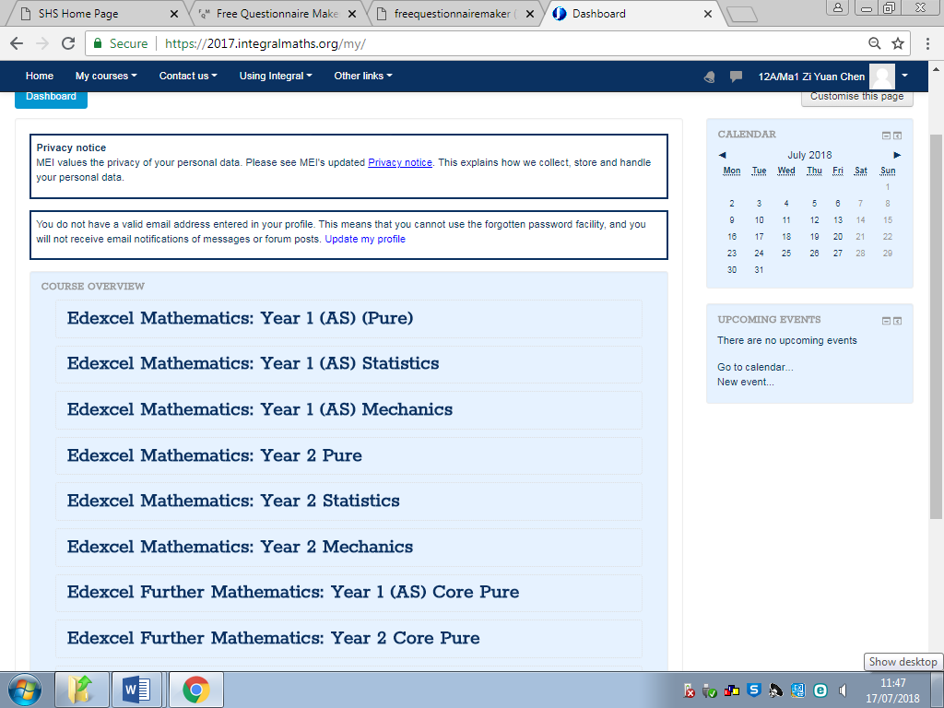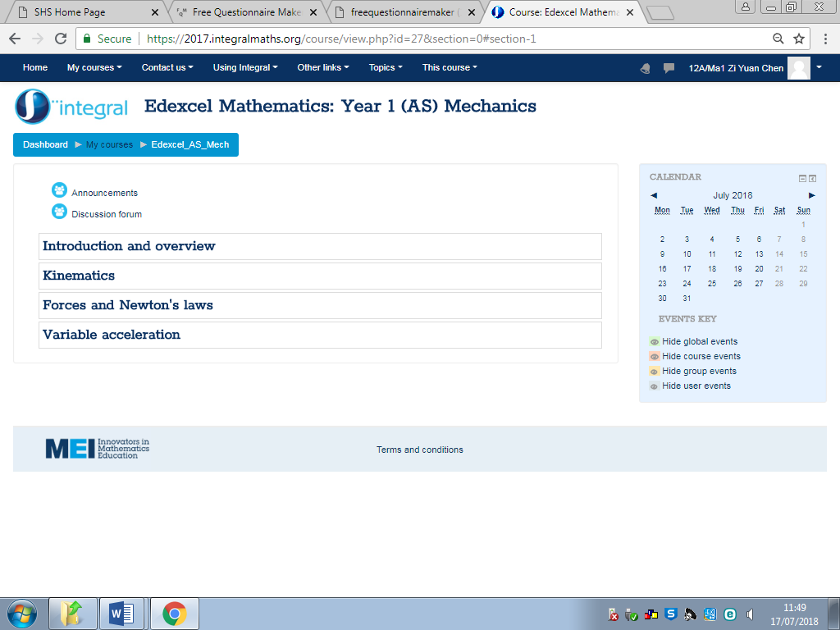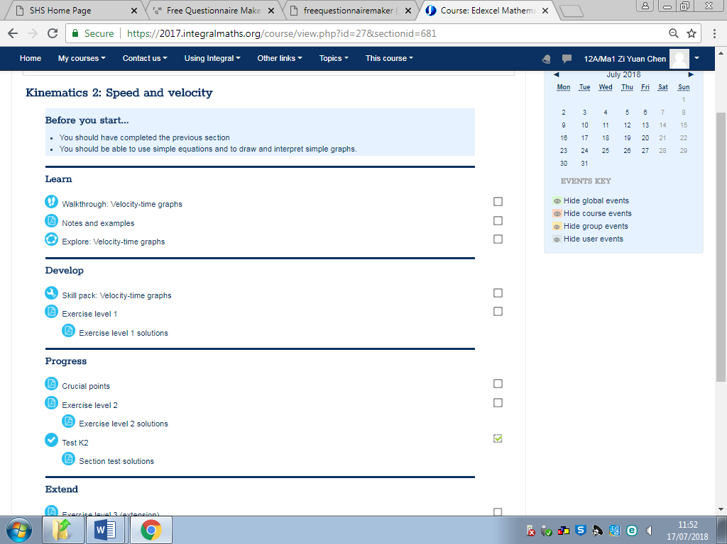Integral is a website which holds information and revision resources for topics in maths. It included resources for mechanics. (Figure 2)[4] By seeing what they have done for the resources I will learn what will be required for it to be educational and any improvements that I may add to my program that will overall improve it.

Figure 8 Course Overview of Entire A-Level

Figure 9 Within the Dashboard of Sub Topic

Figure 10 Walkthrough through a Sub Topic

Shows and displays all topics that have been signed up for and displays it to the students in chronological order. Within that holds each topic from the section and each topic has sub topics so it’s easier to revise parts of it from.

Within each section, its splits further down into smaller topics and within those hold tests, PowerPoints and information to help the students throughout their a-levels.

Their way of assisting students is by having a presentation for each topic of a section with worksheets and examples to work through. They also have topic tests to test the overall knowledge of the topic.

Advantages of this is that it’s a good way of learning as it gives the users the ability to learn through their own pace and it has relevant information and explanations for them to understand everything. (Figure 3)[5] It also contains topic tests for them to test their own ability and has the feature of a teacher being able to view their progress. The site does have a checklist so you can check what parts you’ve completed and what you haven’t. (Figure 4)[6]

However, disadvantages for this is that it’s designed to be broadly used so it cannot be focused on specific users, also they have the same resources so there is a limit to all the work that can be done on the site. There is also the need to have a teacher sign up for the site and apply for each topic that you will be needing.

The ideas that I could use from integral is that it has questions of different levels and assigned to different topics. This will be useful for me so that the correct students will be assigned to the right subject areas and difficulty. They also have a point system to how much work the student achieved which is what I intend to create so that this can track their progress for them and their teachers whilst it being similar to a c=scoreboard for a competitive nature.

### Exam Solutions

Exam solutions is a website that provides users will the necessary information and exam papers and questions for the users to use and practice. There is also quick summaries and explanations that explain the steps involved and how to achieve the right answer. It’s mainly holds past papers and other officially made papers for students to download in each section of the subject so they can practice questions in an actual exam questions to improve their ability.

Figure 11 Shows Course for Entire Year with PowerPoints and Papers

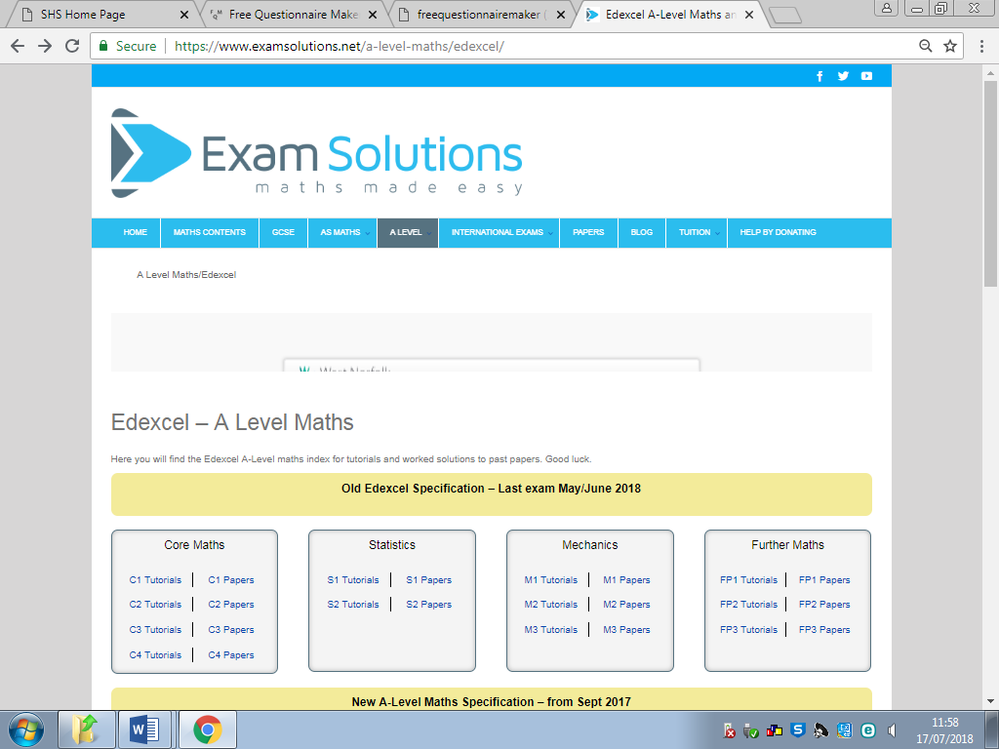

Holds Tutorials for students to study and then papers to practice for each topic.

Advantages of this system is that there is a plethora of questions to go through and it’s very unlikely that the students will run out of practice questions. It assists them in actual exam styled questions and gives them plenty of practice for the questions. (Figure 5)[7]

Disadvantages of this is that the questions are usually similar and can become tedious and boring for the users. There are no incentives for the students apart from getting it right and also even though it has exam solutions, it may not go through all possibilities so if a student is confused, the site will not be able to help.

What I will be using from this is their exam style questions as these are the type of questions that would come up in an exam situation. Also, its plethora of questions so that the students shouldn’t run out of questions to practice. It contains the questions for them to answer and answers afterwards to assess their own work. This will be implemented into my program so that they can see what went wrong and how to progress through.

### Popular Solutions (GOLF IT)

Golf It is a golfing game for PC and consoles. It’s developed and published by Perfuse entertainment and was released in February 17th of 2017. The game designs focus on real life golf as a digital game but inputting different ideas into it. For example, they have high ramps and loop de loops for the users to pass through to get to the end hole in the least number of strokes. There is also use of obstacles that will require good timing or angle to get pass like logs and the classic windmill for golf. (Figure 6)[8]

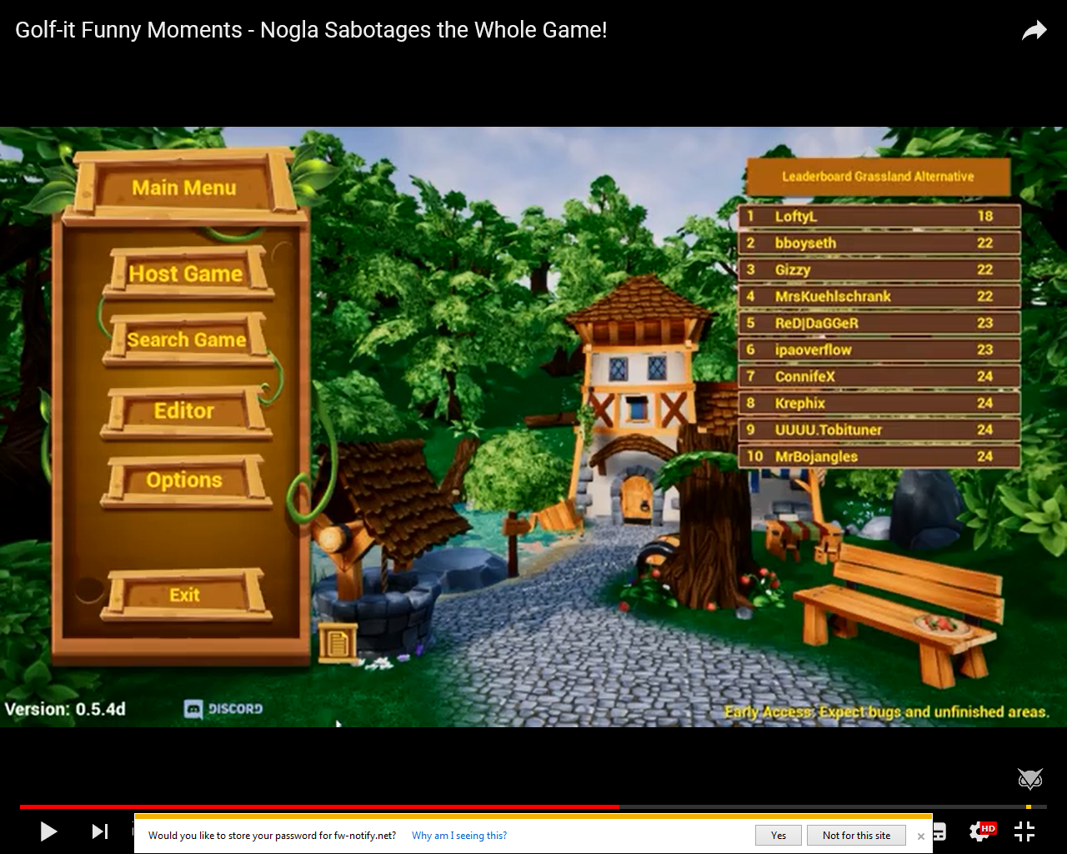

Figure 12 Main Menu for the Popular Game GOLF IT.

Has the menu set up in a good layout with a background image and music, also the leaderboard is visible on the right of the screen.

They also have special events like Halloween and Christmas versions to add more content to the game and a workshop mode mostly for PC so that users can also design a golf course and publish it the workshops o that anyone with the game can download it. This adds lots of possibilities for the game and in theory infinite number of courses. The game also includes multiplayer so that you can play with friends to make it into a more competitive game.

It uses variables such as speed, friction, momentum etc. They use these to create a game version of the real-life golf, the mechanics for the game is hard to master but fun. This is what I hope to achieve for my project so that it can be fun and interesting to play, I will be adapting ideas from this game into my program so that it will be fun and easy to use.

From GOLF IT, I will use ideas such as the game mechanic, menu style and visuals to implement into my program. The game mechanic already includes various variables which is from mechanics in maths however these would need to be adjusted to be more fitting for a maths game. The menu style is simplistic and easy to follow so this is a good example of what my menu will be like. Finally, its visual makes it fun and visually entertaining so it wouldn’t bore people.

### Similar Code

This sets the variable as an object within the game so it can be affected by forces and other variables.

public GameObject arrowPrefab;

GameObject Arrow;

Vector3 StartPos;

These find the start position of the object and the current position.

Vector3 CurrentPos;

// Update is called once per frame

Updates code every frame per second so faster computer will have this code executed more as fps will be higher.

void Update () {

// If screen is touched

if(Input.touches.Length >=0 )

This if for mobile but I can adapt it for keyboard and mouse inputs.

{

// Make start position

StartPos = Input.GetTouch(0).position;

Debug.Log (Input.GetTouch(0).position);

}

(Source: https://answers.unity.com/questions/495616/need-help-with-a-golf-game-script.html)

int score = 0;

int i = -1;

Sets up the initial variables to be used in the code below.

int a = 0;

string[ ] questions = new string[ ]

{

Stores all questions and answers in different arrays called questions and answers. Also, it makes sure that the questions and answers entered are read as string values and not Boolean.

"What is 9 cubed?", "What is 6+3?",

"What type of animal is tuna sandwiches made from?",

"What is 18 backwards?"

};

string[ ] answers = new string[ ] {

"9", "81", "729", "2",

"4", "2", "9", "1",

"zebra", "aardvark", "fish", "gnu",

"31", "81", "91", "88"

Stores the answers that has been received by the user.

};

string [ ] quizAnswers=new string[ ]{"729","9","aardvark","81"};

private void btnStart_Click(object sender, EventArgs e)

{

if (i < questions.Length)

i++;

//txtScore.Text = score;

Displays each question with the 4 options below and waits for the user’s input as their answer. This is looped every time a question is answers and code below if executed until i is less than the amount of questions in the bank

lblQuestion.Text = questions[i];

radA.Text = answers[a];

a++;

radB.Text = answers[a];

a++;

radC.Text = answers[a];

a++;

radD.Text = answers[a];

a++;

btnStart.Visible = false;

btnStart.Enabled = false;

Different variables and states which is shown and useable for the user.

btnSubmit.Visible = true;

btnSubmit.Enabled = true;

}

private void btnSubmit_Click(object sender, EventArgs e){

if(getSelectedAnswer().Equals(quizAnswers[i]))

This is an IF statement and it checks that the answer that the user has picked is either correct or incorrect. This is then displayed and score is changed accordingly. The Start and Submit buttons are reset so that the next question can be displayed and answered again. The initial IF statement above uses a function which is further down in the code.

{

MessageBox.Show("Correct");

score++;

txtScore.Text = Convert.ToString(score);

btnSubmit.Enabled = false;

btnSubmit.Visible = false;

btnStart.Visible = true;

btnStart.Enabled = true;

btnStart.Text = "Next";

}

else

{

MessageBox.Show("Incorrect");

score--;

txtScore.Text = Convert.ToString(score);

btnSubmit.Enabled = false;

btnSubmit.Visible = false;

btnStart.Visible = true;

btnStart.Enabled = true;

btnStart.Text = "Next";

}

}

string getSelectedAnswer()

This is a function used in returning the selected answer into a string format so the above IF statement can compare it to the correct answer.

{

if (radA.Checked)

return radA.Text.ToString();

if (radB.Checked)

return radB.Text.ToString();

if (radC.Checked)

return radC.Text.ToString();

if (radD.Checked)

return radD.Text.ToString();

return "";

}

(Source: https://stackoverflow.com/questions/19898349/create-a-multiple-choice-quiz-with-arrays-in-c-sharp)

The ideas from that I will be taking forward into my project are:

* To be able to retrieve the positions of a game object and to set it to a different value
* Using random to generate a random question for the quiz
* Using multiple lists for each component in a quiz, the question and each answer box
* Having feedback after answering the question, if its correct or not

## Requirements Specification

From my questionnaires and research on various websites, I have come up with main requirements for the game which are listed below.

### Design requirements:

* A good colour palette so it looks good on the game and doesn’t make the game look messy. This was said by my focus group in the questionnaire
* A simplistic layout so nothing will be cramped on screen and users like students and teachers will be able to navigate through with ease (Focus Group Questionnaire)
* Tutorials and help icons so help is providing on explaining how the game works and guides the user if they are new and makes sure their use of the program can be easier
* Questions with answer boxes which the user will have to select to pick their answer choice or input for the more capable ones. This is done so it can familiarise them with the questions and improve their ability to answer them (Client Interview)
* Multiple choice questions so it gives them a helping hand as there aren’t too many chances, done so they can figure out why it’s the correct answers and provides hints for them (Client Interview)
* Non-multiple-choice questions which challenge the more capable (Client Interview)

### Input requirements

* Mouse input to move cursor on screen, clicking to select items and click and drag to move items
* Student account so they can access the game and achieve scores and access to their provided questions (Focus Group Questionnaire)
* Teacher accounts so they can access the question banks (Client Interview)
* Different sections in the question bank for different type of questions (Client Interview)
* The possibility to set different questions to different users (Client Interview)
* Teachers being able to add and remove questions from the question bank (Client Interview)
* Keyboard so different buttons can be used for different effects or to be used to answer a question
* Mouse click or keyboard input of an answer to a question (Focus Group Questionnaire)
* Input of a wrong answer and providing feedback at the end (Client Interview)
* Students can select what type of questions they would like to improve on (Client Interview)

### Processing requirements

* Check their account login to see if its valid and what they can access, upon this decide what privileges they can access (Focus Group Questionnaire)
* Points are rewarded for completing objectives and answering questions correctly
* Points deducted for wrong answer
* Time for questions and randomiser for what questions

### Output requirements

* Leaderboards so student can see each other’s scores (Focus Group Questionnaire)
* Student stats so they can see how they’ve been progressing (Client Interview)
* Teacher’s access to all scores (Client Interview)
* Feedback and points at the end of the game and the correct solution if they want it
* Display text over help icons which provide help to the users
* Sound for the background music and sound feedback for certain events (Focus Group Questionnaire)

### Storage requirements

* Question banks to hold all questions and different sections for different topics
* A hard drive to store the actual game files requires (Hardware Limitation)
* Unity to be downloaded and stored on the system (Software Limitation)
* Files should be accessible by teachers and changed within the storages

### Success Criteria

1. Their ability to answer maths questions and their scores, this will be tested with some maths questions at the start and end of testing to see their progression and if they have improved or not. It will be a success if more than 50% of users achieve a 10% increase in score. (Maths Questionnaire)
2. Their revision and gaming times to see if the program affects this by improving their revision time as the game is a combination of revision and gaming. This can be tested and measured with the questionnaire and there should be at least a 50% increase of users revising 12 hours a week. (Beta Questionnaire)
3. The leaderboards should also show their progress by showing their points, their name and rank position all ordered top to bottom so it provides a visual feedback to how they’ve progressed. For this to be a success, there should be a 20% score rise in the leaderboard after their first day of use. (Program)
4. Their view on the music and sounds to see if it is suitable for the game, this will be measured after their beta testing. This will see if they enjoy the sounds and music for my project and if it wouldn’t be anything that would distract them from the actual program. This is a success if 75% of the focus group enjoy the music. (Beta Questionnaire)
5. Their opinion on the controls for the game, if they fit the program and easy to learn and use. This information will be gathered by questioning them after they test the game and they can give details on what worked and what needed adjustment, however this will be a success if 75% are favourable of the controls. (Beta Questionnaire)
6. There will also be questions on the layout of the game to check if it’s suitable and easy to navigate through. Also, to see if settings and the leaderboard is easy to access and load up. This will be considered a success if 75% agree that it’s easy to use. (Beta Questionnaire)
7. If they have improved their confidence in SUVAT equations by having 90% think it’s “alright” or better and 50% of those are in “Good” or “Great”. (Beta Questionnaire)
8. I will also be conducting a second meeting with my Client to see if they have any additional opinions and if the program was suitable to my Client’s needs. Also, they can check if the questions are a good challenge. If more than 70% of the questions are suitable then this will be a success. (Client Interview)
9. My focus group will also answer question in relation to the screen resolution as the majority have chosen 1920x1080 as their screen size from the focus group questionnaire. This is to see if it actually is suited for the program or if it needs amending. If 80% or higher still want the 1920x1080 then it is a suitable screen size for the program. (Beta Questionnaire)
10. As I have a few colour blinded people in my focus group I will ask them if the program is biased against them as I should have usability features in the game so that they wouldn’t struggle with anything. This is a success if 90% of them agree that the program is still easy to use. (Beta Questionnaire)

# Design

## Top Down Design

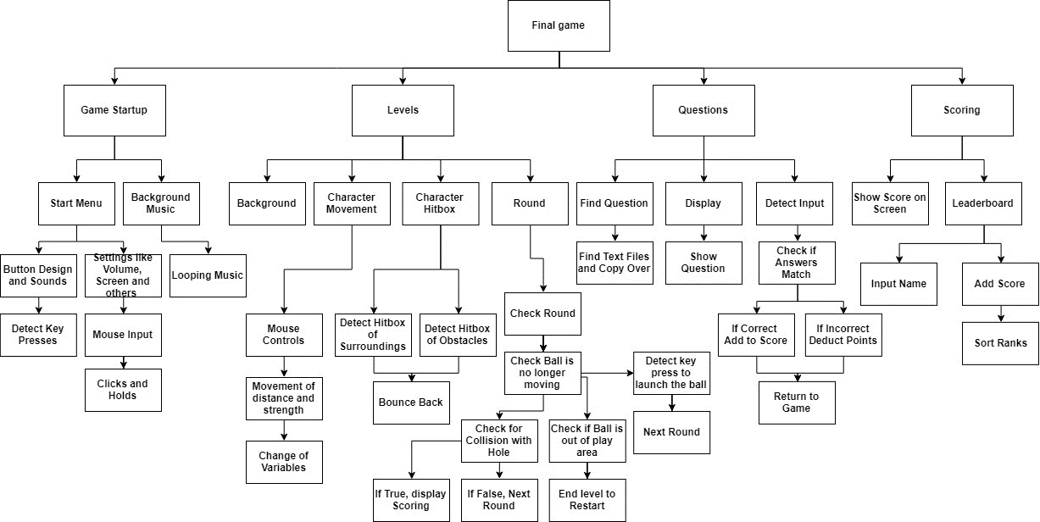

Figure 13 Top Down Design

## Explanation of each strand

### Justification

I have used a top down model to break my project into different sections and parts. Within each section there are small modules which would need to be worked on and made. These smaller modules will have to be created first so that I can move on to the higher modules. Once each strand of the project works, they will be implemented to the main game and tested. This top down model helps me create a timeline of what to work on and what needs to be completed before each strand. It’s also used for my progression checks so I won’t forget what needs to be made.

### Strands and Modules

I have 4 main strands which are:

Game Start-Up: This is the first strand, this contains the modules for the game start up and background music. All variables are initialised and the GUI is loaded up into view for the user. It will include the title of the game and buttons that the user can navigate through so that they can select and access the required area. Each button will have tis specified area, there will be a Start button to access the levels menu so that they can select and complete a level. There will be settings so that they can change some settings that will improve their experience with the program. Leaderboards will also be included so that they can compare their scores to other people which will be ranked. By doing this, a competitive nature will be introduced to the program. A button to quit the game will also be on the menu so that if the user decides to exit the application, they can do it with ease. Along with the GUI of the menu, there will also be background music for the menu on loop.

Levels: This is the next strand which contains the map and the levels for the game. Within each level there is character designs and hitboxes. These would detect and output what would happen if a charter hits something within the level and the penalty for it. It contains the mouse and keyboard controls for the game so the user can control the movement of the character. Finally, the last module for this are the rounds where it would alternate turns after moves are finished and this part also checks if anything has less than 0 health at the end of the round. If they had 0 health then they would be deleted and points will be achieved or deducted.

Questions: This strand contains the questions that will be presented to the user at specific moments within their game, there will be a randomiser to select a question, and this will then be presented to the user which they will have to answer. The question will be presented with 4 multiple choice boxes for the user to pick from. Depending on their choice, the program will output either “Correct” or “Incorrect. A factor of time will also be included so the longer they take to answer the question then the less points they will score. The results for the question will either assist them or hinder them so the more correct answers, the higher their score for the game.

Scoring: This is the final strand; this strand displays their score at the end of the level they completed and inputs it into a leaderboard with their name which they will have to input. This would add a competitive nature to the game so that people would want to achieve a higher score so that they are at top. This will mean they will have to play better and answer questions correctly to be able to achieve a higher score. Therefore, they will have more experience with questions and this will improve their ability in the topic.

### E:\Springwood\Comuter Project\Flowcharts\Start Menu.jpgMenu

Figure 14 Start Menu Flowchart

#### Flowchart

#### Pseudocode

START  
Def StartMenu()  
 Check = False  
 WHILE Check = False then  
 IF mouseclick.left = True then  
 x = xposition  
 y = yposition  
 IF startX1 < x < startX2 and startY1 < y < startY2 then  
 StartGame()  
 ELSE IF settingsX1 < x < settingsX2 and settingsY1 < y < settingsY2 then  
 Settings()  
 ELSE IF leaderX1 < x < leaderX2 and leaderY1 < y < leaderY2 then  
 LeaderBoards()   
 ELSE IF exitX1 < x < exitX2 and exitY1 < y < exitY2 then  
 ExitProgram()  
 END IF  
 END IF  
 END WHILE  
END

#### Trace Table

For my trace table, I will be testing it for only one if the buttons as the other 3 will have the same code but different coordinates. This will mean it will save some time and if there are any bugs, they will be found early. It is also easier to display as a trace table.  
For this module, I have implemented a test button at the coordinates x 200-250 and y 300-320 as a temporary test. This will make it easier to test and to get working before I move and add more buttons for my program.

Test Data:

|  |  |  |  |  |  |  |  |  |
| --- | --- | --- | --- | --- | --- | --- | --- | --- |
| Test No | Check | mouseclick.left | x | y | startx1 | startx2 | starty1 | starty2 |
| 1 | True | False | 220 | 310 | 200 | 250 | 300 | 320 |
| 2 | False | True | 100 | 100 | 200 | 250 | 300 | 320 |
| 3 | True | True | 220 | 310 | 200 | 250 | 300 | 320 |

Trace table:

|  |  |  |  |  |  |  |  |  |  |  |
| --- | --- | --- | --- | --- | --- | --- | --- | --- | --- | --- |
| Step | Variables | | | | | | | | Output | Notes |
| Check | mouseclick.left | x | y | startx1 | startx2 | starty1 | starty2 |
| Test1- 1 | True |  |  |  |  |  |  |  |  | The True for Check is changed to False and nothing else is executed |
| 2 |  | False |  |  |  |  |  |  |  |
| Test2-1 | False |  |  |  |  |  |  |  |  | Click detected, nothing is executed as mouse position is incorrect |
| 2 |  | True |  |  |  |  |  |  |  |
| 3 |  |  | 100 | 100 |  |  |  |  |  |
| 4 |  |  |  |  | 200 | 250 |  |  | False |
| 5 |  |  |  |  |  |  | 300 | 320 | False |
| Test3-1 | True |  |  |  |  |  |  |  |  | All factors are correct for it to launch the module StartGame() |
| 2 |  | True |  |  |  |  |  |  |  |
| 3 |  |  | 220 | 310 |  |  |  |  |  |
| 4 |  |  |  |  | 200 | 250 |  |  | True |
| 5 |  |  |  |  |  |  | 300 | 320 | True |
| 6 |  |  |  |  |  |  |  |  | StartGame() |

### Levels

#### Flowchart

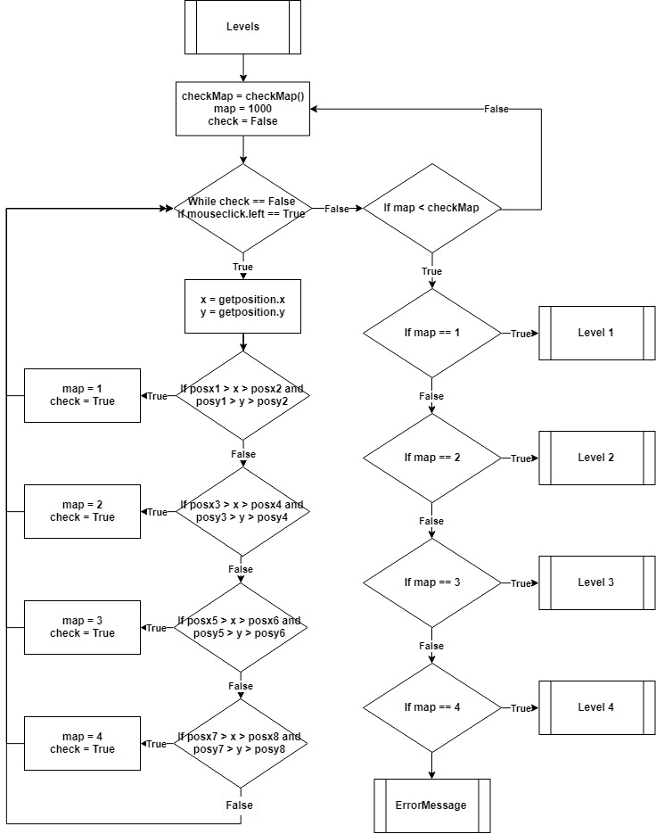

Figure 15 Levels Flowchart

#### Pseudocode

START  
Def Levels()  
 checkMap = checkMap()  
 map = 1000  
 check = False  
 WHILE check == False  
 IF mouseclick.left == True then  
 x = getposition.x  
 y = getposition.y  
 IF posx1 > x > posx2 and posy1 > y > posy2 then  
 map = 1  
 check = True  
 ELSE IF posx3 > x > posx4 and posy3 > y > posy4 then  
 map = 2  
 check = True  
 ELSE IF posx5 > x > posx6 and posy5 > y > posy6 then  
 map = 3  
 check = True  
 ELSE IF posx7 > x > posx8 and posy7 > y > posy8 then  
 map = 4  
 check = True  
 ELSE then  
 check = False  
 END IF  
 END WHILE  
 IF map < checkMap then  
 IF map == 1 then  
 Level1()  
 ELSE IF map == 1 then  
 Level2()  
 ELSE IF map == 1 then  
 Level3()  
 ELSE IF map == 1 then  
 Level4()  
 ELSE then  
 ErrorMessage()  
 END IF  
END

#### Trace Table

The trace table here will be similar to the previous Menu trace table as this one also contains functional buttons. For the levels trace table, it will hold all the buttons and their position, there is an “if” statement which calls a class to detect a mouse press. Once this is detected, it will execute the check for the buttons, if the mouse is within proximity of a button then it will set a variable to the relative to the level number they have picked. Then the next if statement will check if it’s a level that they would have access to, if it is then it will load the map. If not, then a message will display.

The code and flowchart only hold an example of 4 levels however if there would be more levels then it can be easily fixed by extending the “if” statements to hold more possible levels.

Similarly, to the Menu, the test data and trace table will only be testing one button as if that one works then so will the rest as they have the same code.

Test Data:

|  |  |  |  |  |  |  |  |  |
| --- | --- | --- | --- | --- | --- | --- | --- | --- |
| Test No | checkMap | mouseclick.left | x | y | posx1 | posx2 | posy1 | posy2 |
| 1 | False | False | 120 | 120 | 100 | 200 | 100 | 150 |
| 2 | False | True | 300 | 300 | 100 | 200 | 100 | 150 |
| 3 | True | True | 550 | 520 | 500 | 600 | 500 | 550 |
| 4 | True | True | 150 | 120 | 100 | 200 | 100 | 150 |

Test number 1 and 2 will be checking what occurs if mouse button isn’t pressed and if it is pressed but it’s out of the specified range of any buttons. Test 3 tests if the user tries to access a level that they shouldn’t have access to. Finally test 4 will just be checking if it would actual work if the user can enter a level, they have access to.

For all these tests, I have made the “checkMap()” function return a 5 as their access level. This is only temporary and is done to make sure this code has a fair test.

Trace table:

|  |  |  |  |  |  |  |  |  |  |  |  |  |  |
| --- | --- | --- | --- | --- | --- | --- | --- | --- | --- | --- | --- | --- | --- |
| Step |  | |  | | Variables | | | | | | | | Output |
| checkMap | map | | check | | mouseclick.left | x | y | posx1 | posx2 | posy1 | posy2 |
| Test1- 1 | 5 |  | |  | |  |  |  |  |  |  |  |  |
| 2 |  | 1000 | | False | | False |  |  |  |  |  |  |  |
| Test2-1 | 5 |  | |  | |  |  |  |  |  |  |  |  |
| 2 |  | 1000 | | False | | True |  |  |  |  |  |  |  |
| 3 |  |  | |  | |  | 300 | 300 |  |  |  |  |  |
| 4 |  |  | |  | |  |  |  | 100 | 200 |  |  |  |
| 5 |  |  | |  | |  |  |  |  |  | 100 | 150 |  |
| 6 |  |  | | False | |  |  |  |  |  |  |  |  |
| Test3-1 | 5 |  | |  | |  |  |  |  |  |  |  |  |
| 2 |  | 1000 | | False | | True |  |  |  |  |  |  |  |
| 3 |  |  | |  | |  | 550 | 520 |  |  |  |  |  |
| 4 |  |  | |  | |  |  |  | 500 | 600 |  |  |  |
| 5 |  |  | |  | |  |  |  |  |  | 500 | 550 |  |
| 6 |  | 5 | | True | |  |  |  |  |  |  |  |  |
| 7 |  |  | |  | |  |  |  |  |  |  |  | ErrorMessage() |
| Test3-1 | 5 |  | |  | |  |  |  |  |  |  |  |  |
| 2 |  | 1000 | | False | | True |  |  |  |  |  |  |  |
| 3 |  |  | |  | |  | 150 | 120 |  |  |  |  |  |
| 4 |  |  | |  | |  |  |  | 100 | 200 |  |  |  |
| 5 |  |  | |  | |  |  |  |  |  | 100 | 150 |  |
| 6 |  | 1 | | True | |  |  |  |  |  |  |  |  |
| 7 |  |  | |  | |  |  |  |  |  |  |  | Level1() |

There were no errors that has occurred whilst testing all the data. All outcome was the outcome expected.

For test 1, all variables were set to their corresponding values at the start of the code, there was no mouse click so nothing was executed and the code awaits the user for an input.   
Test 2, there was a mouse click detected however no buttons was in range so the check variable was remained False and the while loop still occurs.   
Test 3, mouse click was in range of a button so the next IF statement is processed within this function however the code “map < Checkmap” failed as they do not have access to the level. Therefore this calls another function which will explain the reason why they wouldn’t have access to the level.  
Test 4, mouse click was in range of a button and the next IF statement was successful as they have access to the level. This means that the corresponding level, in this case it’s “Leve1()” is loaded for the user.

### Questions

#### Flowchart

#### Pseudocode

START  
Def Questions()  
 Num = Rand.int(1-3)  
 Time = 0  
 Questions = [“From text file”]  
 Answers = [“From text file”]  
 Output(Questions[Num])  
 Time = seconds.count  
 UAnswer = UserInput  
 Time = seconds.stop   
 IF Answer == Answers[Num] and TimeStatic <= 90 then  
 Score = 100 - TimeStatic  
 return Score  
 ELSE IF Answer == Answers[Num] then  
 Score = 10  
 return Score   
 ELSE   
 Score = -50  
 return Score  
 END IF  
END

Figure 16 Questions Flowchart

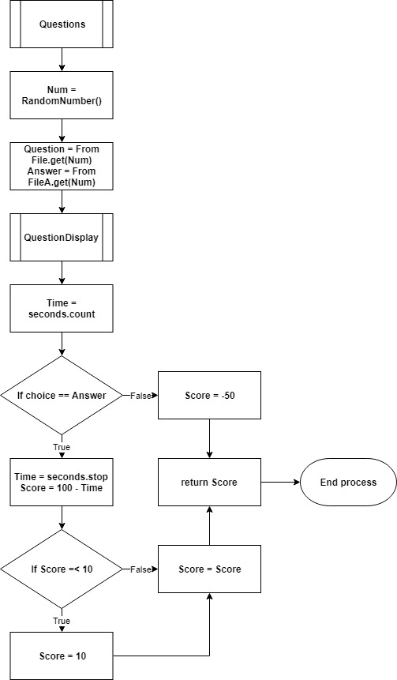

#### Trace Table

File:

|  |  |
| --- | --- |
| Questions | Answers |
| Question 1 | Answer 1 |
| Question 2 | Answer 2 |
| Question 3 | Answer 3 |

Test Data:

|  |  |  |  |  |  |  |
| --- | --- | --- | --- | --- | --- | --- |
| Test No | Num | Time | Question | Answers | UAnswer | Score |
| 1 | 2 | 100 | Question 2 | Answer 2 | Answer 1 | 0 |
| 2 | 3 | 10 | Question 3 | Answer 3 | Answer 1 | 0 |
| 3 | 2 | 100 | Question 2 | Answer 2 | Answer 2 | 0 |
| 4 | 1 | 10 | Question 1 | Answer 1 | Answer 1 | 0 |

Trace Table:

|  |  |  |  |  |  |  |  |  |
| --- | --- | --- | --- | --- | --- | --- | --- | --- |
| Step | Variables | | | | | | Output | Notes |
| Num | Time | Questions | Answers | UAnswer | Score |
| Test1- 1 | 2 | 0 | Question 2 | Answer 2 |  | 0 |  | Question is randomly retrieved and displayed. User Answer incorrect so score return of -50 |
| 2 |  |  |  |  |  |  | Question 2 |
| 3 |  |  |  |  | Answer 1 |  |  |
| 4 |  | 100 |  |  |  |  |  |
| 5 |  |  |  |  |  | -50 |  |
| 6 |  |  |  |  |  |  | Return Score |
| Test2-1 | 3 | 0 | Question 3 | Answer 3 |  | 0 |  | Question displayed, incorrect answer and less time to answer however still a loss of 50 points |
| 2 |  |  |  |  |  |  | Question 3 |
| 3 |  |  |  |  | Answer 1 |  |  |
| 4 |  | 10 |  |  |  |  |  |
| 5 |  |  |  |  |  | -50 |  |
| 6 |  |  |  |  |  |  | Return Score |
| Test3-1 | 2 | 0 | Question 2 | Answer 2 |  | 0 |  | Question displayed and answered, user was right but took 100 seconds so a score return of 10 |
| 2 |  |  |  |  |  |  | Question 2 |
| 3 |  |  |  |  | Answer 2 |  |  |
| 4 |  | 100 |  |  |  |  |  |
| 5 |  |  |  |  |  | 10 |  |
| 6 |  |  |  |  |  |  | Return Score |
| Test4-1 | 1 | 0 | Question 1 | Answer 1 |  | 0 |  | Same as before but trial data suggests user took 10 seconds so there is a score return of 90 |
| 2 |  |  |  |  |  |  | Question 1 |
| 3 |  |  |  |  | Answer 1 |  |  |
| 4 |  | 10 |  |  |  |  |  |
| 5 |  |  |  |  |  | 90 |  |
| 6 |  |  |  |  |  |  | Return Score |

### Scoring

#### Flowchart

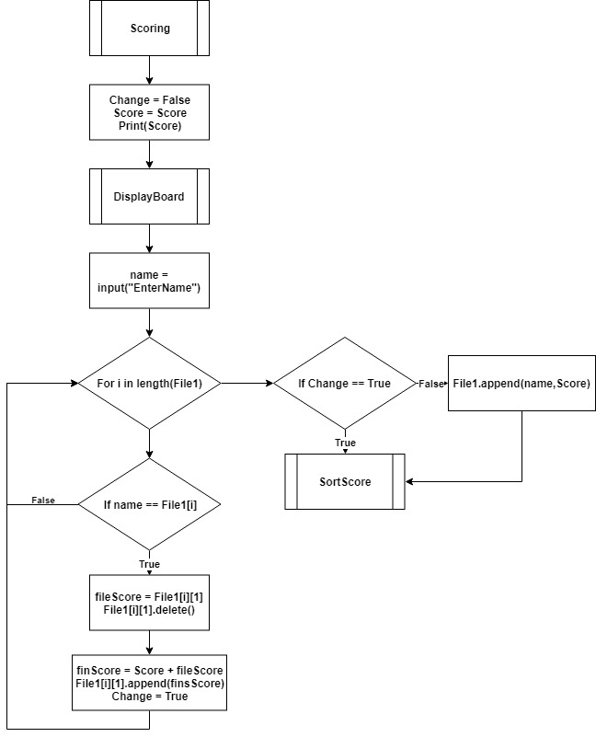

Figure 17 Scoring Flowchart

#### Pseudocode

START  
Def Scoring()  
 Change = False  
 Score = Score  
 Print(Score)  
 DisplayBoard()  
 name = input(“Enter Name”)  
 For i in range(len(File1)) then  
 IF name == File1[i] then   
 fileScore = File1[i][1]  
 File1[i][1].delete()  
 finScore = Score + fileScore  
 File1[i][1].append(finScore)  
 Change = True  
 END FOR  
 IF Change == True then  
 SortScore()  
 ELSE then  
 File1.append(name, Score)  
 SortScore()  
 END IF  
END

#### Trace Table

File:

|  |
| --- |
| File1 |
| John, 20 |
| Albert, 150 |
| Ellie, 30 |

Test Data:

|  |  |  |  |  |  |
| --- | --- | --- | --- | --- | --- |
| Test No | Change | name | Score | fileScore | finScore |
| 1 | False | John | 20 | 20 | 0 |
| 2 | True | Albert | 100 | 150 | 0 |
| 3 | False | Ellie | -10 | 30 | 0 |
| 4 | True | Elli | 50 | 30 | 0 |

Trace Table:

|  |  |  |  |  |  |  |  |
| --- | --- | --- | --- | --- | --- | --- | --- |
| Step | Variables | | | |  | Output | Notes |
| Change | name | Score | fileScore | finScore |
| Test1- 1 | False |  |  |  |  |  | Score and name are first retrieved then it’ll find if the name already exists in the list. In this case it does so the score total is updated and replaces the original score |
| 2 | False |  | 20 | 20 |  | 20 |
| 3 |  | John |  |  |  |  |
| 4 |  | John |  |  | 40 |  |
| 5 | True |  |  | 40 |  |  |
| 6 |  |  |  |  |  | SortScore() |
| Test2-1 | True |  |  |  |  |  | Albert exists in the list and the “Change” Boolean is set to false beforehand so having it as true from the start will not cause problems |
| 2 | False |  | 100 | 150 |  | 100 |
| 3 |  | Albert |  |  |  |  |
| 4 |  | Albert |  |  | 250 |  |
| 5 | True |  |  | 250 |  |  |
| 6 |  |  |  |  |  | SortScore() |
| Test3-1 | False |  |  |  |  |  | When the score is negative, it will not have an effect on any of the code as it’ll be stored as a string value |
| 2 | False |  | -10 | 30 |  | -10 |
| 3 |  | Ellie |  |  |  |  |
| 4 |  | Ellie |  |  | 20 |  |
| 5 | True |  |  | 20 |  |  |
| 6 |  |  |  |  |  | SortScore() |
| Test4-1 | True |  |  |  |  |  | When a user enters a different name or a slight error, the code will treat this as a new entry which means that it’ll append the name and score as new |
| 2 | False |  | 50 | 30 |  | 50 |
| 3 |  | Elli |  |  |  |  |
| 4 |  | Elli |  |  | 80 |  |
| 5 | True |  |  | 80 |  |  |
| 6 |  |  |  |  |  | SortScore() |

## Data Structures

To meet my required specification and to ensure correct coding for the project, I will plan beforehand the major scripts and data structures for the project. In Unity, a script is used to describe a file of code and within the code is usually a class that holds the code and functions.

### Simple Data Structures

Simple structures that will be widely used in my program are:

* String, stores any value with quote marks such as “test12*”. Which is used to hold a certain value that will need not need to be changed, only added, removed or displayed.
* Boolean, stores either true or false. Mostly used for validation so code isn’t being ran more than what’s needed. Also used to store conditions that are met such as if the user completes a question or presses a key.
* Integer, stores a whole real number. Used to store certain values to keep track of the user’s information. I will be using this to store score, number of strokes and others that will need whole numbers.
* Float, stores a decimal number for more accurate results in calculation. I will use floats as a way to calculate certain values to be used in the code so that they can be as accurate as possible, the results can then be rounded if necessary.
* Game Object, stores the physical properties and components of an object within the scene. I can then use code to take the properties or components and replace them with a different one such as to change the speed, position, colour and more.

### Buttons

Buttons will be very commonly used in my program as it will be used in the main menu, the quiz to answer question and possibly more. To make sure buttons will act like buttons, in Unity the buttons will linked to a Boolean which is set to be an enabler for the button. The Boolean will be responsible for a part of a script to be executed only when the Boolean is true, then it will be set back to false, minimising error.

To get this to work, within Unity, there’s a feature for the button where I will be able to set functions and scripts to the button so that the button can either call it or reference it. Consequently, the Boolean will be made as part of a function so the buttons will be able to call and run the function. Therefore, this means that the buttons will act accordingly and that I can reuse this idea and template for any other buttons in the program.

### Dynamic Lists

The quiz script will hold lots of dynamic lists and functions. It will have to contain lists for all the questions, each list which is responsible for the display of each button and finally a list which will hold all the correct answers. This class will also hold a random integer for which question and answers are to be displayed, the random integer will be used for all these lists so that they will be using the same number.

There’s the use of dynamic list which means that the data stored can be stored, appended, deleted and displayed. However, for my program I will only need to add, store and display them. Therefore, the dynamic lists are used so that they will not run out of room, waste space and so that I can use them to display questions and answers for the quiz.

### Player Prefs

Player Prefs will be used for the leaderboards to store entries. This works similarly to a text files where string values can be stored as an array in the file but instead each entry is stored separately in the registry. When using Player Prefs, it will hash the data that’s stored meaning that it’s encrypted and the key can be used to find data easily. This also means that I will have to store bother the name and the score as one string so I will have to use a string value that I will pre-set to be able to separate the entry.

Once the entry is separated, I can then store it as a dynamic list in the code for later display. Therefore, I will Player Prefs to store score entries so that they can be saved on the computer which means that whenever the program is re-opened, the score will remain.

### Classes/Scripts

Within Unity, scripts are used to store the code written for the program and are used to attach to different objects or scenes within the program. This means that some code can be reused and common features can use the same scripts of code to make my program more efficient.

In the scripts, classes are used to define the code within the script and each script can contain more than one class but I will try to keep it to one class to one script so that it will be more separated and easier to assign to the correct objects. When an object uses a script, they refer to the class within the script and the code is ran from that and can store certain variables that will be relative to the object it is attached to.

## Unity Modules

There is a range of modules which I plan to use within my Unity program and these modules will be able to assist me in code and enable the use of new components and updated features for Unity. The modules are up to date along with the version of Unity I’m using which is “Unity 2018.3.7”.

### Unity Engine

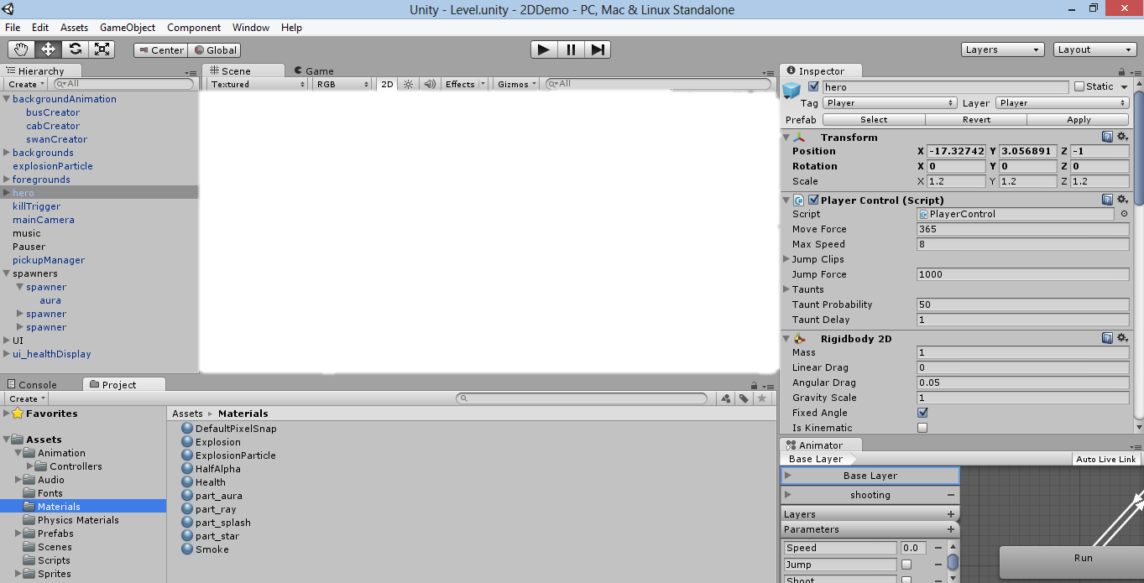This is the game engine for the program “Unity”. The entire engine means that I can develop games using their technology and coding. This also provides an Integrated Development Environment (IDE) so that I will be able to develop the game whilst viewing what the user will see. It allows for web plugins, desktop platforms, consoles and mobiles devices however for my project I will only need to focus on the desktop version. Within the Engine it provides a changeable Interface where I can have different areas on the screen for my benefit meaning that when I produce a physical level it can be viable in the hierarchy (Figure VII)[9].

Figure 18 Unity Interface

### System Collection and System Collection Generic

This module is the basis for Unity as it can be widely used and is necessary for most commands and code. It provides scriptable objects which will be a major part in my project as the class which contains the code is stored as a script. Then this script can be attached to objects for the code to refer to meaning that components and positions of the object can be controlled or limited by using these modules.

By using these modules, it allows me to:

* Code referencing to its own objects and other
* Store the working scripts onto the object
* Control parts of objects
* The spawning of prefabs and deletion of objects

### Unity Engine Scene Manager

As the Main Unity Engine provides the use of the UI and all the basic requirements for the program to work, this specific package provides more possible commands to use. The Scene Manager can be imported and it’s used to control what scene is visible by the use of its specific code. For example, the code “SceneManager.LoadScene()” which calls the module then executes the code. The code “LoadScene()” Loads the scene provided either by providing a build index of the scene that wants to be displayed or by just using the name of the scene which is case sensitive.

### Unity Engine UI

Another package which can be imported and that I need to use is the UI module which provides me with the ability to change components of an image which I can either import or use a pre-set from Unity.

By being able to use the Image component, lots of attributes can be change such as the colour of the image which is in RGBA (Red, Green, Blue, Transparency), the positioning and the hierarchy for the image. When changing colour, it’s similar to changing an objects position where a new 3d vector is used to replace the old but in this case its colour. For example, “object.color=new Color(0,0,0,0)” which will replace the colour of the object into the new colour set. When using this, colour is spelt as color as Unity is an American product.

### System Linq

System Linq is a smaller module where the main features of this is to order lists or other things in unity such as objects. This is easily achieved by the use of the code “OrderByDescending()” or “OrderByAscending()” where the brackets hold the conditions of the ordering.

### TMPro

Finally, the last module I imported is the Text Mesh Pro, this is an addition to the already existing text, buttons, input fields and more. However, this is a more up to date version which provides much better visuals and extra features because the basic one usually had poor graphics or stretched components.

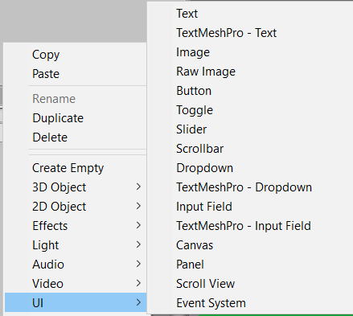TMPro can be used the same way as any unity code however it must be called upon when it references an item which was created by TMPro. (Figure VIII)

Figure 19 TMPro UI List

For example, “object.GetComponent<TextMeshProUGUI>” finds the object and retrieves the component if the object is a TMPro object. Then whatever part of this can be modified and updated such as “.text”, “.transform” and more.

## Data Dictionary

|  |  |  |  |  |
| --- | --- | --- | --- | --- |
| Variable Name | Data Type | Validation | Comment | Local/Global |
| Leaderboards | Boolean | Yes – Only allows the code to run once this is true | Used to make sure code is only ran once this variable is true | Global Static (Static in Unity means that the value changed will remain) |
| Main | GameObject | No | Holds the Main Menu panel as an object | Local |
| LeaderBoard | GameObject | No | Holds the Leaderboards panel as an object | Local |
| Camera | GameObject | No | Holds the camera from the scene as an object | Local |
| Ball | GameObject | No | Holds the ball from the scene as an object | Local |
| CameraHeight | Integer | No | Provides the script a number for the height of the camera. | Local |
| zForce | Float | No | Holds the amount of force that will be applied onto the ball. | Local |
| clubObj | Transform | No | Holds the transform component (positioning) of the club object so that it can be moved | Local |
| arrow | Transform | No | Holds transform component of the arrow object so it can be moved and rotated | Local |
| mouseEnd | Boolean | Yes – Allows the next UI to be displayed once true | Makes sure that the only code is only ran before it enters the hole and once it does, this is changed so code will no longer run | Local |
| endMouse | Boolean | Yes – Allows ball to be hit when still | Makes sure that mouse clicks are only valid when the ball isn’t in motion for the “mouseEnd” variable to be ran | Local |
| yScale | Float | No | Holds the value in which the arrow would be increased/decreased by | Local |
| forceColour | Float | No | Holds the number responsible for the colour change of the arrow’s body | Local |
| AForceColour | Float | No | Holds the number responsible for the colour change of the arrow’s head | Local |
| strokes | GameObject | No | Holds the text object that will display the number of strokes the user has used using “currentStrokes” | Local |
| currentStrokes | Integer | No | The number of strokes that the user is currently on | Global Static |
| endPanel | GameObject | No | Holds the End panel as an object to be displayed after the level ends | Local |
| difPanel | GameObject | No | Holds the Difficulty panel as an object to be displayed | Local |
| quizPanel | GameObject | No | Holds the Quiz panel as an object to be displayed after the difficulty | Local |
| LastUI | GameObject | No | Holds the Last Interface panel as an object to be displayed once quiz has ended | Local |
| Checker | Boolean Button | Yes – Allows only one choice to be made | Used to ensure that code for this part is only ran once when its true then at the last line, it sets itself to false which means it’ll run once. | Global Static |
| difChecker | Boolean Buttons | Yes – Allows the next UI when difficulty is chosen | Ensures the code is ran once | Global Static |
| quizChecker | Boolean Buttons | Yes – Allows the next UI when quiz is complete | Ensures the code is ran once | Global Static |
| difSelector | String | No | Holds the string which the user has chosen as the difficulty which is passed onto the “Quiz” script | Global Static |
| dif1 | Boolean Button | No | Used so when the button is pressed, the Boolean becomes true and is then used elsewhere as the Easy difficulty | Global Static |
| dif2 | Boolean Button | No | Used so when the button is pressed, the Boolean becomes true and is then used elsewhere as the Medium difficulty | Global Static |
| dif3 | Boolean Button | No | Used so when the button is pressed, the Boolean becomes true and is then used elsewhere as the Hard difficulty | Global Static |
| button1 | Boolean Button | No | Used so when the first answer button in the Quiz is pressed, it is registered | Global Static |
| button2 | Boolean Button | No | Used so when the second answer button in the Quiz is pressed, it is registered | Global Static |
| button3 | Boolean Button | No | Used so when the third answer button in the Quiz is pressed, it is registered | Global Static |
| button4 | Boolean Button | No | Used so when the fourth answer button in the Quiz is pressed, it is registered | Global Static |
| questions | Dynamic List | No | A list which contains all the questions for the quiz part of the program | Local |
| correctAnswer | Dynamic List | No | A list which contains the correct answers relative to each question in the “questions” list | Local |
| firstChoice | Dynamic List | No | List which stores the answers to be displayed as choice 1 | Local |
| secondChoice | Dynamic List | No | List which stores the answers to be displayed as choice 2 | Local |
| thirdChoice | Dynamic List | No | List which stores the answers to be displayed as choice 3 | Local |
| fourthChoice | Dynamic List | No | List which stores the answers to be displayed as choice 4 | Local |
| selectedAns | String | No | Holds the string value of the answer that the player has chosen to compare with the actual answer | Local |
| question | GameObject | No | Holds the text object responsible for the display of the question | Local |
| ansButton1 | GameObject | No | Stored the first answer button so it can be referenced in the script | Local |
| ansButton2 | GameObject | No | Stored the second answer button so it can be referenced in the script | Local |
| ansButton3 | GameObject | No | Stored the third answer button so it can be referenced in the script | Local |
| ansButton4 | GameObject | No | Stored the fourth answer button so it can be referenced in the script | Local |
| answer1 | GameObject | No | Holds the text object for the display of the first choice | Local |
| answer2 | GameObject | No | Holds the text object for the display of the second choice | Local |
| answer3 | GameObject | No | Holds the text object for the display of the third choice | Local |
| answer4 | GameObject | No | Holds the text object for the display of the fourth choice | Local |
| scoreNum | GameObject | No | Holds the text object that is responsible for displaying the user’s score | Local |
| quizPanel | GameObject | No | Holds the Quiz panel | Local |
| ansCheck | GameObject | No | Holds the button the user has picked so that it can be used and changed | Local |
| nextScreen | GameObject | No | Holds the next panel which displays after the quiz panel | Local |
| correcting | GameObject | No | Holds the text object which is changed depending whether or not the question was answered correctly | Local |
| countDown | GameObject | No | Holds the text object responsible for the integer display for a countdown after the Quiz | Local |
| choiceCheck | Boolean Buttons | Yes – Allows only one choice for the quiz answers | Ensures that a choice can be made but once a button is clicked, the Boolean is changed preventing any code below this to be ran. Stops the user from clicking the same button or all of them | Global Static |
| timeCount | Float | No | Used to store the seconds that has passed once activated by using Unity | Local |
| deNum | Integer | No | Stores the number which is being reduced to therefore provide a countdown | Local |
| selectCheck | Boolean Buttons | Yes – Adds the score once | Ensures that once an answer is selected, the score is only changed once and not any more | Local |
| randNum | Integer | No | Used to produce a random number to be used for the question and answer display | Local |
| questionCheck | Boolean | Yes – Allows only one question | Makes sure that the displaying of all the question and answer is only done once | Local |
| difNum | Integer | No | Value which shifts the random number generator depending on which difficulty was chosen | Local |
| totalScore | Integer | No | Stores the user’s score | Local |
| par | Integer | No | Holds the par of the level | Local |
| timeUsed | Integer | No | Holds how much time the user has used which can be multiplied and deducted from their score | Local |
| quizObject | GameObject | No | Holds the Object which holds the “Quiz” script so functions can be called out of it | Local |
| timeBar | Image | No | Holds the image for the time bar | Local |
| maxTime | Float | No | Contains the value that is the maximum time the user ahs | Global Static |
| timeLeft | Float | No | Uses the “maxTime” to count down and then the value is constantly stored here | Global Static |
| timeColourG | Float | No | Holds the RGB value of green as there will be an decrease gradient change | Local |
| timeColourR | Float | No | Holds the RGB value of red as there will be an increase gradient change | Local |
| elapsed | Float | No | Holds the elapsed time so I can set a value which will update the colour every x seconds | Local |
| colDiv | Float | No | Used to subtract or increase the colours by this amount | Local |
| levelpar | GameObject | No | Holds text object to display the par of the level in the Last UI | Local |
| userStrokes | GameObject | No | Holds text object to display the strokes the user has used of the level in the Last UI | Local |
| finScore | GameObject | No | Holds text object to display the par of the level in the Last UI | Local |
| par | Integer | No | Used to retrieve the value of the par from a different script with the same variable so that the par values will match | Global Static |
| finalScore | Integer | No | Holds the integer of the final score as this is updated by a different script hence its global static | Global Static |
| scoreCount | Integer | No | Holds the number which is the max number of score entries which should be displayed | Local |
| scoreboard | GameObject | No | Stores the object which contains this script so that function can be called from it | Global Static |
| Separator | String | No | It’s a string value used to separate the string which will contain the name and score as this string will be in between the values | Global Static |
| inputName | TMP_InputField | No | An Input field for which the user can enter their name to be stored as a string value | Local |
| inputScore | Integer | No | Holds the final score value to be used in the leaderboard | Local |
| scoreObject | GameObejct | No | Holds the prefab object (One or more objects that can be called) which is used to display the score | Local |
| scoreRoot | GameObject | No | The panel of where the “scoreObjects” will be placed for the display of the user | Local |
| textName | TMP_Text | No | Contains a string of the name which is retrieved from the Text Mesh Pro text | Local |
| textScore | TMP_Text | No | Contains a string of the score which is retrieved from the Text Mesh Pro text | Local |
| playerScore | List | No | Holds all name and score entry, entries can be entered | Local |

## Usability features

I will incorporate features and change different parts of the program such that it can be accessible to my target audience which are sixth formers studying maths/physics. I will consider features such as:

### Using Clear English and Easy Instructions

I will have instructions at the beginning of the game which will guide the user through the game so that they know what to do. They will also be icons which can be hovered over to provide additional help to the item oriented around the item. For example, an icon on the question box explaining that they are given a question to work out and answer. Controls will also be shown to them and accessible in the menu. This is done so navigating through the program will be as easy as possible and no confusion is created.

The program will also be in simple English so no complicated works even though they are year 12/13, but having a simple vocabulary for the game will provide additional ease for the user.

They will also be instructions in the game showing them their objective and a Pause feature so they can reconcile with the help or leave if they wanted.

The help and instructions will pop up every time they encounter a certain event which could become annoying so there is a feature in the settings to turn this off if they are confident with the game and understand how to navigate and use it. However, this can be turned back on at any time.

### Features for Epilepsy

Epilepsy is a common condition that causes seizures when there is a burst of electrical activity in the brain which is commonly triggered by flashing of images (Figure IX)[10].

I have taken this into account and will not create anything in my program that will cause this. This is to ensure that the program is not a health risk.

Figure 20 Epilepsy

### Features for Colour Blindness

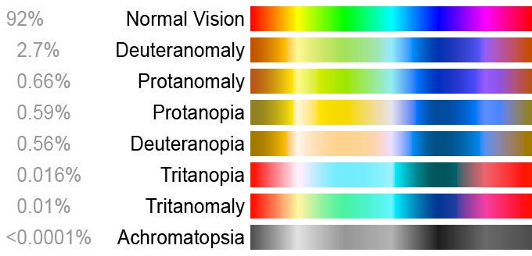There are a variety of different forms of colour blindness, from the most common one called Deuteranomaly to extremely rare ones such as Achromatopsia (Figure X)[11].

Figure 21 Types of Colour Blindness and Rarity

The cause of colour blindness is the cause of a mutation in the X chromosome hence the reason why women are less likely to get colour blindness. This mutation cause deficiency in distinguishing between colours such as red, green or blue. The most common type of colours that causes issues are red and green. Therefore, there’s a range of ways to prevent any issues such as[12]:

* Having words or symbols along thing the colours to prevent confusion with what to do
* Keeping the designs minimal so that everything is simple to view with or without colours
* Use high contrasting colours as colour blind users will be able to see that there is meant to be a difference in colours
* A list of colours that should be avoided if possible, in my project are:
  + Green & Red
  + Green & Brown
  + Blue & Purple
  + Green & Blue
  + Light Green & Yellow
  + Blue & Grey
  + Green & Grey
  + Green & Black

In conclusion I can design my program so that it will also be suitable for colour blind users which I have included in my focus group. I will design my program by trying to avoid the colour combinations unless it makes the game look poor to non-colour-blind users, I will also add text to important colour display and try to keep colour use in the game to a minimal whilst making the game look good.

## User Interface Design

### Main Menu

Play

Leaderboards

Settings

Quit

Title

Sky (91,155,213)

Gradient change from (255, 0, 0) to (0, 255, 0) for title and black outline (0, 0, 0)

White colour for clouds, (255, 255, 255)

Red Flag (255, 0, 0)  
White Pole (255, 255, 255)  
Black Hole (0, 0, 0)

White Ball (255, 255, 255)  
Green Land (15, 214, 0)

White Buttons (255, 255, 255) with Black Outline (0, 0, 0) and Red Text (255, 0, 0)

Figure 22 Main Menu UI

This is the main design for the first user interface for the Main Menu and it’s also the first part of the top down design that I will be following. This should mostly stay the same where the font is Calibri however, I may change the font styles of the text if they will be more suited and also a better background that’s more detailed.

The menu will have buttons and each should show a new section of UI for the user:

* The “Play” button will take the user to level selection
* The “Leaderboards” button will take the user to the leaderboards
* The “Settings” button will take the user to options
* The “Quit” button will quit the program

These will be using the algorithm designed on page 26 where depending on which button was clicked, the user will be shown the next UI relative to each button available.

Depending on which button is pressed, a different UI will appear. All the other UI’s for the menu has the same background and button style, they just contain different functions of the button.

For example, the levels screen:

“Back” Button takes the user back to the Main Menu UI.

Each “Level” button takes the user to that level. The number of levels is undecided for now.

Same background and format for the buttons. The colour used are the same.

Back

Level 6

Level 4

Level 5

Level 3

Level 1

Level 2

Figure 23 Levels UI

The levels UI is the second component from the top down design which I have designed and each button will initiate part of a script which runs code to send the user to the correct location. The “Back” button in all the UI’s will start the algorithm which is part of the game start up to load the first UI for the game which means it’ll take the user back to the first screen shown before.

### Quiz

The quiz UI will be made so that once a level is complete, it’ll go to difficulty UI then the Quiz and finally the end UI.

White buttons (255, 255, 255) with black text (0, 0, 0) to stand out.

Black Background (0, 0, 0) to make the buttons stand out.

The background will be the level that the user has completed so that the background isn’t plain

Hard

Medium

Easy

Figure 24 Difficulty UI

Each of the buttons will set a difficulty for the quiz, whichever button is pressed, it’ll load the quiz screen next. The button chosen will set a string variable to tis relative name so that the difficulty chosen is saved within the code.

After a choice is made, the Questions algorithm will be ran which I have previously designed and tested on page 32 and the choice made here will set new limits to the random number relative to the difficulty chosen. The Quiz UI is then loaded up and the rest of the algorithm is executed and the design for this UI is shown on the next page.

Figure 25 Quiz UI

Choice 1

Choice 3

Choice 2

Choice 4

Question

Score:

This UI will be the same as the difficulty panel however there will be a question displayed in white. The question will be accompanied with 4 buttons which will each show an answer to the question. Then the top right will have a score that the user has received from the golf level and this is be updated depending on their answer. The fonts and sizes for the buttons may change in the actual game depending on whichever will look best.

Once an answer is received, score will be amending according to whether it was right or wrong. Then it will take the user to the final panel.

Figure 26 End Screen UI

Menu

Leaderboard

Next

Score: 0

Input name…

Strokes: 0

Level Par: 0

LEVEL END!

The final UI after the Quiz will show all the scores and strokes in the same format as before.

On this UI, there will be an input field for the name the user wants to enter. This will mean that the score will be saved under that name and can be used for the leaderboards of the game.

The final 3 buttons will take the user to the place that it states:

* The “Menu” button will take the user back to the main menu so that they can have a variety of options such as “Play”, “Leaderboard”, “Options” and “Quit”.
* The “Leaderboards” button will take the user directly to the leaderboard screen so that they can bypass the menu if they want to.
* The “Next” button will take the user to the next level of the game.

In conclusion, these are my main ideas for all of the UI that will be within the game. The current font I will use for all the texts will be Calibri as it’s simple and easy to read and understand. On the Main Menu, the text colour will be red so it stands out but within the program, it will contrast the background. E.g. If it’s white then the text will be black and vice versa. Some parts of it may change such as layouts of text and buttons, text font and their size but it should remain mostly the same. I will also consider extra features that may be helpful in the game if I come across anything that will be needed.

## Post Development Test Table

Normal Test Data

Extreme Test Data

Erroneous Test Data

|  |  |  |  |
| --- | --- | --- | --- |
| Test No. | Testing | Test Data | Expected result |
| 1  Functionality | Testing that the program can be loaded up | Double Left Click – clicking on the unity file | Program should load up in one window ready to be compiled and ran |
| 2  Functionality | Testing the program can start up and be ready to use for the user | Left Click - Clicking of the play button on the top of the screen | Game should load up ready for use |
| 3  Functionality | Testing window can be closed by using red x | Left Click - Clicking on the red x | Closes the game |
| 4  Validation | Testing window can be closed by using red x | Holding left click on the red x | Should only close game when mouse is released and still over the x button |
| 5  Functionality | Testing on all of the menu | A-Z keys  Numerical Keys (0-9)  Special Keys (@|\#)  Mouse movement + left, right click  Test data I will use is: “Azu98*:” left and right click | Nothing should occur when these buttons are pressed on any of the menu at the start of the game. However left clicks on a button should cause it to execute and work |
| 6  Validation | Testing on all of the menu | Holding left click on button | Button should only work once left click is released and mouse is still on the button |
| 7  Functionality | Testing the Quit button on the menu scene | Left Click – Movement of mouse and clicking on the quit button to quit the game | The program should close once this is pressed |
| 8  Functionality | Testing if Play button on menu scene loads levels | Left Click – Movement of mouse and clicking on the Play button to load the levels screen | Should load up the levels screen for the user to pick a level to play from |
| 9  Functionality | Testing if Leaderboards button on menu scene loads the Leaderboards Interface | Left Click – Movement of mouse and clicking on the Leaderboard button for display | Should load the leaderboards into view for the user |
| 10  Functionality | Testing if all back buttons work in the different parts of menu | Left Click – Movement of mouse and clicking on the different back buttons | Wherever this is pressed, should bring the user back to the main menu |
| 11  Functionality | Testing of loading first level through menu | Left Click – Movement of mouse and clicking on first level to load it | Menu should disappear then the playable level is loaded |
| 12  Functionality | Testing putter controls | “A”, ”D” keys – Pressing or holding these should move the angle of which to fire  “W”, “S” keys – Pressing or holding the keys should increase or decrease the power of the force  Left Click – Fires the ball with the given strength and angle | Using the keys, the user should be able to control the direction of the ball including the amount of strength they are going to use.  The ball should fire once Left Click is pressed and the ball should move according to the strength and direction the user has chosen |
| 13  Validation | Testing putter controls | A-Z keys  Numerical Keys (0-9)  Special Keys (@|\#)  Test data I will use is: “Hjkl.,0:” left and right click | These should not have any effects on the ball and should not execute anything unless the keys that control the balls are pressed |
| 14  Validation | Testing putter controls | Multiple Clicks or buttons such as holding down left click or spamming “A” | Holding down left click will only execute once as if it was a click and the spam of any button should all register unless the ball is in motion |
| 15  Functionality | Testing collisions with the ball | When the ball is in motion, the walls and floors should act as collisions | The ball should treat the walls and floors as physical objects and will not pass through them |
| 16  Functionality | Testing friction and bounciness in level | When the ball is in motion on the ground and collides with a wall | The ball should slow down into a stop and when it collides with a wall, it should cause it to bounce back with less force |
| 17  Functionality | Testing of the hole in the level | When the ball falls into the hole for the level | Once the user gets the ball in, the level should complete and the next panel should appear over the current level |
| 18  Functionality | Testing after a level is complete | A-Z keys  Numerical Keys (0-9)  Special Keys (@|\#)  Test data I will use is: “Gh7*&.” left and right click | Once the level is complete, nothing should be executed or ran when these buttons are pressed |
| 19  Functionality | Testing of difficulty choice | Left Click – Mouse movement onto the choice of difficulty | Should select a difficulty for the quiz which should appear after a choice was selected |
| 20  Functionality | Testing of Quiz | Left Click – Mouse movement onto the choice of answer | When a choice is made, the timer should stop and if the answer was right, it’ll show correct, if wrong then it’ll show your choice and whichever was the correct answer. Then a 10 second wait before the end screen is displayed |
| 21  Functionality | Testing of end screen buttons | Left Click – Mouse movement onto the choice of buttons | Depending on which button, it should take the user to the desirable location. Also, when a button is pressed, the score is saved along with their name they entered |
| 22  Functionality | Testing of Name input for leaderboard ready for users | Valid Value – 10 characters length, any characters  Test data I will use is:  “TestData1” | It should accept any character and if it’s longer, it’ll be truncated to 10. This will then be stored on the leaderboard |
| 23  Validation | Testing of Name input for leaderboard | Entering no character and 16 characters  Test data I will use is:  “TestData@@//**1287!!iop” | Shouldn’t save when no characters are entered and should truncate name if longer than 15 characters |
| 24  Usability | Testing controls and visuals are still providing information for colour blindness | Going through the game as normal | Even if some colours are less visible, the UI should provide enough information for the user to understand |
| 25  Functionality | Testing of the display and update of the leaderboards | Loading the leaderboards in any way to view it like loading it from the menu and after level finish | When it loads, all stored entries should display in descending order for the view of the user’s |
| 26  Success  Criteria 1 | Asking Maths questions after my focus group has used the program multiple times | Maths Questionnaire | At least 50% of user’s math scores achieve a 10% increase |
| 27  Success  Criteria 2 | How many hours do you revise school work? | Beta Testing Questionnaire | Revision time of the user’s at least 50% increase |
| 28  Success  Criteria 3 | Does the Leaderboards display name that was inputted | Beta Testing Questionnaire | Leaderboards scores with 20% increase after multiple use |
| 29  Success  Criteria 4 | Would music be beneficial? | Beta Testing Questionnaire | At least 75% of the focus group to enjoy the music |
| 30  Success  Criteria 5 | Are the controls suitable and easy to use? | Beta Testing Questionnaire | At least 75% of the focus group are favourable of the controls |
| 31  Success  Criteria 6 and Usability | Is it easy to navigate through the menu? | Beta Testing Questionnaire | At least 75% of the focus group find the layout easy to navigate through |
| 32  Success  Criteria 7 | Are you confident with the use of SUVAT? | Beta Testing Questionnaire | Confidence in SUVAT of the focus group to increase at least 50% |
| 33  Success  Criteria 8 | Are the questions suitable? | Maths Questionnaire | Questions used are at least 70% suitable |
| 34  Success  Criteria 9 | Was 1920x1080 resolution suitable? | Beta Testing Questionnaire | At least 80% of the focus group agree with the resolution of 1920x1080 |
| 35  Success  Criteria 10 and Usability | If you’re colour-blind, was it easy to use the program | Beta Testing Questionnaire | At least 90% of colour-blind users find the program to be easy to use |
| 36  Limitations | Testing of performance of the program | Using the program | Should all run smoothly |

Throughout development, I will be using the trace table and test data at the required intervals to test if the program is functioning and runs as planned here.

Most of the success criteria and further usability features will be tested after the final product and I will conduct surveys or interviews with my focus group to gather data for my success criteria and will include extra questions for some of the users that are affected by the usability features I have chosen. These questions will either be included in my alpha/beta questionnaires if they’re relevant or in a separate questionnaire or interview which will be shown after my development.

# Development

## Menu

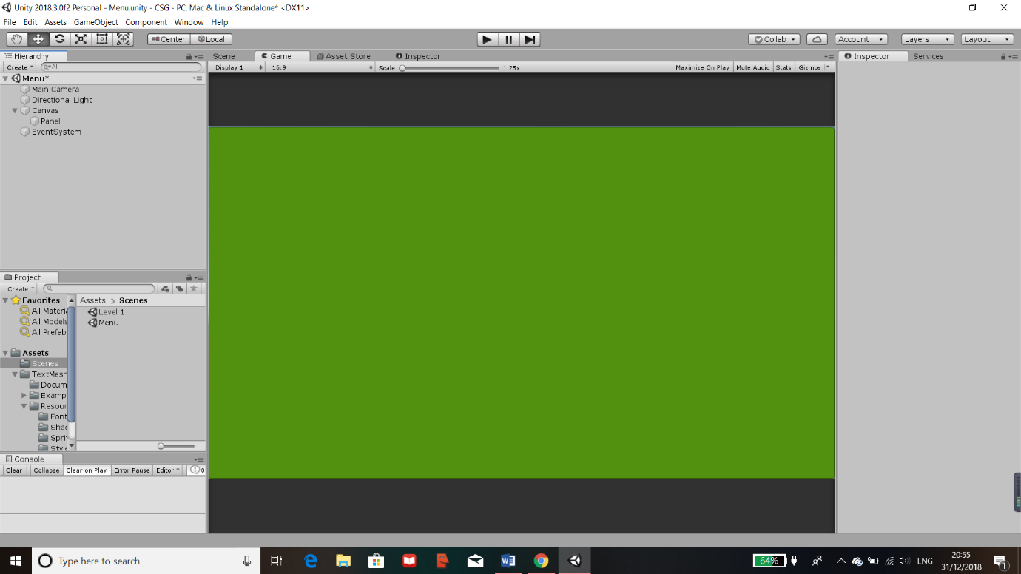To create a menu, first I had to create a new scene within my project where I can work on the Menu. The scenes that I have used and any future scenes will be placed in the scenes folder where unity can read from. This ensures separate parts of the program so that the code in the scripts wouldn’t cause any conflicts with one another. This also means that my program is separated out so that I can focus on different sections, one at a time.

Figure 27 Creating Green Canvas

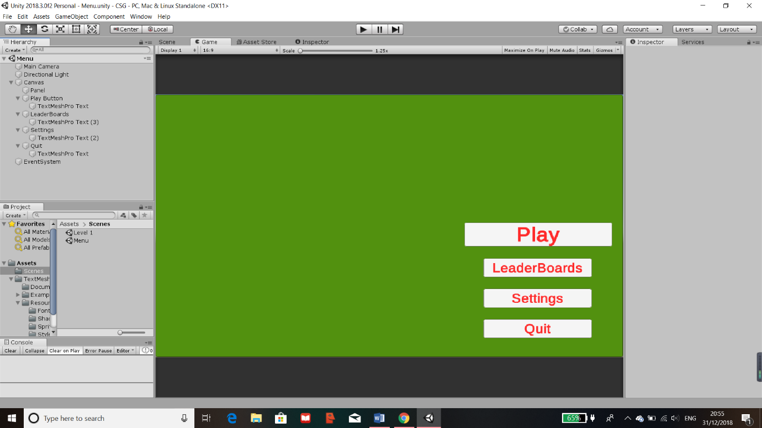The first part of the menu will need to be made on a canvas. Within the canvas contains the panel which can be edited and an image can be added later on.

Figure 28 Adding Buttons

Next, I created buttons for my menu and laid them out in the places they should be. I resized them accordingly so that they are the correct size then I labelled them where each button would take you.

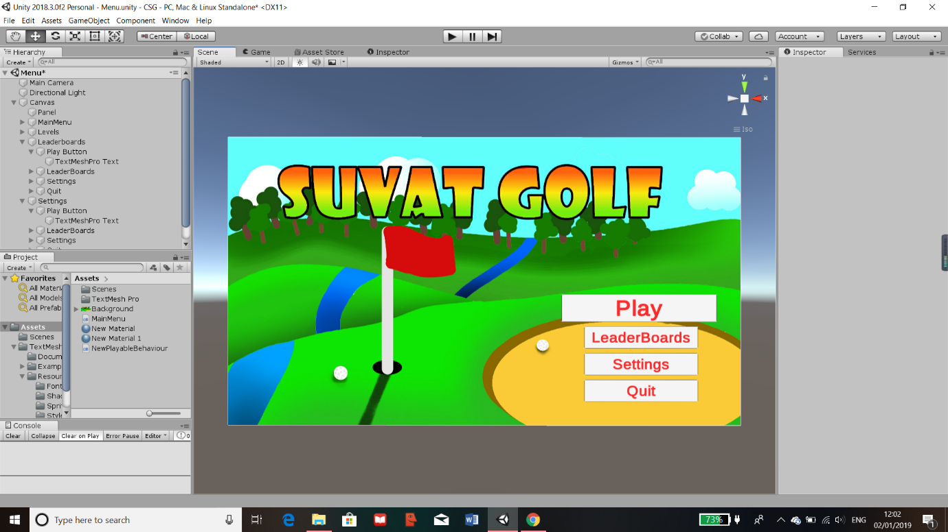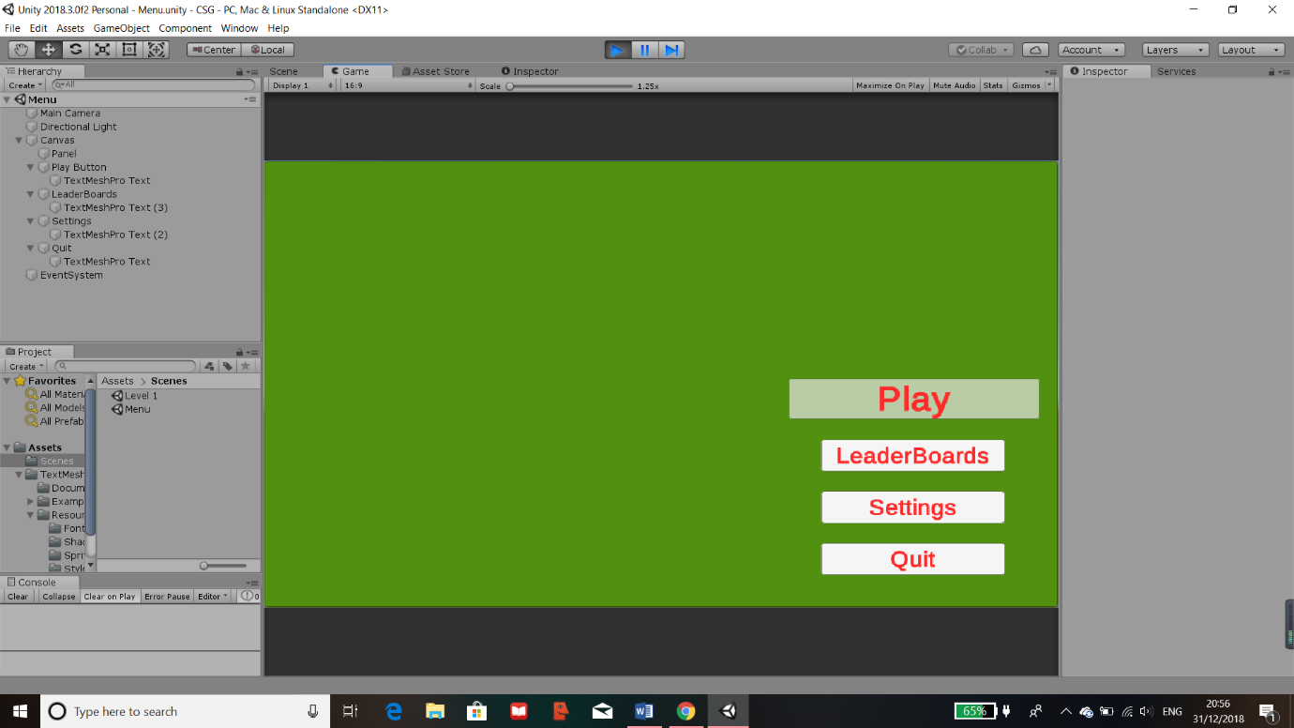Additionally, I have changed some settings in the components of the buttons so that the button changes transparency when hovered over which gives the user visual aid to make sure they know the mouse is over which button.

Figure 29 Adding Hover Effect

I then proceeded to update all the objects to the suitable names and import an image which will be the background for the “Menu” scene.

Figure 30 Adding Background

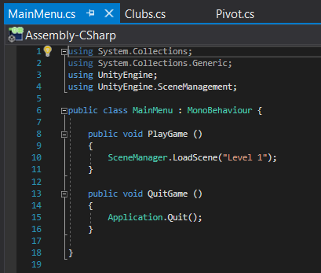This will be the template for all the buttons on the menu that will require the use of “SceneManagement” which means that the code will have control onto what happens to the scene. It can either switch to a specific scene, the next scene or previous scene. Currently the only buttons to use this are the levels button which I currently only have level 1 and also the quit button which would quit the game.

Figure 31 Main Menu Code

Figure 32 Levels UI

Figure 33 Leaderboards UI

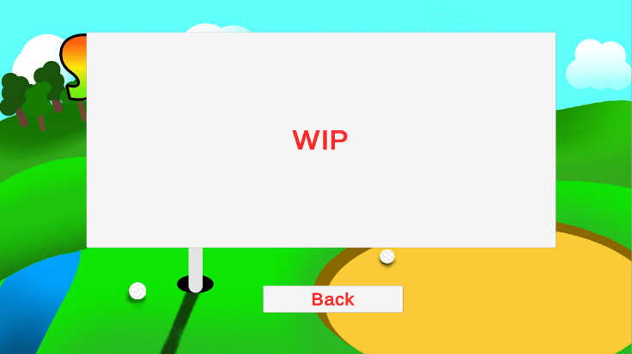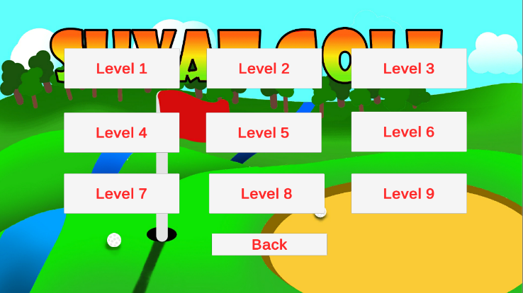Then I created different panels which will overlay the original background, each containing their buttons and objects relative to each button it’ll be linked to. In this case it’s the “Play” button for the levels and the “LeaderBoards” for the leaderboards.

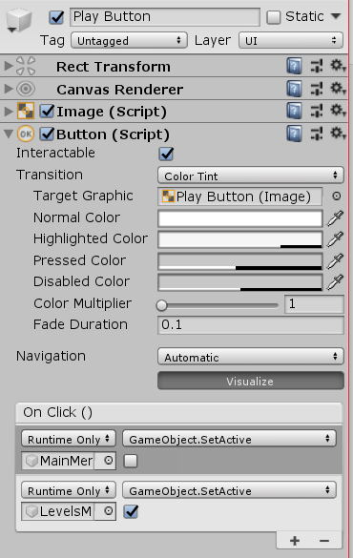Technically all these panels are on the same background and are all shown, to make it seem like the user can switch between these panels, the correct panels will be set as active or inactive(All objects/panels in Unity has a tick box to be set as active or not which means if its visible or not). E.g. For the initial set up, only the main menu panel is active and if the program detects a click on a button like “Play” then the main menu button will become deactive and the levels panel will be active.

This is achieved by using “Button” Component on the panels which contains the “On Click()” shown on the right. This has lots of uses such as activating a function in a script which can be attached to this button, a pre-set feature/function by Unity or “SetActive” which is what I’ll be using for the menu.

The “On Click()” is used such that once this button is clicked, the attached object which is “MainMenuPanel” will be set as deactive. Then the “LevelsMenuPanel” will be set as active. However this can only be done when the required function or feature is selected previously which in this case its “GameObject.SetActive”. This retrieves the component “SetActive” from the attached “GameObject” as if it was a class.

Figure 34 Button Components

### Menu and Levels Testing

After completing the menu, I have used the test data that was planned in the design section on pages 26-31. For the Menu testing I have done the tests stated before and the results are:

* Test 1 where nothing happens when the mouse is moving even if it’s on the button
* Test 2 where nothing is executed when the mouse is clicked anywhere else apart from the buttons
* 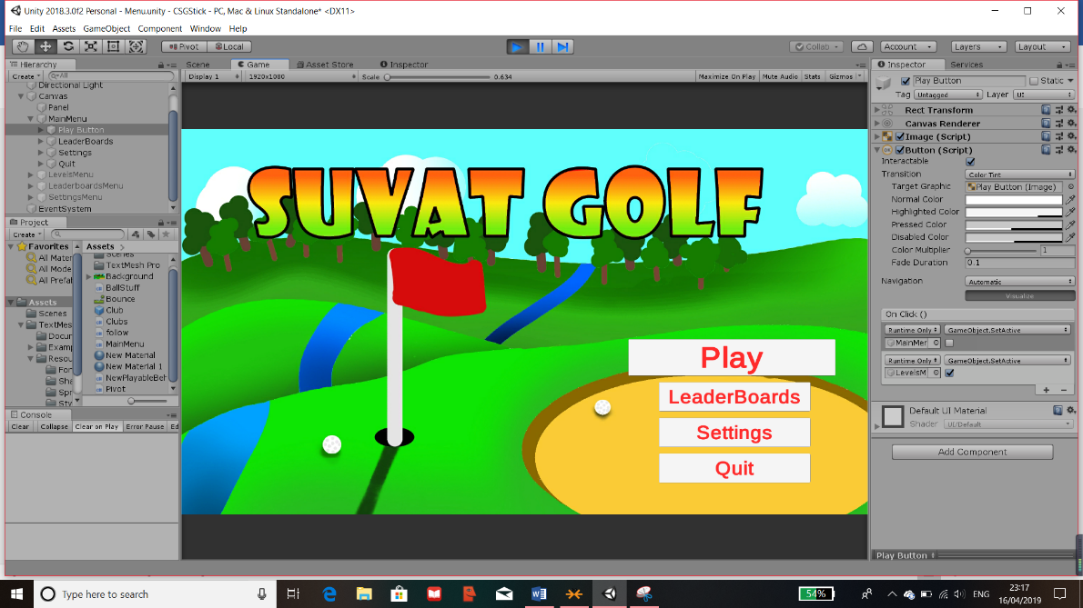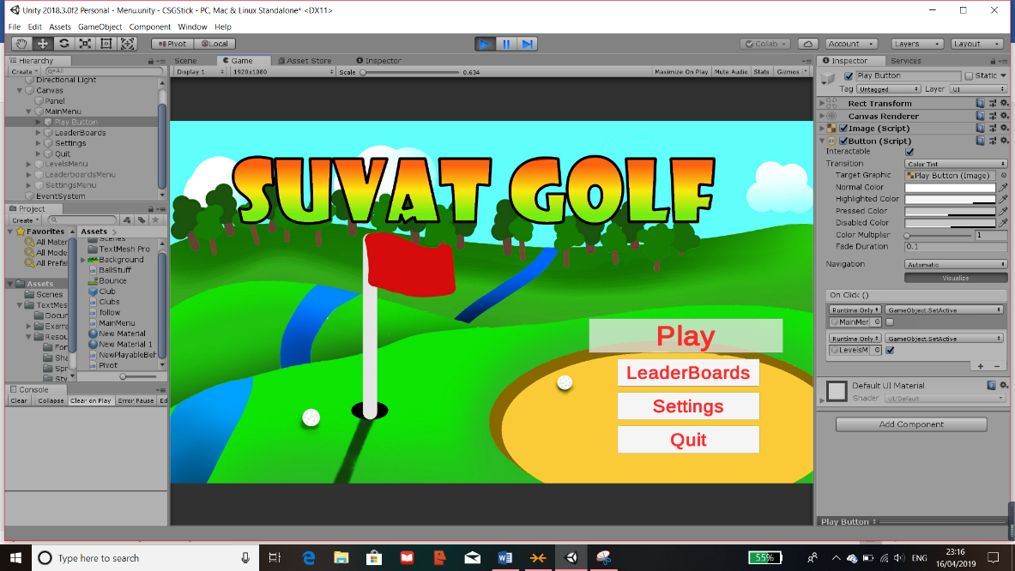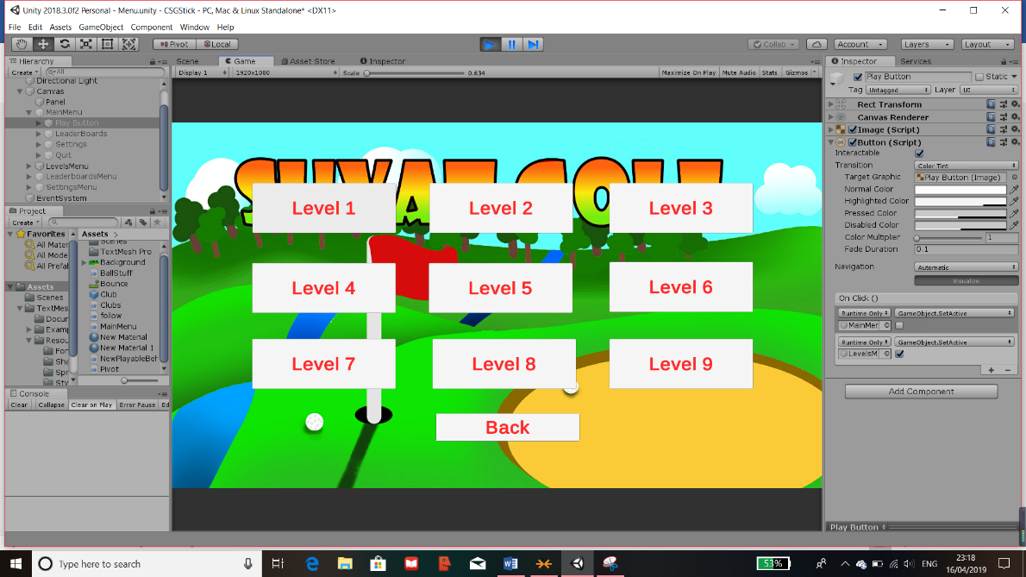Test 3 where I do click on a button and it executes and loads the panel necessary

Figure 35 Menu Test 1

Test 1, 2 and 3 are shown here. Tests are in order.

Figure 36 Menu Test 2

Figure 37 Menu Test 3

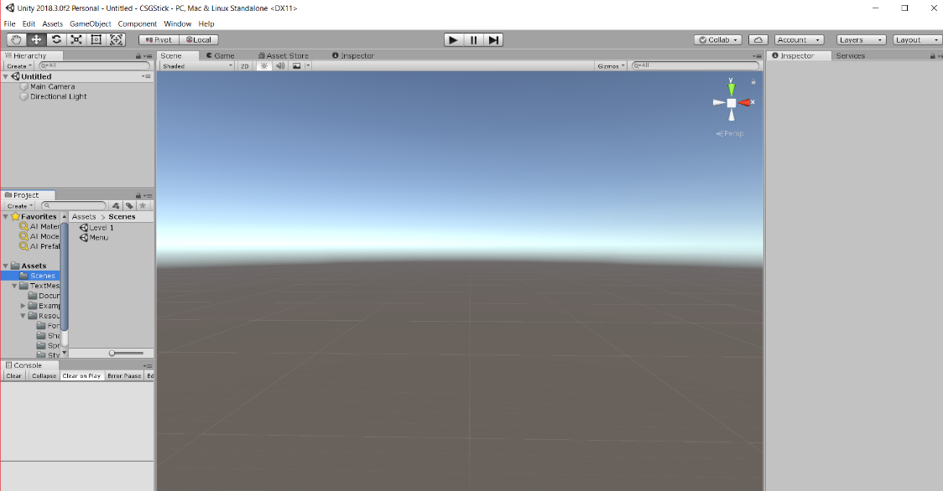I proceeded to test the levels menu the same way where the outcome was the same as the menu because it uses the same components and code and the menu one but the output is modified to load the next scene. The same testing was done and the same results are retrieved such that the button doesn’t work if it is not clicked on within its hit box. Once this is clicked, it loads the next scene which I will be designing for the level but currently its empty shown below.

Figure 38 Levels Scene

## Level Design

Figure 39 Creating Floor

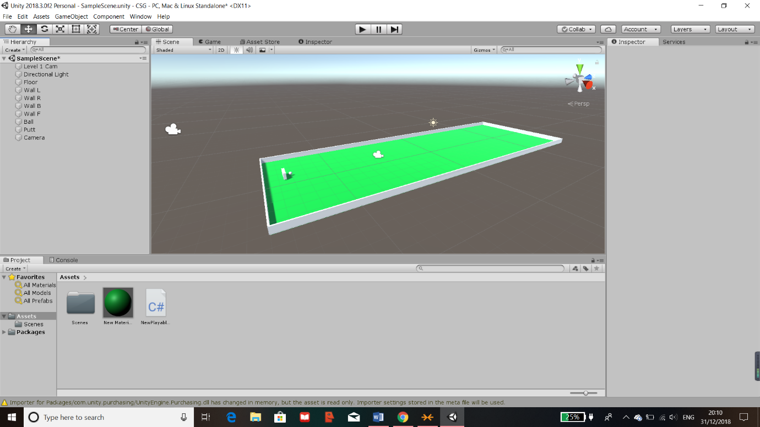The first step in beginning my coding for my project was to create various cubes and objects which would be used as the building blocks for the golf course. I had to create multiple objects each with different components, these were all amended and made on the inspector tab on the right-hand side of the image. Through the use of the built-in modules of unity, I added a “Box Collider” to all the objects that would need to have a hit box within the program.

Figure 40 Creating Other Objects

In the above image, I have completed creating a base for the first level, I have also labelled all the objects relative to their uses which is shown on the scene tab on the left.

### Components

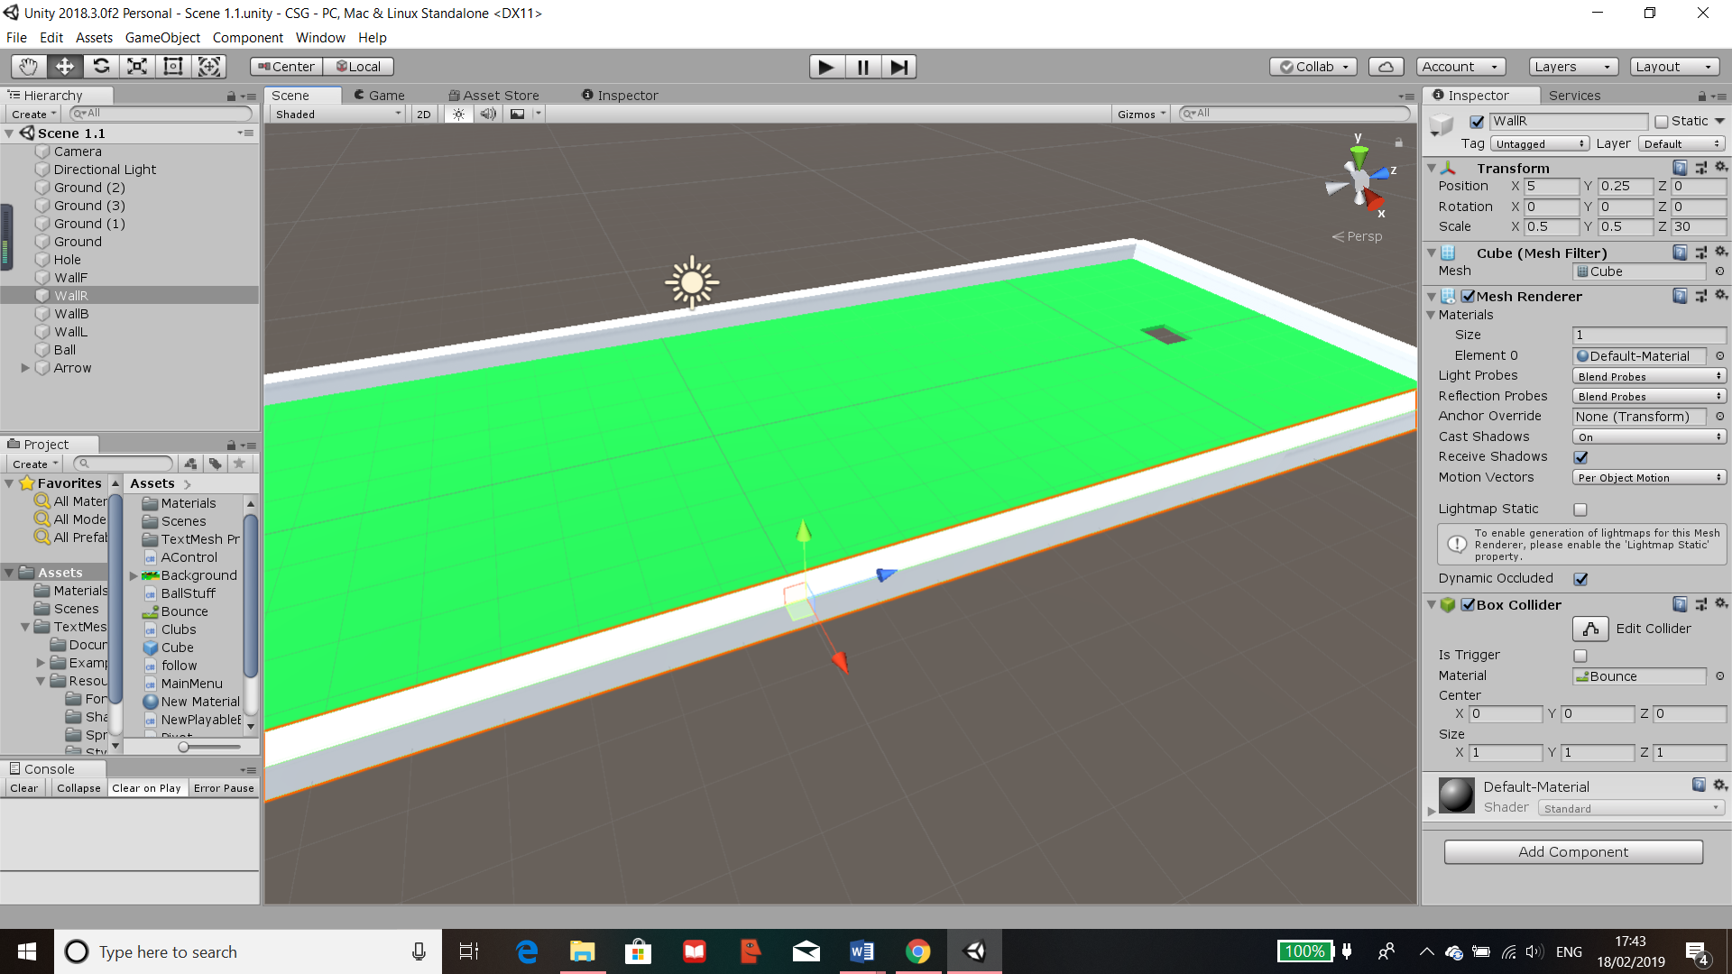

This is the “Bounce” attribute which has been assigned to all walls as the material. I have modified it by reducing the friction on other objects it comes in contact to and the Bounciness causes it to bounce back with less speed due to the friction. This would make any object it touches rebound hence I called it “Bounce”. It is stored in assets so it can be reused in other levels.

The “Box Collider” describes the hitbox of the object and there is an option to change its centre of collision. The material can also be changed. For walls such as this one, I have attached the “Bounce” attribute to the hitbox. On the other hand, floors wouldn’t need a bounce mechanic so objects like those has a default material.

The “Mesh Renderer” holds mostly visual effects on the object such as reflections, shadows and occlusions (which is how each point is affected by ambient lighting). Here you can also assign different materials for the object such as a change in colours.

The mesh is the type of object it is. Unity holds many meshes such as cubes, spheres and other custom-made ones.

The above is the name for the object/item. In the inspector tab holds all the components of the objects which can be amended. The “Transform” changes the size of the object by using the scale, the position which is changed to fit correctly within the level and the rotation which is normal.

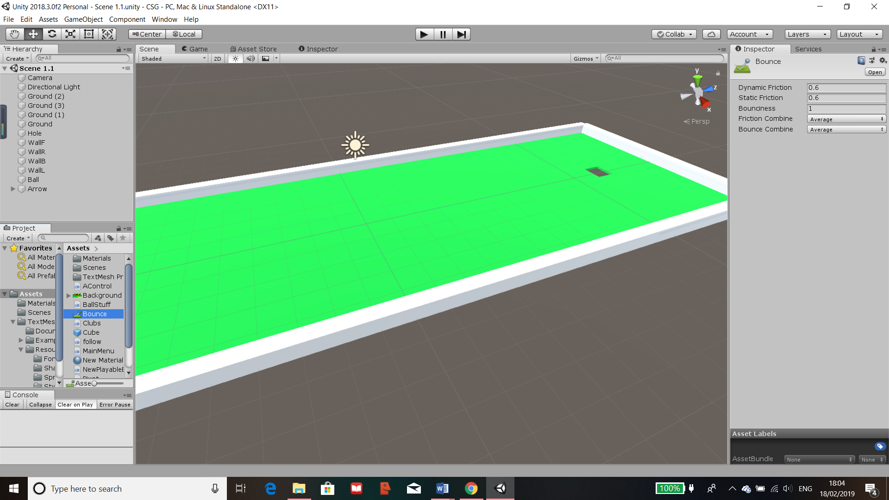

Figure 41 Object Component

Figure 42 Bounce Component

### Lighting

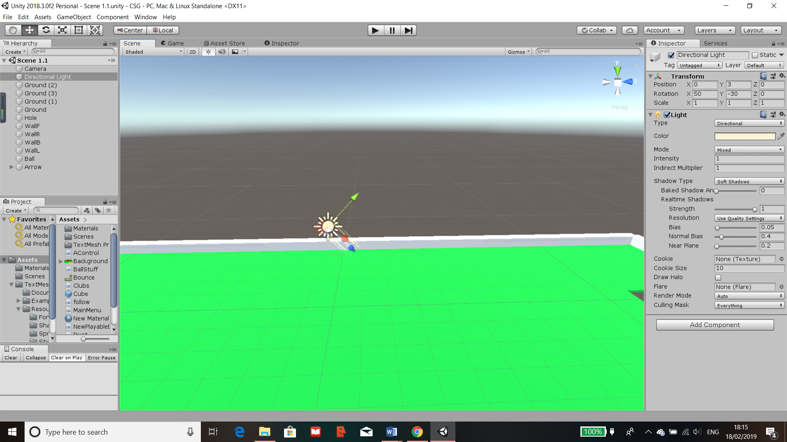

This is the “Light” as an object in the scene, this is placed in the centre of the scene and is pointed in the direction I set to provide the possibility of a shadow for the level.

Figure 43 Lighting Object



Figure 44 Light Component

The “Transform” component holds where the light object is and the rotation that it is facing.

This is the “Light” Component which hold all attributes for the light. Its set to direction so that shadows can be clearly seen. I have also added a slight hue to the light so that it is more natural.

The rest of the settings were left as the default because they either didn’t need to be changed like the strength attribute of the light or they were not needed for the level

## Camera Control

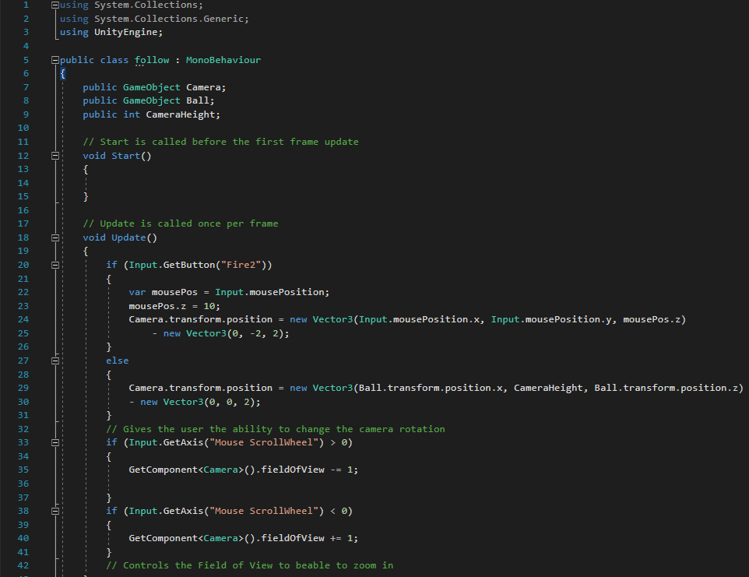

Figure 45 Camera Control Code

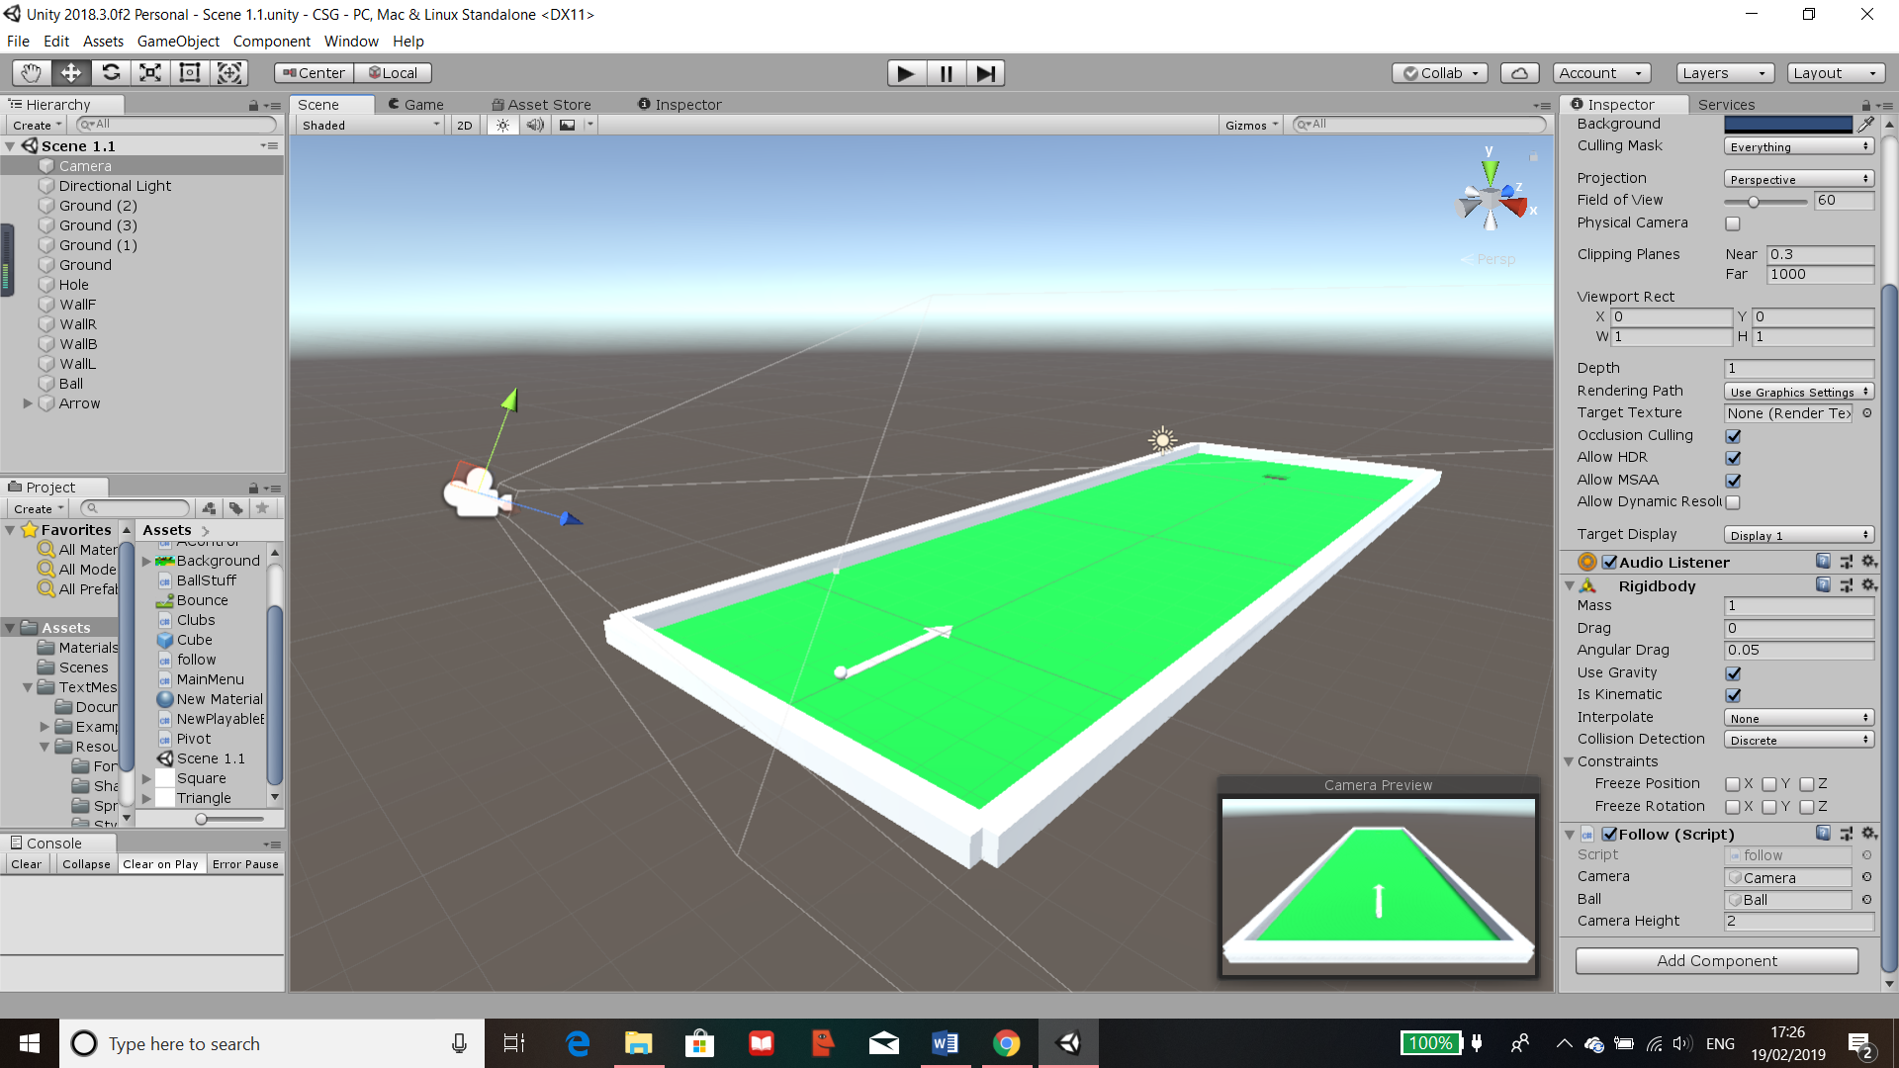Firstly, I created a script (what a class containing code is known as in Unity) for the camera as that will control what the user will be able to see. Within the script, I provided ways for the user to adjust various elements of the camera however the camera will remain in the fixed height and length away from the ball. This is done so that the play would not lose track of the ball or wander outside of the play area of the game.  
There are public variables, 2 of which are “GameObjects” and one is an integer. These are called “Camera”, “Ball” and “CameraHeight”, the values of these variable are set outside the script in the component of the camera shown below.

Through here, I have set each variable by dragging the object it is referring to into the box and the camera height by an integer. This can be adjusted if the camera needs to be higher or lower in other levels.

The elements that are controllable are the rotation and the FOV of the camera by the detection of key presses such as the scroll wheel and the right mouse button. Once the scroll wheel is detected, depending on if it’s increasing or decreasing, the “fieldOfView” is changed accordingly in the camera components. If the mouse click is detected the variable “mousePos” updates with the latest mouse position and it changes the camera positioning whilst the right mouse click is held down.

Figure 46 Follow Script Component

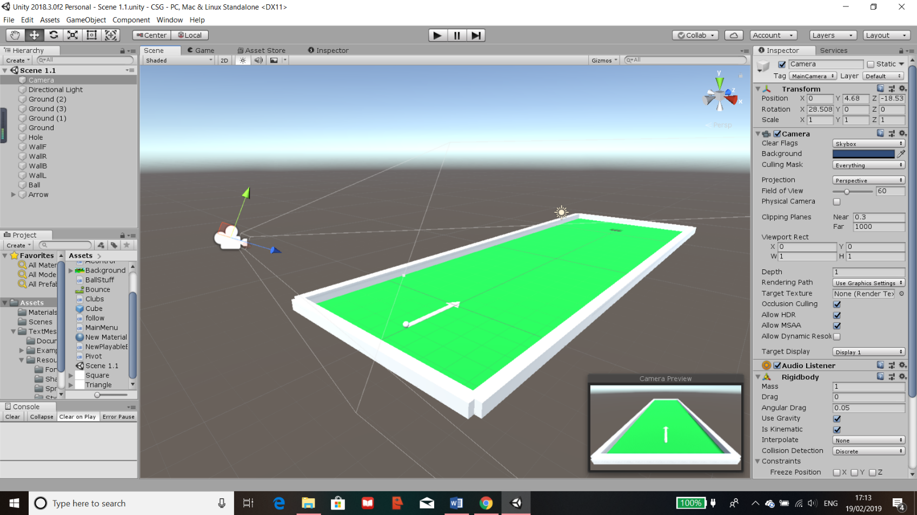

Figure 47 Camera Positioning

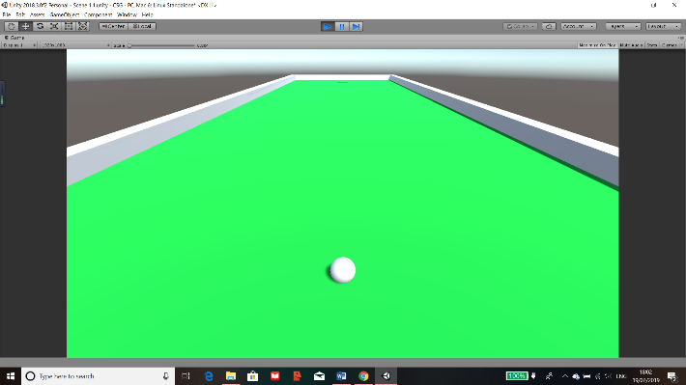The camera is positioned at the correct angle and distance away from the ball, this is checked through the “Camera Preview” shown on the bottom right. The height is then adjustable through the variable in the script. Most of the other components of the camera are left default as the game would not need any special camera settings or effects. However, the FOV level is adjusted through the script and it is defaulted to 60 every time the level loads.

Figure 48 Normal FOV Test

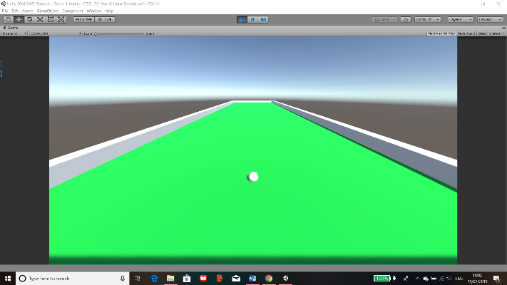

Figure 49 Increased FOV Test

FOV increased

FOV: Default, 60

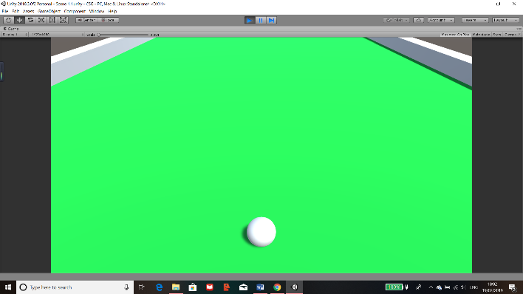

Figure 50 Decreased FOV Test

FOV decreased

## Putter/Arrow

The main designs of a putter which I will implement in this project are:

* Putter positioning (Where the putter will be relative to the ball)
* Pivot control (Which direction the putter is aiming relative to the ball)
* 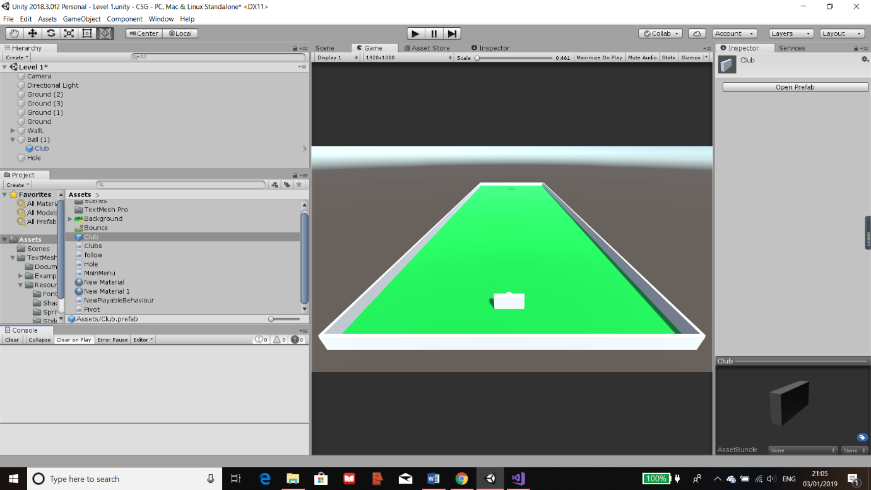Strength control (The amount of force that will be exerted onto the ball)

Figure 51 Prefab Creation

To make sure the putter would be in the correct positioning for the game, I have made the putter a Child Class and the “Ball” its Parent Class (Shown on the left tab). This would mean that the co-ordinates for when the putter is spawned will be relative to the ball.   
I had also created an “Object” Prefab (A saved group with at least one object which can be called upon or deleted within the script) for the putter shown in the asset tab.  
All scripts are saved in this asset tab no matter what scene they may be in. This could be changed however I have kept them all in the same file so that I can call certain features from ones that I have made previously.

Figure 52 Ball Coding

Once space is pressed, Club prefab is loaded into new positions relative to the new location of the ball and all orientation and angles are reset so no errors can occur.  
The positions and angels are retrieved using “GetComponent<name>”, this gets the component of the name giving by the object that the script is attached to. I’ve done this for the “eulerAngles” and the velocity of the ball and have set it to new Vectors (0, 0, 0) to stop the ball.

If commands for amount of strength on the putter. This is done by detecting the key input assigned to each task.

Ensures the force that will be set on the ball won’t be too high to too low. Done to prevent errors.

Releases the force that was set as “zforce” which will propel the ball in the direction it’s facing.

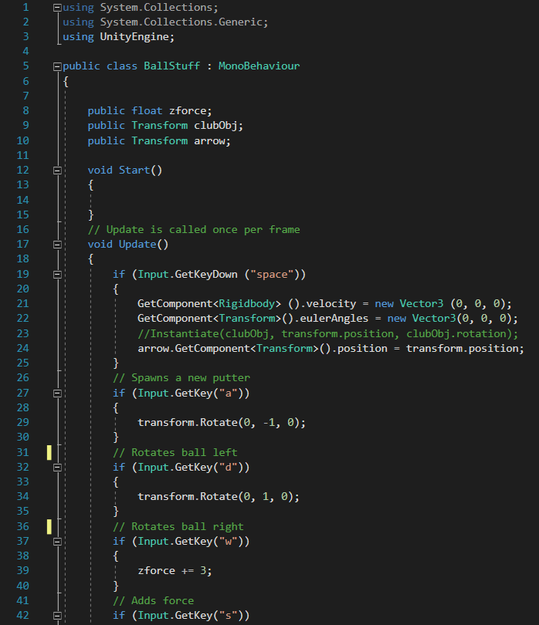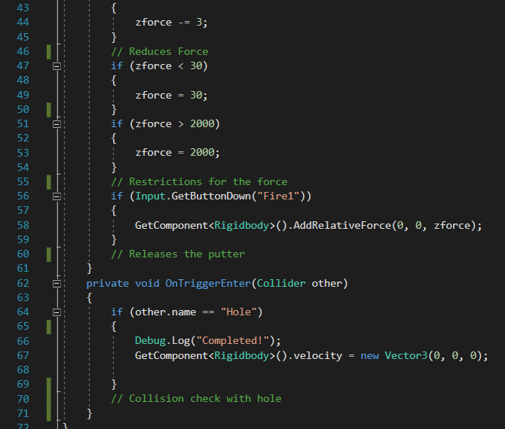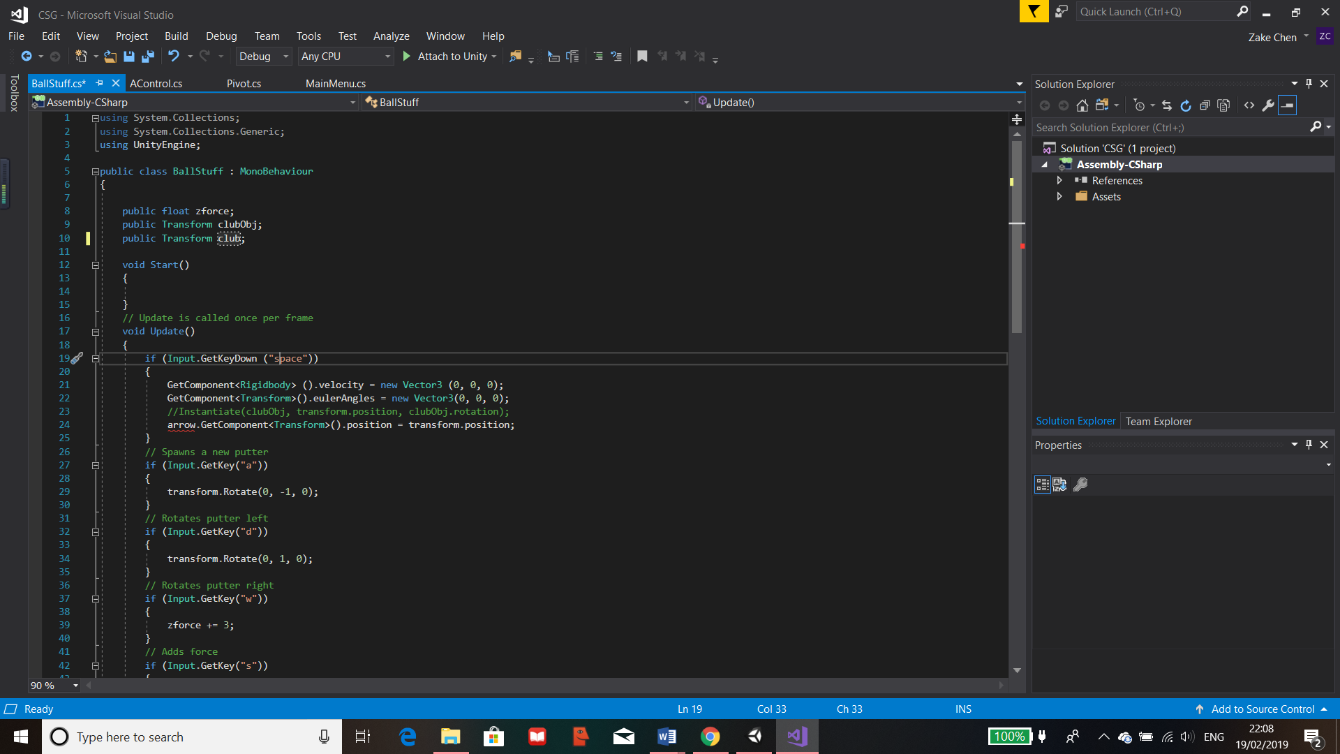

Creates a function so that when a collision occurs, it will run. In this function, if the ball collides with the object called “Hole” then it will print out “Completed”, this will later be changed to move to the next GUI. I have created an object with no physical features to be below the hole to act as a collision detector for the ball.

Public variables. “zforces” is the strength of a force stored as float. The other 2 holds 3d vectors of the positions of the held items.

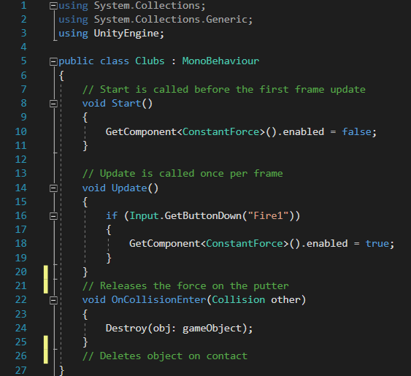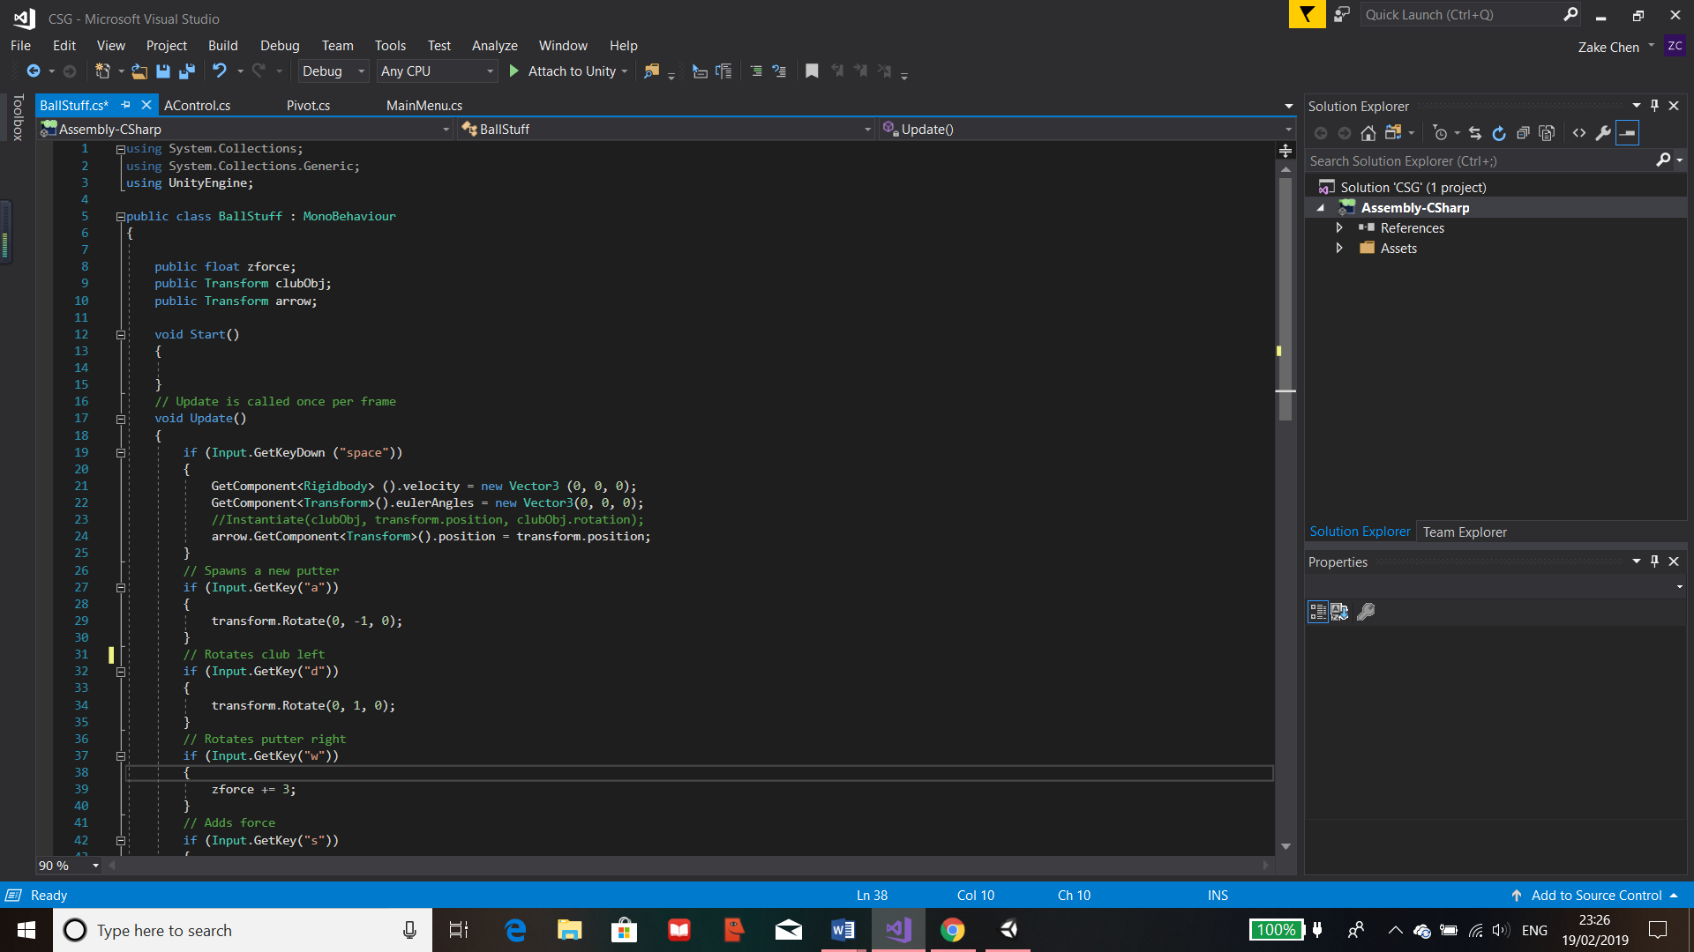

Figure 53 Clubs Coding

The above script uses functions to control the putter. When the scene the script is linked to, the “Start()” function will run once, this would disable the force which has been pre-set on the club by getting the component called “ConstantForce” and the bool called enabled within it. This would mean that the putter will remain motionless until this is reactivated, once this occurs, the putt will release with the current force that is stored as one of its elements in its components.

“Update()” function will then be running every frame that the scene is loaded. This function has the code which calls a class built in to Unity for detecting a key press. I have it to detect when the left mouse button is pressed. Once it’s pressed, the component “ConstantForce”, retrieved by “GetComponent<>”, will be enabled launching the ball in the direction chosen by the user. It will also detect the keys “a” and “d” and once these are pressed, it will rotate the putter accordingly in that direction, this is so the user can aim the putter to hit the ball at different angles. This is achieved by “transform.Rotate” which looks for the transform part of the object the script is attached to then the “Rotate” part within it, the code then increases/decreases it in the y axis, which is the horizontal axis in unity for every frame the key is pressed or held down.

Finally, the “OnCollisionEnter()” function is used to detect any collisions that occur on the object that this script is attached to, in this case it’s the putter. Within the brackets of the function, I have set to detect any collisions with any other objects on the scene. Once a collision is detected, the object will be deleted by the function “Destroy()” so that it can be instantiated by the script attached to the ball.

Error  
Due to the use of the putter as a physical object, on some occasions, when the object collides with the ball it would sometimes bug out and cause the ball to glitch off screen. This meant that the ball would be out of area and unplayable. Through my alpha testing, one of the testers have found that you could spawn multiple putters around the ball if the pivot was changed for each object. This would therefore create more problems.

Solution  
My solution to this problem was to replace the putter object with an arrow as this would also be beneficial to the user to be able to see clearly the direction of the ball. To fix this, I had to create a new arrow object using different shapes and creating an overall prefab for them. I then replaced everything that was related to the putter into the new arrow. Consequently, this has removed the bugs that were found in the alpha testing and I have created solution which has worked.



Figure 54 Clubs Amendment 1

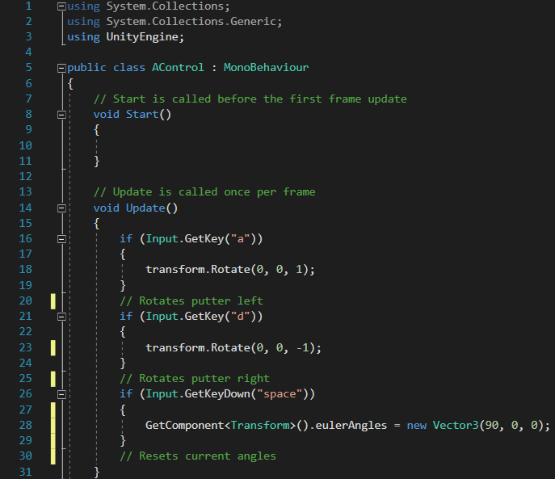

Figure 55 Clubs Amendment 2

The “BallStuff” script has been amended to fix the bug, there is a new public variable arrow which replaces the club variable. There’s also an addition of rotation of the ball in the “BallStuff” script, this has to be done as there will not be a physical object colliding with the ball so that once the “zforce” is enabled on the ball, it will propel in the direction with the given amount of force.

As the golf ball is a sphere, the user will not be able to tell if the ball is rotating or not. Consequently, I have created a new script for the class called “AControl”, this would rotate the arrow the same amount as the ball so the user would know which direction the arrow would be fired at.

The script is shown above, both scripts currently contain a key detection of Spacebar, this will be later removed as it is currently use to test if resetting of the arrow and ball works. It acts as a debugging tool for me and will be replaced so that the ball and arrow will automatically reset after a given time.

### Arrow Reset

As mentioned previously, I wanted the ball and arrow to reset automatically. To achieve this, I have amended the “BallStuff” and the “AControl” scripts to include a function which waits a certain amount of time before resetting the ball.

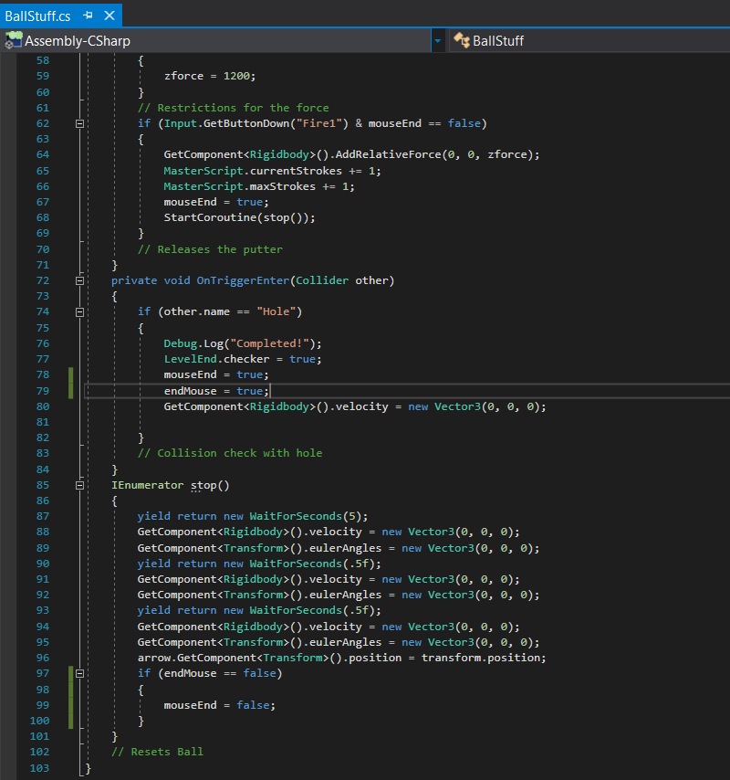I have added new bool variables called “mouseEnd” and “endMouse”. The use of these variable is to stop the spam of left click when the ball is still moving. So, when the mouse is clicked, the mouseEnd is set to true so that the function cannot be ran until the “IEnumerator” finishes, then it checks if “endMouse” is false, if so then its set back to false, if not then the ball will not reset. The variable “endMouse” is set to true in the “OnTriggerEnter”, in this function, the attached object, the ball is checked is it’s colliding with something. If it collides with an object called “Hole” then the code below this if is ran. This means when the ball collides with the hole “endMouse” is set to true meaning spam click won’t work after the level is complete. This can be shown in the image below.

Figure 56 Adding Delay

I used the unity module called “IEnumerator”, shown in the class above, and made a function called “stop()”. The “IEnumerator” module provides the use of the yield command which means that I can call a yield to return a value. In this case I have used “WaitForSeconds(5)” so that the yield will call the procedure “WaitForSeconds” in unity. This means that the when “stop()” is called, it will wait the given amount of time then run the code below it line by line. I have used multiple lines of the same code as there seems to be an error because when the ball is reset, it may still move at a small fraction of the original power.

Through research I have found out that many users have had the same issues with trying to stop a moving object and I could not find a solution. In conclusion I have reset it multiple times, the first resets the ball after 5 seconds, the next two resets with a half second difference. This has fixed the problem.

After the reset code executes, the next line is to move the arrow to the ball pointing in the correct default direction. I used “GetComponent<>” but relative to the object arrow which is a variable I created at the start of the program in “BallStuff” and I have assigned the arrow Object to the variable outside of the code. This would get the component called transform which means I can get the position of the arrow and make it equal to the “transform.position” of the object that this is attached to, in this case it’s the ball.

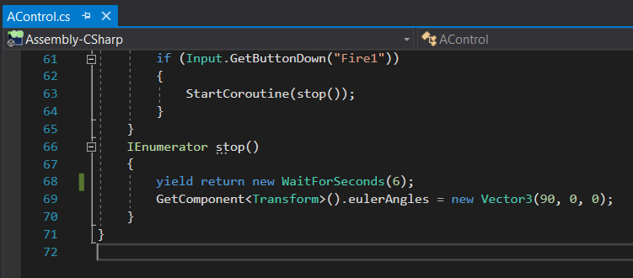

Figure 57 IEnumerator Function

Once the ball is reset, the user will also need the arrow to be loaded as well. The position is moved relative to the ball in the previously shown script. The angle however will be reset in the “AControl” script which is achieved by a similar premise as the resetting of the ball. I used the “IEnumerator” to wait the same time as the previous script so that the command to reset the angles of the ball will execute at the same time as the ball and arrow position.

The angles are set by the “GetComponent<>” of the transform component of the object the script is attached to which is the Arrow. Then the “eulerAngles” of the arrow is retrieved and replaced with a new 3d Vector of (90, 0, 0). This is set to this value as it will face y and z at 0 which is forwards and then x is changed to 90 degrees because if it’s 0 then the arrow will face directly up instead of forwards.

### Arrow Effects

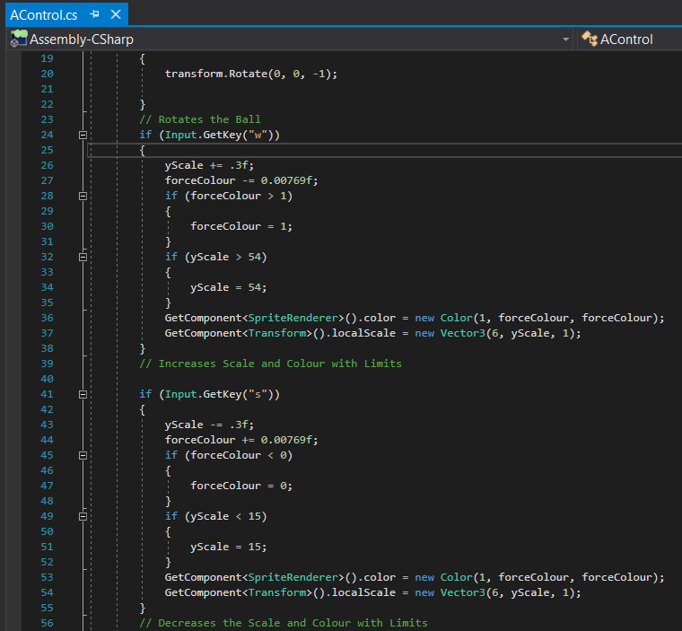The next task I worked on was the arrow effects and visuals, my goal was to make sure the visuals were informative as I didn’t want the program to display the amount of power because this means that it would be easier for the user to remember the amount of power used for the level, therefore them gaining a higher score by unfair use.

Figure 58 Arrow Effects Code

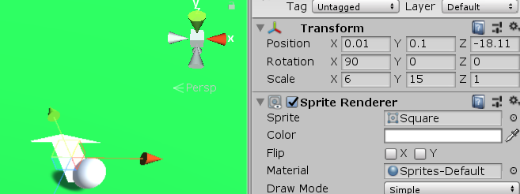To get the arrow to change length and colour, I would have to add additional code to the script “AControl” on the key detection “w” and “s”. I set a new float variable called “yScale” and for each frame the key is pressed it either increases or decreased “yScale” by 0.3. I then tried different lengths to see where the arrow should be limited to. This was done through the Unity’s main UI by changing the Scale of y in “Transform” shown below.

Figure 59 Arrow Positioning Component

I found that the arrow should has 15 as its smallest length and 54 as its largest. In “BallStuff”, I have the force limiter of “zForce” as 30 and 1200. This has been changed from the previous value along with the change of “zForce” increase and decrease of 9 instead of 3. This was done because 2000 was too large of force and 3 was too small of a force change.

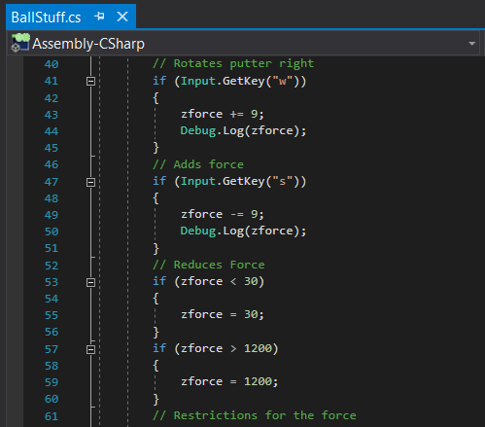

Figure 60 Scaling of Arrow

As there is a difference of 1970 between the 2 force limiters, I then used this to find a suitable number for the “yScale” to change by so that these would be in proportion to one another. I also had to do this for the colour change of the arrow. This is how I got the “yScale” value of 0.3 and the “forceColour” to 0.00769. Both of these attributes are changed through “GetComponent” but once searched for the “SpriteRenderer().color” and the other as “Transform().localScale”.



Figure 61 Colour Change

This would then change the arrow relative to the variables “forceColour” and “yScale” whenever “w” or “s” was pressed or held down. The colour was changed creating a new colour using RGB as I wanted this to change from white to red so “forceColour” would begin at 1 then decrease to 0 to become red as red is “Color(1,0,0)”.

“yScale” was changed by setting the “localScale” to a new 3d vector which included the new “yScale”. As “yScale” increases, the arrow length increases, as it decreases, the length decreases.

However, the script “AControl” only refers to the arrow neck and not the head as that is where the object was attached to. This means that I had to create a new Script which I named “ArrowHeadColour” which does the same thing as the “AControl” but only the colour change as the arrow head didn’t need to be scaled.

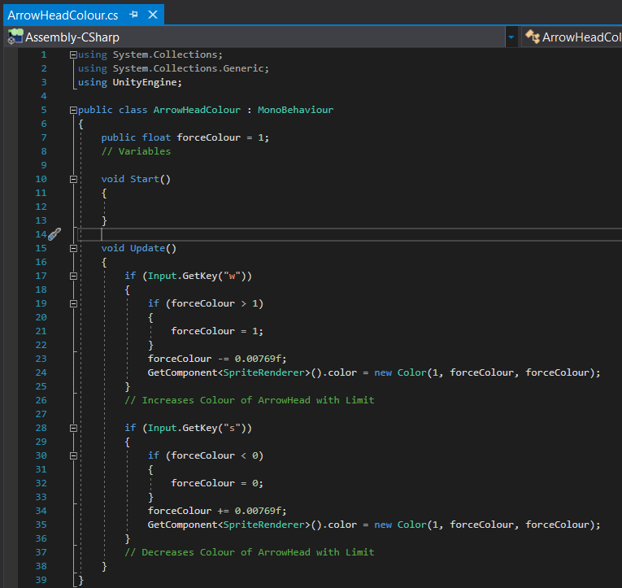

Figure 62 ArrowHeadColouring Coding

Figure 63 Default Arrow

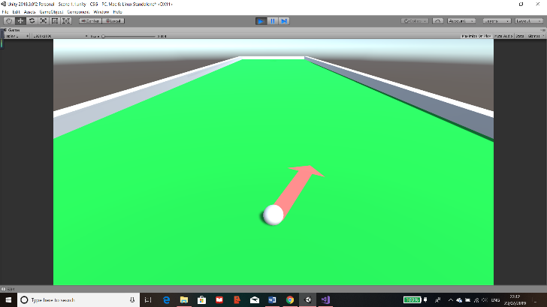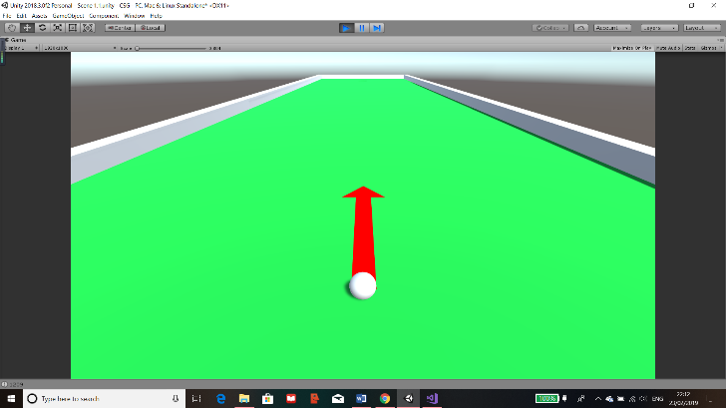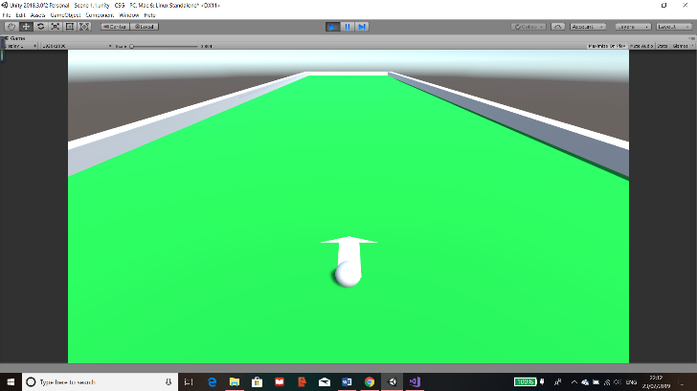

Figure 64 Extended Arrow

Here it is when the force is in between, the colour gradient works as an increase in force is an increase in the colour. Also, this works when the arrow is angled

Here is the arrow fully extended meaning a max force of 1200 and a max scale of 54. Also, the colour is fully red.

The arrow at the default state when the scene is loaded. The scale at 15 and the colour as complete white

Figure 65 Retracted Arrow

## Stroke Counter

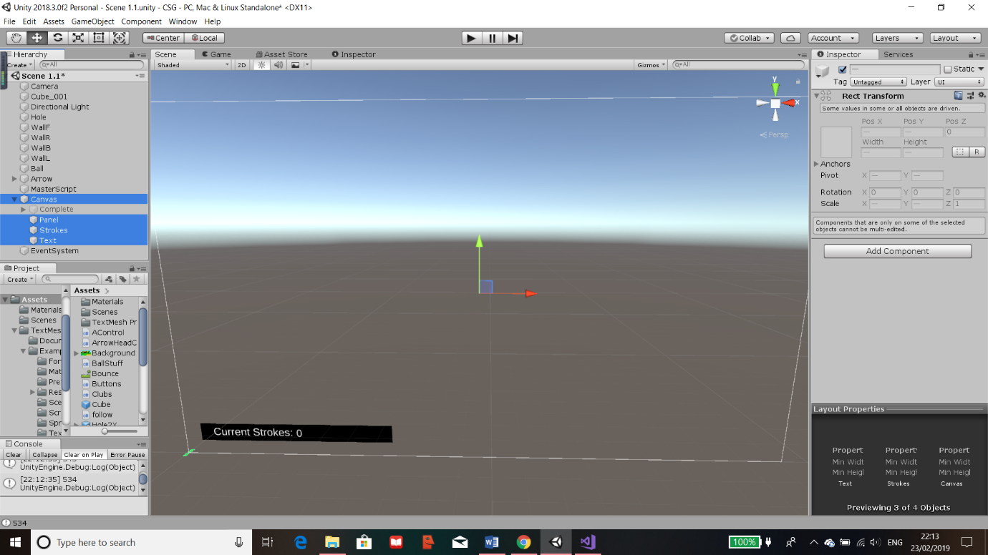The next phase of my project was to establish that the user knows how many strokes they have had in each level. This ensures that their goal is to get into the hole but using as few strokes as possible.

Figure 66 Overlay Creation

I first created a canvas in the scene “Level1”, the canvas is an UI Object and it means that the canvas will display as an overlay for the user. This means even if the golf course seems small at the bottom left, it will remain the same size and the canvas will scale accordingly. The canvas can be changed and modified in a lot of ways and lots of objects can be added to it, the ones that I will mostly use are images, panels, “TextMeshPro”, text, “scrollPanel”, buttons and possibly others. The use of the canvas it to provide a GUI for the user. Everything that will be added to the canvas should be created as a child of the Canvas. This would make the Canvas the parent of all the UI’s meaning that if I want the UI to deactivate all I would need to do is to change the parent.

The current canvas I have created has a black panel and 2 texts, one of which is the “Current Strokes” and the other is the number. The reason this is separate is so that when I create the script, it can change the number in the text object. Consequently “Current Strokes” will not change. The highlighted objects are the ones used for the strokes display.

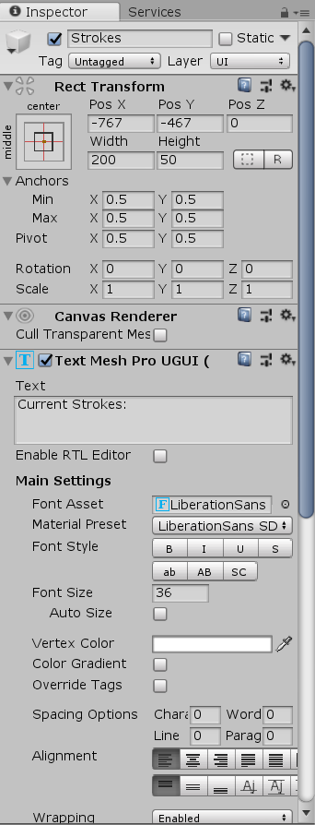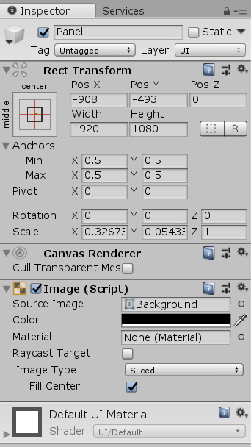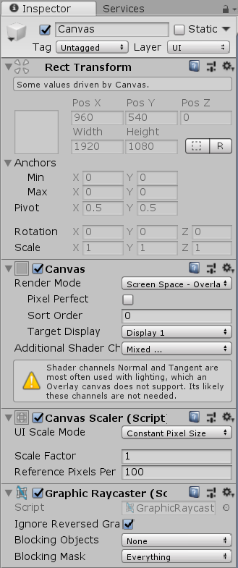

Figure 67 Canvas Component

Figure 68 Strokes Component

These are the main components of each object I have made. The canvas is shown on the left and most of the attributes were correct because this creates a GUI on “Display 1” with a normal “Scale Factor” from the components “Canvas” and “Canvas Scaler”. The other components did not need to be changed for my project.

Figure 69 Panel Component

The middle is a “TextMeshPro” text object which is an additional package provided with unity. This is basically an improvement on the usually text objects that unity usually provides. Through this I have changed the components “Rect Transform” and “Text Mesh Pro UGUI” to position the text correctly and what is displays.

Finally, the last object I have used is a panel which is a background for the texts I have used. I have scaled the panel relative to the size of the text that I want and I have changed the “Image” component of colour to black so that the text is easily readable.

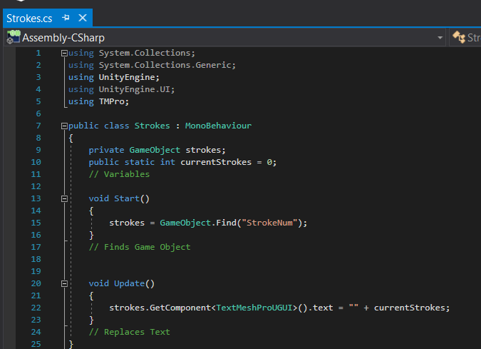This is the main script for the Stroke Count, I have called it “Strokes”. To achieve a counter, I didn’t need too much code so this script was relatively small.

Figure 70 Strokes Coding

It contains 2 variables, one which is a private GameObject called “strokes”. This variable is private meaning that it is only referenced to in this class and cannot be changed. The “strokes stores the gameObject called “StrokeNum” which holds the text for the number of strokes. To make sure the variable is referencing the text, in the “Start()”, I set the variable to the GameObject by using the Unity function “Find()” which looks for an object with the exact name. The other variable is a public static int, it’s an integer variable called “currentStrokes” and static means that it can be referenced and changed from in other scripts.

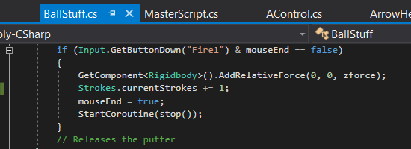In the “Update()” function, it looks for the component “TextMeshProUGUI” of the variable “strokes” and sets the text to be replaced with the “currentStrokes”. This is done in the “Update()” so that is will always stay up to date.

Figure 71 Adding Strokes as Global Variable in BallStuff

In the “BallStuff” script, I have added a line of code which calls the class Strokes and adds one to the static variable “currentStrokes”. This means that every time the user clicks and the ball moves, it will add 1 to the counter. Additionally, due to the fact that I have made sure that left click can’t be spammed, this means that the counter can’t be spammed either and only adds 1 if the ball moves.

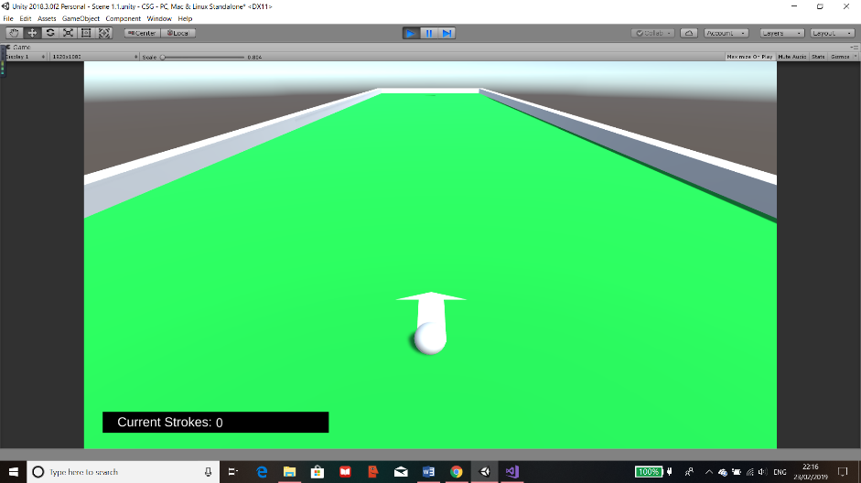

Figure 72 Stroke Counter at Start Test

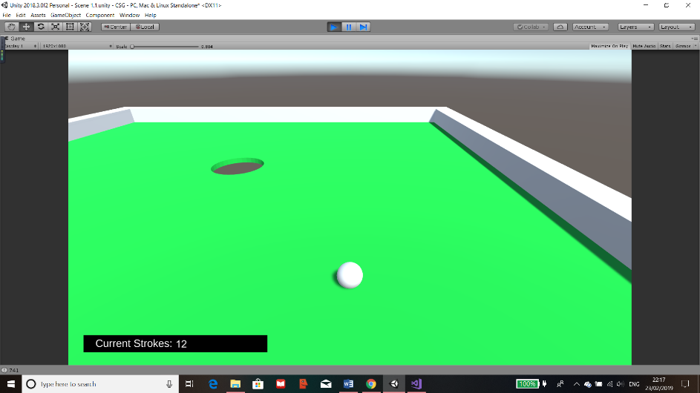

Figure 73 Stroke Counter at End Test

As the images show, the display is presented correctly and doesn’t obstruct anything important. Also, it increases correctly as I have hit the ball 12 times but have clicked the mouse a lot more whilst the ball is moving. This means that the code works and it doesn’t take into account the possibility of spamming left clicks.

## Level Completion

After the user completes the level, I plan to create a quiz which pops up but does not cover the screen so that they can still see the level and the strokes counter.

### Difficulty

Figure 74 Difficulty Panel

Before the actual quiz, I want to also create a difficulty so that they can get questions depending on how confident they are in SUVAT. I have created a new panel and named it Difficulty. Then I proceeded to implement 3 buttons each named after what they would do. The main button components can be seen on the right in the inspector. The component “Button” is what makes it act as a button. It has attributes such as the colour when it’s on screen, the colour when a mouse is over it and when it’s clicked, also it has an “On Click” which can be used to called function I have inputted into it or to set objects or variables as true or false.

The panel was created as a child of the empty gameObject “Complete” which is a child of the parent “Canvas”. The buttons are then children of the Difficulty panel and in each button, they have a text object as their child object. Each text displays each corresponding button.

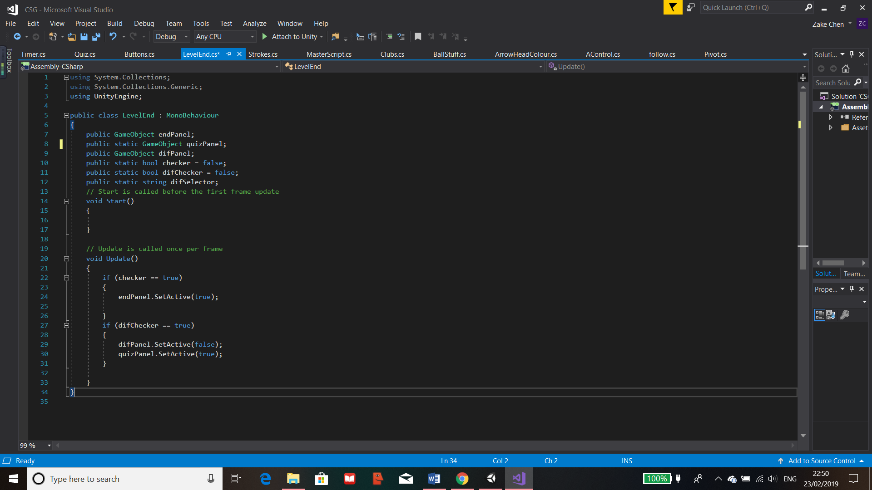

In the “LevelEnd” script, there are 6 variables, 3 are GameObjects, 2 are bool variables and the last one is a string. The GameObjects are used to set the assigned objects to these variables so that I can use them to either set them as active or inactive by the function “SetActive()”.

Figure 75 Level End Coding

In the update function, the bool “checker” and “difChecker”, are used to see if they are true. If this is the case, depending on which one was true, the relative panels are set as active or inactive. If its “checker” that’s true then the “endPanel” is shown, this contains the difficulty as it’s a child of the “endPanel”. If “difChecker” is true then, the difficulty panels become inactive and the quiz panel is set as active so that the quiz can be shown to the user.

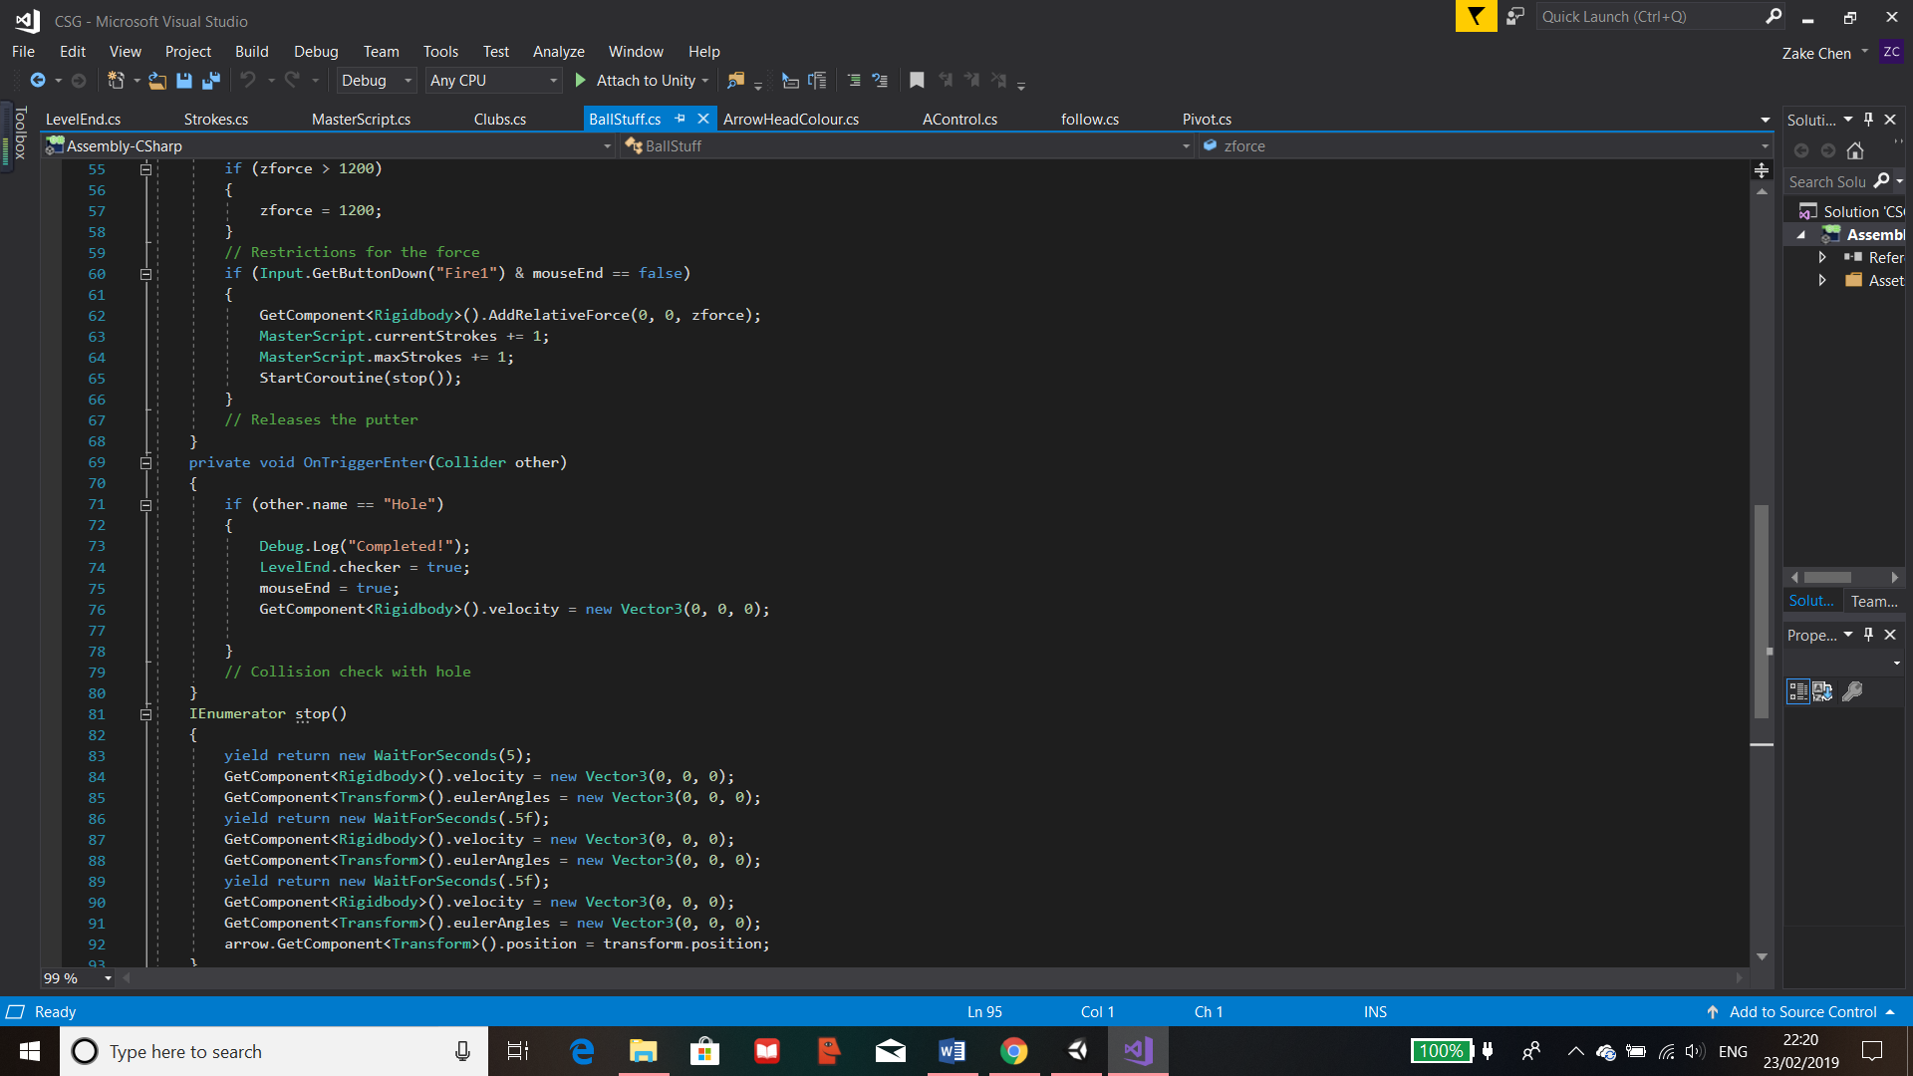

Figure 76 Level End Code in BallStuff

To get the difficulty panel to appear only after the level ends, I have added a line of command which call the class “LevelEnd” then changes the variable checker to true so that the panel can be displayed. This will only be set to true when the ball collides with the hole which is when the level is set to end.

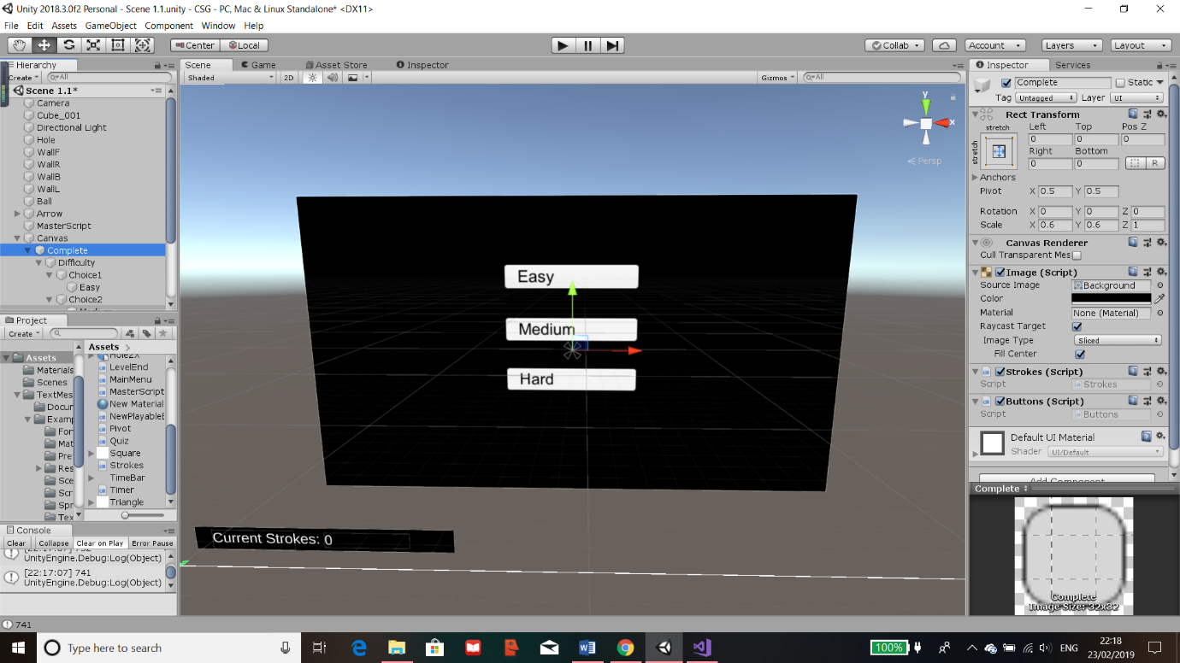Whilst I made the difficulty panel, I have also prepared the quiz panel along with the buttons I was going to use. This was because they are going to refer to the same scripts. I have created the scripts and have attached it to the “Complete” panel shown in the components on the right. The scripts are “Strokes” and “Buttons”.

Figure 77 Difficulty Panel Buttons

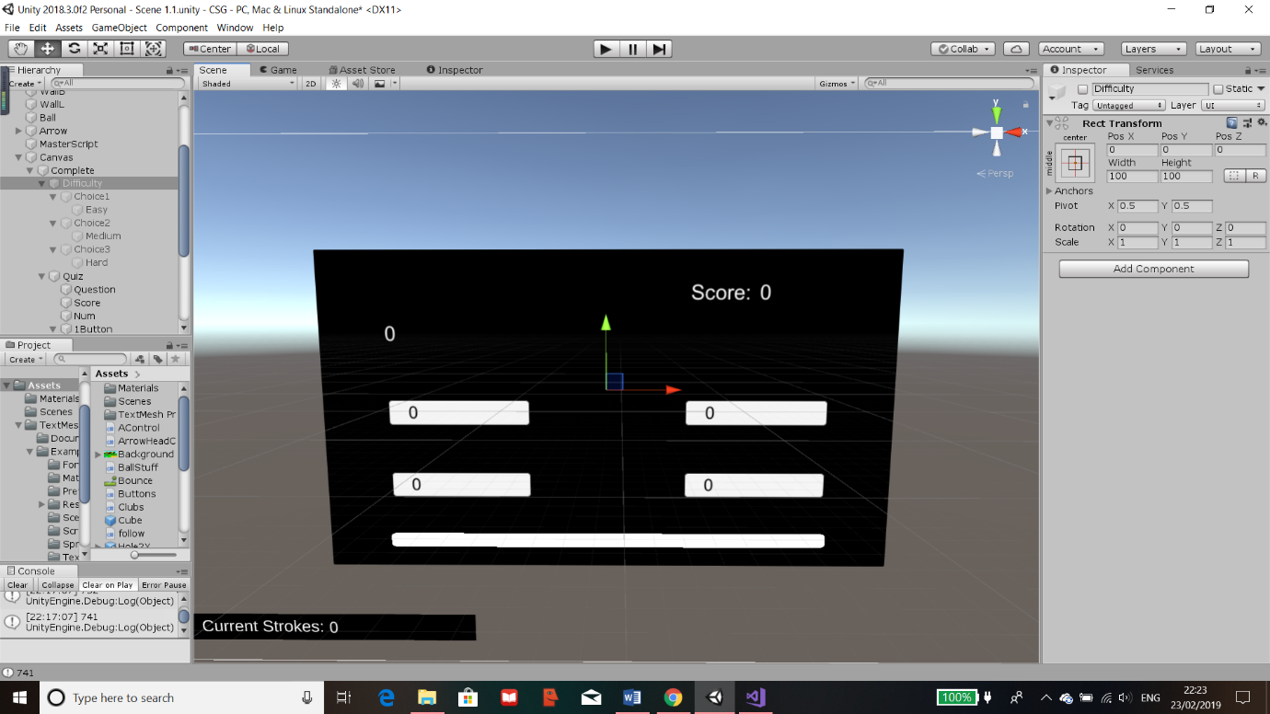This is the panel for the Quiz, it contains a text object for the question, the score displays on the top right which are made up of 2 text objects. Then 4 buttons with texts for the user to answer the question. Finally, I have prepared an image on the bottom for the timer which will be implemented in the future.

Figure 78 Quiz Panel

### Buttons

Each of these functions correspond to each button for the quiz, they are numbered to the choice that the user’s answers. They’re functions so I can ensure that the button would call the correct function within the script to be executed. The variables are then used in other scripts to execute further code.

I have initialised the variables shown. These are all Boolean and static as they are referenced out of the script. There are only Booleans so that they can be used for if the button is pressed which will change the bool.

All the variables are set to false in the “Start()” instead of being defined when creating the variables. This is done so if the user resets or replays the level then they will be set back to this.

These functions are for the difficulty panel shown before. They will be attached to the correct buttons. “LevelEnd.difSelector” finds the static variable “difSelector” from the class “LevelEnd” and changes the string to the difficulty the user will select. The variable “difChecker” is called changed to true so the program knows that a choice has been made and will execute code to move to the next panel I assign.

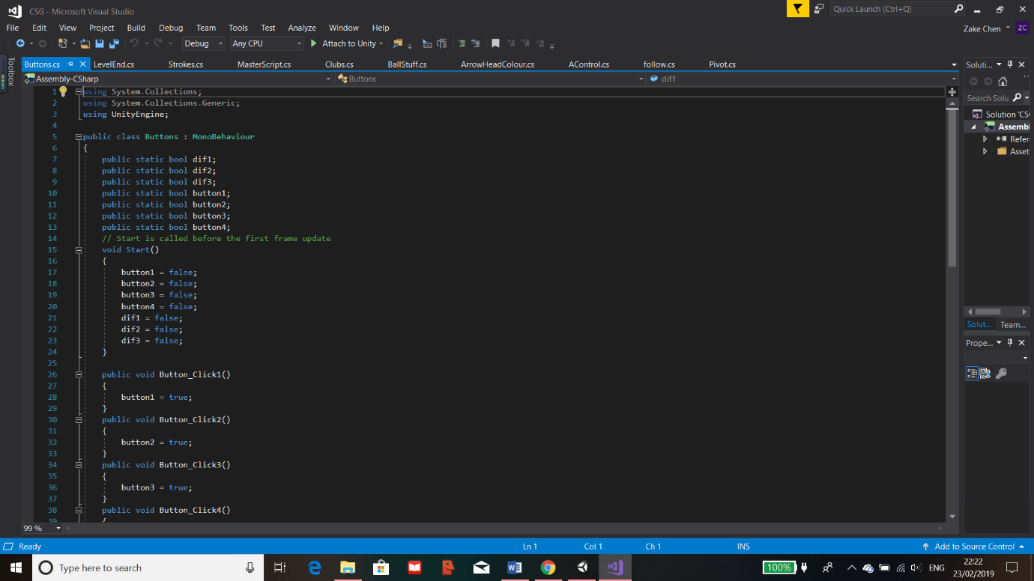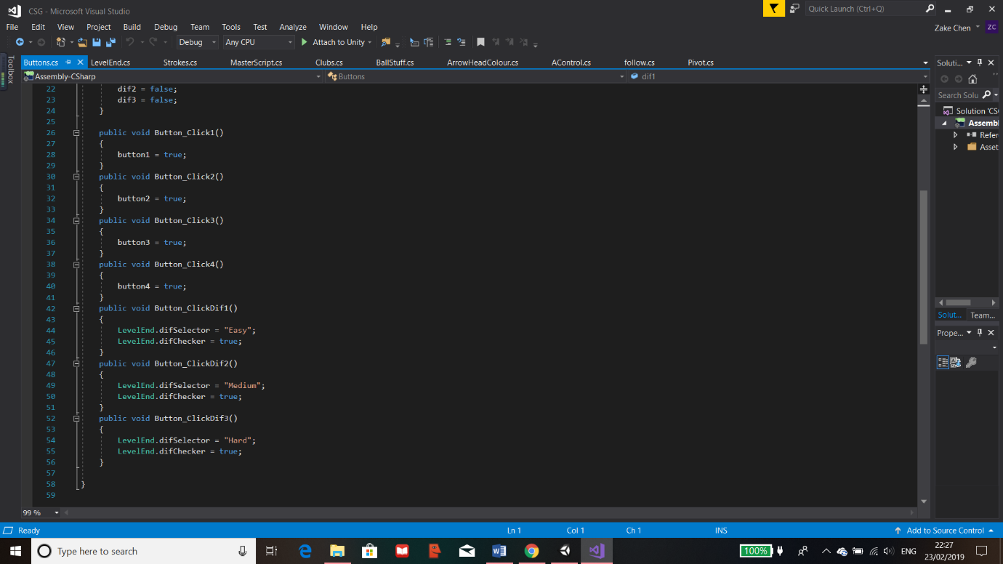

Figure 79 Button Coding

This script is for the use of all the buttons that are in this level. Each function is for a specific button and its action that it will provide for the program.

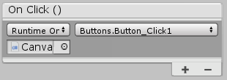To have this work for their specified function, each button will have their “On Click()” component be assigned to the object containing the script. Then Unity will recognise the script which means that the function can be called by the button when pressed.

Figure 80 Adding "On Click()" for Buttons

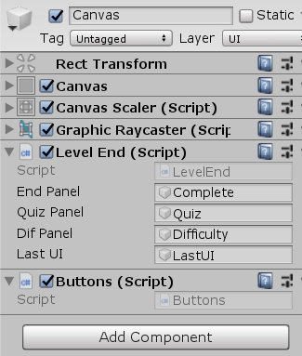In this case, it references the Canvas which contains the script and the function can be found and selected in the drop-down menu on the right.

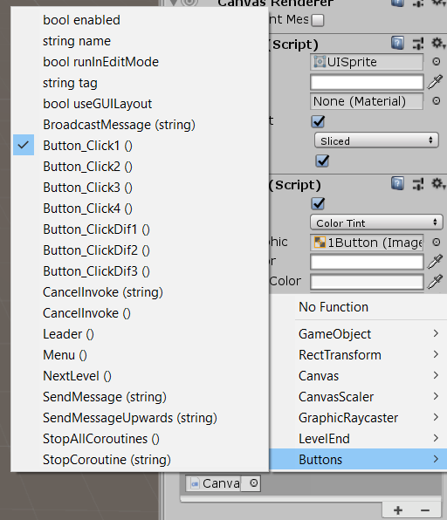

Figure 81 Adding Object Referencing for Code

Figure 82 Assigning Function to "On Click()"

As the image on the right shows, there are lots of options included provided by Unity but it also displays the function within the script of the object attached. This is how the button calls the function when activated. I have assigned each function to the correct button ready for the Level.

## Quiz

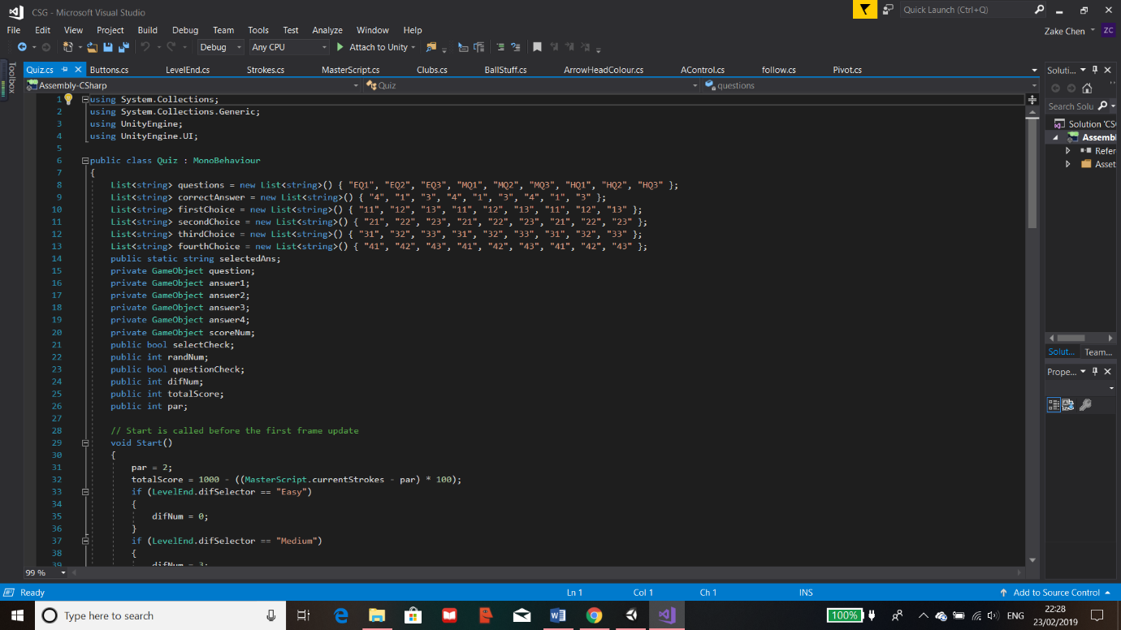Since the buttons are all working and set, I programmed in the quiz which will display a random question based on the difficulty previously chosen with the questions corresponding answers.

Figure 83 Adding Arrays to Quiz

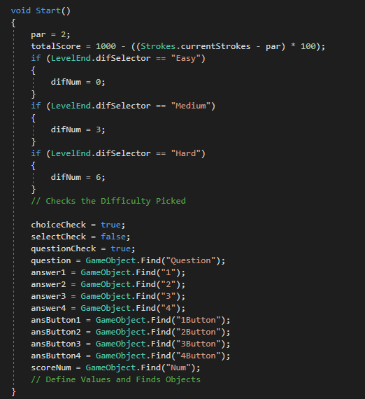First of all, all the variables are defined at the start of the program and their types are also displayed. For the quiz, I have also used lists to store the questions and answer. Currently the questions hold placeholders but this will be changed in the future. The “questions” List holds all the questions where “EQ1” stands for easy question 1 and “MQ1” stands for medium question 1 and so on, these are currently used to distinguish between the differences in the questions. Then there is the 4 choices list each hold an answer to display for each of their buttons. Finally, the list”correctAnswer” which holds the correct answer as a number, the number is referencing the correct list.

The next part of the code is mostly for defining variables. The “par” is for the current level and the current “totalScore” takes into account the number of strokes the user has gone over, if any. The “difNum” varies depending on the difficult selected which is retrieved from the static variable “difSelector” in the “LevelEnd” class.

The rest is to define some Boolean variables and to get the code to find the GameObject for each of the variables instead of assigning them in the Unity menu as this would be easier.

Figure 84 Difficult Selection Code

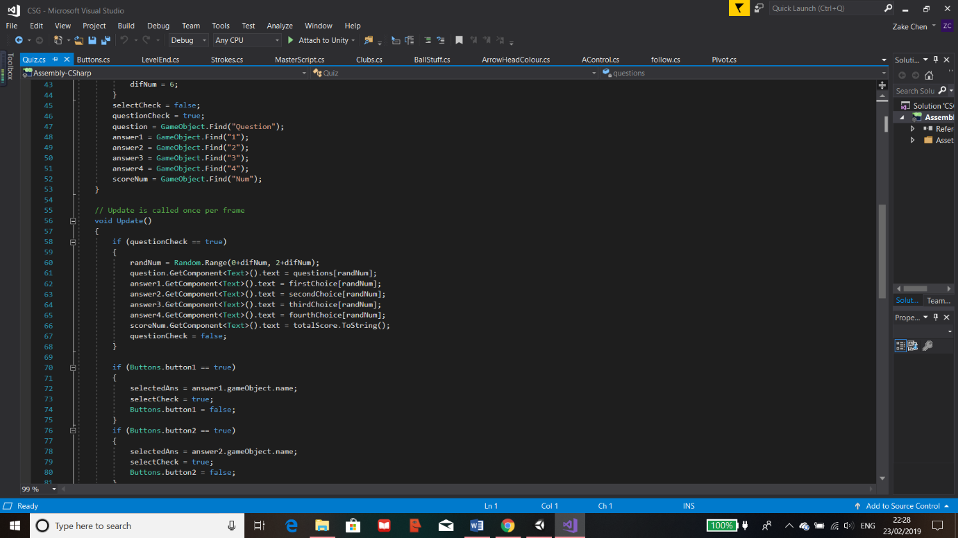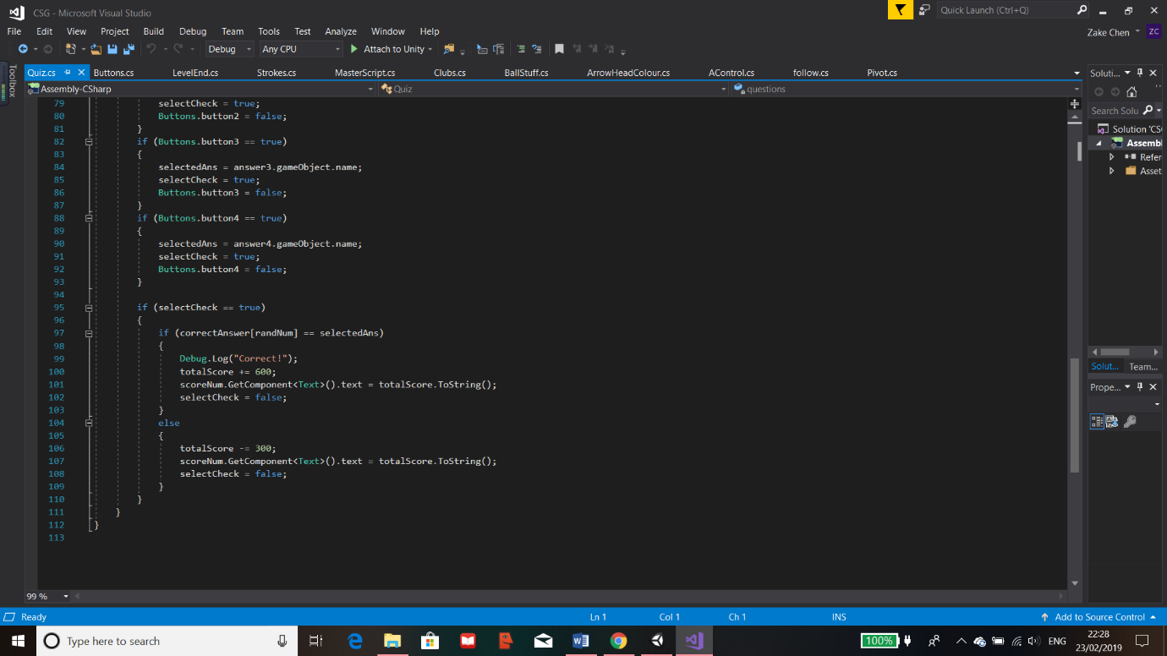

Figure 85 Answer Selection Code

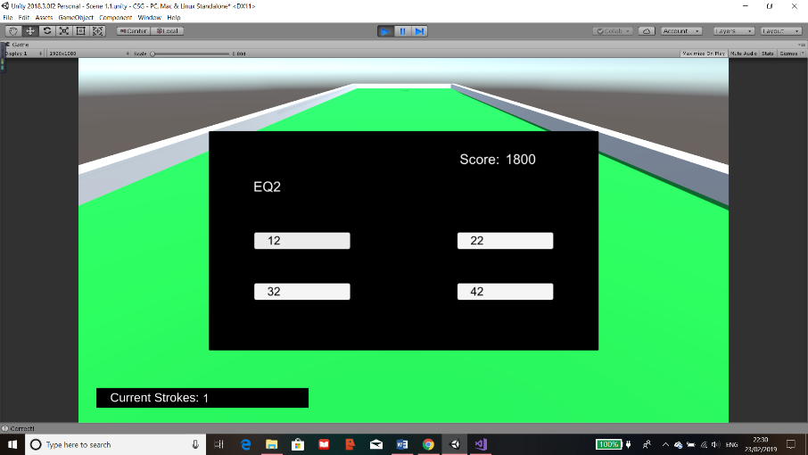The code shown here detects which button has been pressed from the reference of the class “Buttons”, once this is true, “selectedAns” becomes the answer the user selected and “selectCheck” becomes true. Once it’s true, it runs additional code which displays “Correct” if it was right in the console this is for my debugging, then depending if its right or not, points are changed accordingly and the score is changed. Then the Boolean is reset.

The code has worked as it shows a random question and I have clicked all the incorrect answers first and nothing happened which is what I wanted. Only when the correct answer is clicked, the console displays “Correct” which is on the bottom left of the window.

Figure 86 Basic Quiz Display Test

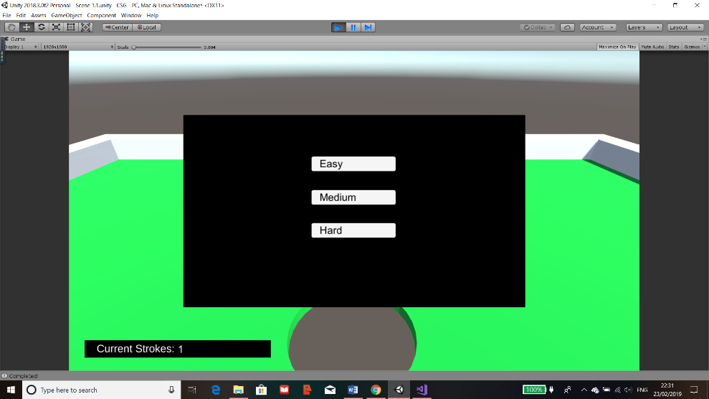

Figure 87 Quiz Testing Part 1

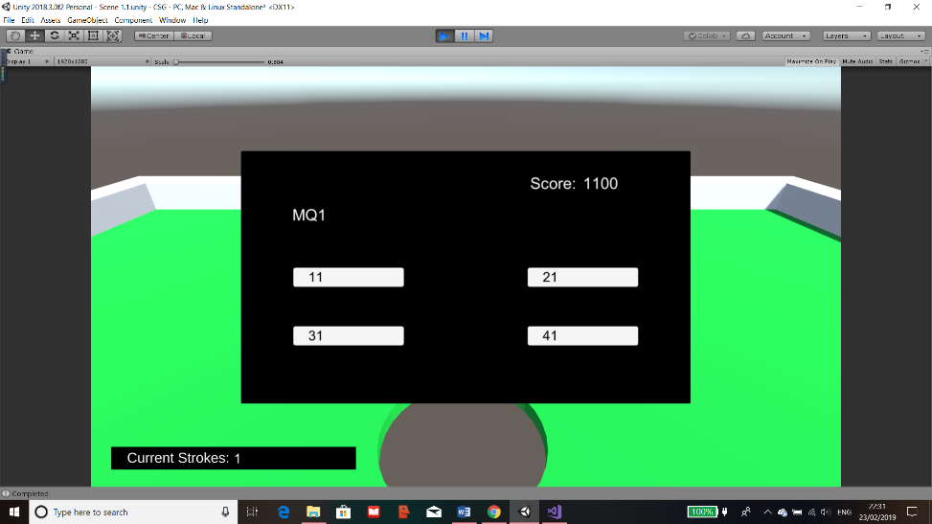

Figure 88 Quiz Testing Part 2

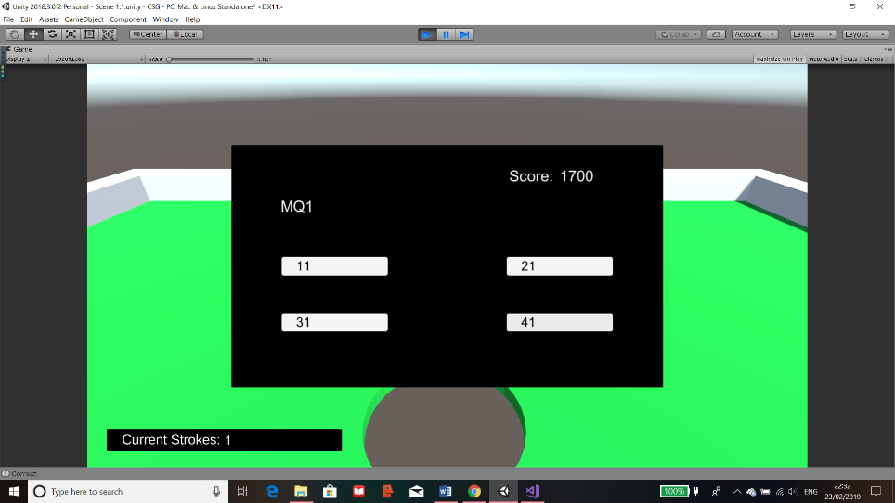

Figure 89 Quiz Testing Part 3

This was a test to see if all the panel switching and scoring works. As the images show, after the level is completed, the difficulty menu shows and when I chose medium, a random medium question appeared and the score is 1100. After I have answered the question correctly, the score increases to 1700.

### Timer

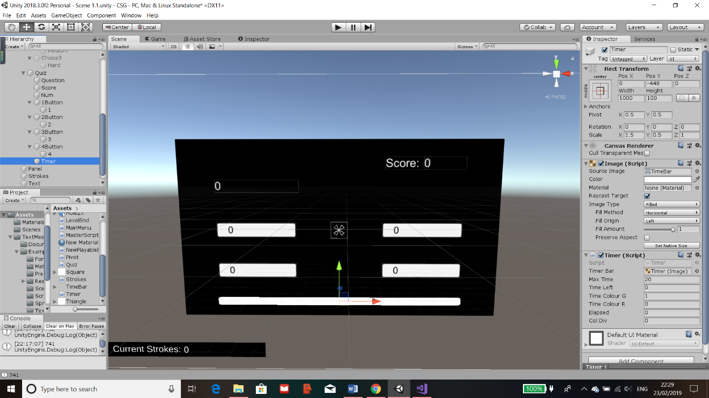The timer will be used to give the user a suitable amount of time to answer a question. If they fail to answer a question then points will be deducted as if it were answered incorrectly. However, if it was answered correctly, the score will now increases depending on how long the user took. Once the quiz section is completed, I plan to add another panel as the next UI to display their final score.

Figure 90 Creating Timer Object

To create a timer, I added a plain image and set a fill to horizontal in the “Image (Script)” component. This means that when I reference this in the script, I can set the amount the image fills by, full as 100% and empty as 0%.

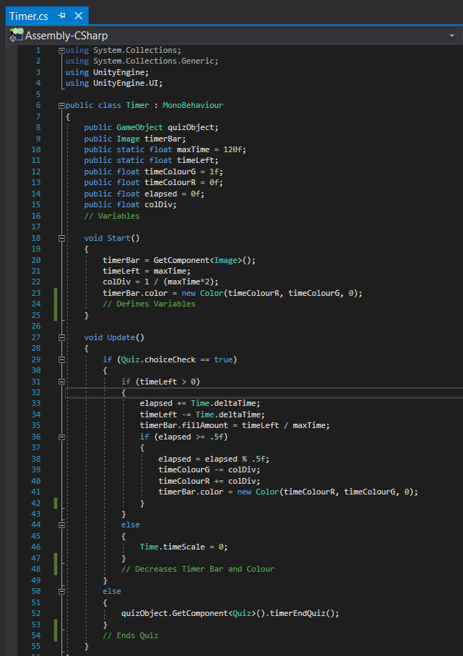

Creates the variables to be used

Figure 91 Creating Timer Code

“timerBar” is defined to be referring to the component called “Image” under this object. “timerLeft is used to countdown, “colDiv” establishes the amount of gradient change depending on the amount of time and the colour of “timeBar is set to green to start with.



Figure 92 Timer Code

Once a choice is detected, from static variable in “Quiz” class then time begins to count down by using “Time.deltaTime”. This is part of a Unity module where a number is incremented for each second. I used this to count down for the “timeLeft” and to count up for the “elapsed” time, this is achieved by either the “+=” or the “-=” sign which means add or subtract from this variable. Then the “fillAmount” is decreased relative to time left.

From my beta testing, they wanted to see a gradient change in colour. To achieve this, this IF statement executes every half second the “elapsed” variable is larger than 0.5. For each timer it is, the “elapsed” timer is modded by 0.5 which will reset it to 0. Then the “timeColourG” and R (Green and Red) changes where red increases whilst green decreases. This sets the “timerBar.color” to the new colour. These repeats until “timeLeft” is 0 or less, which will set the Scale to 0 meaning the bar will be empty.

The final code is to call a function in “Quiz” which ends it when the timer is 0 or a choice is made which is in “Quiz” shown before.

Figure 93 Timer Near Max

Figure 94 Time at Mid

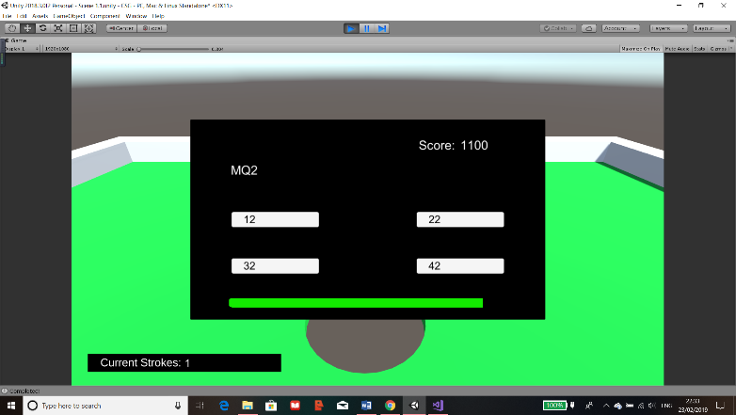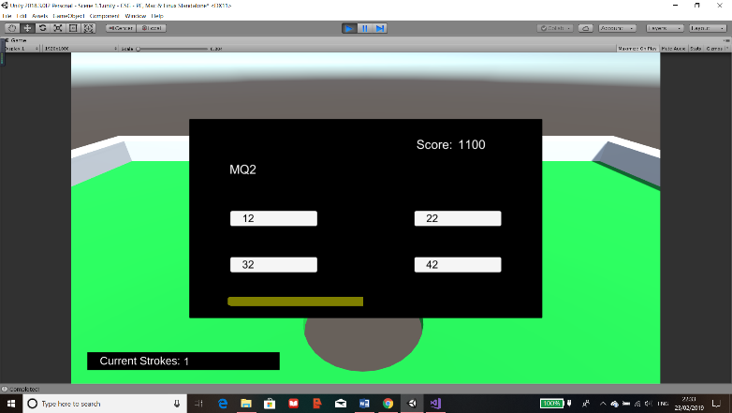

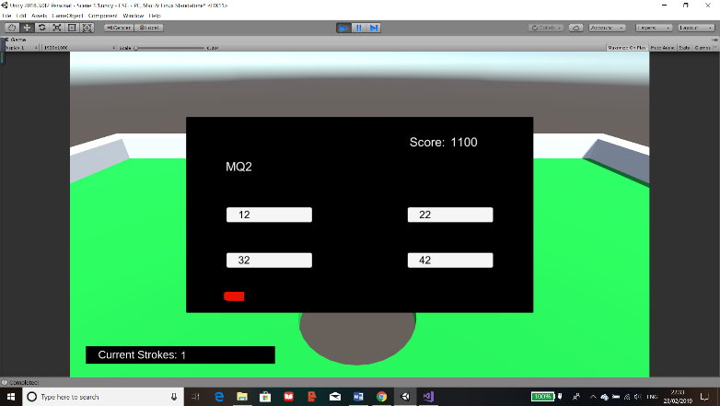

The images show that the time bar is a success as it begins from green and slowly changes to red until the bar reaches 0. When it does, a Boolean is changed for the “Quiz” to run the same code as if the user answered incorrectly.

Figure 95 Time Near End

I then added questions to the quiz so that it can be an actual quiz. When adding questions, there was an issue that the question didn’t fit on the panel therefore I had to resize the text box f the question and decrease its font size which has fixed the problem.

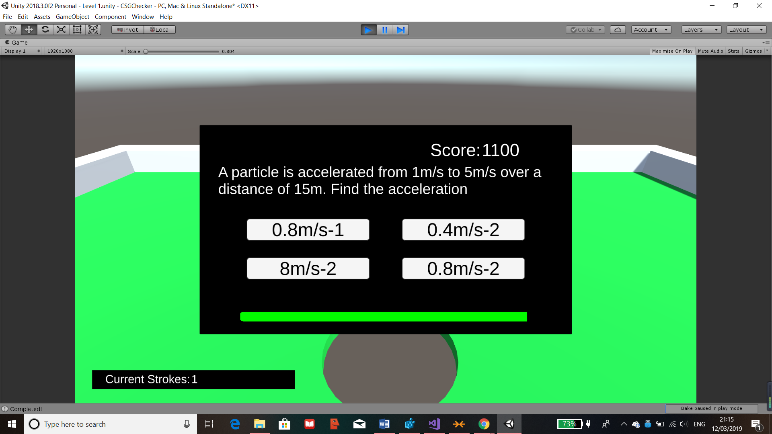

Figure 96 Adding Questions

Improvement

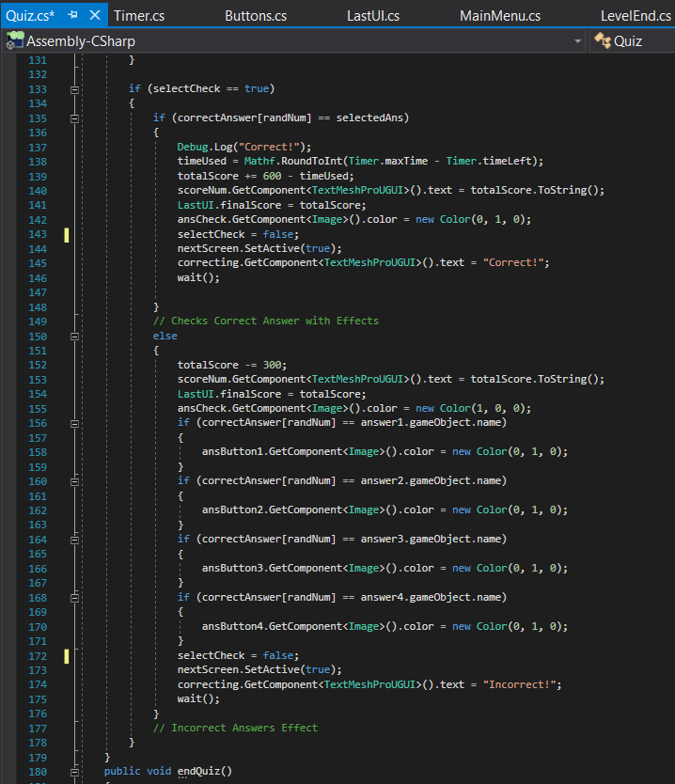From the beta testing I carried out, there was suggestions of having visual feedback after answering a question. I will implement a method to display the correct answer to the user after they have answered the question.

Figure 97 Scoring for Quiz

To have this work, I amended the code in the script “Quiz” by setting the correct answer button to green on after a button is clicked with the code “ansCheck.GetComponent<Image>().color”. The “ansCheck” holds the button which is the correct answer, this changes the colour to green only if the answer was correct. If it was incorrect, then in the else part, it sets the button chosen as red colour to indicate that the answer was incorrect. Then I have used 4 IF statements to check each button to the correct answer. Once there’s a match, which there should be, that button is set to green to indicate to the user that that was the correct answer.

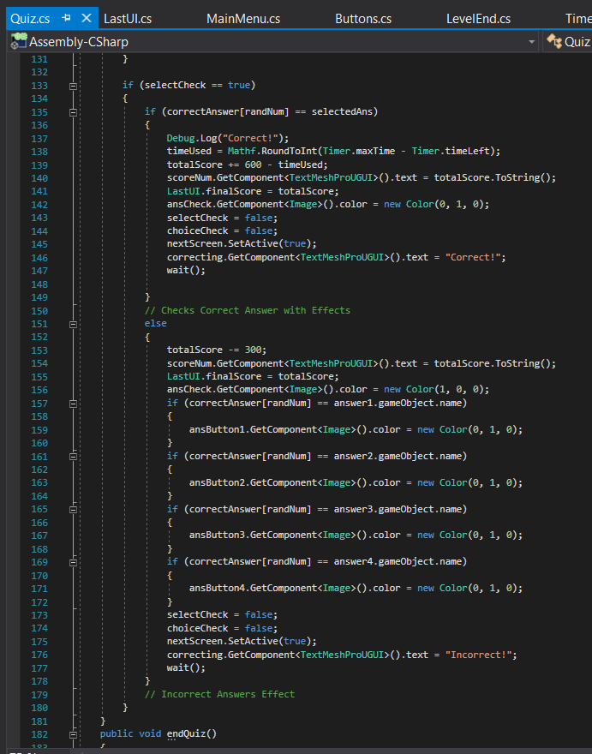Once the colours are displayed, I had to take into account my usability feature of colour blindness so I decided to create a final function to be called which will display text saying whether or not the chosen answer was correct. If incorrect, the user who is colour blind can see the highlighted choice that they didn’t pick as their correct answer.

Figure 98 Visual Output for Quiz

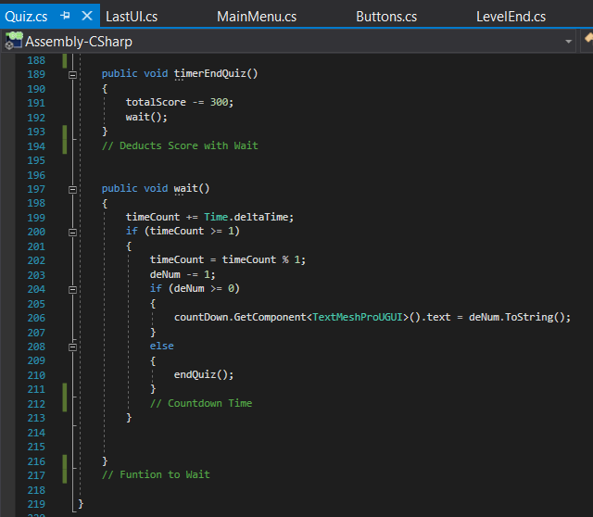This is achieved by adding another text object and just updating it depending if the answer was right or not. It’s updated by the code “correcting.GetComponent().text” where “correcting” is the variable which stores the text object. The image shown is for when the answer is correct and it’s the same code for the incorrect part except that the text is “Incorrect!”.

Additionally, I have introduced another function called “wait()”. This function is responsible for a countdown display for after the quiz is done so that the user will have time to check the correct answer and see where they went wrong. The countdown will also run even if their answer was correct, if not then the screen change may be too fast to be able to see that they were right in the first place.

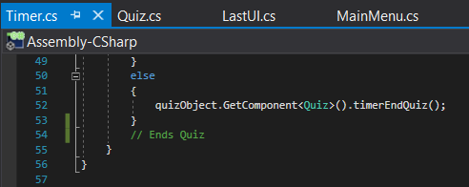

Figure 99 Creating "wait()" Function

Figure 100 Calling Function

The function is called after the visual effects are ran for both right and wrong answers or if the timer has reached 0, then within the timer script, it will call the function “timerEndQuiz()” which deducts points then runs the countdown.

In the “wait()” function I have used “Time.deltaTime” to count up in seconds for the variable “timeCount” and for every second, the variable “deNum” is reduced by 1. This variable can be changed but I have set it to 10 seconds as it seemed a suitable time to wait. The text object “countDown” is constantly updated with the “deNum” to provide the effect that it’s counting down. The “deNum” had to be set to string by the use of “ToString()” as text objects only accept sting formats.

Once “deNum” is 0 or less, then the “endQuiz()” is ran and the quiz panel is removed from view for the next screen.

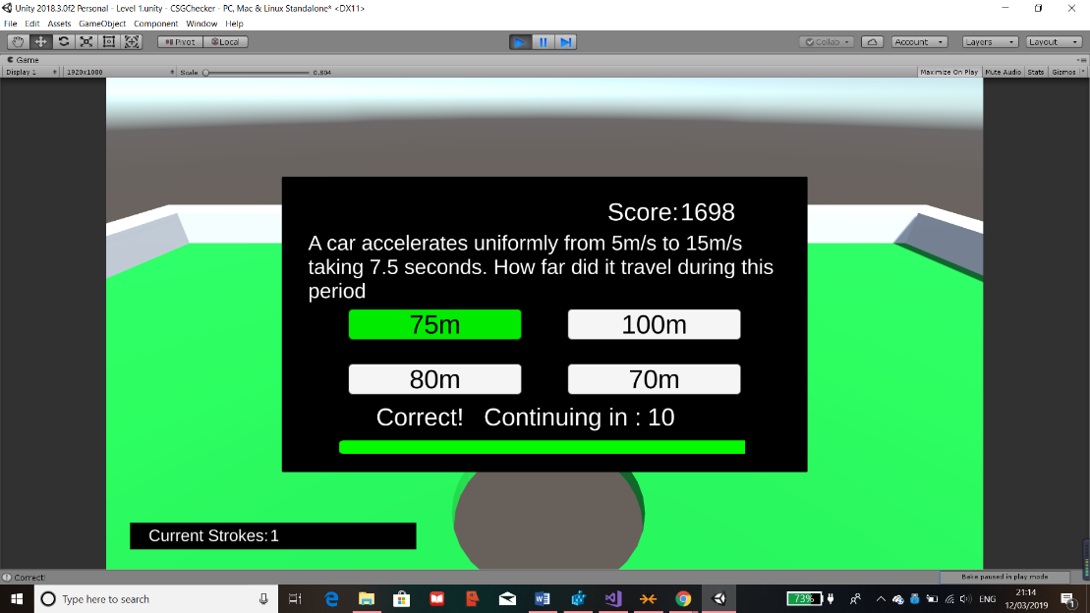

I have answered the question correctly to show that the colour assignment was right and the text successfully shows “Correct!”. The score has also updated.

Figure 101 Correct Answer Test

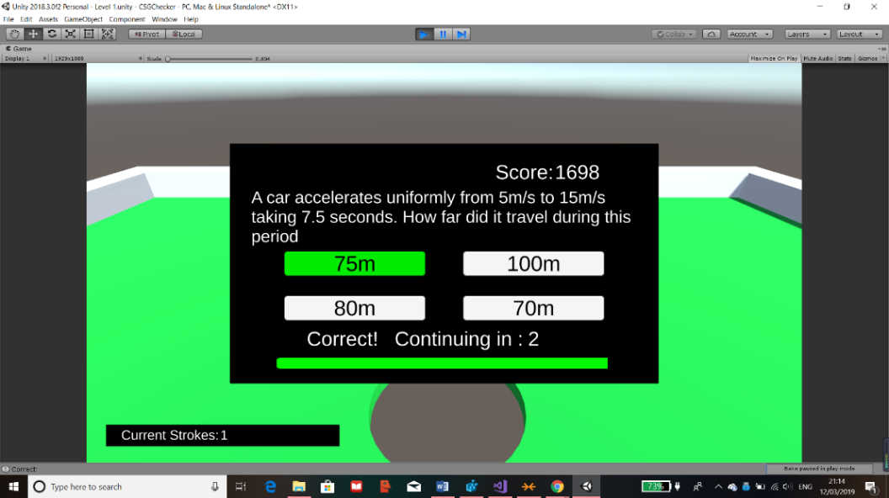

As this shows, the countdown is successfully counting down and once it reaches 0, the panel successfully switches to the next.

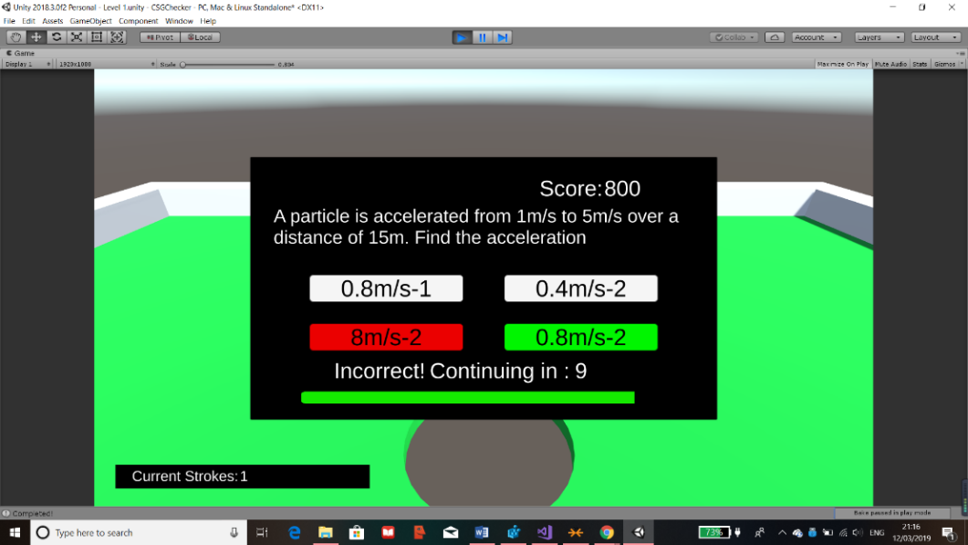

Figure 102 Countdown Test

This is a test for if the answer was incorrect which was also successful. The text displays “Incorrect!” and the red is the option I clicked on and the green was the correct answer.

Figure 103 Incorrect Answer Test

Error  
However, there was an issue where the user could spam the button and add or deduct even more to the score.

Solution  
To fix this, I simply made a Boolean to make sure that after a button is pressed then the button press could not be running again until the scene is reloaded.

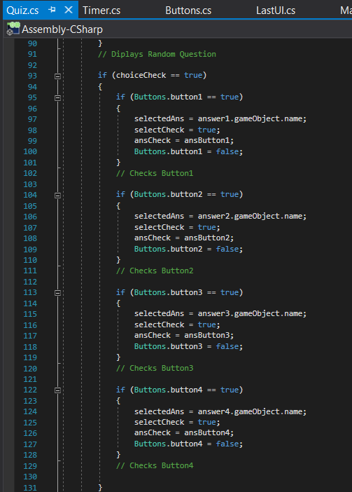

I made a new variable called “choiceCheck” as a Boolean. This is initially set to true meaning the button check code can still be ran. This is only possible when the Boolean is true. Therefore, this means that once it’s set to false then the buttons would stop adding or subtracting score multiple times for the user.

Figure 104 Button Validation Coding

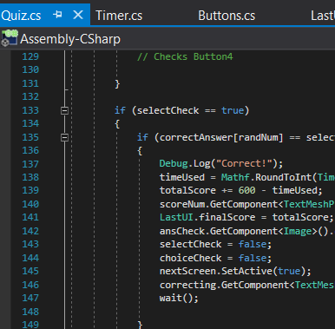

The “choiceCheck” is set to false just after the score is updated for the user and before the code can finish meaning that it can’t be repeated.

In conclusion this has resolved the problem and that the score cannot be tampered with whilst making sure nothing else would cause an error.

Figure 105 Quiz Validation Code

### Final UI

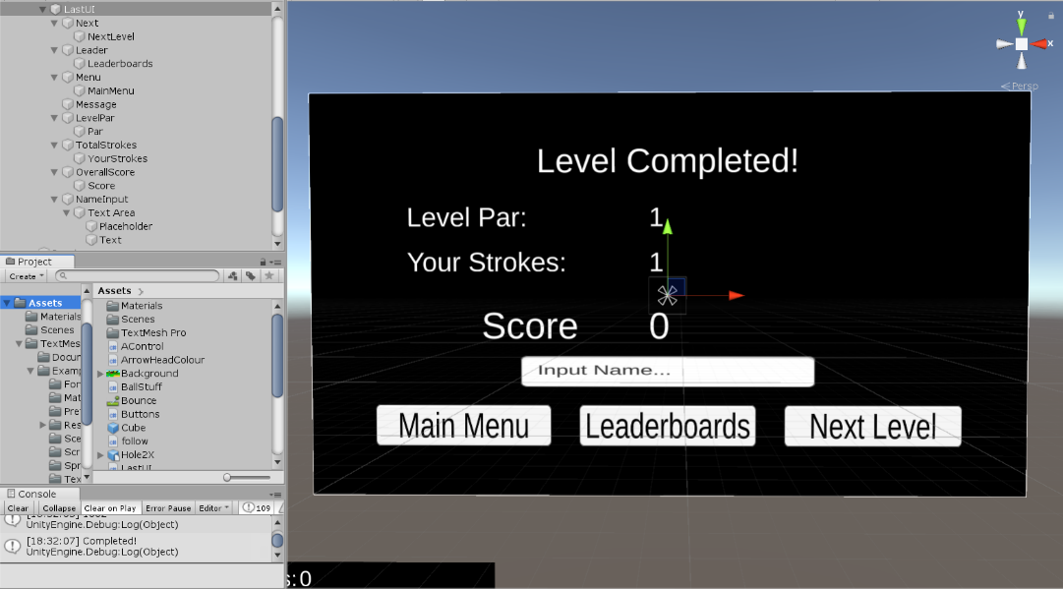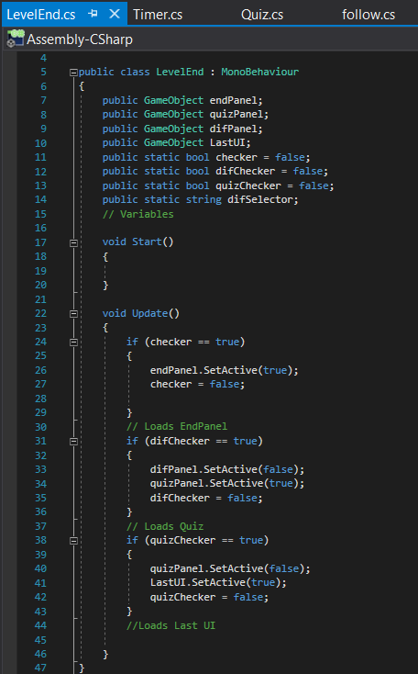The final thing required for each level would be a final display of the score and strokes of the user and the par for the level. There should be buttons for the next level or main menu.

Figure 106 Final UI

This is the panel design for the last UI, the button and text objects I used are shown on the left. There is also a “NameInput” for the leaderboards.

I have updated the scripts which are used to switch panels such as in “LevelEnd” and “Buttons”.

In “LevelEnd” I have included a new function which checks if the quiz has been completed and if it is then this new interface will load into view for the user.

Figure 107 LevelEnd Coding

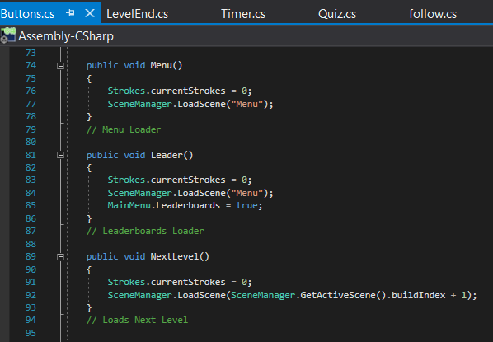

Figure 108 Button Functions for Final UI

In “Buttons”, I added 3 new functions which are to be attached to each of the buttons.

For “Menu()”, “currentStrokes” from “Strokes” is called and reset to 0, then I’ve used SceneManager to load the scene name “Menu”.

For “Leader()”, the strokes are still reset, then it loads the scene “Menu” but it sets a variable in “MainMenu” script to true, this will instantly update so that it will display the leaderboards.

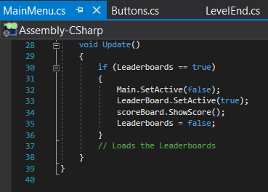

The final function is the “NextLevel()” which still resets the strokes but loads the next scene by getting the current scene using “GetActiveScene()” and its “buildIndex”. Then increasing it by 1, this can be done as the scenes I will use are in order starting from Main Menu, then level 1, 2, 3 etc.

Figure 109 Displaying Leaderboards after Final UI

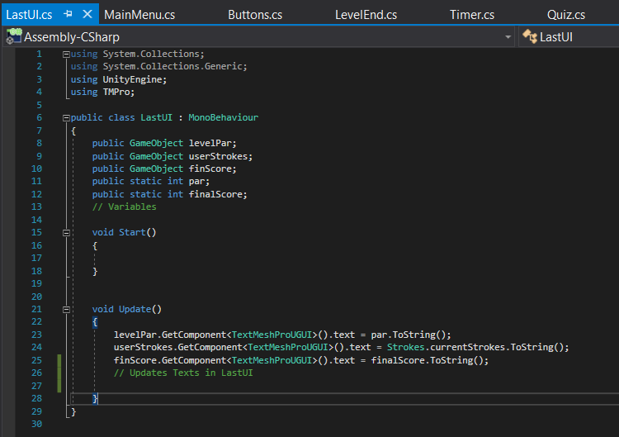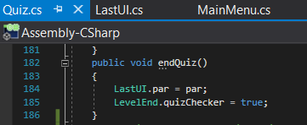

Figure 110 Last UI Score and Strokes Update

Figure 111 Retrieving Par Code

Finally, the last script is to update the 3 text objects to the final scores the user will see. The par is retrieved from the “Quiz” as it updates the variable when the quiz ends. This is done in the “endQuiz()” function.

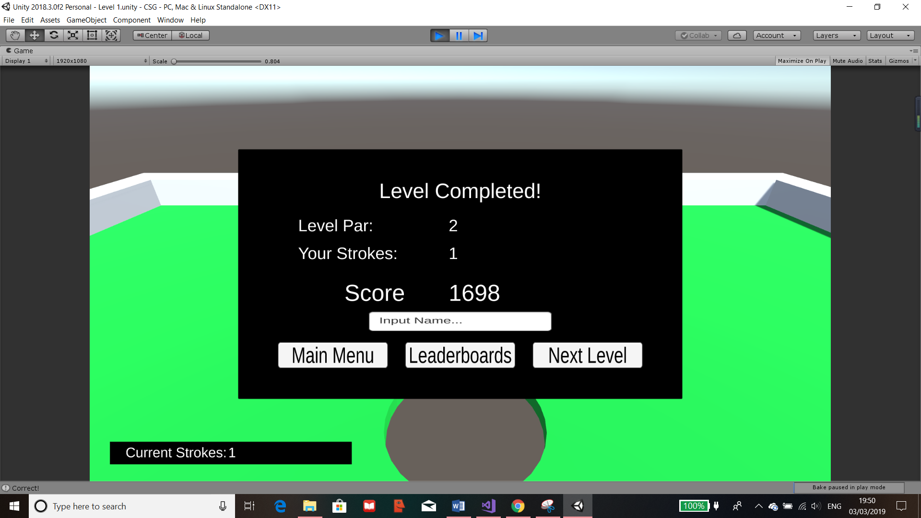

Figure 112 Level End Test 1

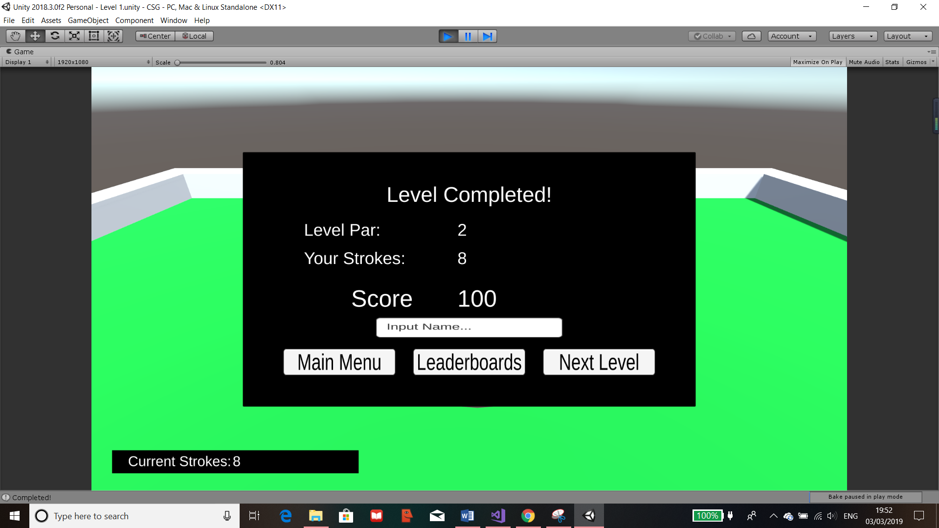

Figure 113 Level End Test 2

The results of the UI and buttons are shown here where I have tested when the strokes is less than the par (I.E Hole In One) and when it’s greater. The score has correctly updated accordingly and the buttons all work.

## Leaderboard

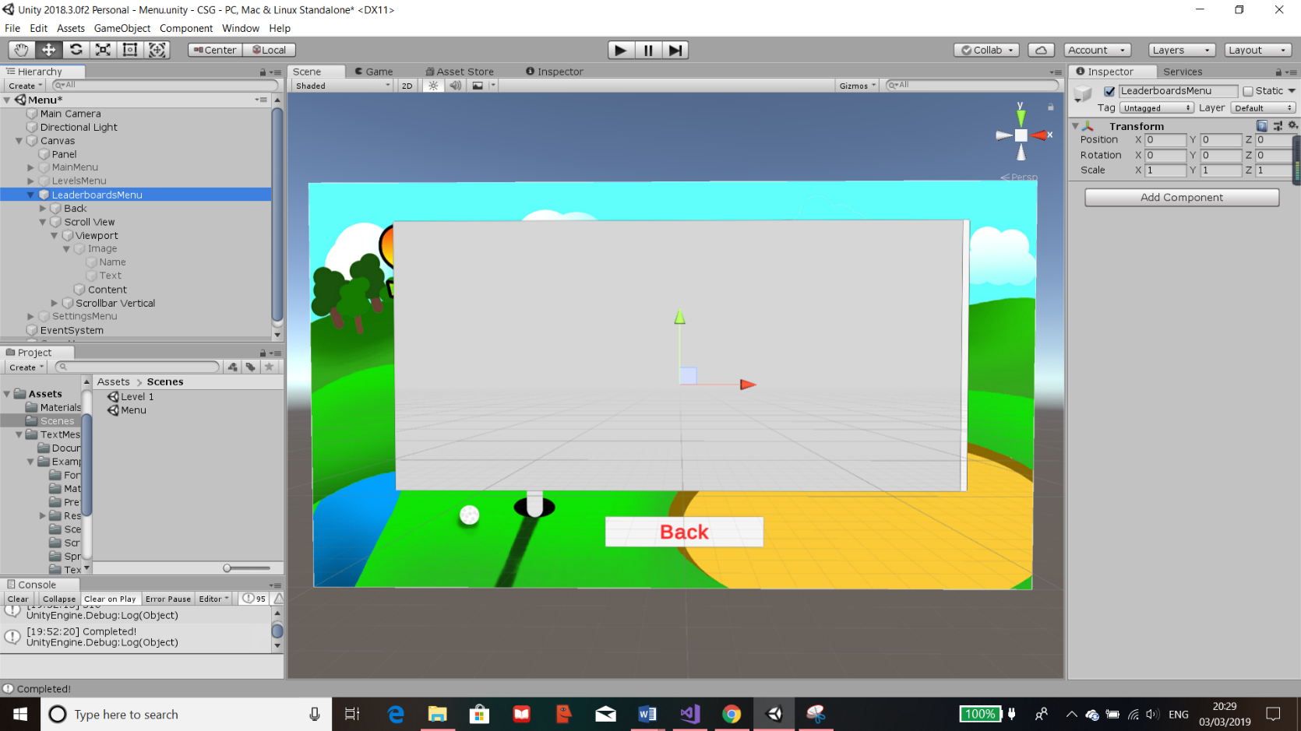As mentioned in my Success Criteria, I wanted to have a leaderboards to show the users score and have them ranked which will provide a competitive part to the gaming. This means that they will be able to view and see their ranks in comparison to others and try to score better to achieve a higher rank.

Figure 114 Leaderboards Object

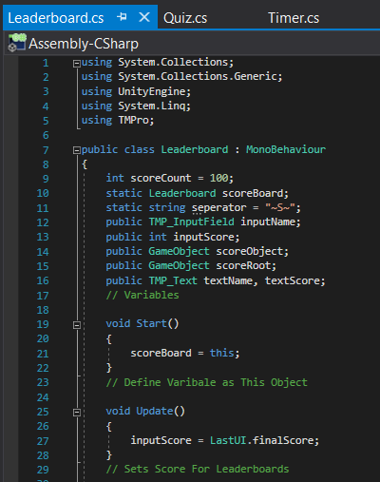I have updated the “LeaderboardsMenu” to have a “Scroll View” meaning that when data is added into this, it can be as large as it needs. This is due to the ability to scroll down the list and it will minimise any bugs that are involved with too much scores on the same panel. Therefore, this is how the leaderboards will be shown.

This is the first part of the “Leaderboard” script. At the beginning of the class, all variables are set and defined.

Most of these define objects that are outside the script and will be attached.

The “scoreCount” is responsible for the number of scores to display. I have set this to 100. The “separator” is the string which will be used to separate out a string as the name and score will be merged together as one entry. The “inputScore” is then the final score the user has, this is constantly retrieved and updated from the “LastUI” class in the “Update()” function. In “Start()”, “scoreboard” is defined to be “this” which means the object the script is attached to.

Figure 115 Variable Initiation for Leaderboards Code

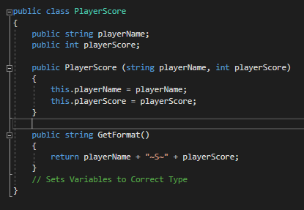Within the script, I have created another class called “PlayerScore”, I have created this here so that it will be easier for functions in the same script to call this.

Figure 116 Name Entry Code

In this class, it’s responsible to update the players name and score in the “Leaderboard” class whenever the function “PlayerScore()” is called. It’s also responsible for the formatting as shown in “GetFormat()” which provides each entry to be stored as a singular entry.

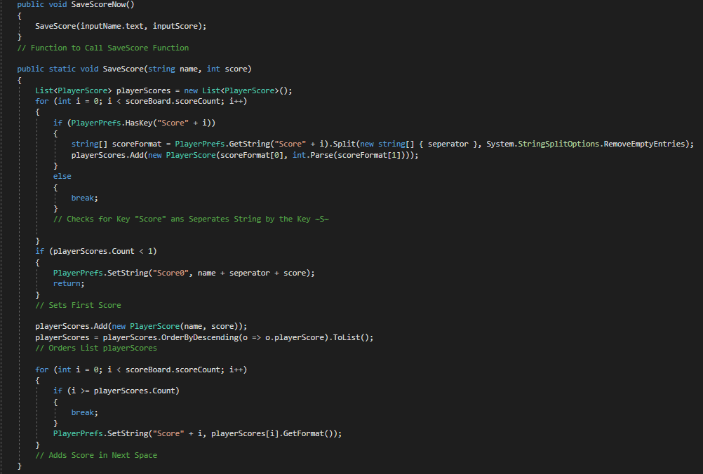

Figure 117 Writing onto Player Prefs Code

“PlayerPrefs” is a way Unity uses to store information set by me similar to text documents. However, they are stored by hashing so that the data is ordered by entry and it holds all the information on the data, also they are stored on the registry. This means that they could be stored on the school’s main server so that everyone would have access to the same leaderboards and the same scores are updated and displayed.

To have the “SaveScore()” run, I have placed it in another function called “SaveScoreNow” so that the parameters passes will have the correct format beforehand.

The new list “playerScores” is created at the start of the function so that whenever a score is saved, a brand-new list is created and everything is re appended. This may seem illogical but it’s the best way to ensure that no duplicates could occur.

Figure 118 Saving Score in Correct Format

For the function “SaveScore()” the first “for” statement is used to count all the entries that are already in the “PlayerPrefs” and add them into the list “playerScores” in the format of a list where the first row of the array has the name then the second contains the score. It’s achieved by retrieving the current i in “PlayerPrefs” as an array with 2 parts as it was separated by the “separator” and the command “System.StringSplitOptions.RemoveEmptyEntries”. Then it’s saved as the string variable “scoreFormat” which is then appended into the list. Once all previous entries are recorded, it then runs “break” which just stops the “for loop” as it’s unnecessary to carry on.

When appending to the list, I have also used “int.Parse” which is a way unity coverts the data into an integer”

Figure 119 Ordering List Code

Then this “if” used to set the first score if the “PlayerPrefs” had no entries as “Score0”. The next line then saves the new score using the parameters that were passed down which were “name” and “score” into the list. It then orders the list so that it is descending for the users to see as ranks.



Figure 120 Adding New Entry

The final “for” statement is used to find the next free space in the “PlayerPrefs” by the use of the “if” checking for when i is larger or equal to the list “playerScores” which will have one additional entry to the pref as it was the new entry added previously. The same spot is then found as i would be the last entry in the list but the next empty in the “PlayerPrefs”. Once this is found, the name and score are added as a single entry as a string by using “.GetFormat()” which I have made and was shown before. This ensures that the “PlayerPrefs” has the same entries for future use because this can’t be deleted unless manually in the registries.

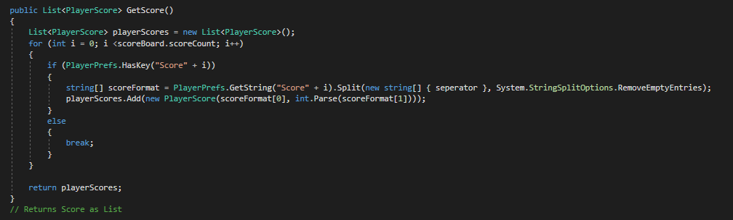

Figure 121 Creating "GetScore()" Code

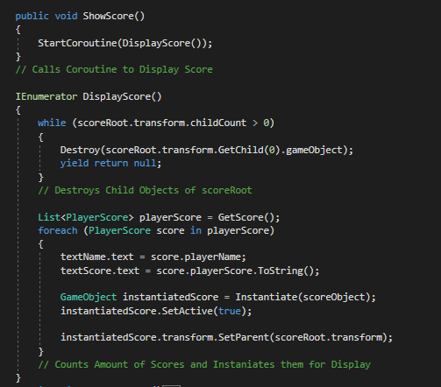The next function in the “Leaderboard” class is the “GetScore()” which is the same as “SaveScore()” because it’s used to create a new list with all the “PlayerPrefs” entry in the correct format however doesn’t add a new entry. Therefore, this is used to return the current version of the list “playerScores”.

Finally, the last functions are responsible for the actual displaying of the scores. “ShowScore()” is used to call “DisplayScore()” as IEnumerator can’t be directly called.

The “while” counts how many children objects are attached to the “scoreRoot” and deletes each all of them one at a time. This is done so no duplicates would be able to be generated.

The “playerScore” is retrieved by the function “GetScore()” which will create and return a list with all the up to date entries.

Figure 122 Displaying Score in Correct Format and Order

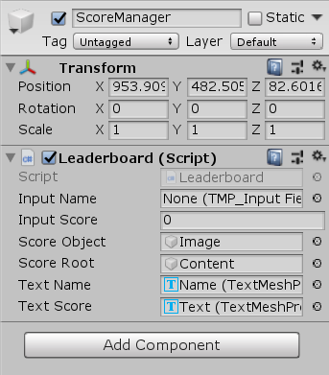The “foreach” command is ran the same number of times as the amount of “score” in the “playerScore” list. For each time this is ran, the “textName” and “textScore”, which is turned to a string using “ToString()”, from the list is retrieved and set to the text. Then an object is instantiated using a predefined prefab in the Unity menu. The instantiated object contains the “textName” and “textScore” and is set to active so that it is visible to the user. The object is then “transformed” (moved) as a child object of the parent object called “scoreRoot”. This is achieved by the function “SetParent()”.

The script is attached onto an object called “ScoreManager” which is outside a spectator object so that it can be always available. I then assigned all the variables as the correct ones and proceeded to test it.

Figure 123 Adding Attributes to Script Component

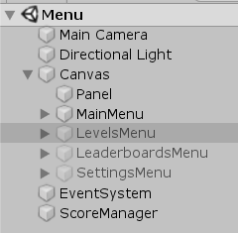

Figure 124 Menu Scene Hierarchy

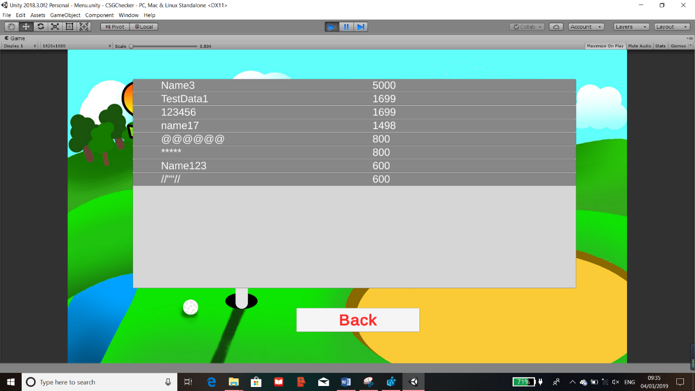

Figure 125 Leaderboards Testing

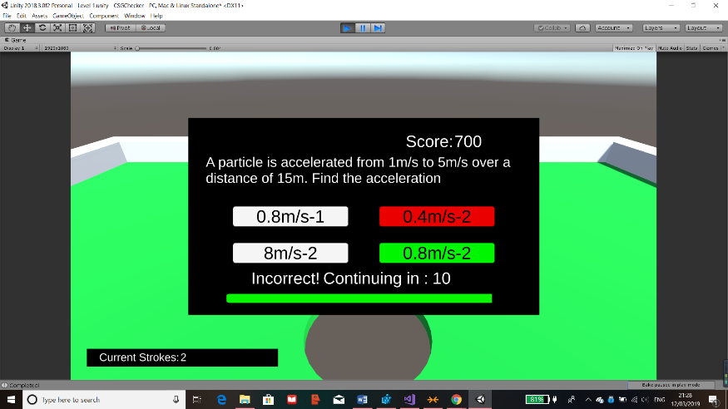I have tried multiple different test data when trying out the level, the results of the leaderboards are shown. As it shows, I have tried different symbols and text and they all work which I think is suitable. It is also correctly ordered where the highest score is at the top and the rest as descending order.

Figure 126 Leaderboard Test Part 1

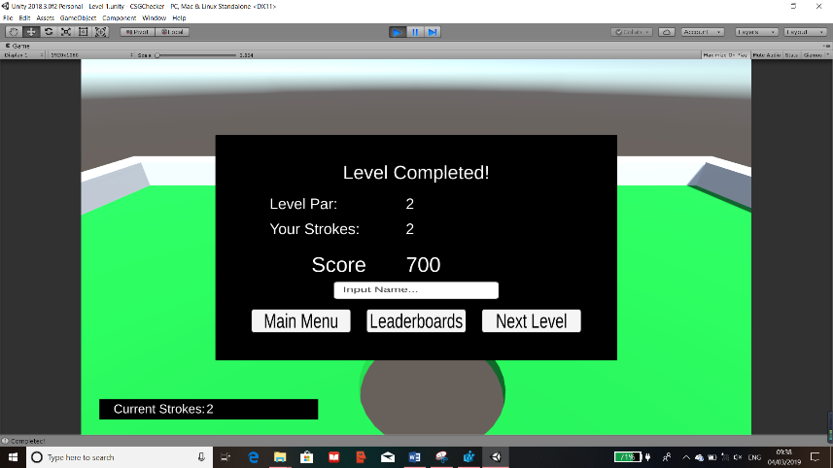

Figure 127 Leaderboard Test Part 2

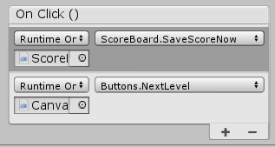After completing the quiz, everything is correctly displayed and my final test it to not put a name in. Whichever button is pressed, it’ll be saved into the “PlayerPrefs” for displaying. This is done by adding another function to be called in the “On Click()” component for each of the buttons which will therefore call “SaveScoreNow()”.

Figure 128 Adding Component for Level End UI Buttons

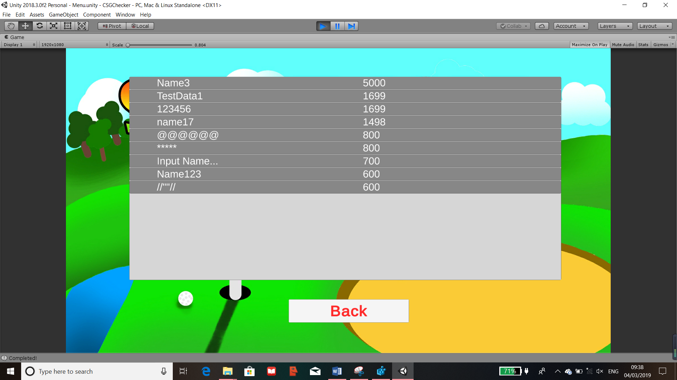

Figure 129 Leaderboard Button Test

After clicking on “Leaderboards” button, it brought me directly to the leaderboards with the updated score. This was a success as the leaderboards has correctly updated and have been ordered. On the other hand, the name is displayed as “Input Name…” when a name wasn’t entered. Even though this is displayed, I left it as it still holds the score of the test trial. I’ve kept this so it means that when users play this, they don’t have to put a name down but still have their score within the leaderboards.

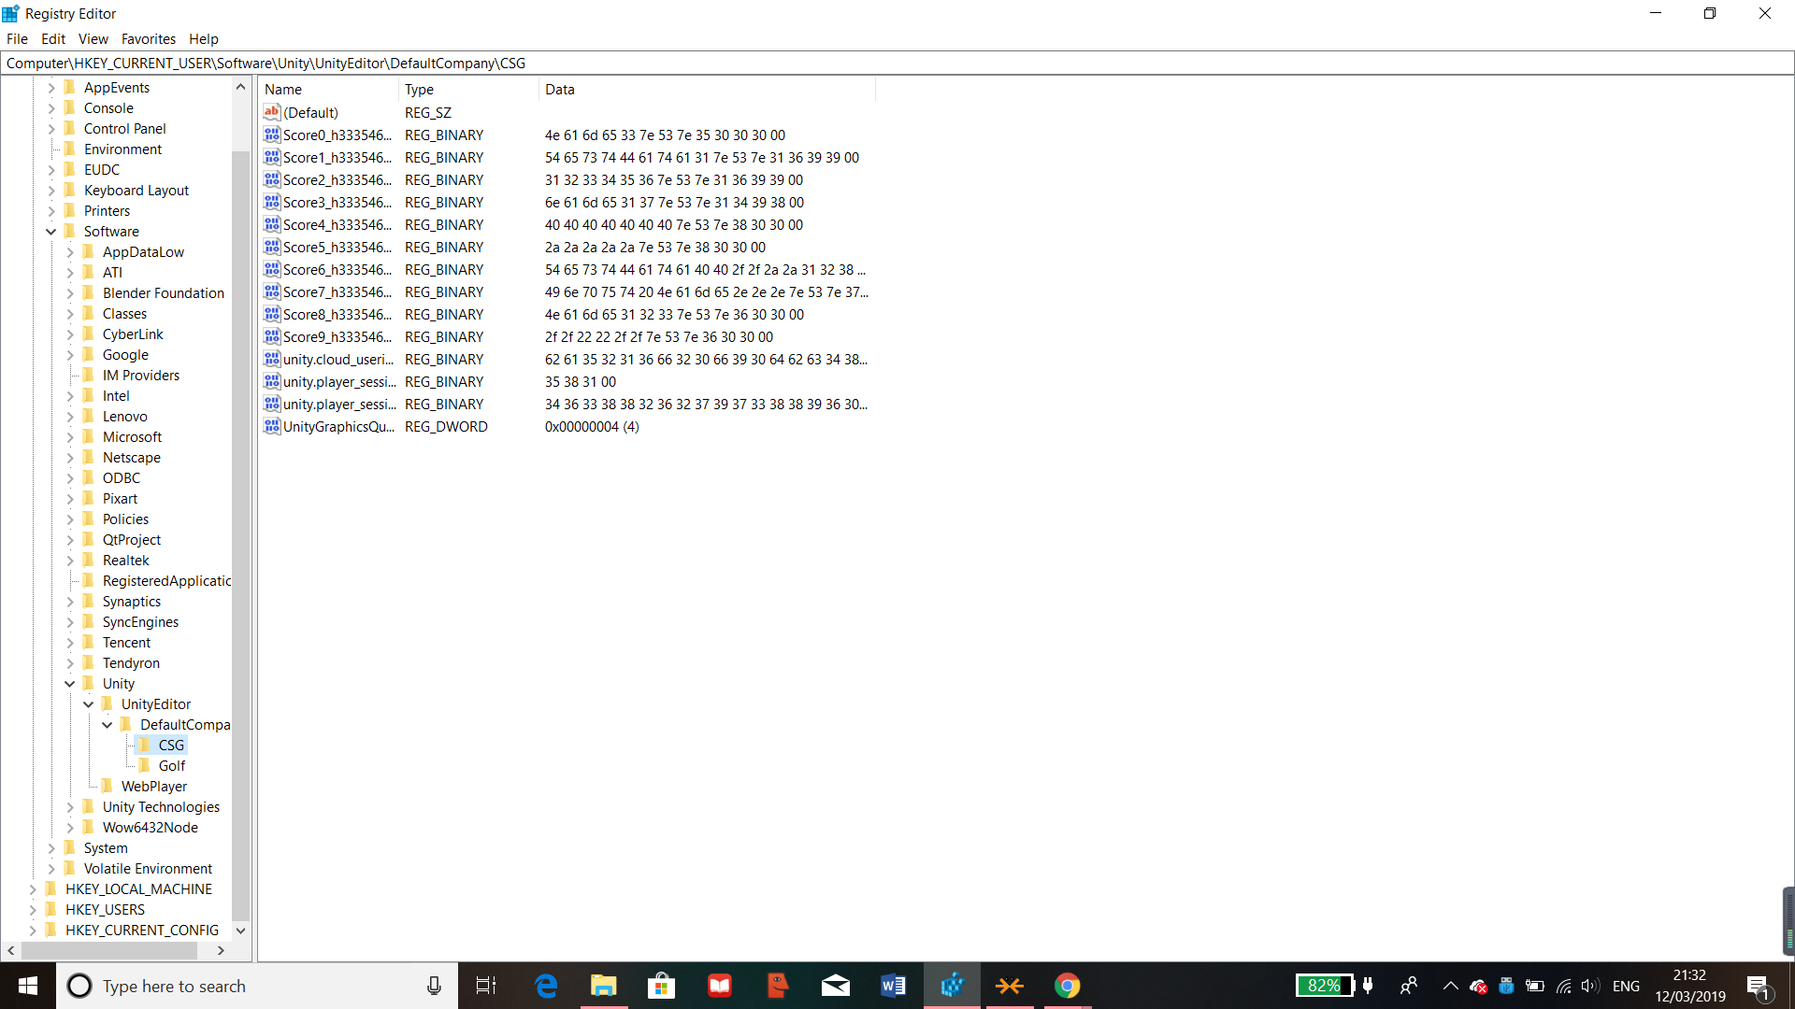

Figure 130 Player Prefs on the Registry

This is where the scores are stored on the registries as player prefs.

### Questions and Scoring Testing

I proceeded to test the questions display and scoring for the entire game by using the test data that was pre planned in my design section on pages 32-36.

Testing will be done with most of the data I used however a few things had to be modified as I have improved the code. I will not be able to set the score used for testing as it’s all calculated with the code that I have written to prevent any cheating. But the score will scale depending on their ability to play and if they get the question correct or not which means that I can still use the testing I have planned. Also, instead of using files for storing scores, I have used Player Prefs which is much more suited to unity and I have explained what this is in the modules in design.

All the tests I will run will have the strokes used to be 1 and the quiz difficulty always at medium so that all tests will be fair and I will also move all the data stored in the current leaderboards out temporary during this testing.

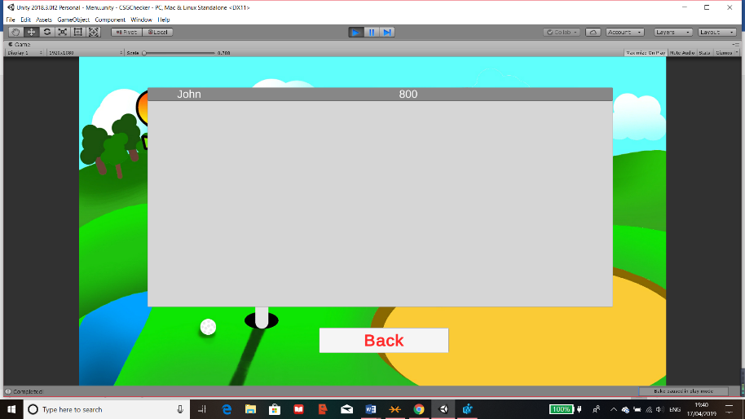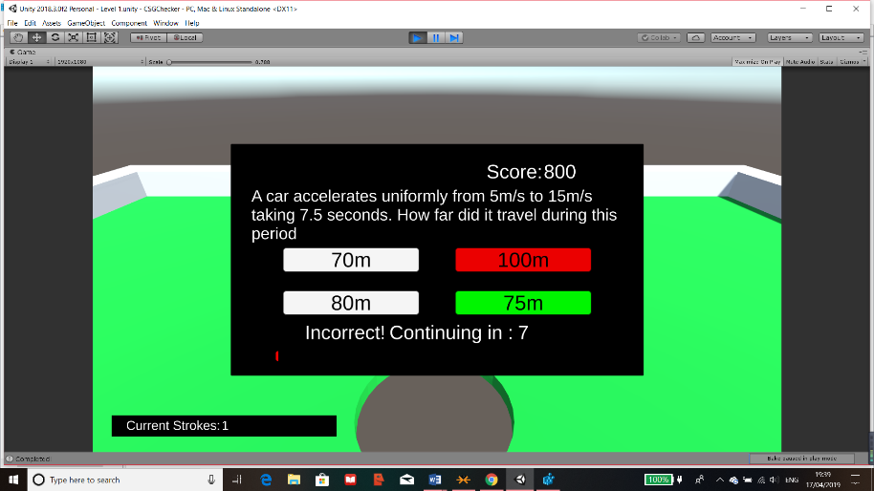The 1st test I have done is to play through the quiz and answer the question incorrectly by running out of time. I will then save the score under the username “John”. The expected outcome is that the score will be 800 because the time will not have an effect on the score.

Figure 131 Questions and Scoring Test 1 Part 1

After performing the test, the overall score was 800 for “John” and currently they are at the top of the leaderboards since its empty. The reason the score is 800 is because time ran out so considered the question to be answered incorrectly which is the output required.

Figure 132 Questions and Scoring Test 1 Part 2

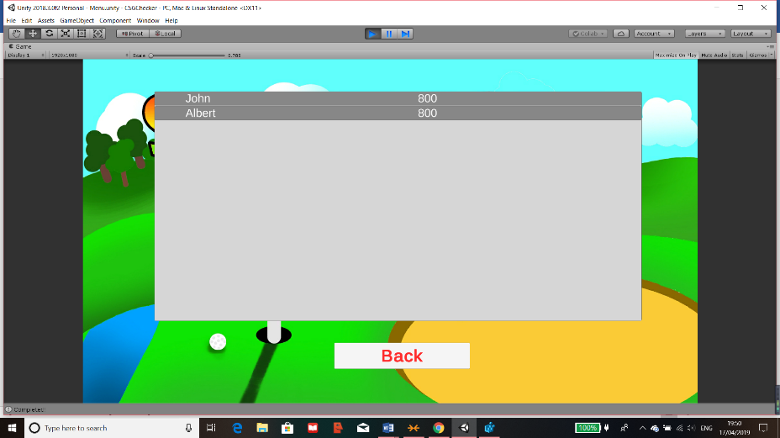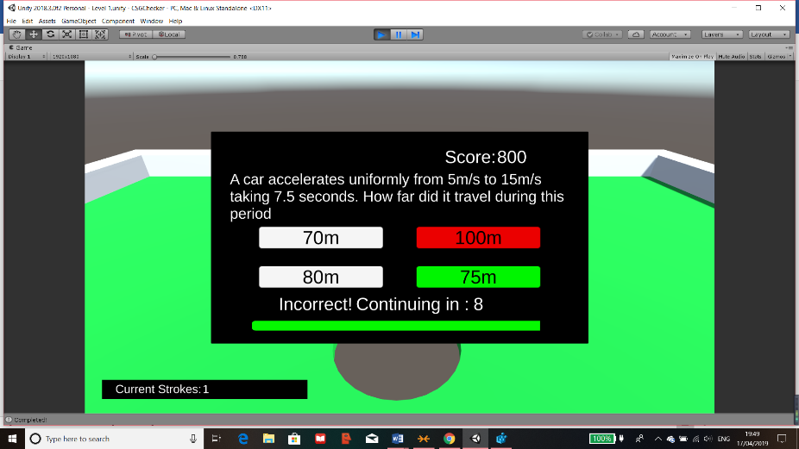The 2nd test is to play through the quiz but get the question wrong in the quiz without using much of the time and this will be done under the name of “Albert”. The expected outcome is that the score will be the same as “John” because the question was answered incorrectly.

Figure 133 Questions and Scoring Test 2 Part 1

Figure 134 Questions and Scoring Test 2 Part 2

After testing, the overall score for “Albert” is 800 since the question was answered incorrectly which overwrites their time used. On the leaderboards they are placed second since the scores are the same but “Albert” was the 2nd entry.

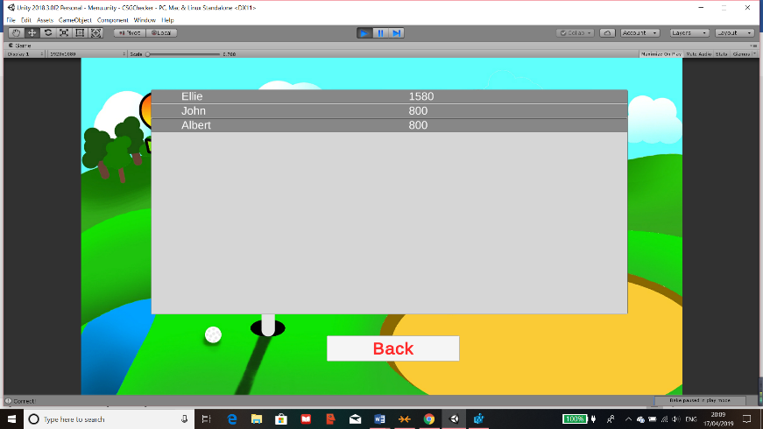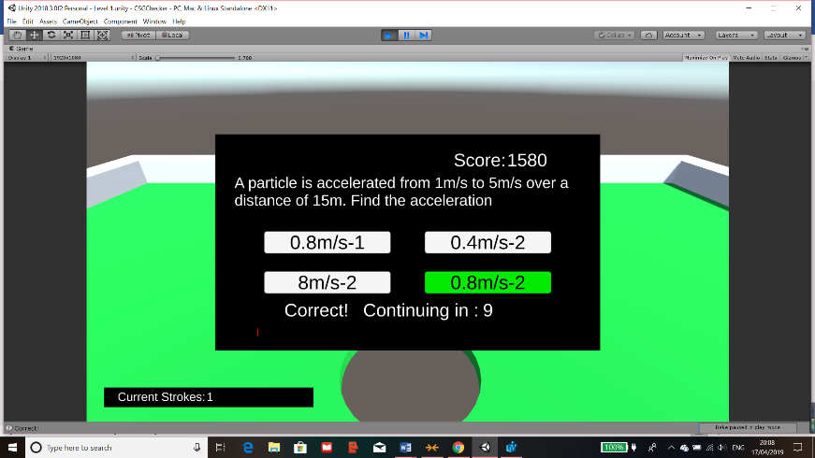The 3rd test is to answer the question correctly but to use a long amount of time which means that the expected outcome will high but will have also deducted the time used since the answer was correct. This will be saved under the user “Ellie”.

Figure 135 Questions and Scoring Test 3 Part 1

After testing, the score was 1580 since the question was answered correctly but since lots of time was used, the score is reduced to what it could’ve been. Also “Ellie” was placed in first place in the leaderboards since the score is the highest.

Figure 136 Questions and Scoring Test 3 Part 2

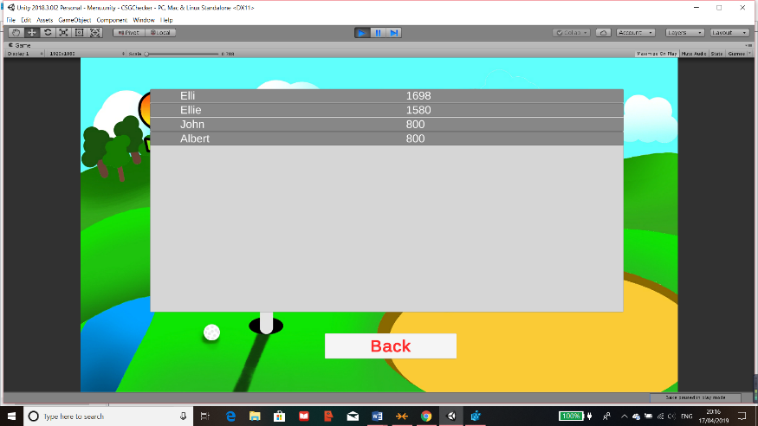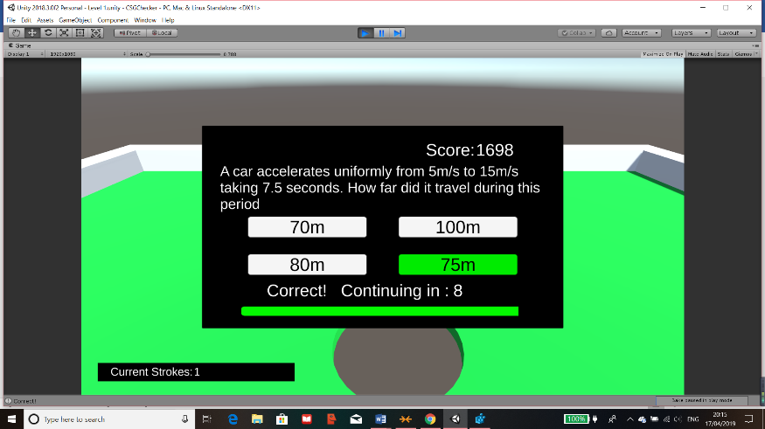The final test is to answer the question correctly as quickly as possible so it should be near the highest possible score which is 1700 and I will store this under the user “Elli” so it doesn’t overwrite the other score.

Figure 137 Questions and Scoring Test 4 Part 1

After the final test, the outcome was as expected because the score was 1698 which may not be 1700 but this is because I can’t answer the question instantaneously. This is also the highest score so “Elli” is placed at the top of the leaderboards.

Figure 138 Questions and Scoring Test 4 Part 2

Overall, the tests I have done have been quite successful and the outcome of it means that the scoring and quiz part of the game works and can played by my focus group.

## Prototype Product for Testing Code Before Test

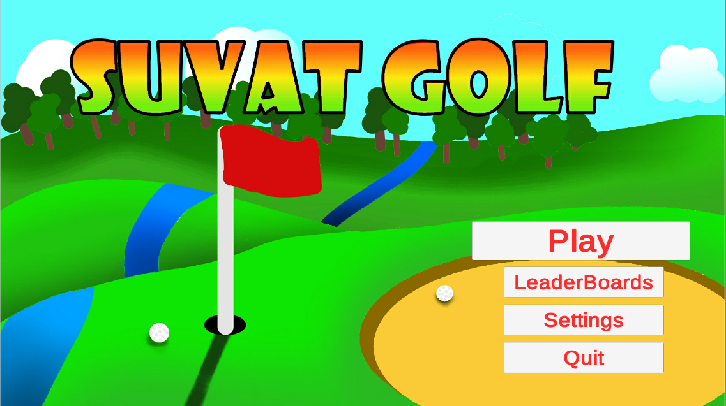

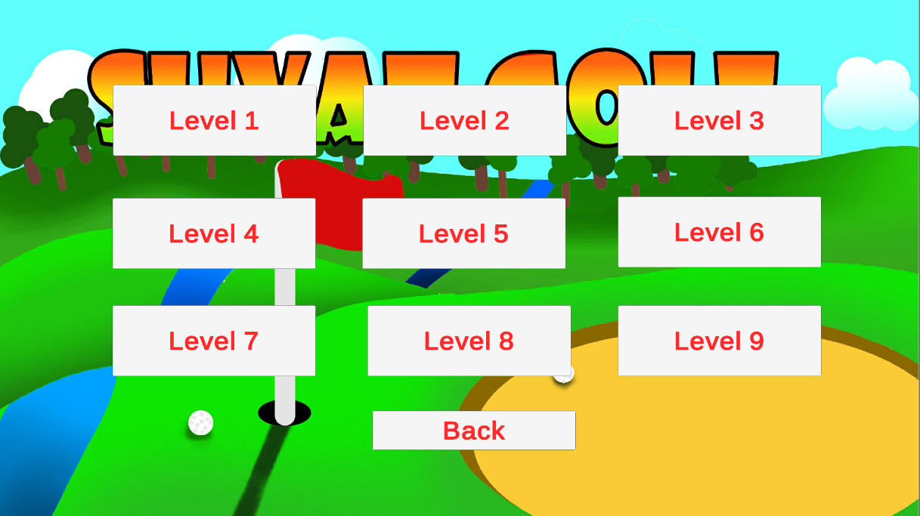

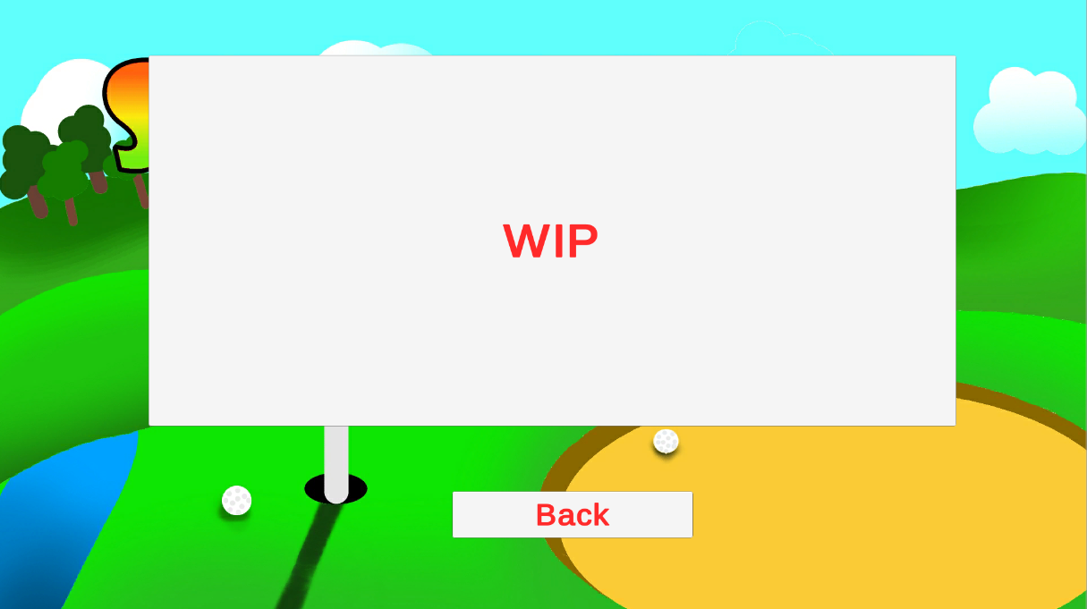

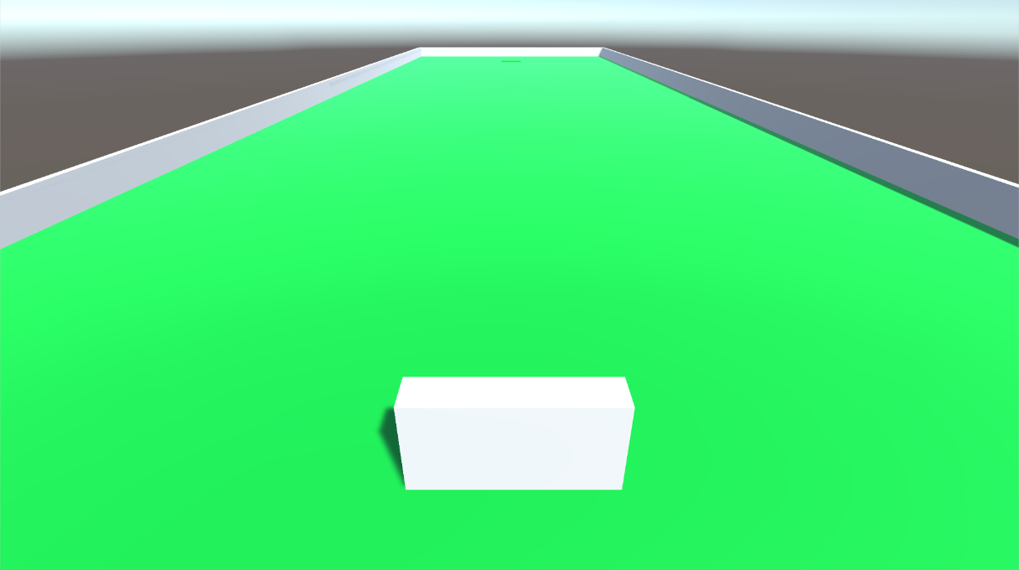

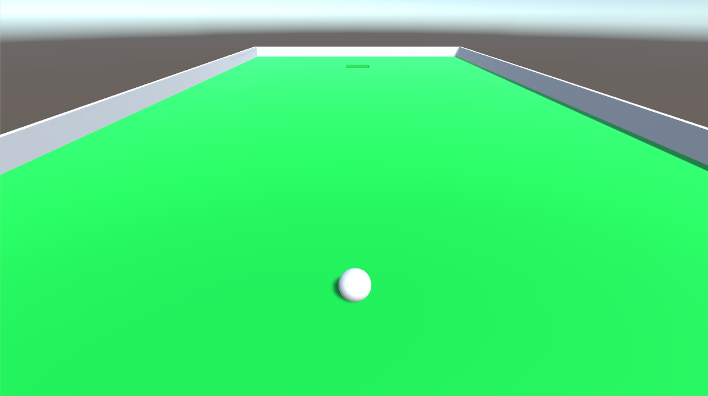

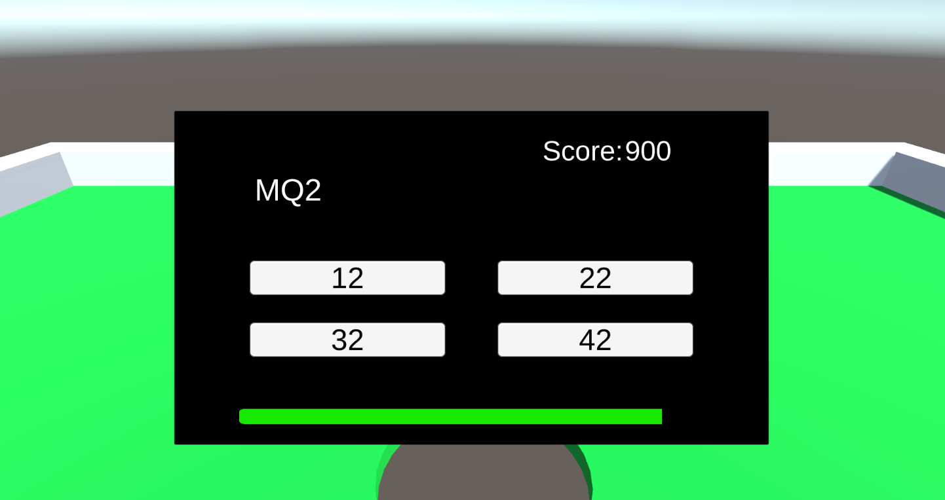

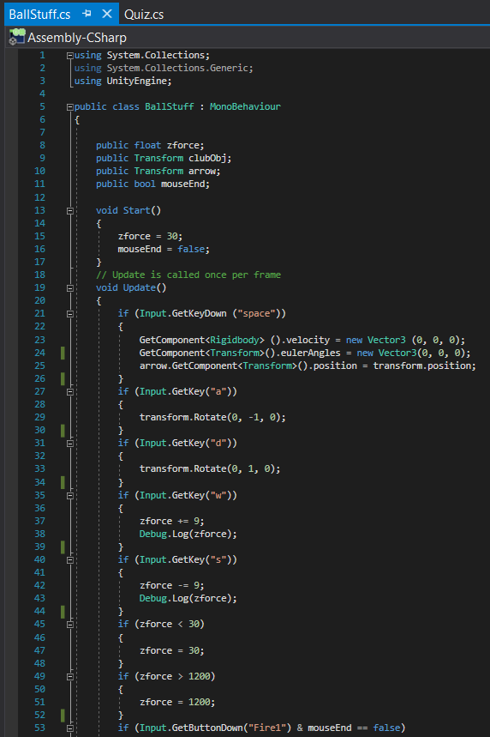

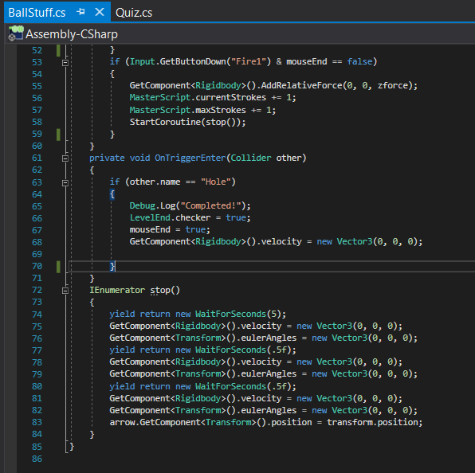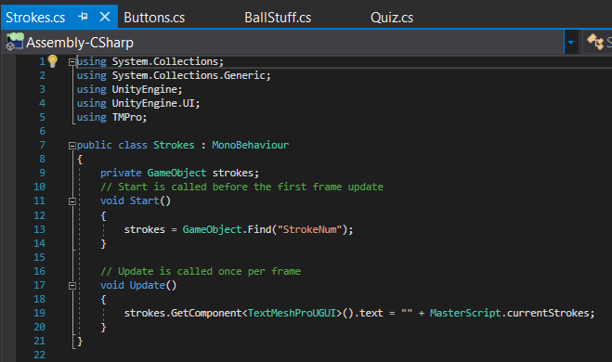

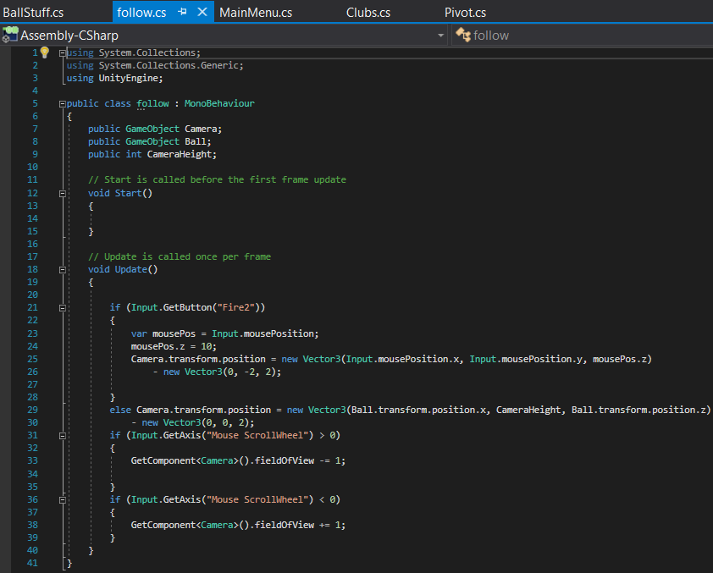



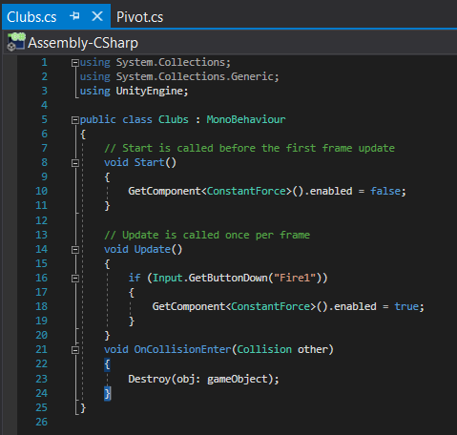

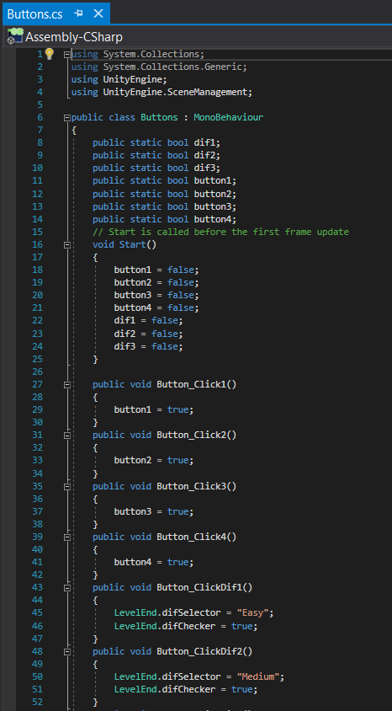

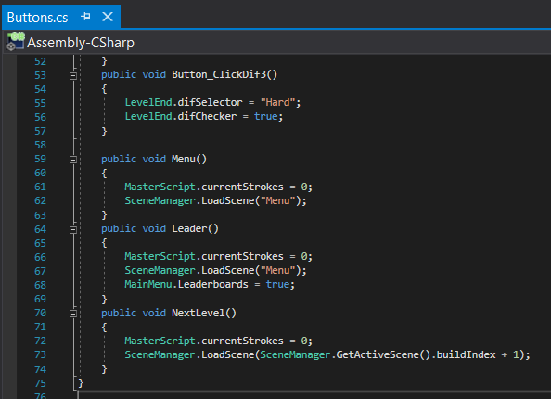

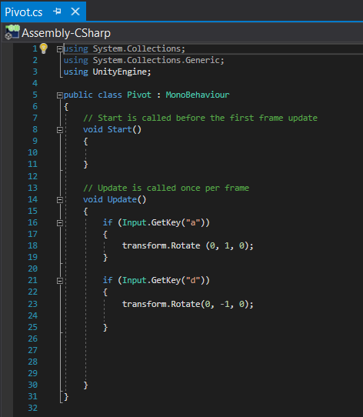

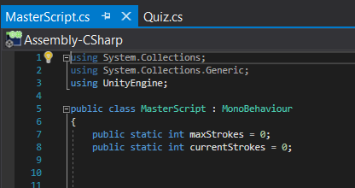

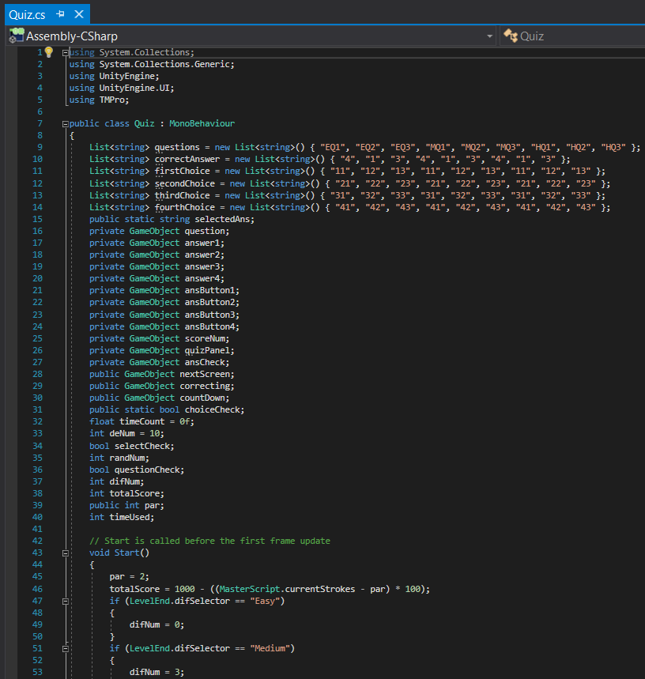

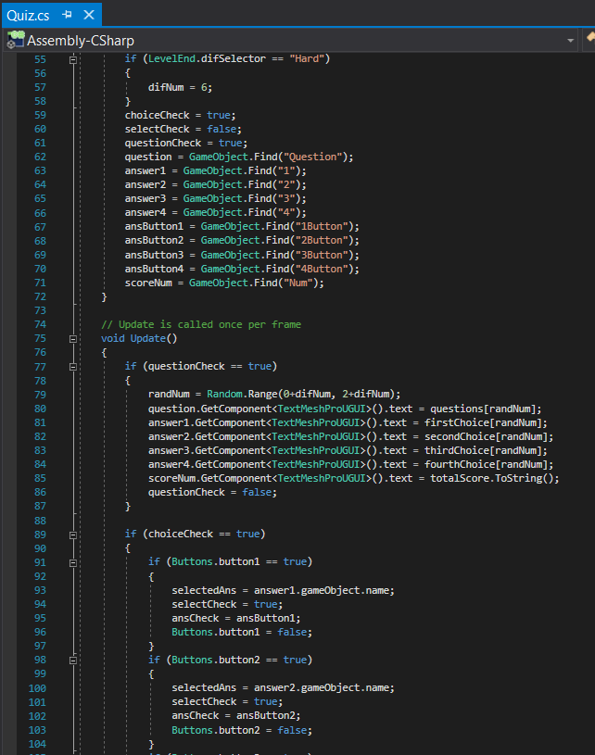

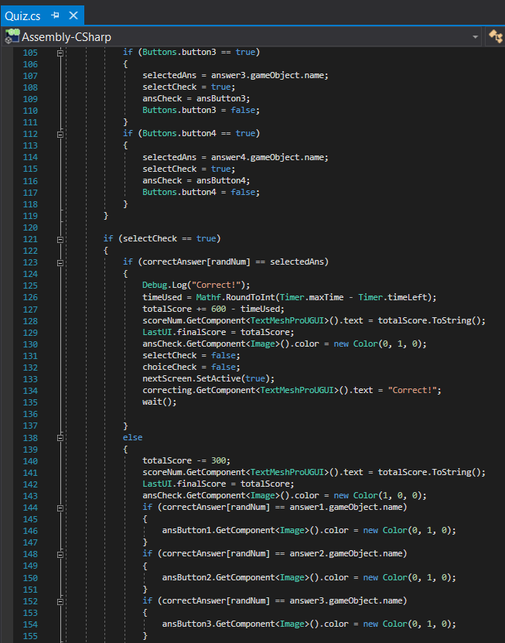

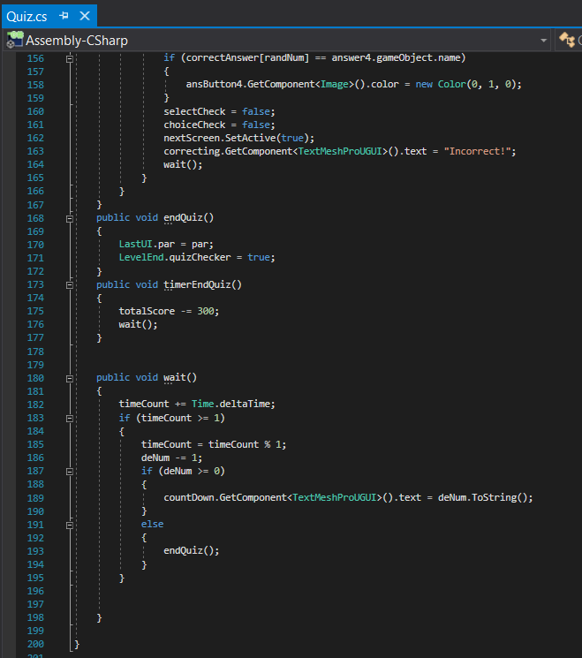

## Prototype Product After Test

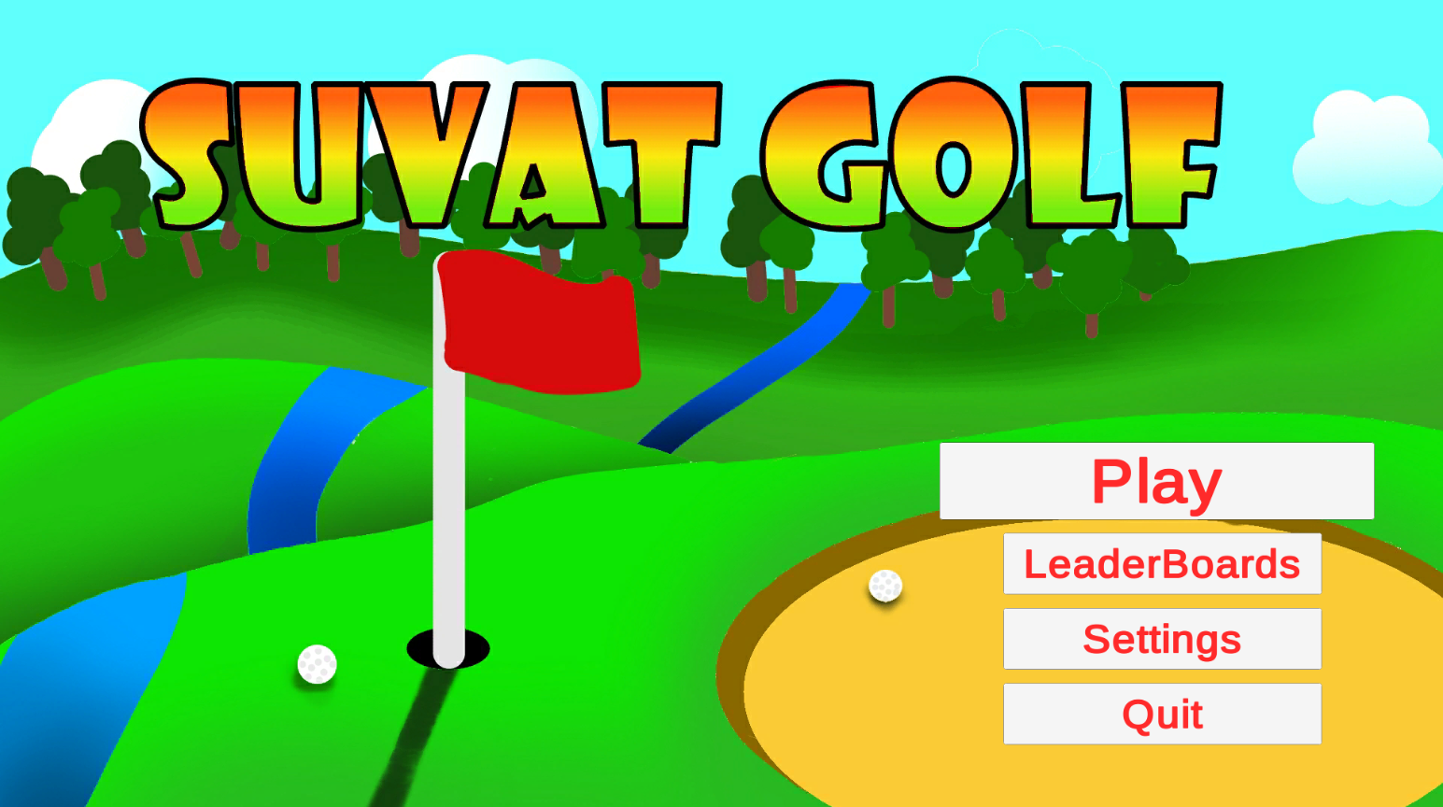

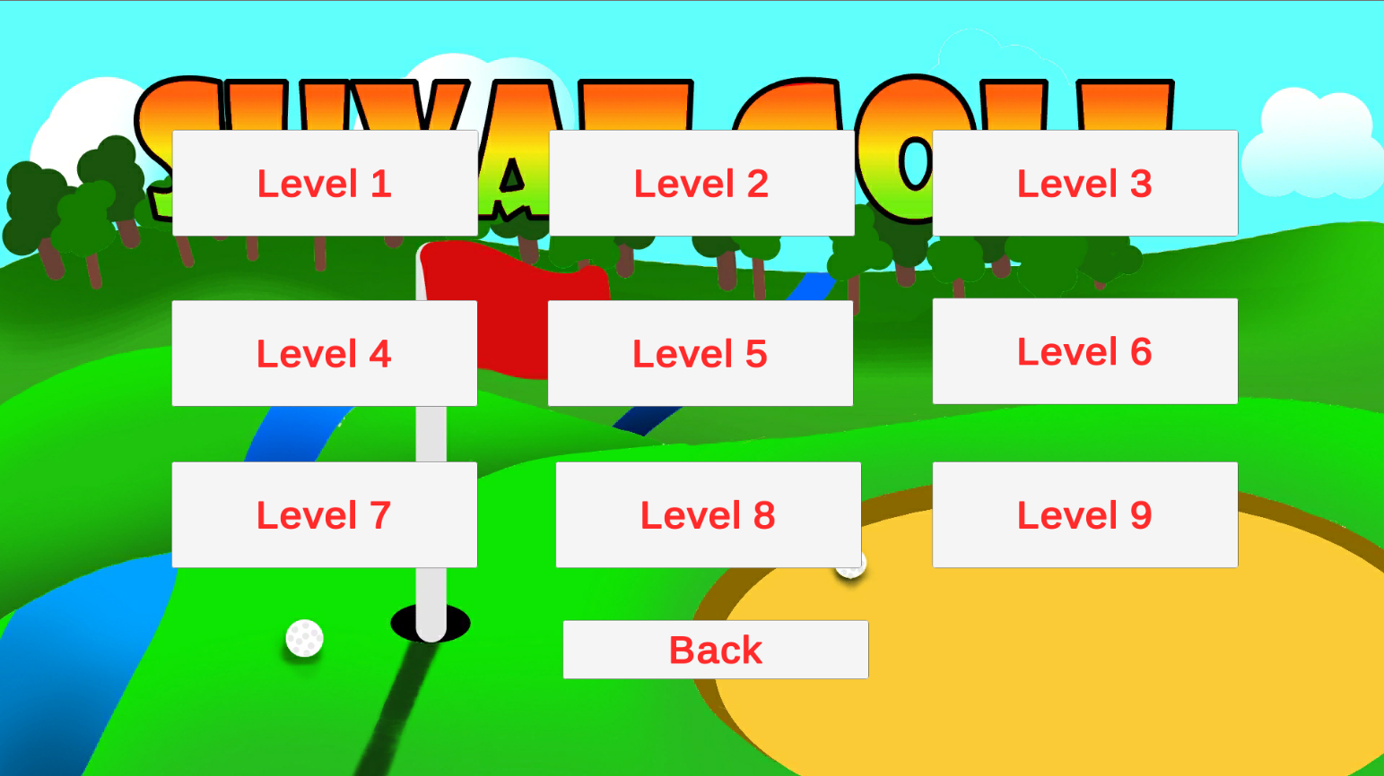

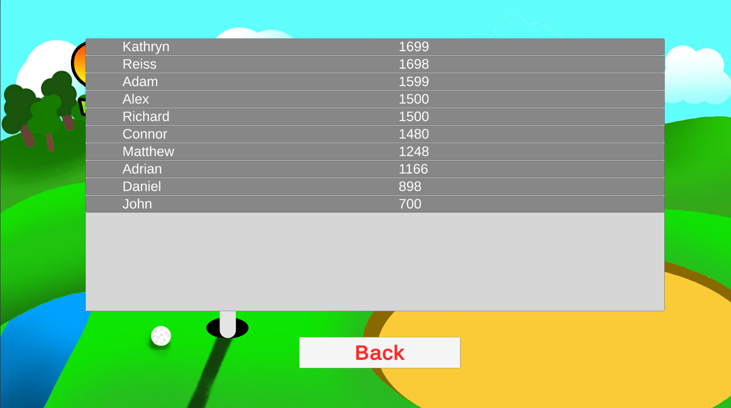

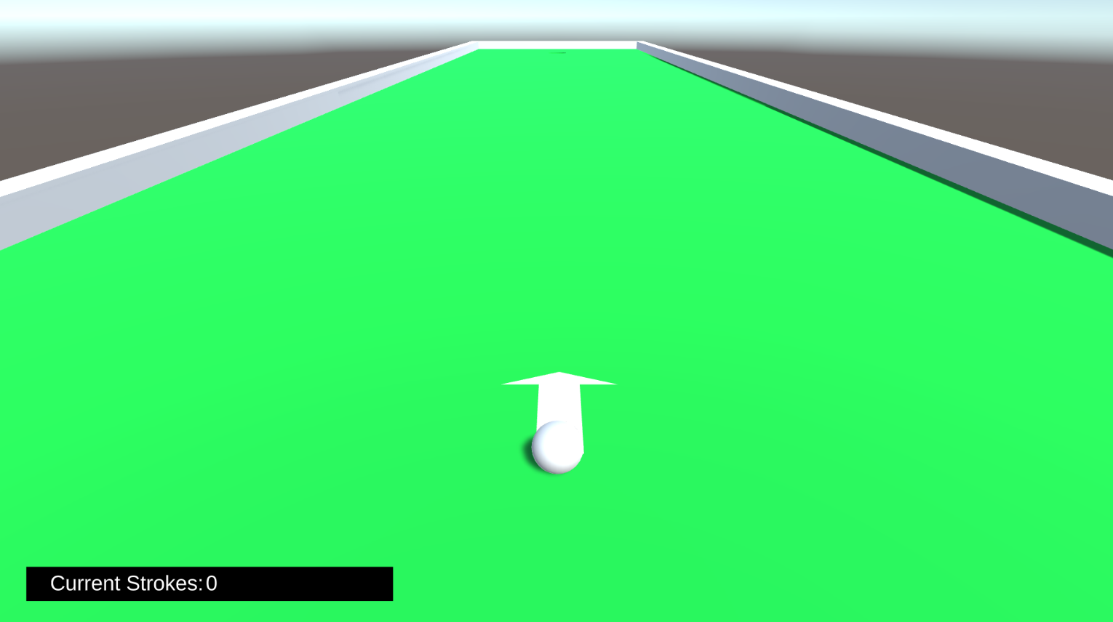

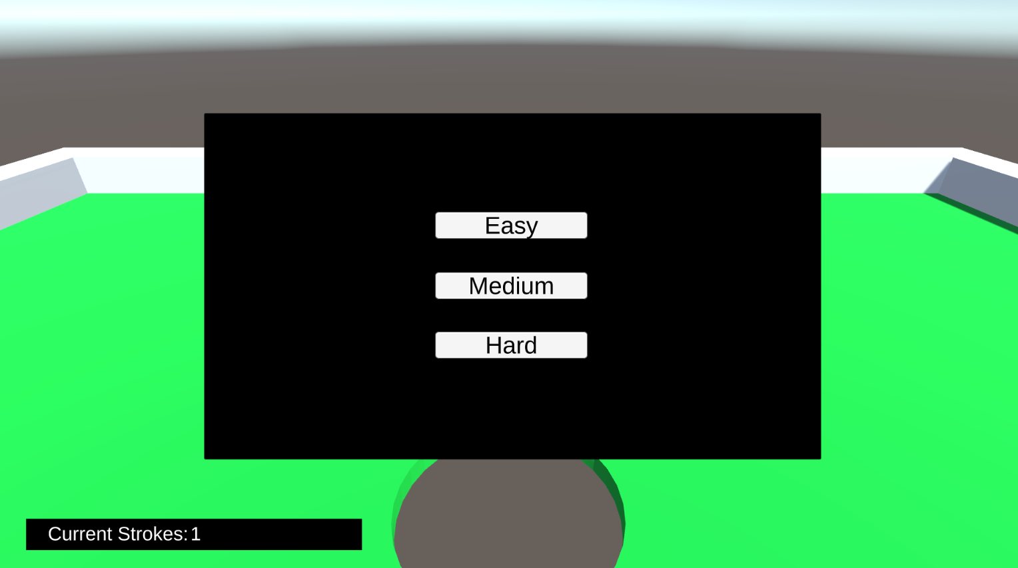

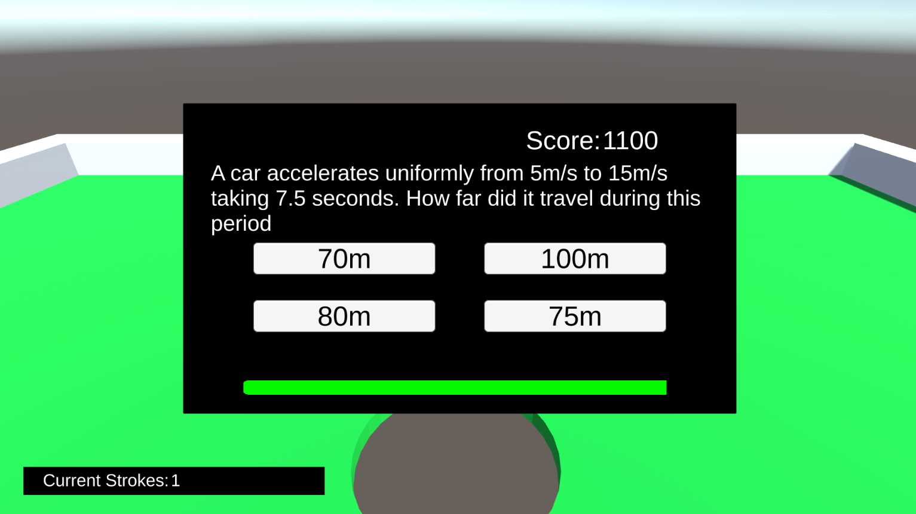

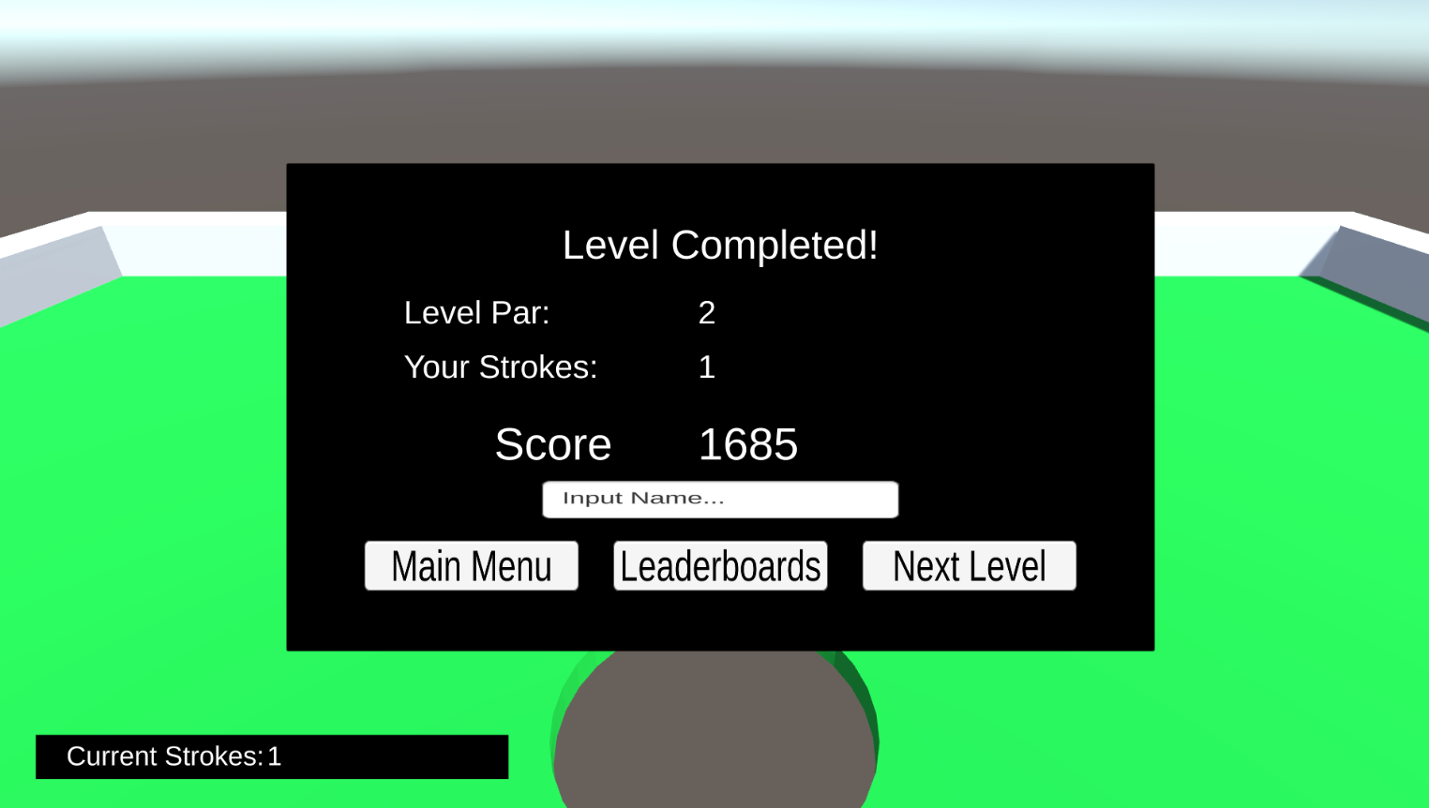

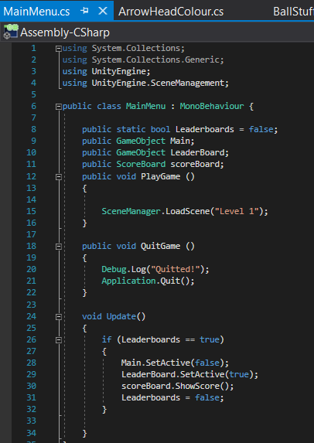

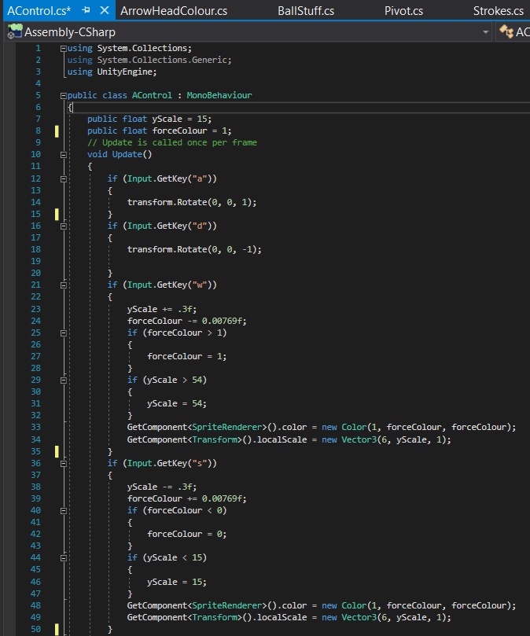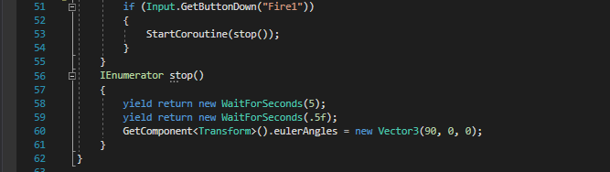

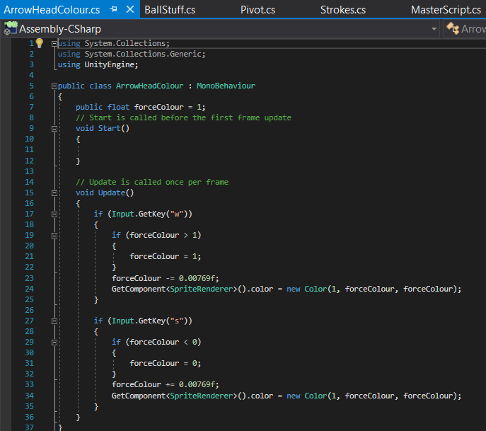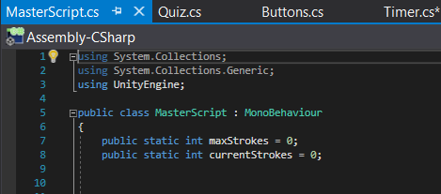

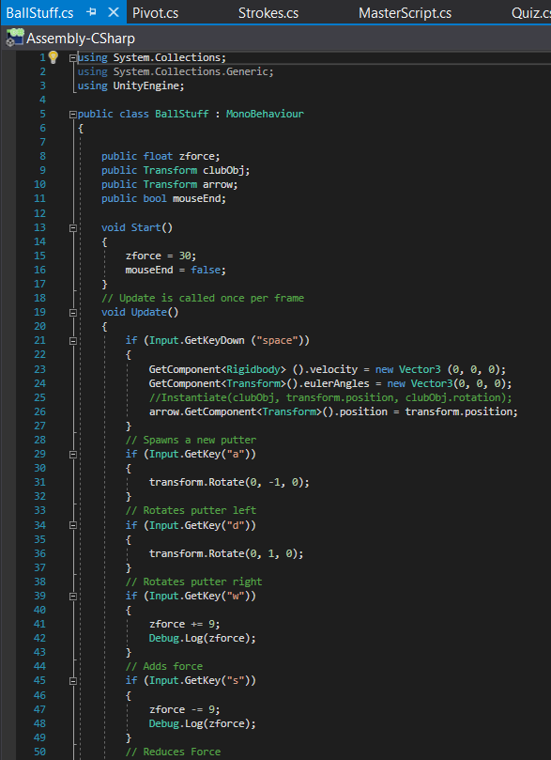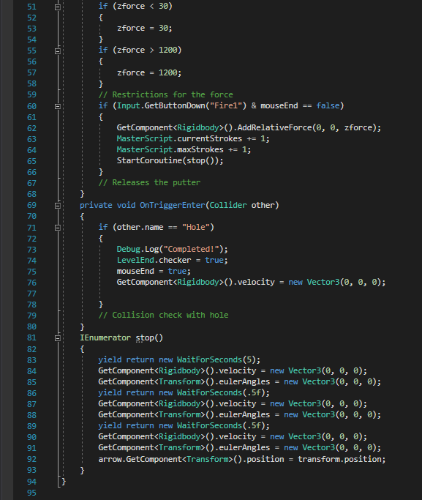

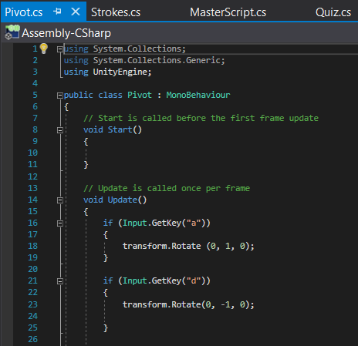

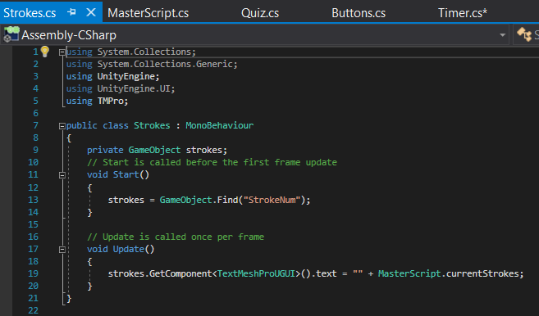

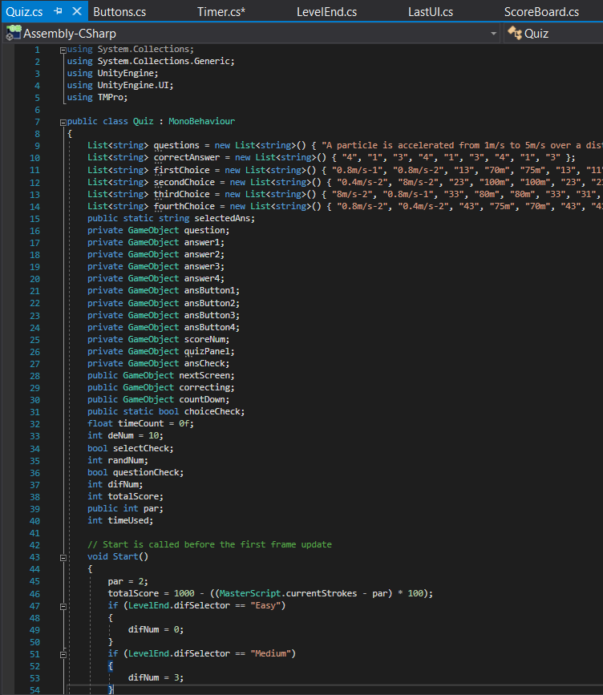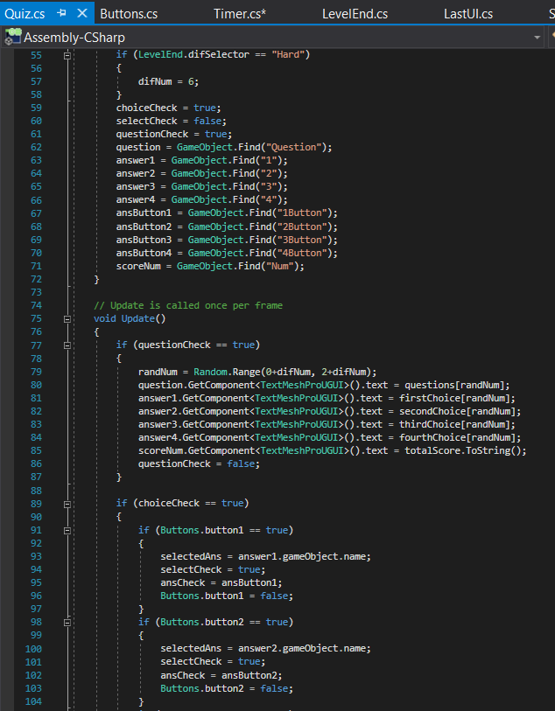

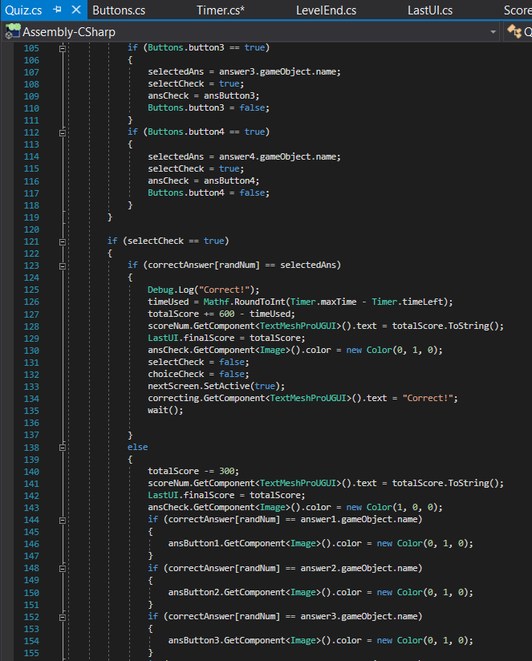

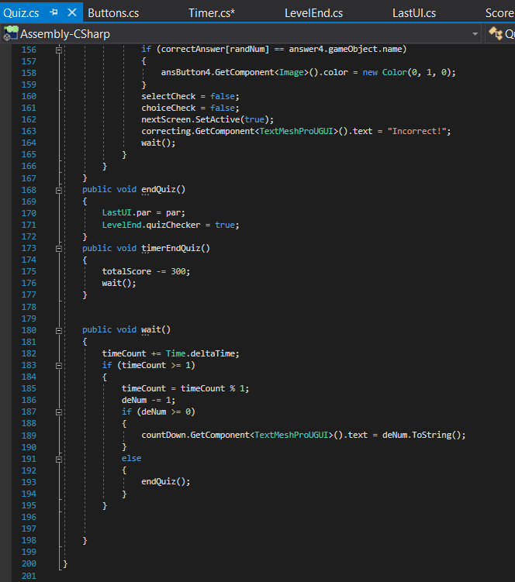

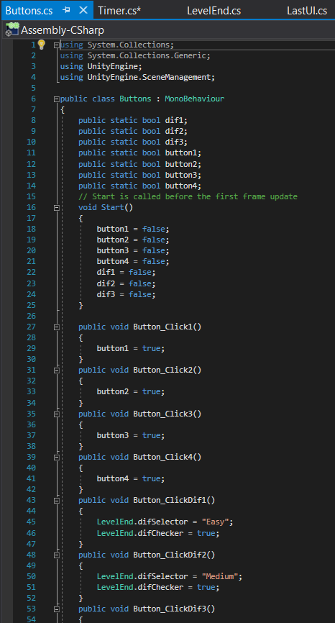

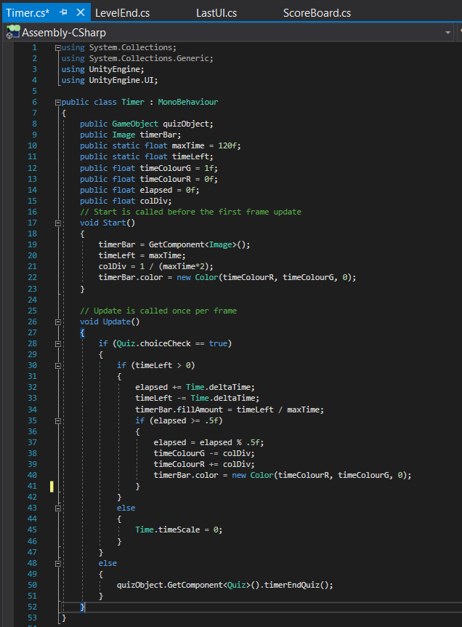

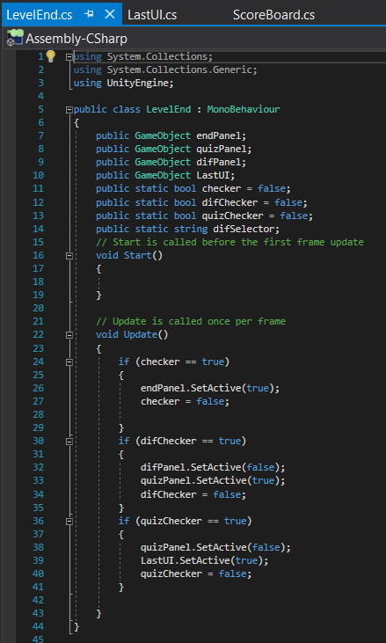

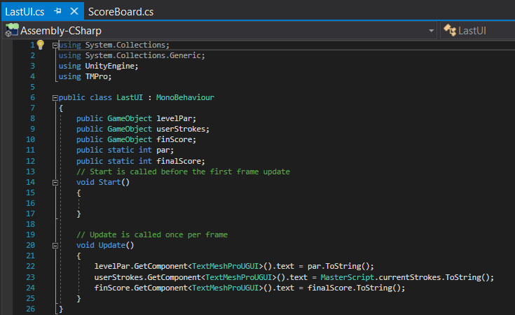

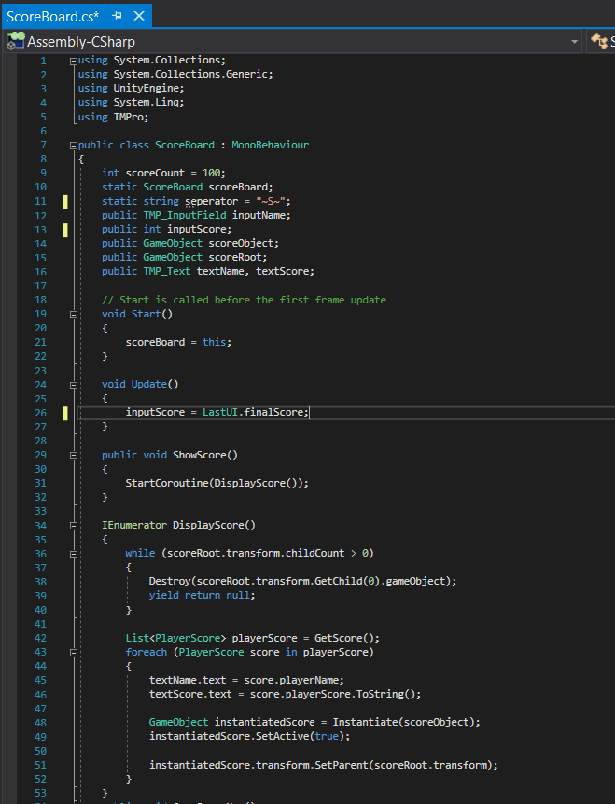

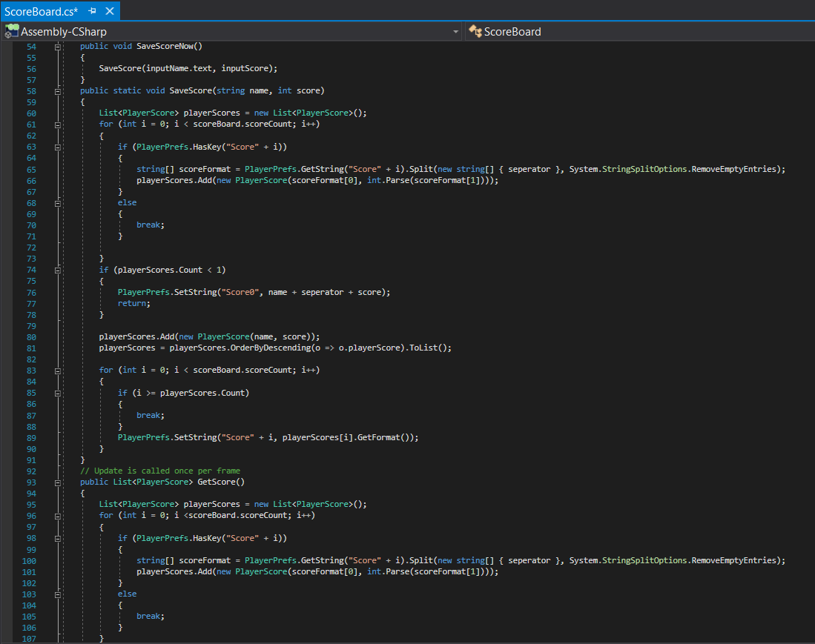

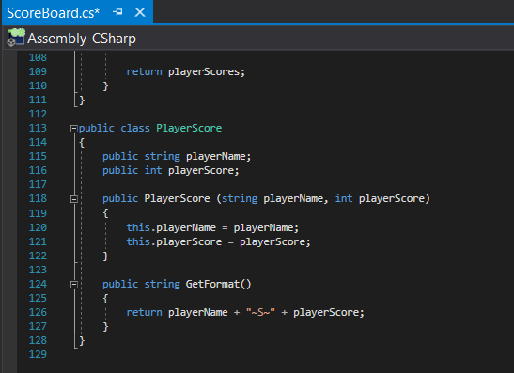

## Final Product UI’s

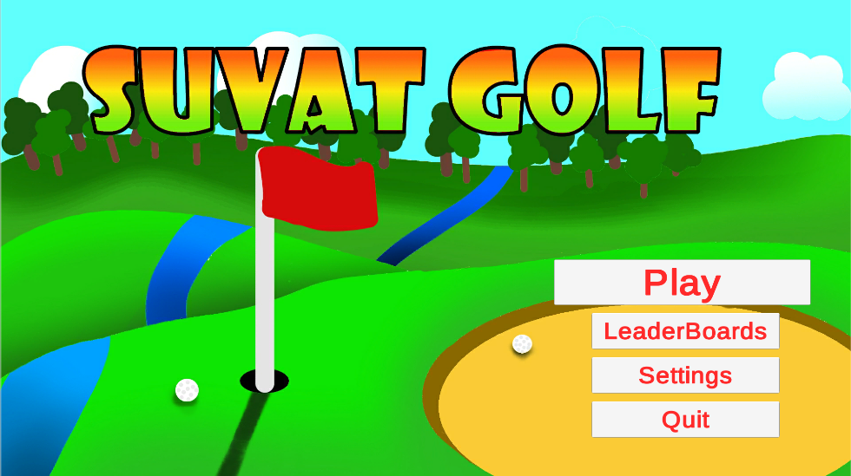

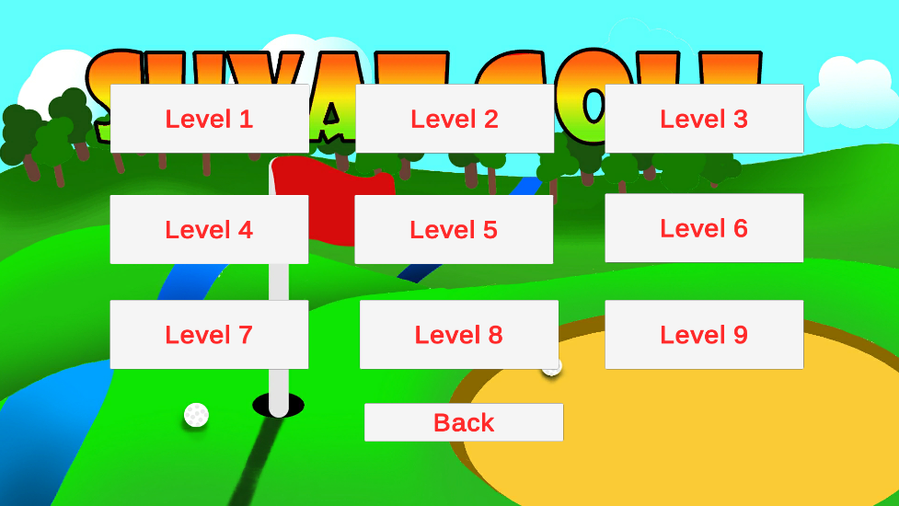

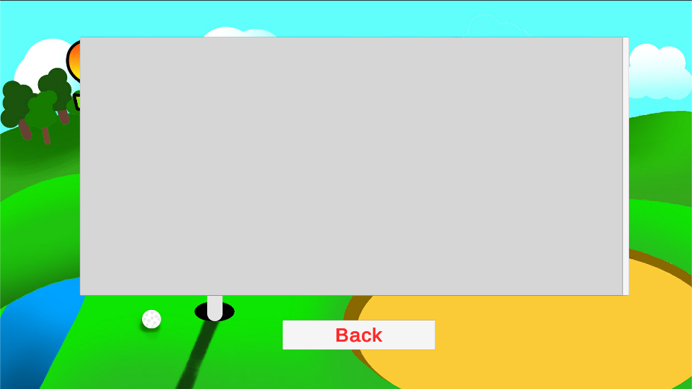

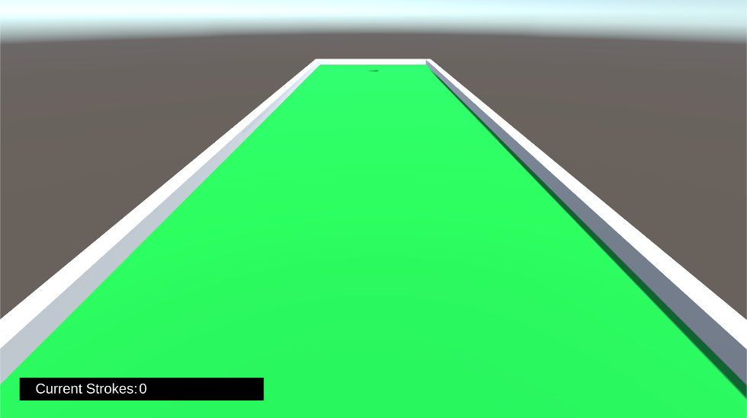

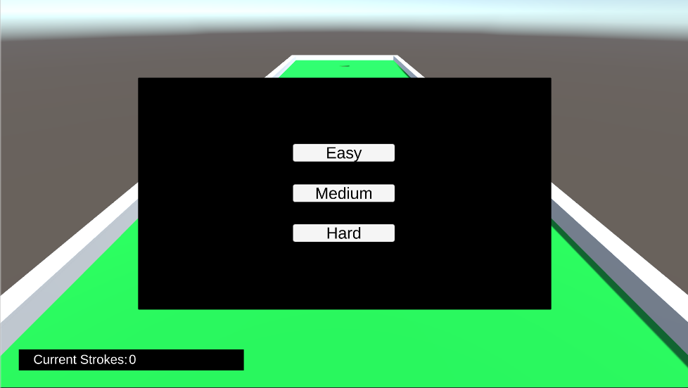

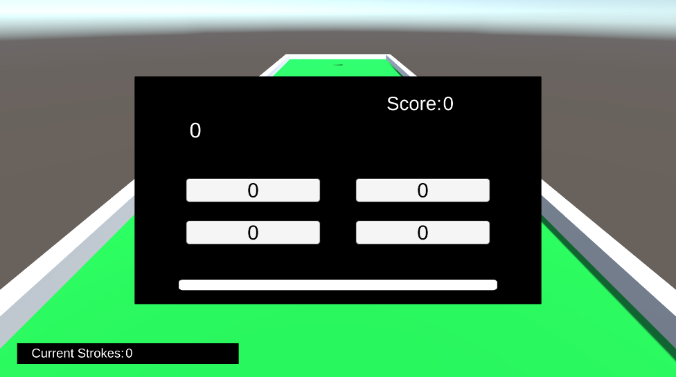

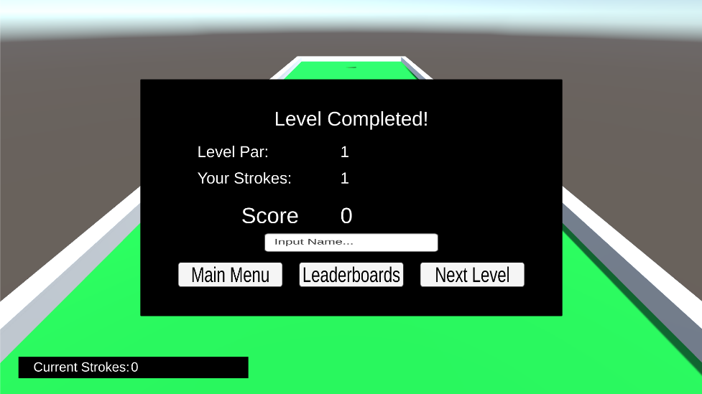

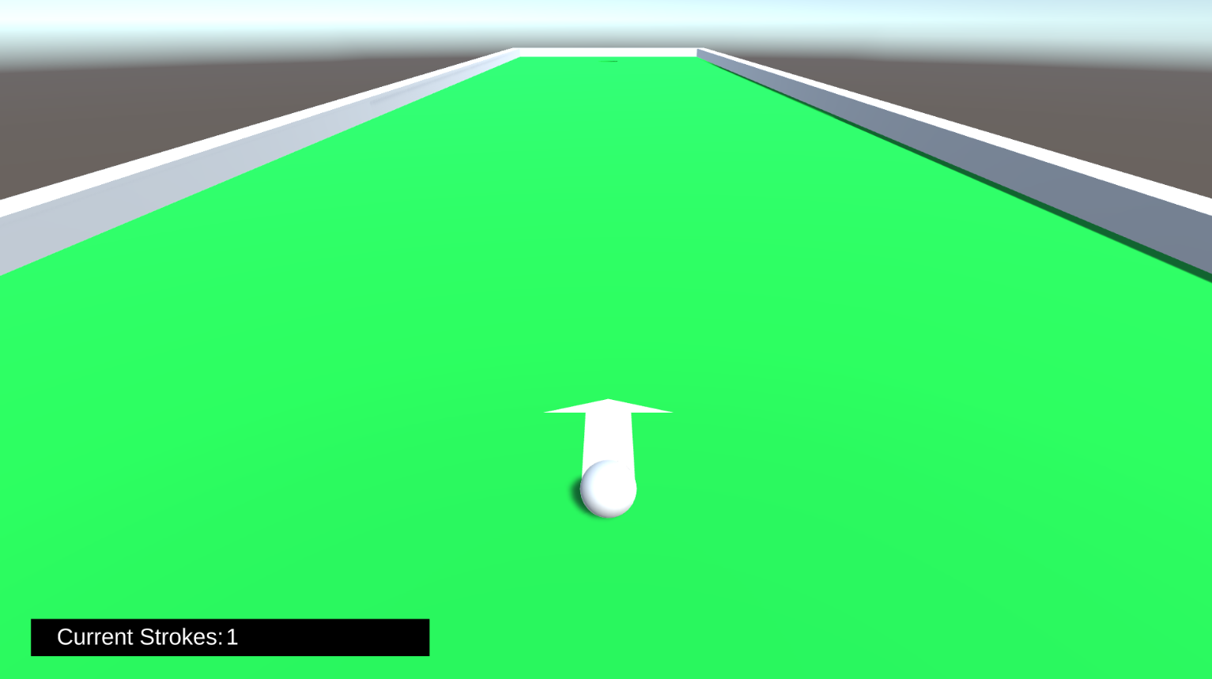

## Final Product Code

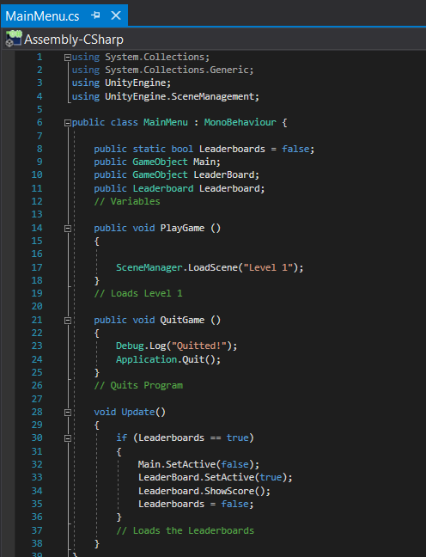

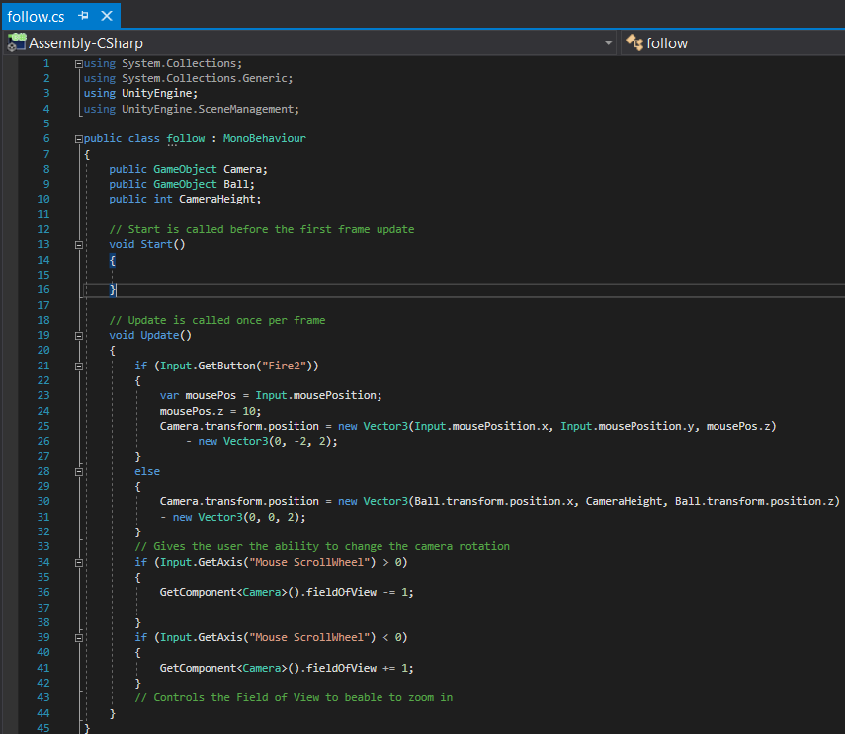

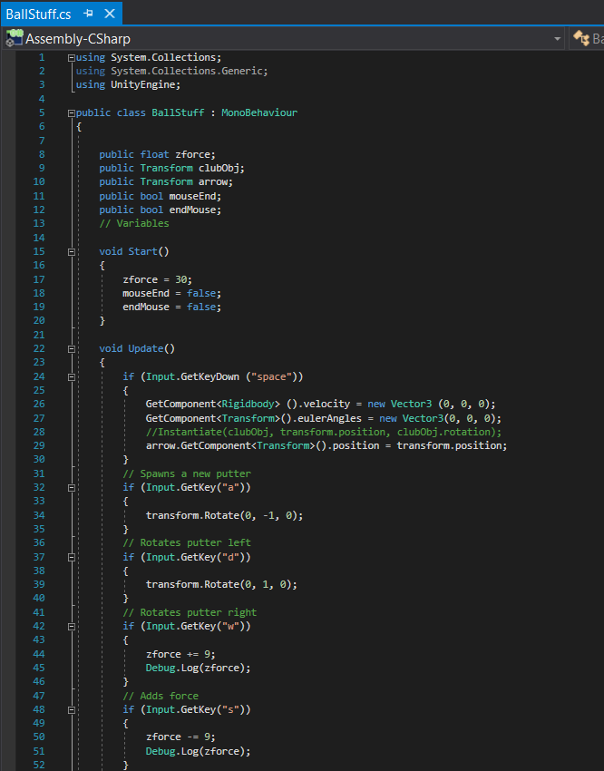

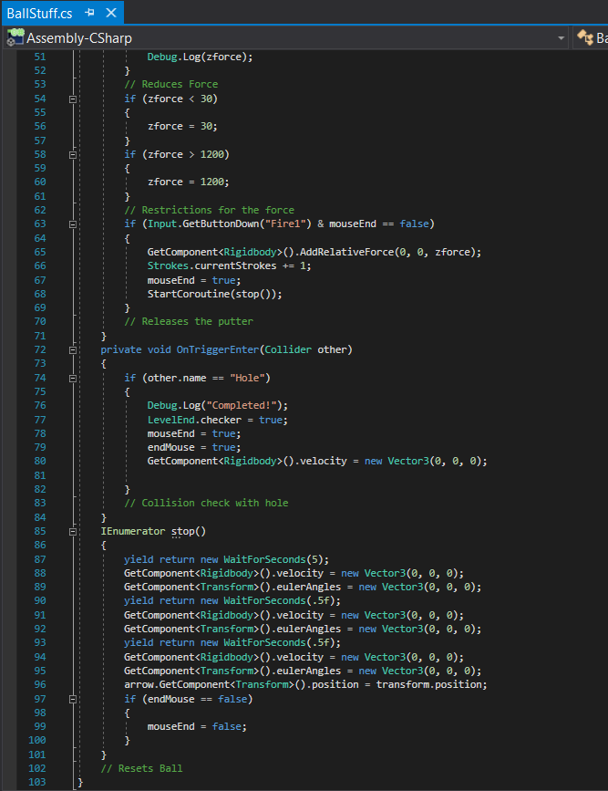

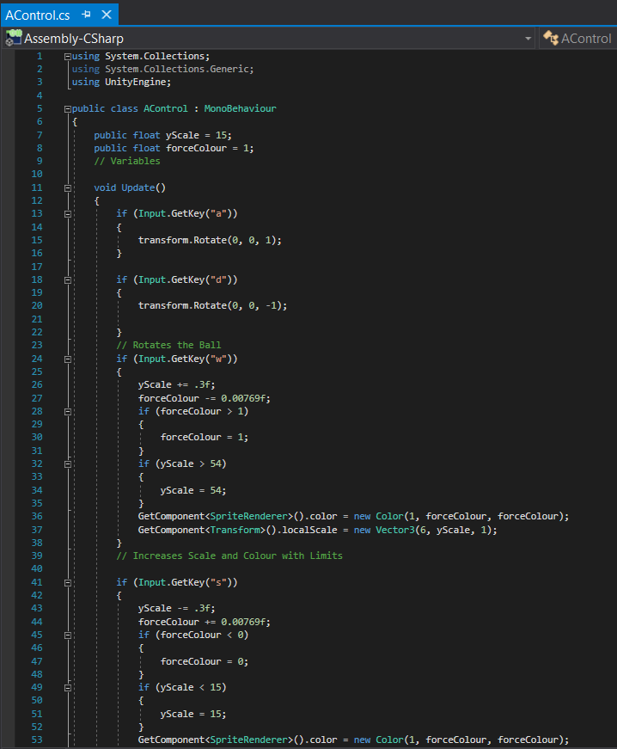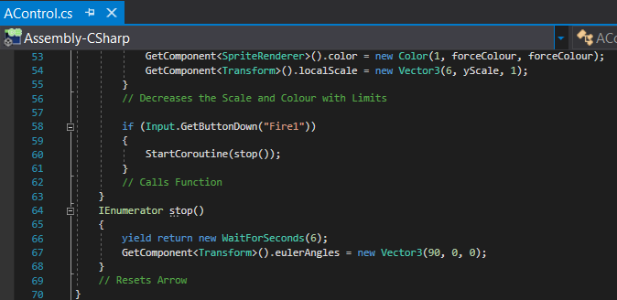

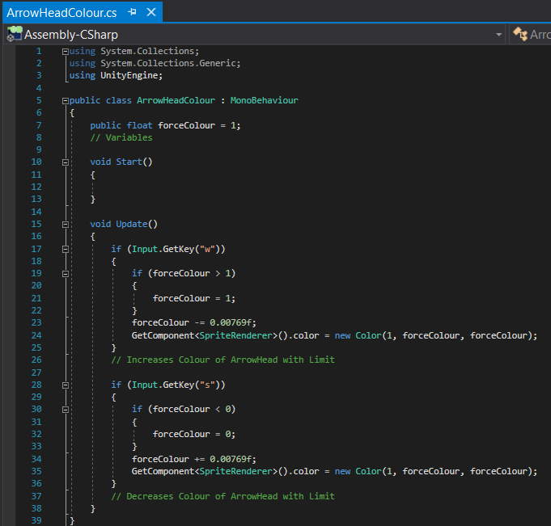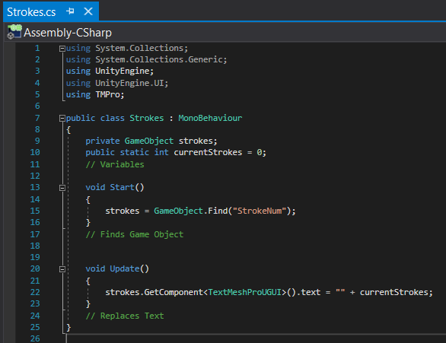

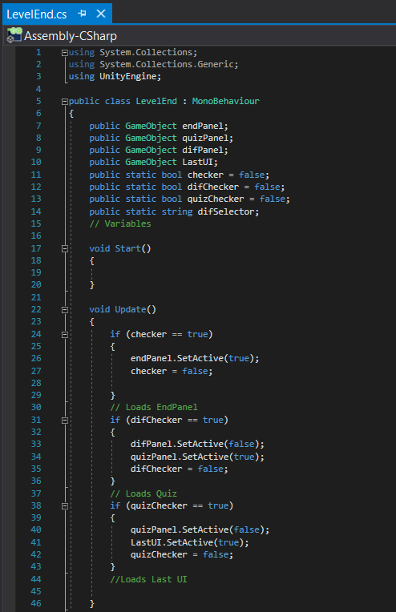

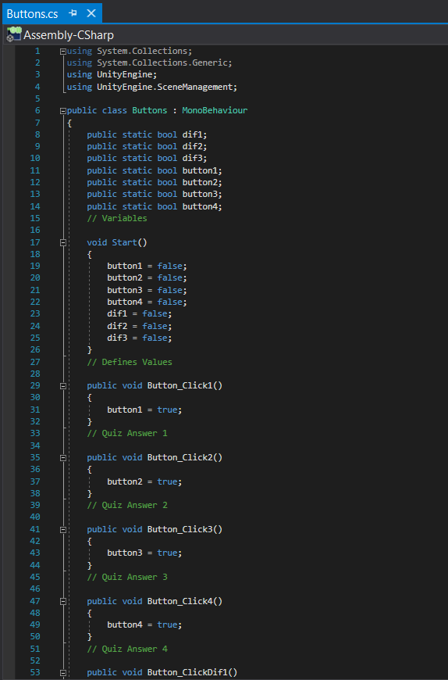

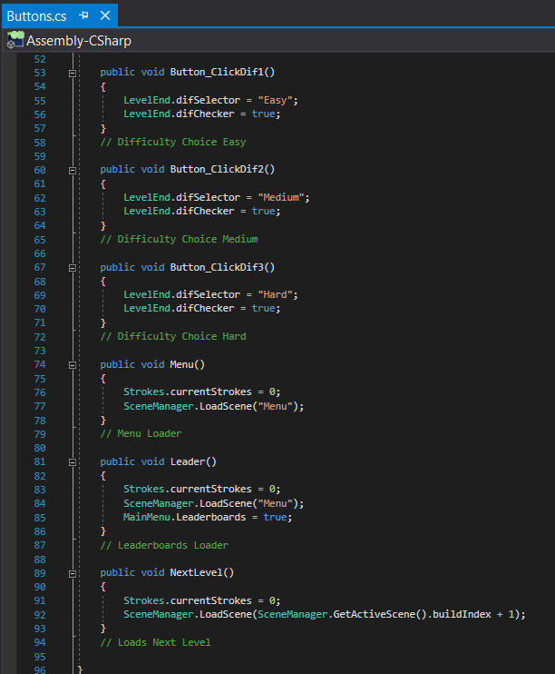

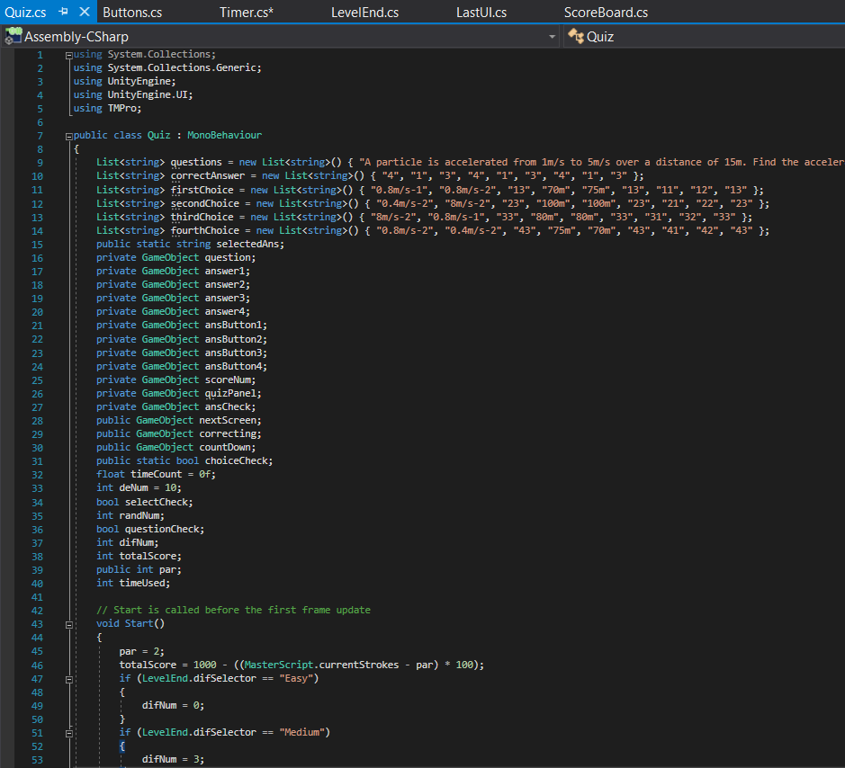

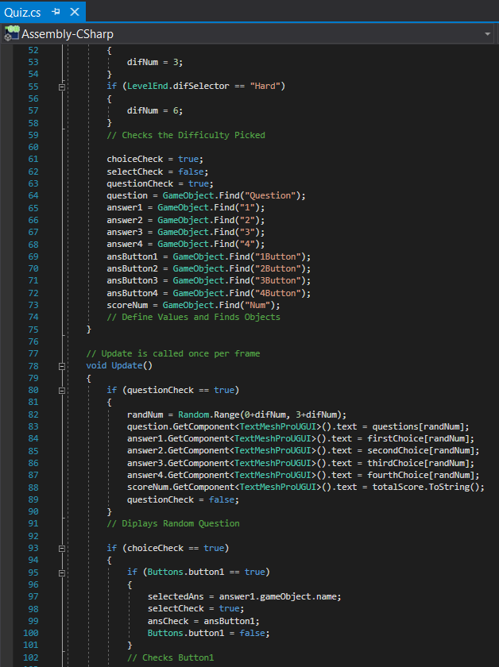

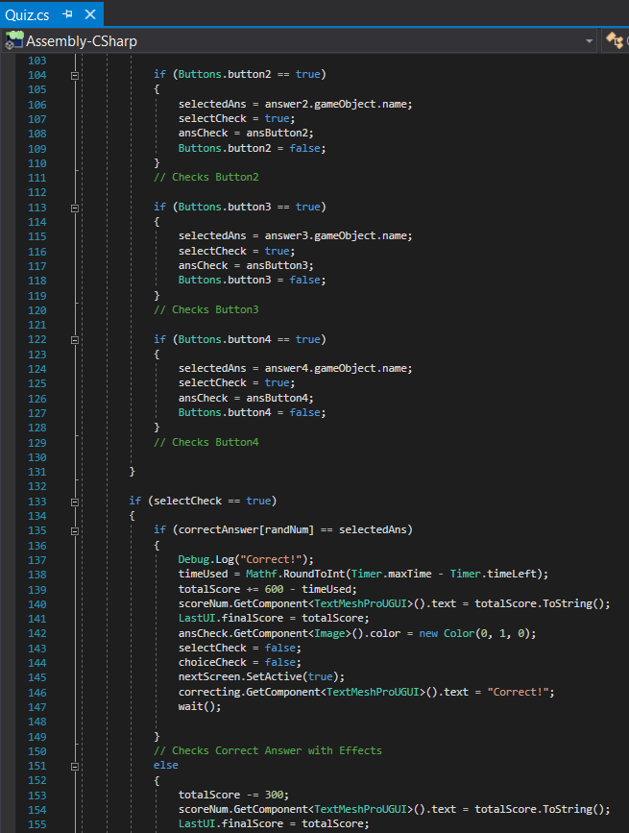

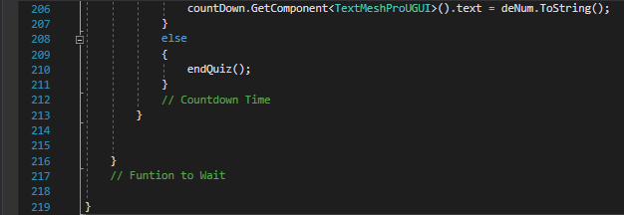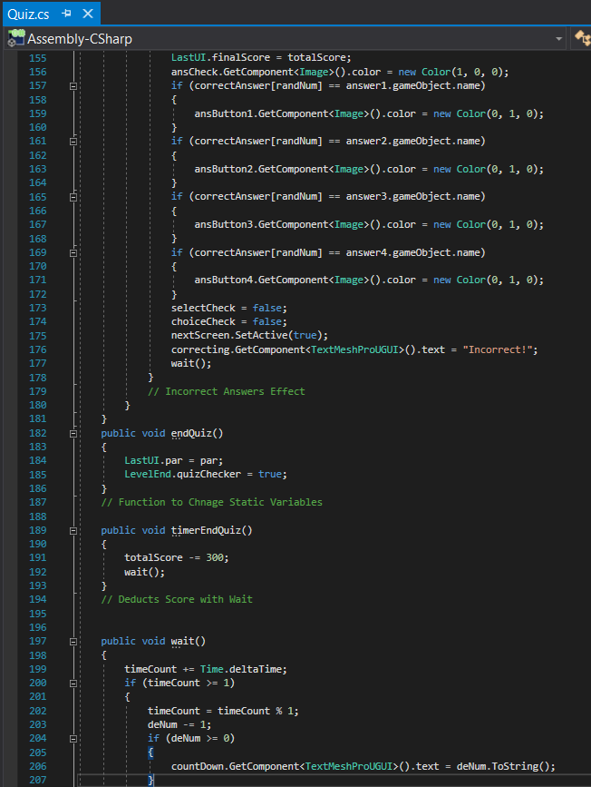

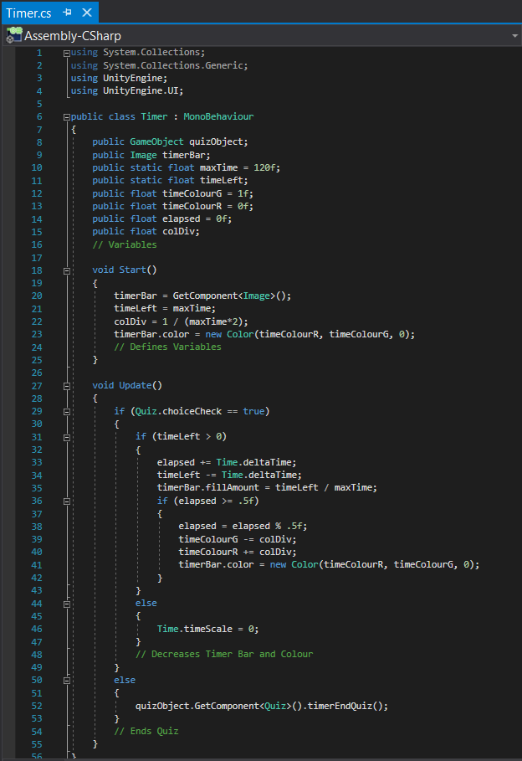

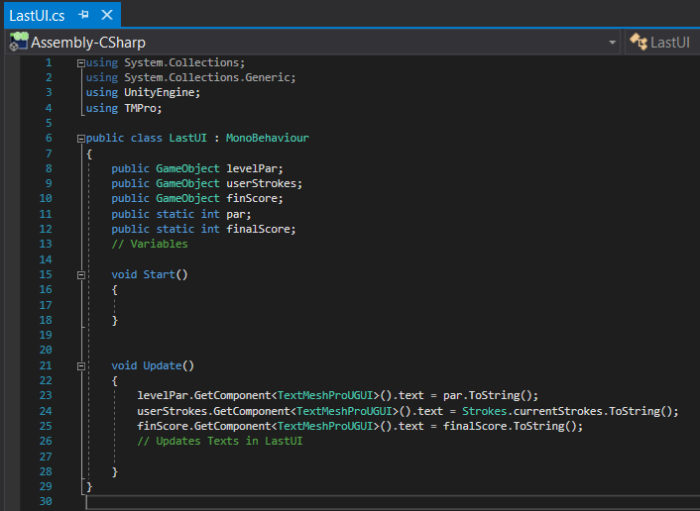

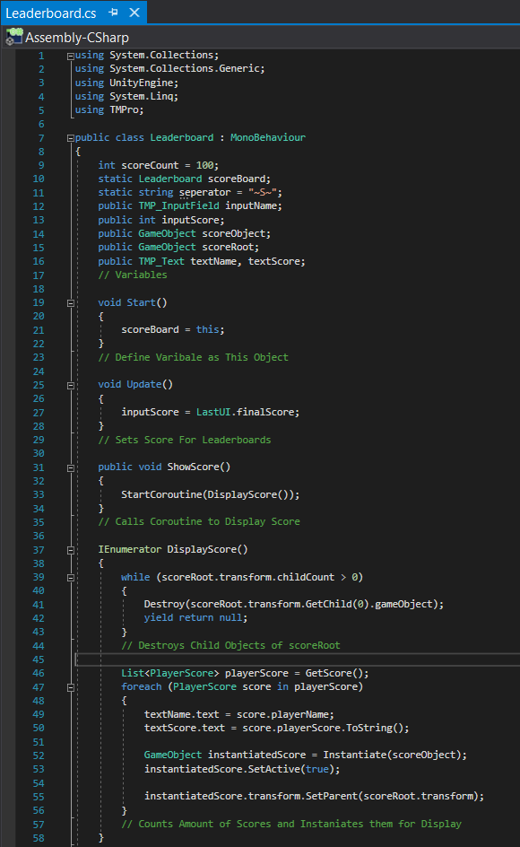

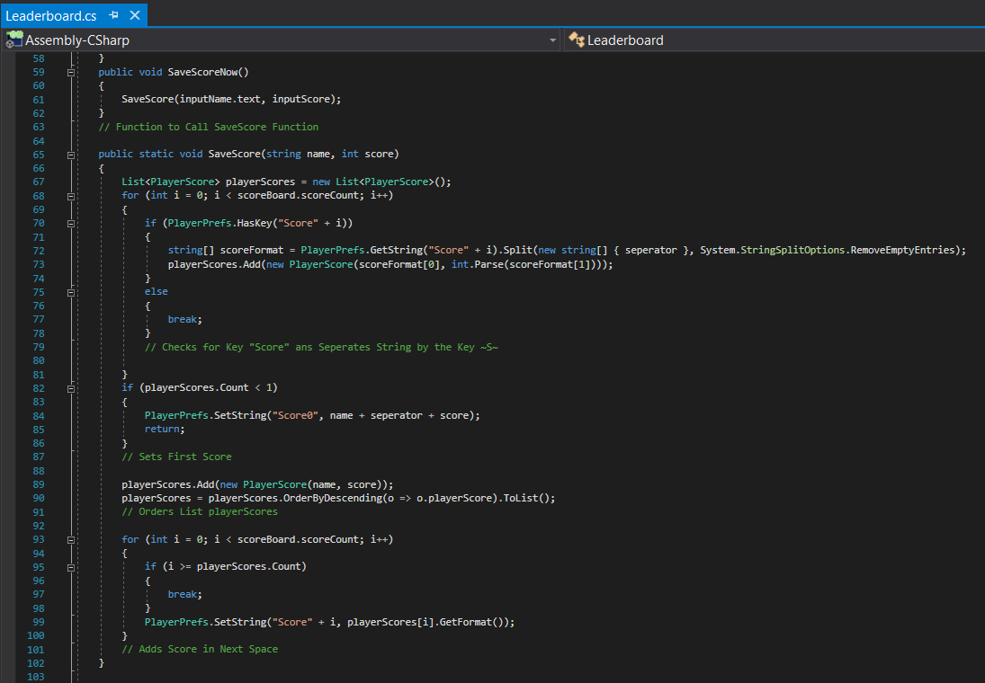

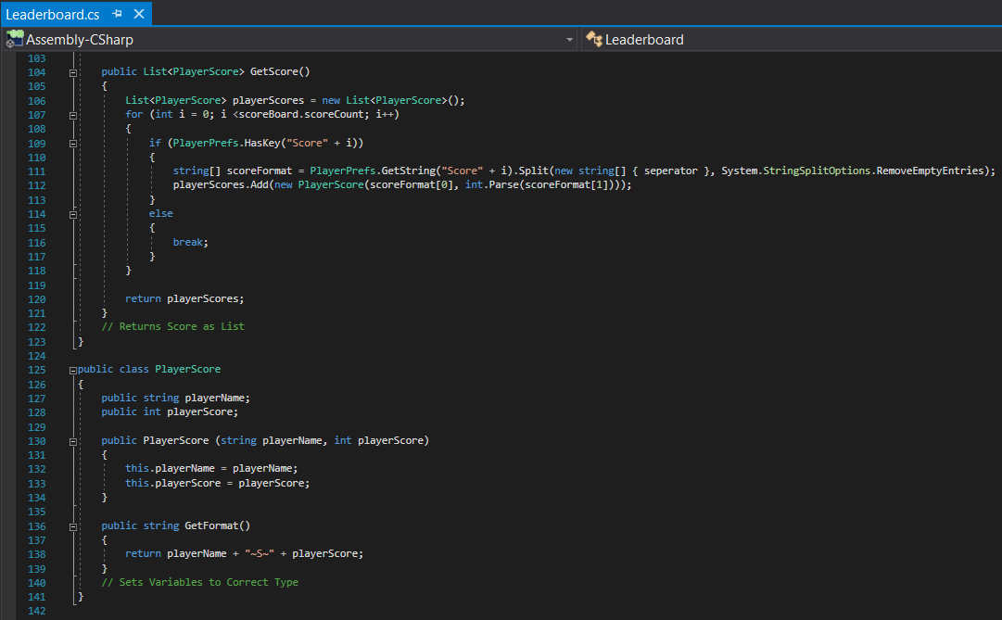

## Testing

Through various ways of testing, I will have different users look through my current work to find any improvements or bugs that would need to be changed. This will help my development of my program and help it progress.

### Alpha Testing

In my alpha testing, I will have experienced coders which will be my Computer Science class to looks through my current work and highlight any code that would need to be adjusted. They will also be able to look for any bugs that may cause a problem in the future for me and help me test the current program. The primary focus for my alpha testing is to outline any code to be improved and any suggestions that they may have to help me in my program for the future.

The aim of doing this alpha testing is to get an input from other experienced coders to help me improve my work and give me any suggestions for my work. These suggestions are important so that I can have more opinions on mainly the code so that this will ensure I won’t make the same mistakes that I may have made and any habits I would need to adjust for my program.

E.g. does the game load, does quit buttons work, do levels load, and do the movement buttons work.

The questions that I have asked were:

**Part 1**

* **1. Does the program load when the play button is pressed on the top of the Unity GUI?**
* **2. Are all the assets and colour visible once loaded?**
* **3. Is there any problems causing the program to slow down or lag?**
* **4. Other Information and Details on any problems:**

**Part 2**

* **1. Does the Quit button work in the Main Menu?**
* **2. Does the Play Button load the Levels Scene?**
* **3. Does the Leader Boards Button load the Leader Boards Scene?**
* **4. Does the Settings Button load the Settings Scene?**
* **4i. Does the Slider work for the volume?**
* **5. Do all the Back buttons work and if not list the ones that don’t?**
* **6. Other Information:**

**Part 3**

* **1. Does the scroll wheel zoom in and out the screen centred on the golf ball?**
* **2. Does the Left Click hit the ball in the direction the putter is facing?**
* **3. Does the keys “A” and “D” rotate the putter around the ball?**
* **4. Does the Right Click give free rotation of the camera?**
* **5. Does the Spacebar spawn a new putter ready to use?**
* **6. When getting the ball into the hole, does the console output “Complete!”?**
* **7. Other Information:**

#### Alpha Testing – Results

In my Alpha testing questionnaires, I have split the game into 3 sections so that they are easier to view and have the coders look through and give any feedback whilst testing my program.

In my first section of my questionnaire I had the coders test the main loading of the program and have them give me any suggestions and changes if there was any. For my question 1, everyone answered yes meaning that the program was compiled and loaded without causing any issues. For question 2 and 3 was also answered yes meaning there was no problems with the visuals of the menu or any delay with clicking and no lag.

In my second section, they have tested and experimented with the game user interface. Throughout there hasn’t been anything that caused a bug or issue. They have said by answering the questions that all the buttons work and has visual representation from when the mouse is over the button and when it’s being accessed. The only suggestion was to change the visuals of the button and some lay outing which I will implement into my program.

In my third section they have tested the actual game section of the program. Throughout this everything works with some minor bugs such as camera control that will need fixing.

### Beta Testing

In this section, I will have my focus group which are year 13s which have taken Physics or Mathematics or both. They will use my program which at this stage would be improved and mostly bug free. They will be using the program under normal conditions for a school which would be the computers running in F13 as they are the specifications for the school. This will assist me on how the program works with my focus group and how they would interact with it. They will also be able to have input on what should be changed and any suggestions. Overall this is done to demonstrate how it runs and to find any bugs that may have been missed in the alpha testing.

The questions I have asked are:

* **1. Does the program load correctly?**
* **2. Is it easy to navigate through the menu system? (Success Criteria 6)**
* **3. Would music be useful for this game? (Success Criteria 4)**
* **4. Was the resolution of 1920x1080 suitable for this game? (Success Criteria 9)**
* **5. Do you find the controls for the game suitable and easy to use? (Success Criteria 5)**
* **6. Are the golf mechanics easy to use?**
* **7. When answering the question in the quiz, is feedback correctly given?**
* **8. Does the leaderboards show your name when you have played through the game and quiz? (Success Criteria 3)**
* **9. If you’re colour blind, was it easy to use and understand the program? (Success Criteria 10)**
* **10. Are you confident with the use of Friction and SUVAT equations? (Success Criteria 7)**
* **11. Do you revise school work, if so, how many hours a week? (Success Criteria 2)**
* **12. Do you actively play Computer Games, if so, how many hours a week? (Success Criteria 2)**

#### Beta Testing Results

I have asked my focus group questions after they have tried the program for a while. The results that for each question was:

* First Question – 10, Yes and 0, No
* Second Question – 10, Yes and 0, No
* Third Question – 3, Yes and 5, Maybe and 2, No
* Fourth Question – 9, Yes and 1, No
* Fifth Question – 8, Yes and 2, No
* Sixth Question – 8, Yes and 2, No
* Seventh Question – 10, Yes and 0, No
* Eighth Question – 10, Yes and 0, No
* Ninth Question – 2, Yes and 0, No
* Tenth Question – 1 for needs improvement, 2 for alright, 5 for good and 2 for great
* Eleventh Question – 1 for less than 2, 2 for 2-5, 5 for 5-8, 1 for 8-10 and 1 for more than 10
* Twelfth Question – 4 for less than 12, 2 for 12-18, 3 for 18-24 and 1 for more than 30

The results here have shown that the program is fun and easy to use for almost everyone. There were not any bugs that was found as it ran smoothly, the main complaint was that a visual background was preferable and some did also ask for music or a quiet ambient noise.

This was the results of my focus group using the final product for the first time.

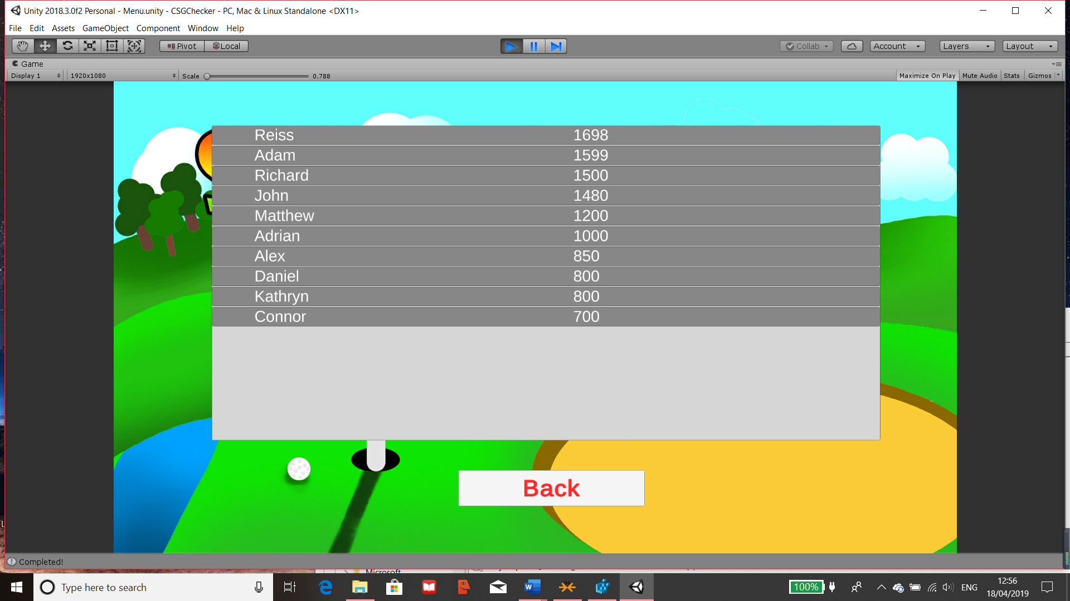

Figure 139 Focus Group First Use Leaderboards

This was the result after their final use and I did have to remove entries where the focus group was previously testing the kinds of data that was allowed.

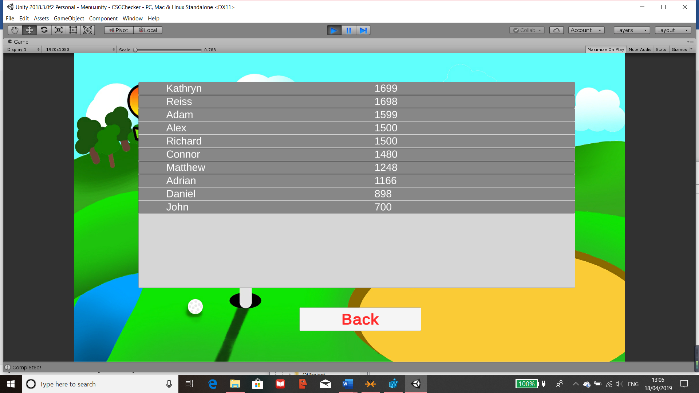

Figure 140 Focus Group Last Use Leaderboards

Overall, most of the users have increased their score after multiple uses of the product.

### Maths Questionnaire

I have asked the users the same maths questions as the ones at the start of the project so that I can compare their results to see if there have been any improvements. The questions I will be asking are:

**A particle is accelerated uniformly from rest, so that after 10 seconds it has achieved a speed of 15 m/s. Find its acceleration and the distance it has covered.**

Answer: 1.5m/s-2 and 75m

**A car accelerates uniformly from rest and after 12 seconds has covered 40m. What are its acceleration and its final velocity?**

Answer: 0.55m/s-2 and 6.67m/s-1

**A car accelerates from 10 m/s-1 to 30 m/s-1 in 5 seconds. What is its acceleration?**

Answer: 4m/s-2

**An aircraft was travelling at a speed of 60 m/s-1 when it landed on a runway. It took 2 minutes to stop. Calculate the acceleration of the aircraft when coming to a stop.**

Answer: -0.5m/s-2

**A train is uniformly slowed from 35m/s-1 to 21m/s-1 over a distance of 350m. Calculate the deceleration and the time taken to come to rest from the 35m/s.**

Answer: -1.12m/s-2 and 31.25 seconds

**A particle moves with uniform acceleration 0.5m/s2 in a horizontal line ABC. The speed of the particle at C is 80m/s and the times taken from A to B and from B to C are 40 and 30 s respectively. Calculate   
(a) Velocity at A**

Answer: 45m/s-1

**(b) Displacement BC**

Answer: 2175m

#### Maths Results

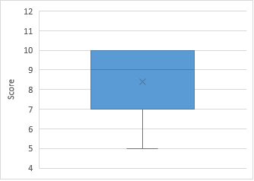The scores that I have received after they have used the program for a while are 10, 10, 10, 10, 9, 9, 7, 7, 7 and 5. The average is 8.4 which is 1.1 higher than the previous test which has shown an improvement of 11%. This is double the success criteria I have set which means that Success Criteria 1 was extremely successful and the program has helped the users.

Figure 141 Maths Result after Final Product

### Final Test Table

The images for the tests are stored in the image table on the next table.

Normal Test Data **F** = Functionality **L** = Limitations

Extreme Test Data **SC** = Success Criteria

Erroneous Test Data **V** = Validation

**UF** = Usability Feature

|  |  |  |  |  |  |
| --- | --- | --- | --- | --- | --- |
| Test No. | Testing | Test Data | Expected result | Actual result | Comment |
| 1  F | Testing that the program can be loaded up | Double Left Click – clicking on the unity file | Program should load up in one window ready to be compiled and ran | As expected | Program loads successfully |
| 2  F | Testing the program can start up and be ready to use | Left Click - Clicking of the play button on the top of the screen | Game should load up ready for use | As expected | Temporary compiles and load the program for use |
| 3  F | Testing window can be closed by using red x | Left Click - Clicking on the red x | Closes the game | As expected | Program successful closes |
| 4  V | Testing window can be closed by using red x | Holding left click on the red x | Should only close game when mouse is released and still over the x button | As expected | Program successful closes |
| 5  F | Testing on all of the menu | A-Z keys  Numerical Keys (0-9)  Special Keys (@|\#)  Mouse movement + left, right click  Test data I will use is: “Azu98*:” left and right click | Nothing should occur when these buttons are pressed on any of the menu at the start of the game. However left clicks on a button should cause it to execute and work | As expected | With random and all test data tried, nothing happens |
| 6  V | Testing on all of the menu | Holding left click on button | Button should only work once left click is released and mouse is still on the button | As expected | Software only closes when left clicked and mouse is still over the button |
| 7  F | Testing the Quit button on the menu scene | Left Click – Movement of mouse and clicking on the quit button to quit the game | The program should close once this is pressed | Doesn’t close | It doesn’t close because the program isn’t fully compiled as it’s not fully released. However does output “Quitted” |
| 8  F | Testing if Play button on menu scene loads levels | Left Click – Movement of mouse and clicking on the Play button to load levels screen | Should load up the levels screen for the user to pick a level to play from | As expected | Successfully loads up the levels screen |
| 9  F | Testing if Leaderboards button on menu loads the Leaderboards | Left Click – Movement of mouse and clicking on the Leaderboard button for display | Should load the leaderboards into view for the user | As expected | Successfully loads up the leaderboards |
| 10  F | Testing if all back buttons work in the different parts of menu | Left Click – Movement of mouse and clicking on the different back buttons | Wherever this is pressed, should bring the user back to the main menu | As expected | Successfully loads up previous screen which is always the main menu |
| 11  F | Testing of loading first level through menu | Left Click – Movement of mouse and clicking on first level to load it | Menu should disappear then the playable level is loaded | As expected | Successfully loads up the first level |
| 12  F | Testing putter controls | “A”,”D” keys – Pressing or holding these should move the angle of which to fire  “W”, “S” keys – Pressing or holding the keys should increase or decrease the power of the force  Left Click – Fires the ball with the given strength and angle | Using the keys, the user should be able to control the direction of the ball including the amount of strength they are going to use.  The ball should fire once Left Click is pressed and the ball should move according to the strength and direction the user has chosen | As expected | Controls can be used to change the power or angle of the ball |
| 13  V | Testing putter controls | A-Z keys  Numerical Keys (0-9)  Special Keys (@|\#)  Test data I will use is: “Hjkl.,0:” left and right click | These should not have any effects on the ball and should not execute anything unless the keys that control the balls are pressed | As expected | Other inputs will not affect the controls of the putter |
| 14  V | Testing putter controls | Multiple Clicks or buttons such as holding down left click or spamming “A” | Holding down left click will only execute once as if it was a click and the spam of any button should all register unless the ball is in motion | As expected | Input for mouse only detects once as expected and spamming the controls all register which is wanted |
| 15  F | Testing collisions with the ball | When the ball is in motion, the walls and floors should act as collisions | The ball should treat the walls and floors as physical objects and will not pass through them | As expected | Successful physics of collisions |
| 16  F | Testing friction and bounciness in level | When the ball is in motion on the ground and collides with a wall | The ball should slow down into a stop and when it collides with a wall, it should cause it to bounce back with less force | As expected | Successful friction and rebounds on floors and walls |
| 17  F | Testing of the hole in the level | When the ball falls into the hole for the level | Once the user gets the ball in, the level should complete and the next panel should appear | As expected | Next panel successfully appears over the current level |
| 18  F | Testing after a level is complete | A-Z keys  Numerical Keys (0-9)  Special Keys (@|\#)  Test data I will use is: “Gh7*&.” left and right click | Once the level is complete, nothing should be executed or ran when these buttons are pressed | As expected | Other keys don’t work which is a success as the original controls of the ball stops as well |
| 19  F | Testing of difficulty choice | Left Click – Mouse movement onto the choice of difficulty | Should select a difficulty for the quiz which should appear after a choice was selected | As expected | Difficult successfully recorded and moves on to the quiz |
| 20  F | Testing of Quiz | Left Click – Mouse movement onto the choice of answer | When a choice is made, the timer should stop and if the answer was right, it’ll show correct, if wrong then it’ll show your choice and whichever was the correct answer. Then a 10 second wait before the end screen is displayed | As expected | Quiz choice displays whether it was correct or not |
| 21  F | Testing of end screen buttons | Left Click – Mouse movement onto the choice of buttons | Depending on which button, it should take the user to the desirable location. Also when a button is pressed, the score is saved along with their name they entered | As expected | Buttons successfully works |
| 22  F | Testing of Name input for leaderboard | Valid Value – 10 characters length, any characters  Test data I will use is:  “TestData1” | It should accept any character and if it’s longer, it’ll be truncated to 10. This will then be stored on the leaderboard | As expected | Any characters works but truncates to 10 characters |
| 23  V | Testing of Name input for leaderboard | Entering no character and 16 characters  Test data I will use is:  “TestData@@ //**1287!!iop” | Shouldn’t save when no characters are entered and should truncate name if longer than 10 characters | Minor Bug | When no characters are entered, it still saves the score but doesn’t cause any problems |
| 24  U | Testing controls and visuals are still providing information for colour blindness | Going through the game as normal | Even if some colours are less visible, the UI should provide enough information for the user to understand | 24  Usability | Testing controls and visuals are still providing information for colour blindness |
| 25  F | Testing of the display and update of the leaderboards | Loading the leaderboards in any way to view it like loading it from the menu and after level finish | When it loads, all stored entries should display in descending order for the view of the user’s | As expected | Leaderboard loads and displays correctly |
| 26  SC 1 | Asking Maths questions after my focus group has used the program multiple times | Maths Questionnaire | At least 50% of user’s math scores achieve a 10% increase | Met  All users had an average of 14% increase | Testing of Criteria on Page 24 |
| 27  SC 2 | How many hours do you revise school work? | Beta Testing Questionnaire | Revision time of the user’s at least 50% increase | Met  More than 50% increase | Testing of Criteria on Page 24 |
| 28  SC 3 | Does the Leaderboards display name that was inputted | Beta Testing Questionnaire | Leaderboards scores with 20% increase after multiple use | Partially Met  Over 20% increase but data could be skewed | Testing of Criteria on Page 24 |
| 29  SC 4 | Would music be beneficial? | Beta Testing Questionnaire | At least 75% of the focus group to enjoy the music | Not Met | Testing of Criteria on Page 24 |
| 30  SC 5 | Are the controls suitable and easy to use? | Beta Testing Questionnaire | At least 75% of the focus group are favourable of the controls | Met  80% | Testing of Criteria on Page 24 |
| 31  SC 6 & U | Is it easy to navigate through the menu? | Beta Testing Questionnaire | At least 75% of the focus group find the layout easy to navigate through | Met  100% | Testing of Criteria on Page 24 |
| 32  SC 7 | Are you confident with the use of SUVAT? | Beta Testing Questionnaire | Confidence in SUVAT of the focus group to increase at least 50% | Met  Almost all improved | Testing of Criteria on Page 24 |
| 33  Sc 8 | Are the questions suitable? | Maths Questionnaire | Questions used are at least 70% suitable | Partially Met | Testing of Criteria on Page 24 |
| 34  SC 9 | Was 1920x1080 resolution suitable? | Beta Testing Questionnaire | At least 80% of the focus group agree with the resolution of 1920x1080 | Met  90% | Testing of Criteria on Page 24 |
| 35  SC 10 & U | If you’re colour-blind, was it easy to use the program | Beta Testing Questionnaire | At least 90% of colour-blind users find the program to be easy to use | Met  100% | Testing of Criteria on Page 24 |
| 36  L | Testing of performance of the program | Using the program | Should all run smoothly | As expected | Program runs well. Testing of limitation on pages 14 and 15 |

#### Test Table Images

|  |  |
| --- | --- |
| Test No. |  |
| 1 |  |
| 2 |  |
| 3 | Game Closes |
| 4 | Game Closes |
| 5 |  |
| 6 |  |
| 7 | Game Closes |
| 8 |  |
| 9 |  |
| 10 |  |
| 11 |  |
| 12 |  |
| 13 |  |
| 14 |  |
| 15 |  |
| 16 |  |
| 17 |  |
| 18 |  |
| 19 |  |
| 20 |  |
| 21 |  |
| 21a |  |
| 22 |  |
| 23 |  |
| 23a |  |
| 24 |  |
| 26-36 | No Images, refer to questionnaires mentioned |

# Evaluation

## Success of the Criteria

Through the beta testing, leaderboards results and the maths questionnaires, I have collected lots of data and opinions which I can compare to my success criteria (on page 23) which are summarised as:

* At least 50% of user’s math scores achieve a 10% increase
* Revision time of the user’s at least 50% increase
* Leaderboards scores with 20% increase after multiple use
* At least 75% of the focus group to enjoy the music
* At least 75% of the focus group are favourable of the controls
* At least 75% of the focus group find the layout easy to navigate through
* Confidence in SUVAT of the focus group to increase at least 50%
* Questions used are at least 70% suitable
* At least 80% of the focus group agree with the resolution of 1920x1080
* At least 90% of colour-blind users find the program to be easy to use

Referring to the first maths questionnaire (page 13) before the final product was made, the focus group achieved an average score of 7.3. For success criteria 1 to be successful, half of the focus group would have to achieve a score of at least 8.1 or higher. After they have used my product for a few times, they then completed another maths questionnaire (page 143) where they scored an average of 8.4. This means that success criteria 1 was fully met.

Revision times was retrieved from the first focus group questionnaire (question 4, pages 8-11) and the beta testing (question 11, page 143). Success criteria 2 was also fully met since in the first focus group questionnaire, 8 people stated that they have spent 5 hours or less revising in a week and in the beta testing, this has decreased to 3 people meaning that there is more than 50% increase of revision time with my focus group.

Success criteria 3 was partially met as shown by the beta testing (question 8, pages 143 and 144) since 9/10 of the focus group managed to improve their scores by at least 20%. However, a couple of the users received the same question since they are given a random question which meant that they may have known what the answer was which would’ve skewed the data to one side. Therefore, success criteria 3 was partially met. This can be solved by having a plethora of questions so that it’ll be less likely for the users to receive the same question which may have skewed the data.

Success criteria 4 was not met since I didn’t have enough time to finish completing all the music I would’ve liked for the game. Also, I could not find music that was suitable for the type of game I have created. This was also mentioned on question 4 in beta testing (page 143). This can be solved by allocating more time to creating the music as I didn’t expect it to be as difficult as it was.

80% of my focus group think that the controls for the game are suitable and favourable which meant that success criteria 5 was fully met and a success. This was shown on question 5 of the beta testing (page 143) after they have used the product. This was also tested in tests 12-14 of the test table on pages 146-157.

100% of my focus group agree with the layout of the buttons and game which made it easy to navigate to the place they wanted to go. Through the alpha testing (pages 141 and 142) and beta testing (page 143), no bugs were found regarding the layout of the game. Additionally, this was tested on test number 1-11, test 20 and 21 on the test table (pages 146-157). Therefore, success criteria 6 was fully met.

On question 1 of the focus group questionnaire (pages 8-11) 27% of my focus group thought that their knowledge of SUVAT was “alright”, 18% “requires improvement”, 36% thought their knowledge was “good” and 19% thought “great”. Afterwards only 10% said they “require improvement”, 20% said “alright”, 50% said “good” and 20% said “great” shown by question 10 in the beta testing (page 143). This shows that success criteria 7 was fully met since almost all of the focus group has increased their confidence in SUVAT.

Success criteria 8 was only partially met since my client believed that the questions I have used was suitable for the 3 types of difficulty I have created shown pages 79-83 however he would like to have the questions more suited toward the weaker areas of the majority of the group. This can be solved by having my client, who is a maths teacher, provide questions and answers that they believe would be best for the students which I would be able to add to the bank of question for future use of this product.

Success criteria 9 was fully met shown by question 4 on the beta test (page 143) as 90% of my focus group agreed with the resolution of 1920x1080 which was pre decided on the preference of my focus group through the first questionnaire which is on pages 8-11.

Finally, success criteria 10 was about my usability feature for the colour blind and this was fully met as 100% agreed with this shown on question 9 of beta testing (page 143) and on test 24 of the test table (146-157). However, even though this was fully met, I only had 2 users who were colour blind so to have better data for this, in future I will have to find more users to test this feature.

## Success of Usability features

The usability features I have focused on were colour blindness, clear and simple English and epilepsy which are shown on pages 47 and 48. Any feature included will help the accessibility of the game and make it available to a larger audience.

The first feature I included was the colour blindness mode which would make the game more accessible to users with colour blindness. To implement this, I made sure that throughout the project, text will be included to almost everything that was important meaning that the game could’ve been played in black and white. This meant that all information within the game would be visible to the colour blind. From the testing done on pages 146-157 and throughout development such as on pages 90-92, it has made the product useable to those who are colour blind. Without these features implemented, these users would’ve had a disadvantage in the use of the product and may render it useless if they do not receive the information required. Therefore, this was an important feature to have been implemented to help the colour-blind use this product meaning that it will be accessible to a wider audience meaning that this has been a major success.

The next usability feature was to make sure that all the English I have used was concise and simplistic so that everyone who uses this product will understand what the information means. This was relatively simple to implement as my product is related to maths and physics meaning that there isn’t much English to worry about. However, where there are English like instructions, buttons (pages 52 and 82) and questions for the quiz (page 89) I made sure that this would be simplistic so it’s easy to read. In conclusion this feature was implemented successfully which means that the users who will use the product can easily progress through the game without being confused or distracted by errors in text or unnecessary words.

Another feature which I have researched on page 47 was epilepsy. This was only a partial success because the overall product didn’t have any flashing images. When there are changes in scene or panels, a pop up appears or the entire scene switches which only takes one frame for it to change. Therefore, there weren’t any changes I could make or implement since my product had no need for an epilepsy mode as it would not affect them. However, if it did contain flashing images then I would ensure that there is a setting to help make sure that people with epilepsy would not be at a disadvantage or receive problems like headaches whilst using this product.

These are the features previously mentioned on page 47 but I have also included a difficulty feature for the quiz within the game so that the users such as my focus group could choose the difficulty that is more suited towards them because they may have a different range of ability within maths and/or physics. The difficulty feature was implemented on pages 79-81 through development of the product. I have created a range of 3 difficulties “Easy”, “Medium” and “Hard” which ensures that the user’s experience will be more tailored to their ability and their choice. Depending on which they choose, the randomiser for the questions will be set to a different range meaning that it will give the user’s more difficult or easier questions depending on which difficulty they have chosen. This was a crucial part for the success of this product as it provides a variety within the game to make it more interesting and appealing. Therefore, this feature was a success.

In conclusion these features that I’ve implemented and any in the future will help the accessibility of the product and its appeal to the audience. These features are useful improvements for the program.

## Maintenance

For future use of my product by my client or other companies, I would have to maintain the product for as long as I can. I would have to find and fix any possible bugs that may appear in the future for the product to be in its best condition so that it wouldn’t require much maintenance for its use.

I will not be able to continue the development and maintenance of the product by the end of the academic year so I ensured that there is heavy documentation of the development of the software with lots of annotations and that it’s split into its correct stages. Consequently, this means that for any programmers that will take over, the development of this software will be clearly staged and labelled so any bugs or improvements that they may find should be solved quite easily. It also means that the documentation will be easy to follow so new programmers will be able to understand the code and be up to date with what I have done for the future maintenance of the program.

Additionally, the entries of the scores in the game of the program does not clear itself meaning that this will increase its size after repetitive use. This may be useful to compare progress with other users and provide a competitive nature about the program to make it more appealing. On the other hand, once this gets too full it will be tedious to scroll through all entries and may be annoying to have the same users at the top all the time. Therefore, to prevent this, I could either write an additional script to erase all entries at a regular cycle such as each month or have the client erase the entries because they are stored in a registry which once navigated to, are easy to delete. This also means that if the client could access the scores, they could save old scores and compare them throughout their time of use.

Currently my program only holds 9 golf levels but this could be increased but using the same functions that I have demonstrated on page 59 and by either adding more buttons on the scene or creating a new panel to overlay. This can be easily done but does need someone with programming knowledge in c#. These levels may also become repetitive and/or easier the more they are used so adding more levels will be likely needed in the future. Another solution is to replace the current levels with new ones that will need to be designed by someone so that the product will be up to date for future uses.

There are 3 banks of questions within my program due to the difficulty range of the quiz shown on pages 79-81 which will have to be updated along with time. The updated questions can be easily added by just replacing the text in an array within the “Quiz” script called “questions” and the “answers” array will also have to be replaced. The current questions within each bank are randomly picked from each time they enter the quiz but after a certain amount of time, these will become repetitive and will skew the scores towards the top end. Therefore, the client or company must update these questions with ones they see fit, this could be based on the topic I have chosen which is SUVAT but the program is easily adaptable to other topics depending on what questions area added. I would recommend the questions to be updated every month along with the clearing of the scores so that it’s more efficient.

In conclusion my product will be easy to maintain as I will have a detailed documentation of the coding for the software for possible bugs that will need to be fixed. There are some parts which will need to be changed at a regular cycle like monthly. The parts are the levels and questions within the game so that this will not become repetitive and boring.

## Future Improvements

Due to the limitations such as time and software ability which was mentioned before on page 14-16, a few things could be improved or fixed within the software such as:

* The camera controls on page 64 and 65 could be made smoother and clearer so that it provided the users a more comfortable view of the software without it seeming poor.
* The GUI design of the panels are currently plain but could be improved massively if given more time so that it will appear more appealing to a larger audience. The current buttons are simple and the UIs are just boxes. Even though these do work for the game and does match mostly, they could be improved by adding more colour or better designs such as wooden buttons and trees, mountains or hills in the background making the game much more visually appealing.
* Music or ambient sound which was suggested in beta testing on page 143 could be added to the game to provide an audible appeal as well. This was previously mentioned on page 158.
* Golf levels in the game could also benefit with obstacles and extra mechanics like wind mills or sand pits which will improve the game. Currently the golf levels increase in difficulty by increases in length complexity and ramps but more complex obstacles would also benefit the game so that it will become more entertaining

These weaker areas of the product that could be improved in the future. All these improvements could be improved and amended with more time. For camera controls, an increase of frames per second would help the camera control become smoother. For the GUI, I could draw and design art style that would fit the panels, buttons and theme. To carry out adding music to the program, I would wither have to learn to create music online or find a copyright free music that I could download and implement into the program. Finally extra mechanics can be added to the game by creating more scripts for each obstacle so that they can be re used in different scenarios and by physically adding obstacles in level design such as more ramps, jumps and more.

## Project Evaluation

I believed overall the project went great as I managed to complete all but one of the success criteria and have added features based on my focus group and client’s opinions to make sure the final product was tailored to their use.

My strengths throughout the project was decompositions of the problem and planning what parts need to be done such as the top down design on page 24 and the trace tables, flowcharts and pseudocode on pages 26-36. These helped me when coding the game as the sections to code was clearly split up so that I could code each part into a function or class within the script so that they could be re used for other parts of the program. Also, the pseudocode made the ideas that I have previously wanted easier to implement when I was coding the project.

My ability to code in C# has also improved throughout coding the entire project meaning that my code was much more efficient near the end however I did go back and improved the efficiency of the code at the start as well. With more time, I could further improve the efficiency of the code throughout the entire project so that it would be easier for new programmers to follow my progress and know what I have done.

My weakness whilst completing this project was some judging what sections was difficult because with some of the sections for the game, I allocated more time so that I can complete the section fully. The section that was much more difficult than I thought was designing the music for the game, this meant that I tried to allocate more time to designing this but after a while, this couldn’t be done so the music was never completed. Luckily this didn’t have any draw backs on the code but it made the game slightly less appealing.

Another weakness is that I didn’t refer to my focus group as often as I could have throughout the developing stage which would’ve made the software much more tailored to them. On the other hand, the end product was enjoyable for the focus group.

A main limiter of the project was time, even though I believed I have allocated time efficiently by using the time scale on page 15 and 16, as I couldn’t complete the music for the game. With more time, I could also fully improve all the coding so that it will be as efficient as I could make it. Additionally, I could also improve the UI design on the game to make it into a certain them like nature because this would suit the gold aspect of the game. Even with this limiter, I have completed the final product to the best of my extents.

Unity 3D also provided its advantages and disadvantages. Advantages of using this is that this software is designed to make 3D games unlike python and pygame so it contains features to make the basic tedious tasks easier like drawing out the shapes to be used within the game. I believed using this software made the game more appealing and made my idea possible since it required 3D. However, disadvantages of using Unity was that I had to refresh and add to my knowledge of coding in C# to make this possible which was time consuming but it meant that the overall product was successful.

In conclusion I believed that the final product I have made was up to standards and as efficient as I can currently make it despite the limitations throughout the project. I have successfully created a final product that is suited to my target audience which were year 12 and 13’s who do maths or physics. The final product can run by itself and is fully functioning apart from a minor bug which doesn’t affect the actual use of the product. It doesn’t need to be constantly maintained and will only need a quick clearing and updating on some parts of the product at least monthly.

# Table of figures

Figure 1 Agile Life Cycle 5

Figure 2 Gaming Hours Against Revision Hours 10

Figure 3 Features Pie Chart 10

Figure 4 Resolution Pie Chart 11

Figure 5 Genre Pie Chart 11

Figure 6 Dislikes Pie Chart 11

Figure 7 Maths Box Plot 13

Figure 8 Course Overview of Entire A-Level 17

Figure 9 Within the Dashboard of Sub Topic 17

Figure 10 Walkthrough through a Sub Topic 17

Figure 11 Shows Course for Entire Year with PowerPoints and Papers 18

Figure 12 Main Menu for the Popular Game GOLF IT. 19

Figure 13 Top Down Design 24

Figure 14 Start Menu Flowchart 26

Figure 15 Levels Flowchart 28

Figure 16 Questions Flowchart 32

Figure 17 Scoring Flowchart 34

Figure 18 Unity Interface 39

Figure 19 TMPro UI List 40

Figure 20 Epilepsy 47

Figure 21 Types of Colour Blindness and Rarity 48

Figure 22 Main Menu UI 49

Figure 23 Levels UI 50

Figure 24 Difficulty UI 51

Figure 25 Quiz UI 52

Figure 26 End Screen UI 53

Figure 27 Creating Green Canvas 57

Figure 28 Adding Buttons 57

Figure 29 Adding Hover Effect 58

Figure 30 Adding Background 58

Figure 31 Main Menu Code 59

Figure 32 Levels UI 59

Figure 33 Leaderboards UI 59

Figure 34 Button Components 59

Figure 35 Menu Test 1 60

Figure 36 Menu Test 2 60

Figure 37 Menu Test 3 60

Figure 38 Levels Scene 60

Figure 39 Creating Floor 61

Figure 40 Creating Other Objects 61

Figure 41 Object Component 62

Figure 42 Bounce Component 62

Figure 43 Lighting Object 63

Figure 44 Light Component 63

Figure 45 Camera Control Code 64

Figure 46 Follow Script Component 64

Figure 47 Camera Positioning 65

Figure 48 Normal FOV Test 65

Figure 49 Increased FOV Test 65

Figure 50 Decreased FOV Test 65

Figure 51 Prefab Creation 66

Figure 52 Ball Coding 67

Figure 53 Clubs Coding 68

Figure 54 Clubs Amendment 1 69

Figure 55 Clubs Amendment 2 69

Figure 56 Adding Delay 70

Figure 57 IEnumerator Function 71

Figure 58 Arrow Effects Code 72

Figure 59 Arrow Positioning Component 72

Figure 60 Scaling of Arrow 73

Figure 61 Colour Change 73

Figure 62 ArrowHeadColouring Coding 74

Figure 63 Default Arrow 74

Figure 64 Extended Arrow 74

Figure 65 Retracted Arrow 74

Figure 66 Overlay Creation 75

Figure 67 Canvas Component 76

Figure 68 Strokes Component 76

Figure 69 Panel Component 76

Figure 70 Strokes Coding 77

Figure 71 Adding Strokes as Global Variable in BallStuff 77

Figure 72 Stroke Counter at Start Test 78

Figure 73 Stroke Counter at End Test 78

Figure 74 Difficulty Panel 79

Figure 75 Level End Coding 80

Figure 76 Level End Code in BallStuff 80

Figure 77 Difficulty Panel Buttons 81

Figure 78 Quiz Panel 81

Figure 79 Button Coding 82

Figure 80 Adding "On Click()" for Buttons 83

Figure 81 Adding Object Referencing for Code 83

Figure 82 Assigning Function to "On Click()" 83

Figure 83 Adding Arrays to Quiz 84

Figure 84 Difficult Selection Code 84

Figure 85 Answer Selection Code 85

Figure 86 Basic Quiz Display Test 85

Figure 87 Quiz Testing Part 1 86

Figure 88 Quiz Testing Part 2 86

Figure 89 Quiz Testing Part 3 86

Figure 90 Creating Timer Object 87

Figure 91 Creating Timer Code 87

Figure 92 Timer Code 88

Figure 93 Timer Near Max 88

Figure 94 Time at Mid 88

Figure 95 Time Near End 88

Figure 96 Adding Questions 89

Figure 97 Scoring for Quiz 90

Figure 98 Visual Output for Quiz 91

Figure 99 Creating "wait()" Function 91

Figure 100 Calling Function 91

Figure 101 Correct Answer Test 92

Figure 102 Countdown Test 92

Figure 103 Incorrect Answer Test 92

Figure 104 Button Validation Coding 93

Figure 105 Quiz Validation Code 93

Figure 106 Final UI 94

Figure 107 LevelEnd Coding 94

Figure 108 Button Functions for Final UI 95

Figure 109 Displaying Leaderboards after Final UI 95

Figure 110 Last UI Score and Strokes Update 96

Figure 111 Retrieving Par Code 96

Figure 112 Level End Test 1 97

Figure 113 Level End Test 2 97

Figure 114 Leaderboards Object 98

Figure 115 Variable Initiation for Leaderboards Code 98

Figure 116 Name Entry Code 99

Figure 117 Writing onto Player Prefs Code 99

Figure 118 Saving Score in Correct Format 100

Figure 119 Ordering List Code 100

Figure 120 Adding New Entry 100

Figure 121 Creating "GetScore()" Code 101

Figure 122 Displaying Score in Correct Format and Order 101

Figure 123 Adding Attributes to Script Component 101

Figure 124 Menu Scene Hierarchy 101

Figure 125 Leaderboards Testing 102

Figure 126 Leaderboard Test Part 1 102

Figure 127 Leaderboard Test Part 2 102

Figure 128 Adding Component for Level End UI Buttons 102

Figure 129 Leaderboard Button Test 103

Figure 130 Player Prefs on the Registry 103

Figure 131 Questions and Scoring Test 1 Part 1 104

Figure 132 Questions and Scoring Test 1 Part 2 104

Figure 133 Questions and Scoring Test 2 Part 1 104

Figure 134 Questions and Scoring Test 2 Part 2 104

Figure 135 Questions and Scoring Test 3 Part 1 105

Figure 136 Questions and Scoring Test 3 Part 2 105

Figure 137 Questions and Scoring Test 4 Part 1 105

Figure 138 Questions and Scoring Test 4 Part 2 105

Figure 139 Focus Group First Use Leaderboards 143

Figure 140 Focus Group Last Use Leaderboards 143

Figure 141 Maths Result after Final Product 144

# Bibliography

1. https://www.pinterest.com/pin/631066966504836922/
2. https://unity3d.com/unity/system-requirements
3. https://answers.unity.com/questions/1286241/how-large-is-the-download-for-unity-55.html
4. https://2017.integralmaths.org/my
5. https://2017.integralmaths.org/course/view.php?id=27
6. https://2017.integralmaths.org/course/view.php?id=27&sectionid=681
7. https://www.examsolutions.net/a-level-maths/edexcel/
8. https://www.youtube.com/watch?v=XPv9UuWeaVw
9. https://designagame.eu/2013/12/unity-popular-videogame
10. https://www.rxwiki.com/news-article/epilepsy-cases-may-be-increasing-united-states
11. https://commons.wikimedia.org/wiki/File:Color_blindness.png
12. https://usabilla.com/blog/how-to-design-for-color-blindness/

    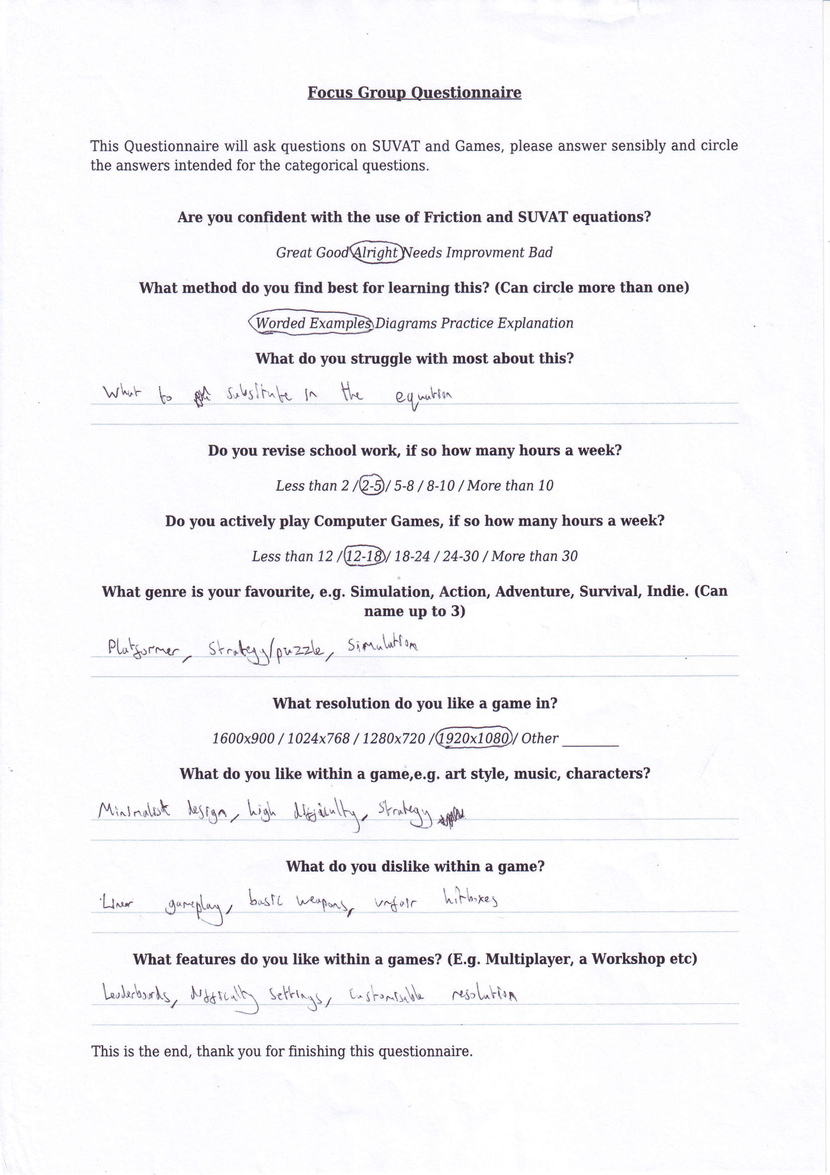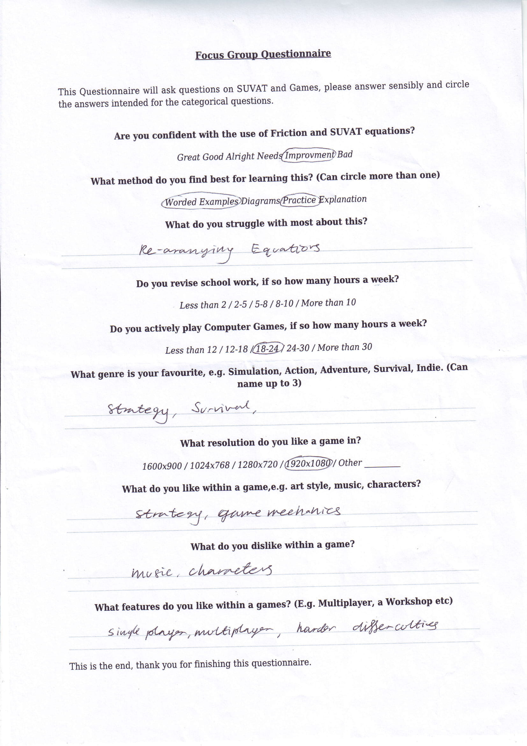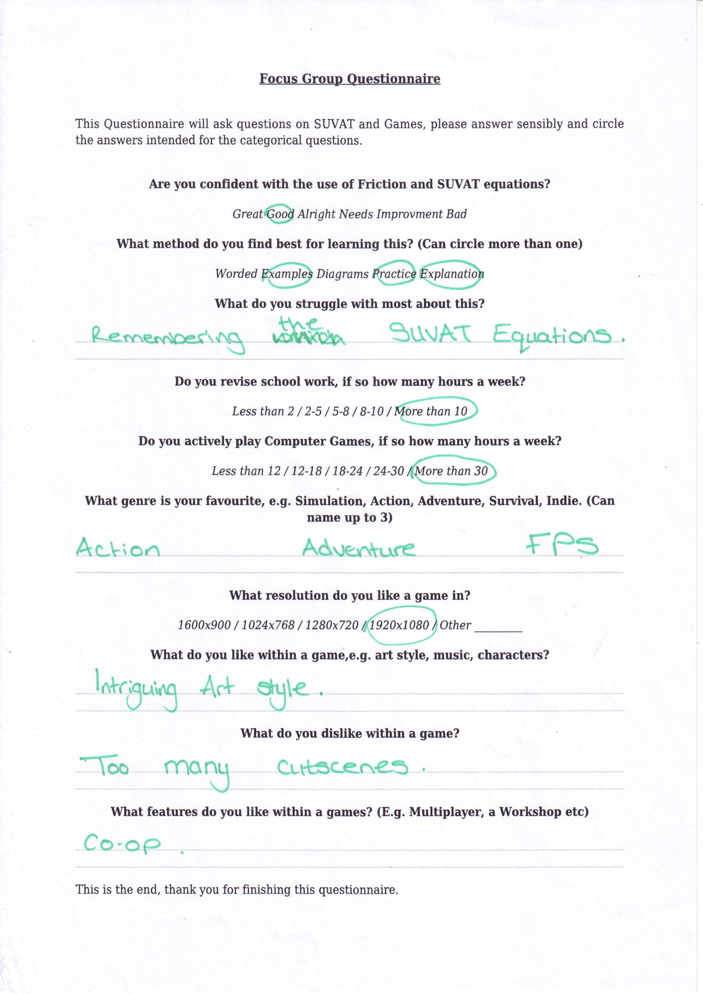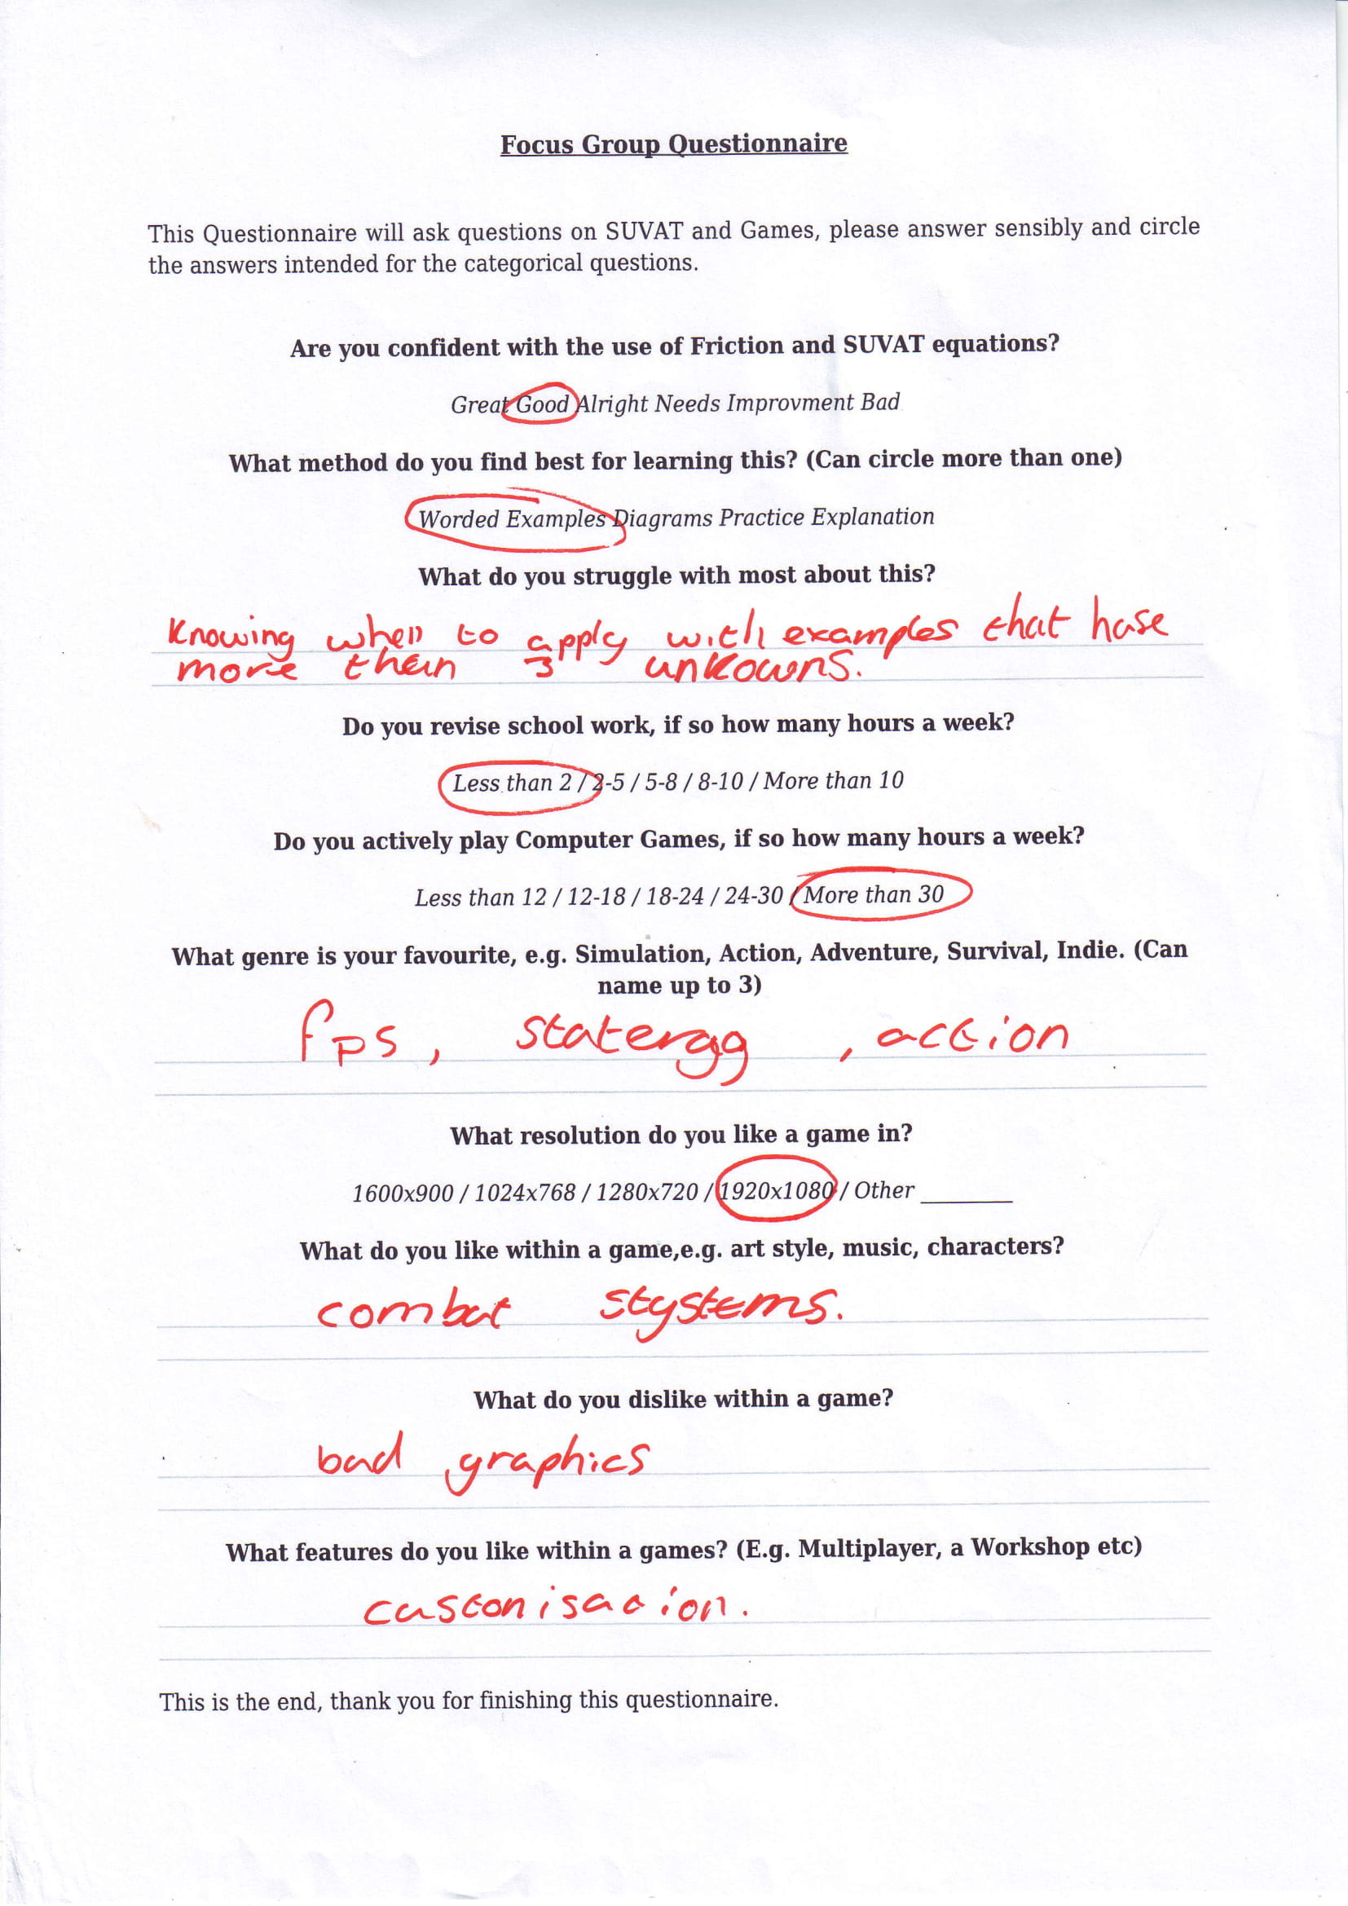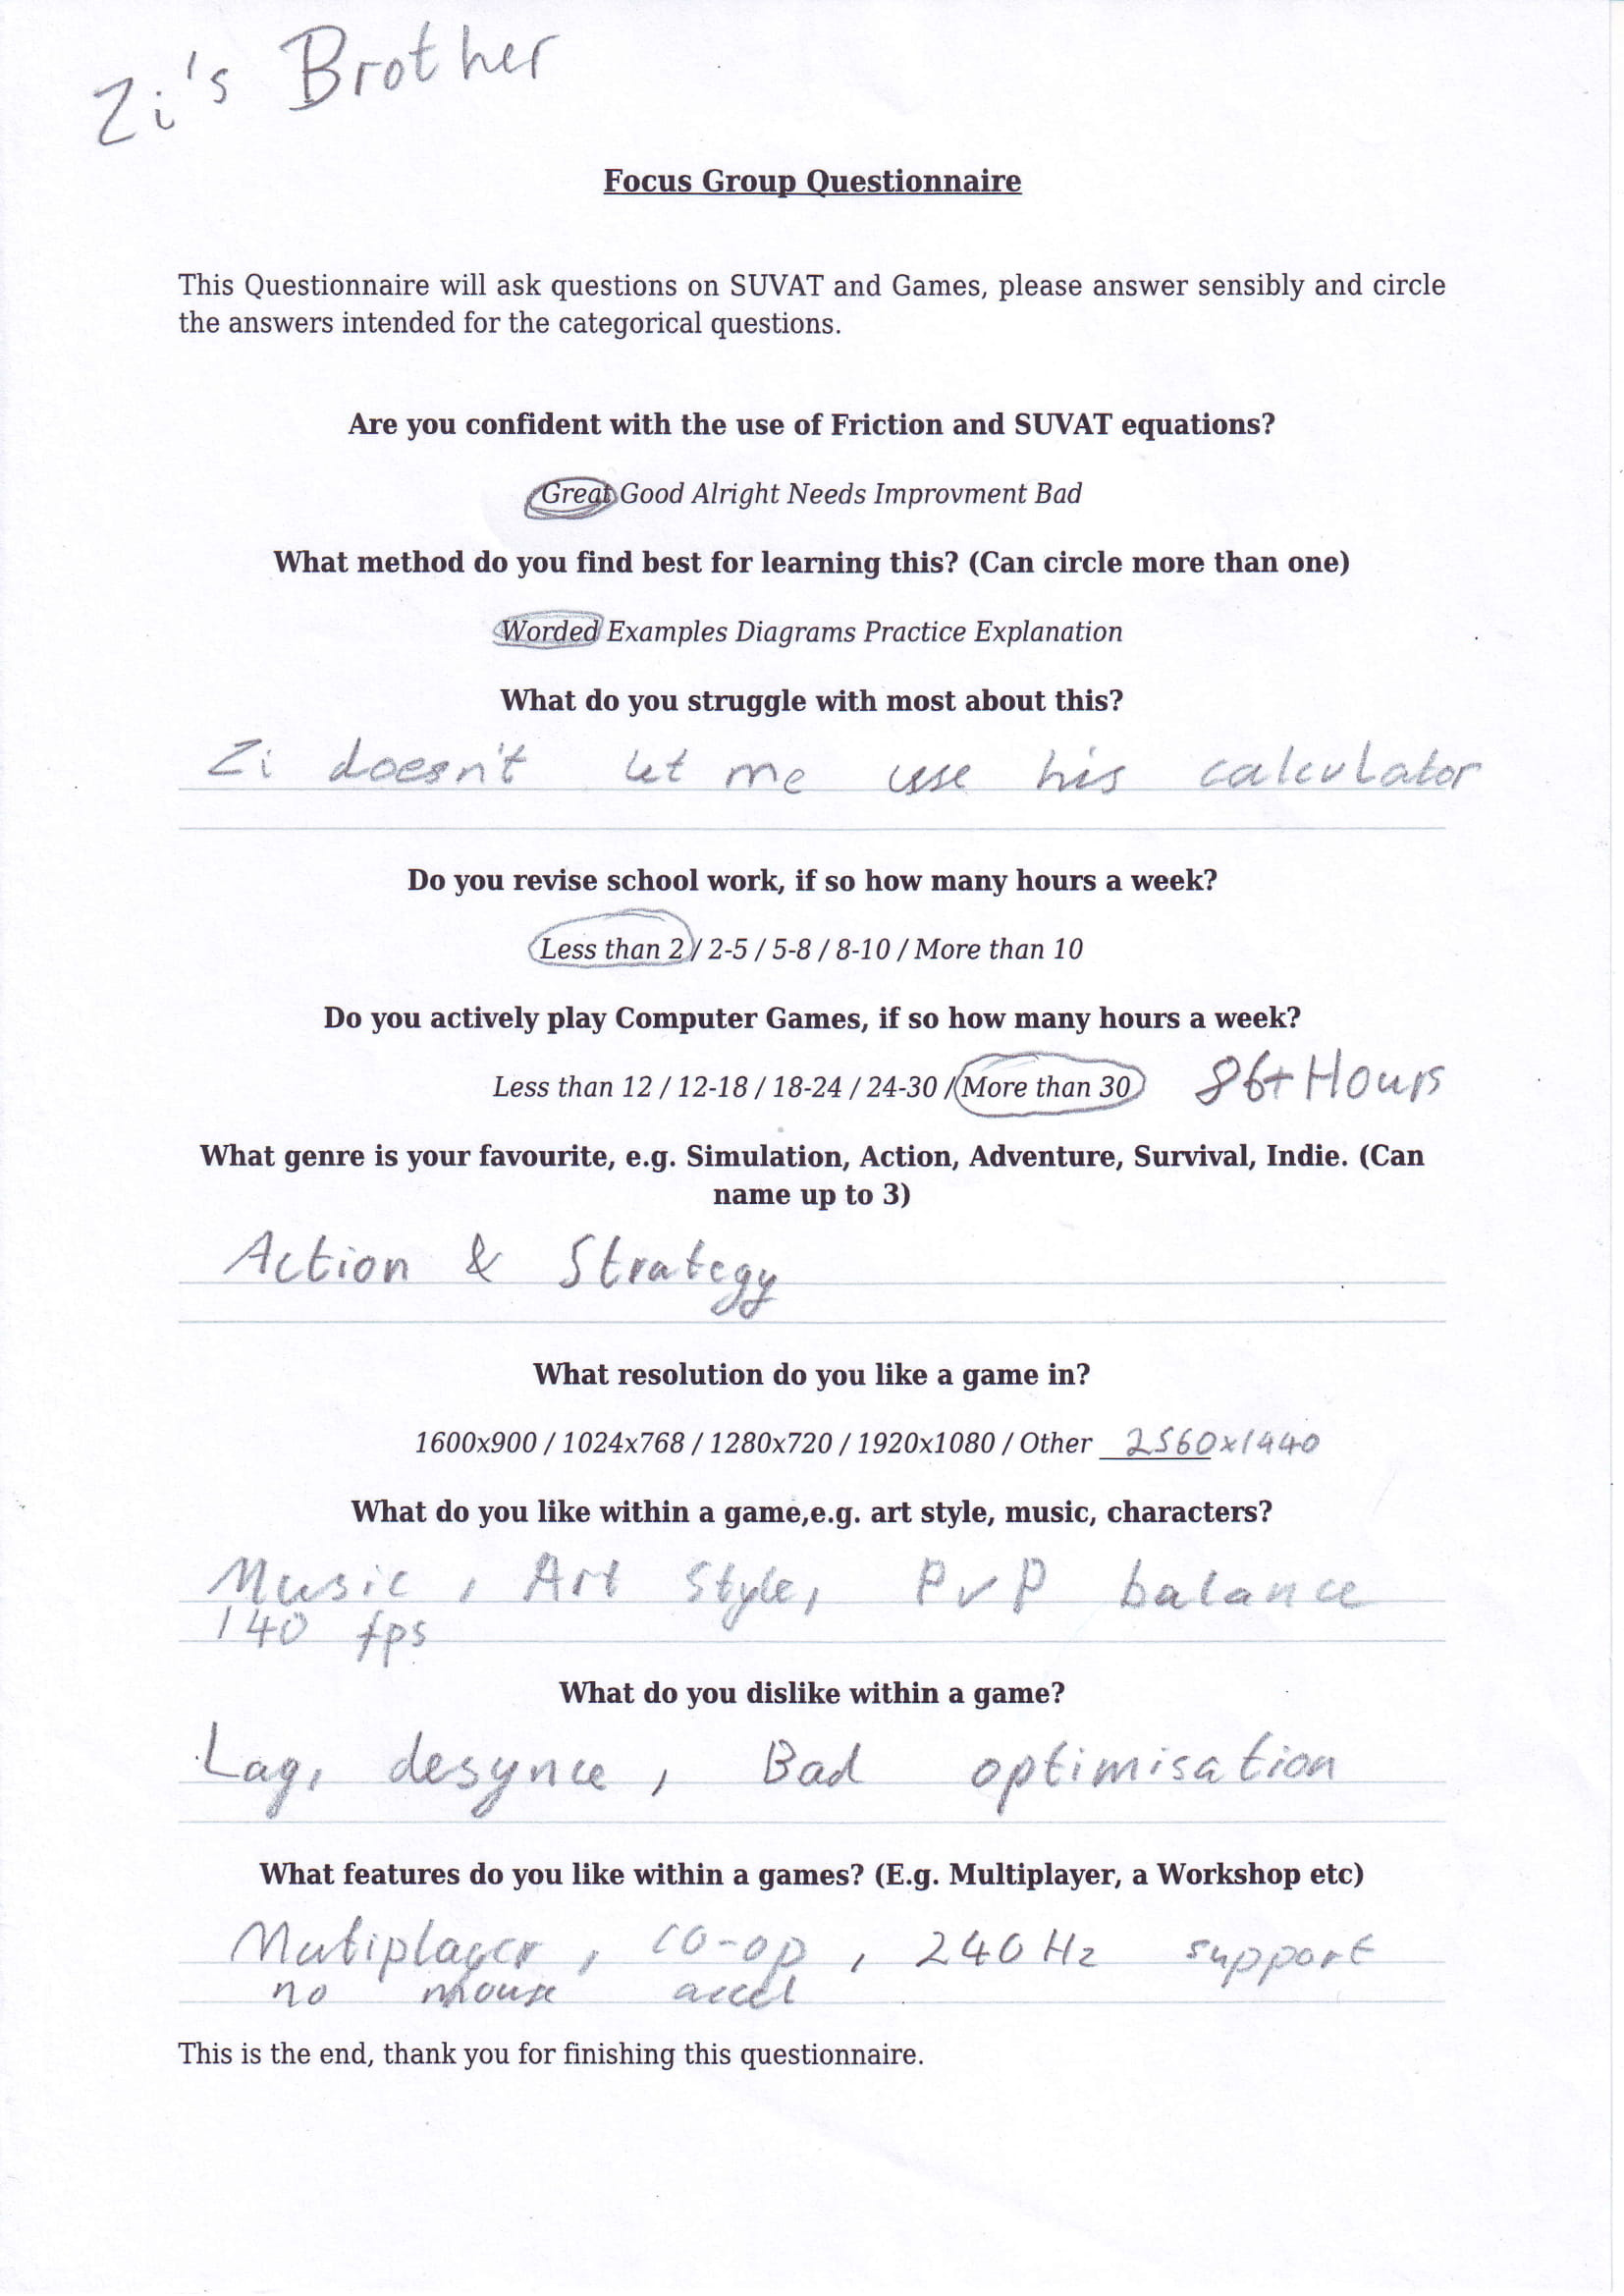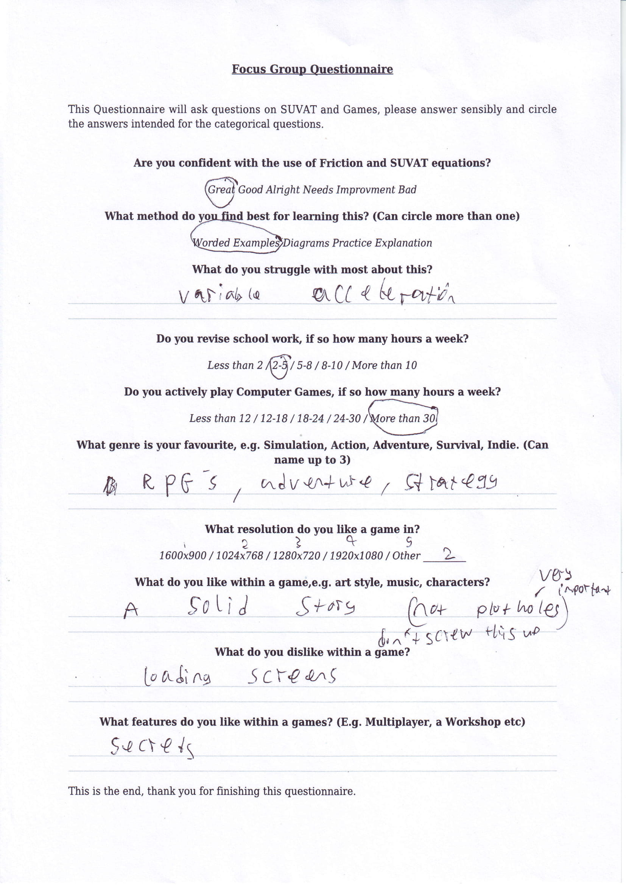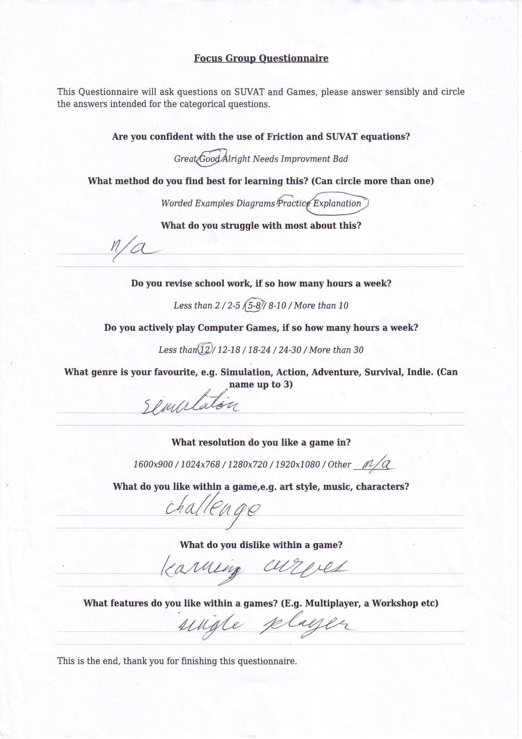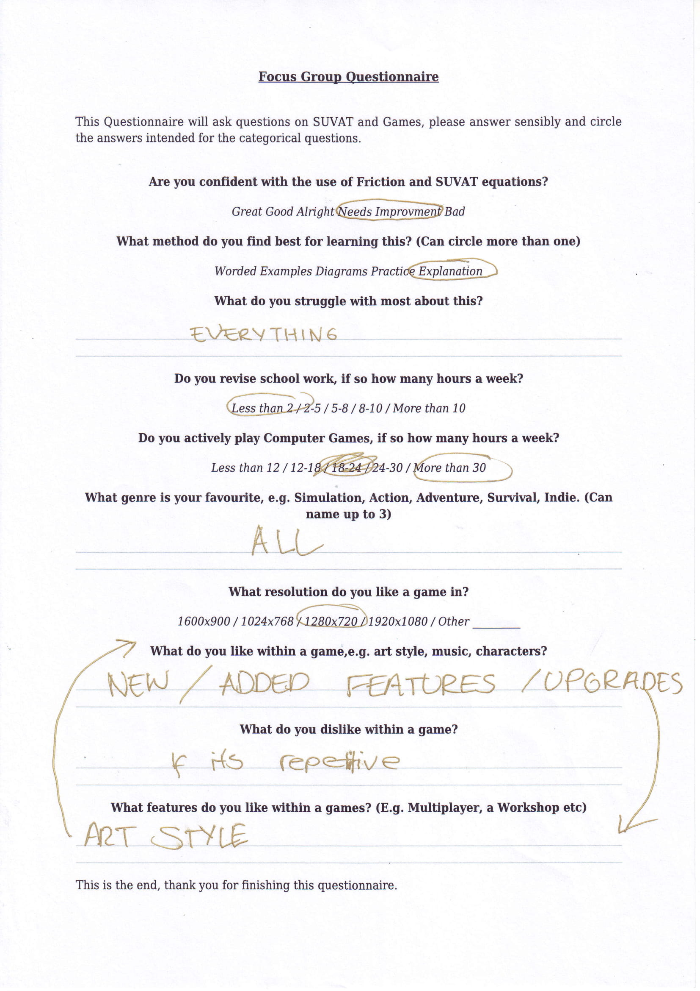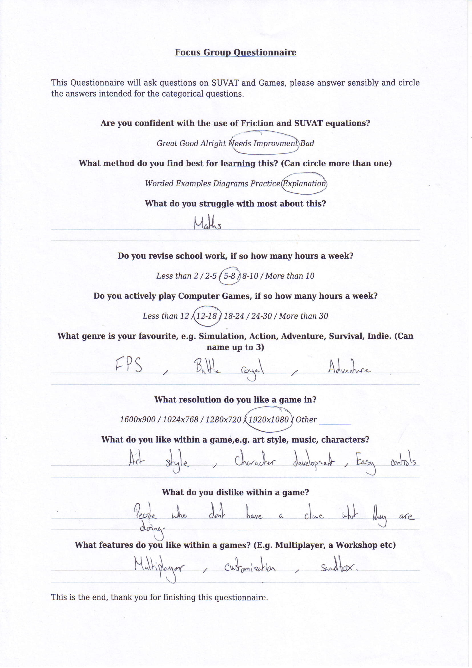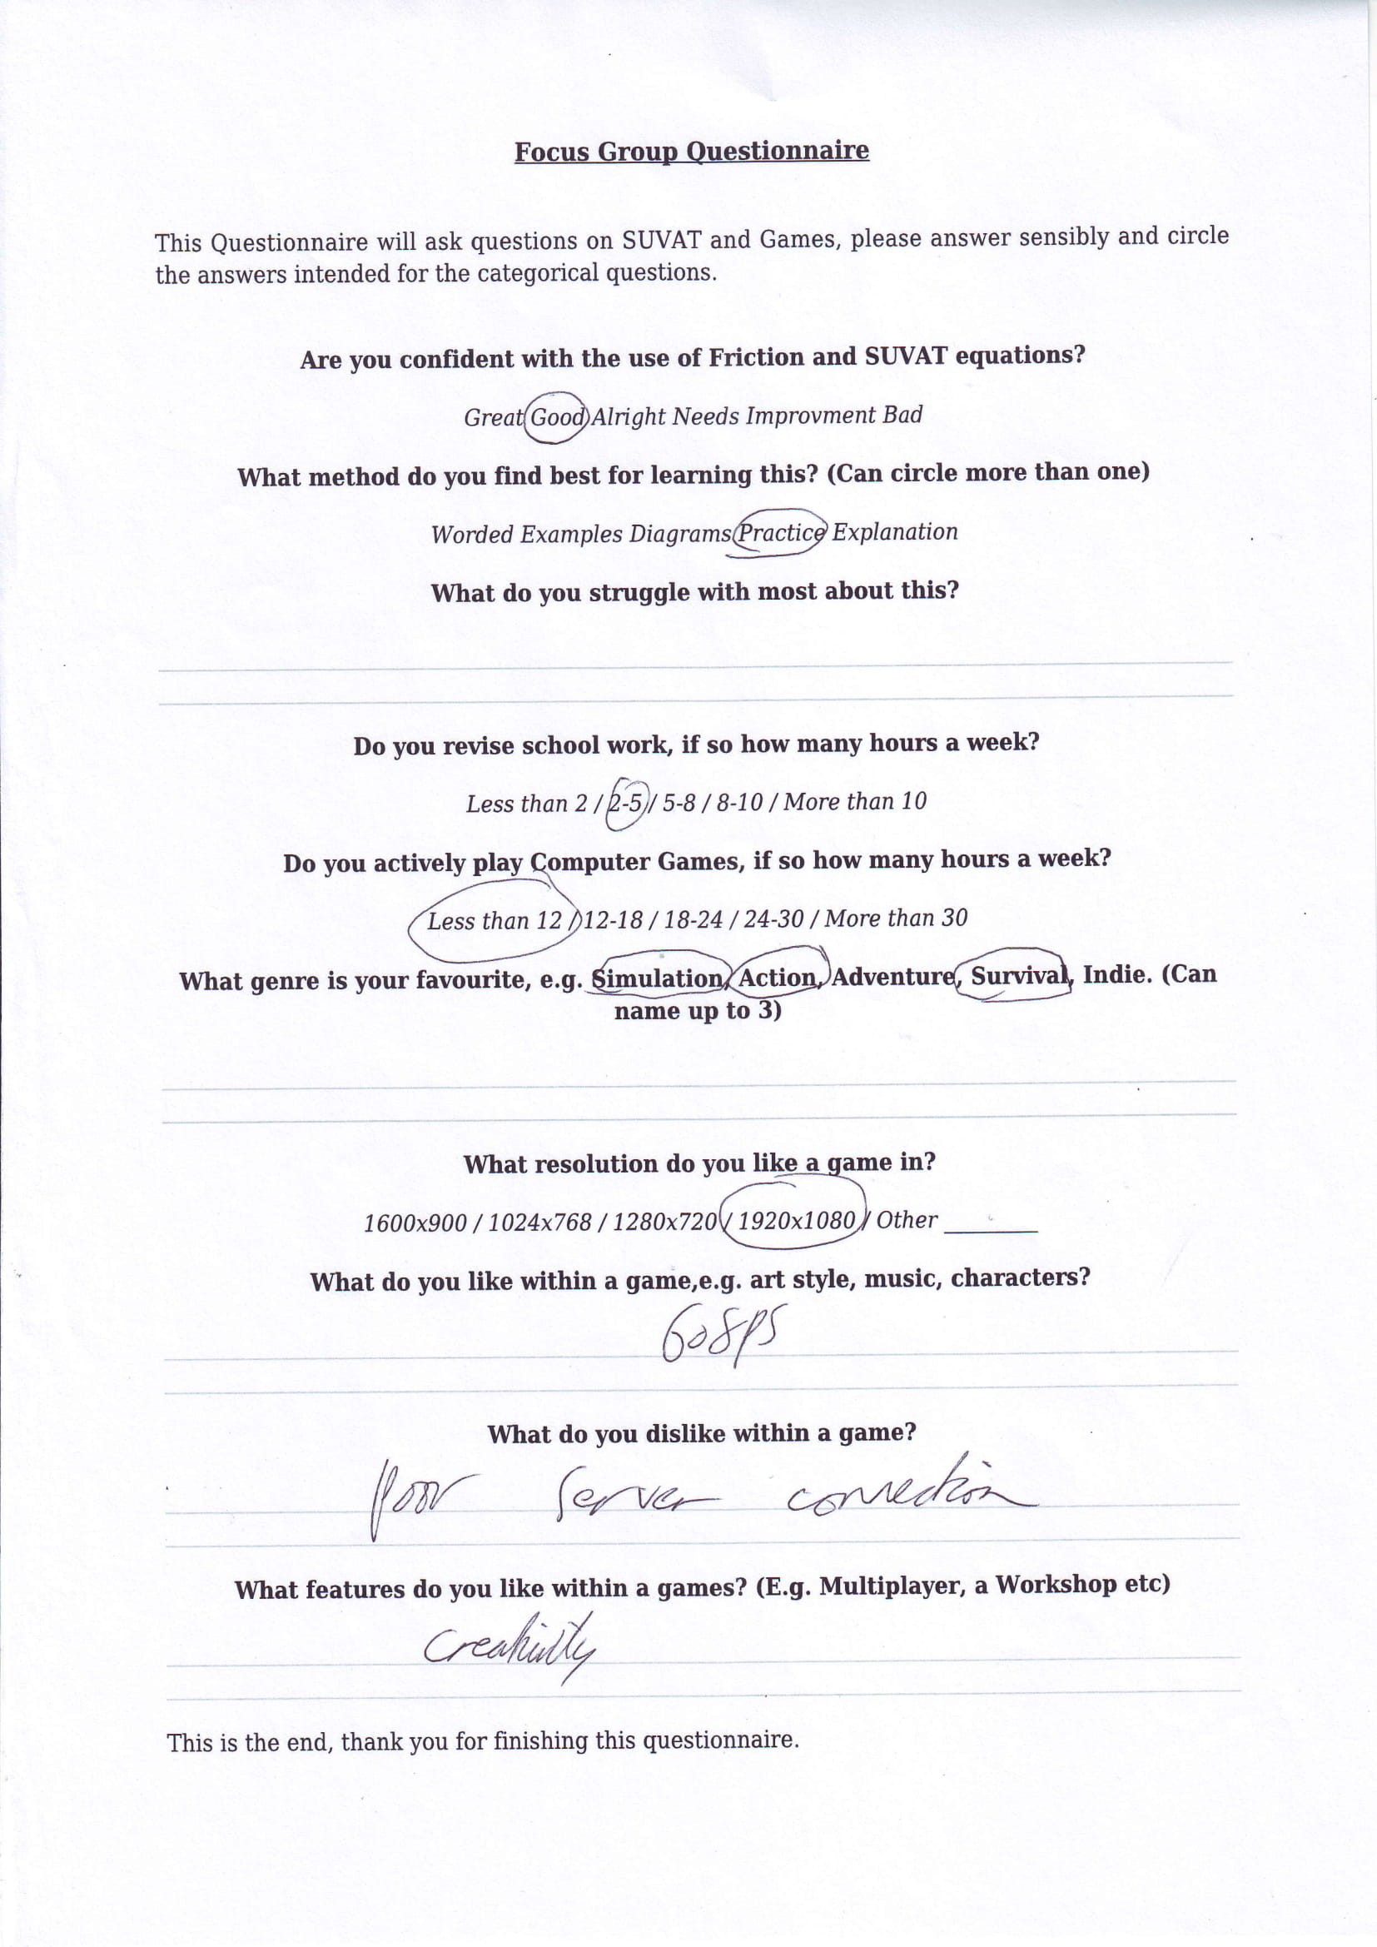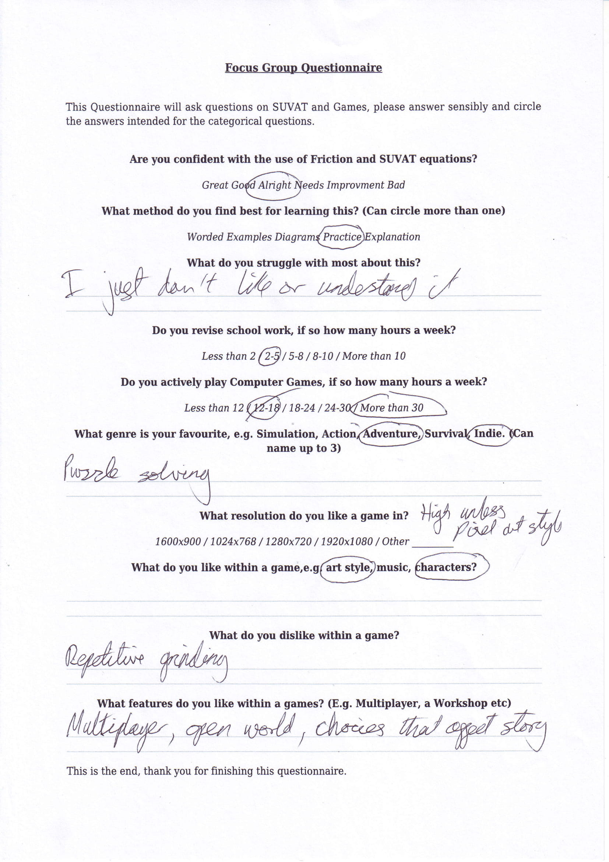

    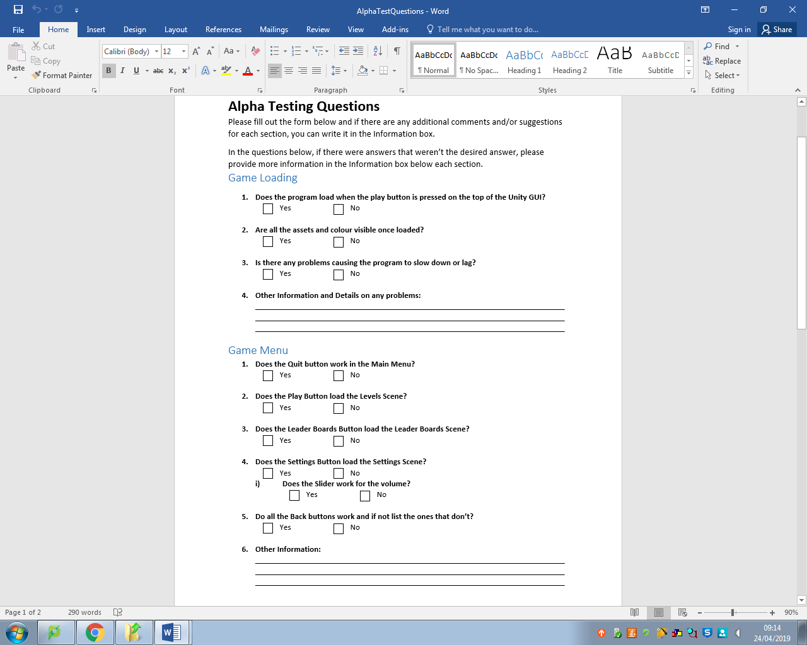

    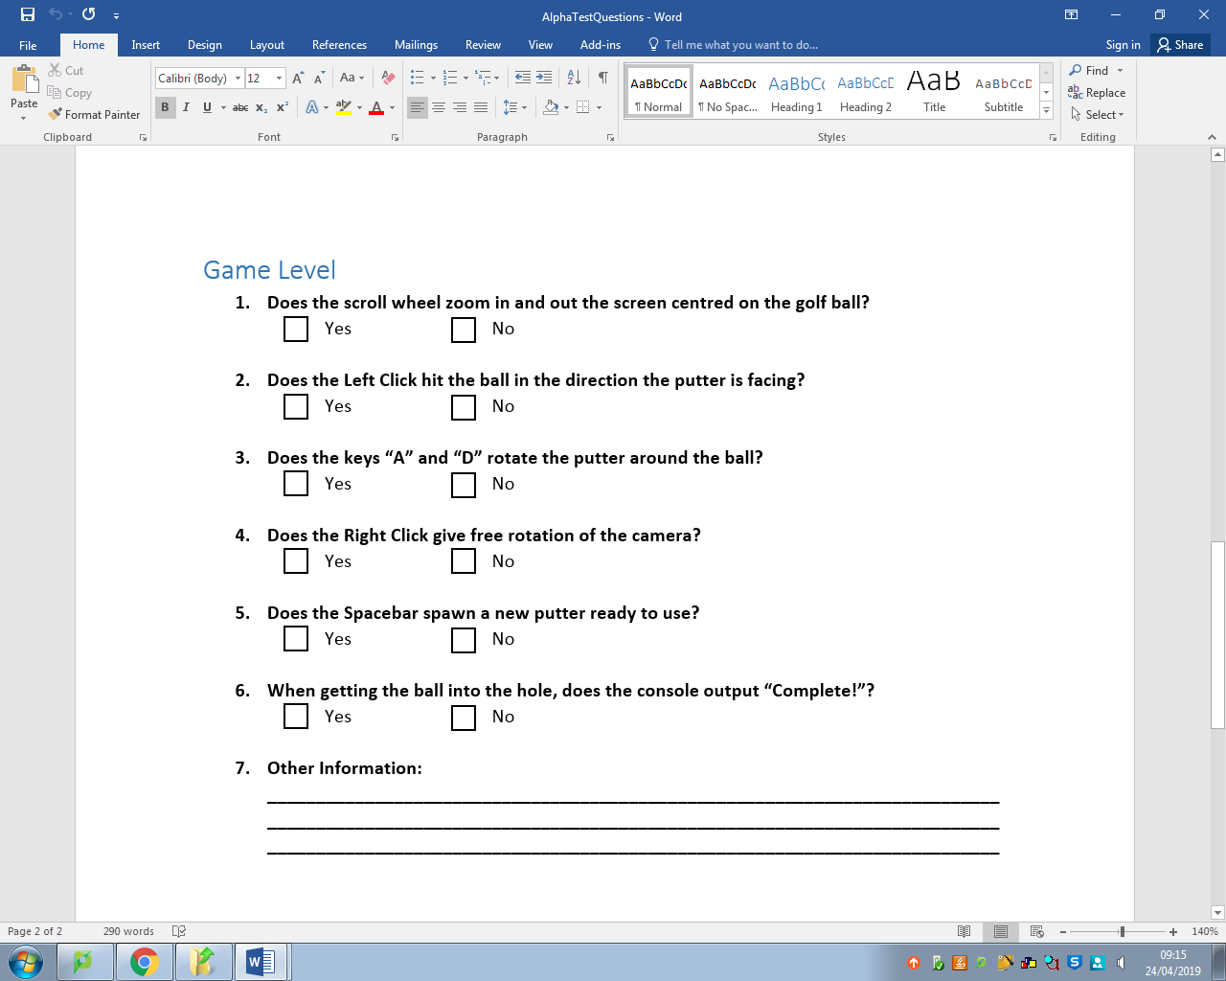

    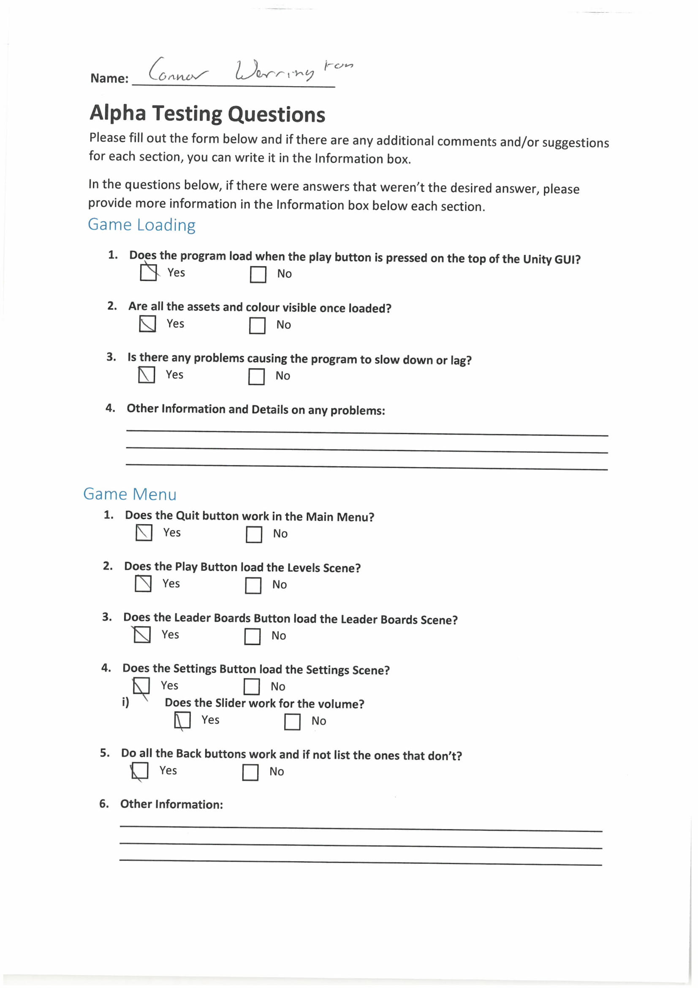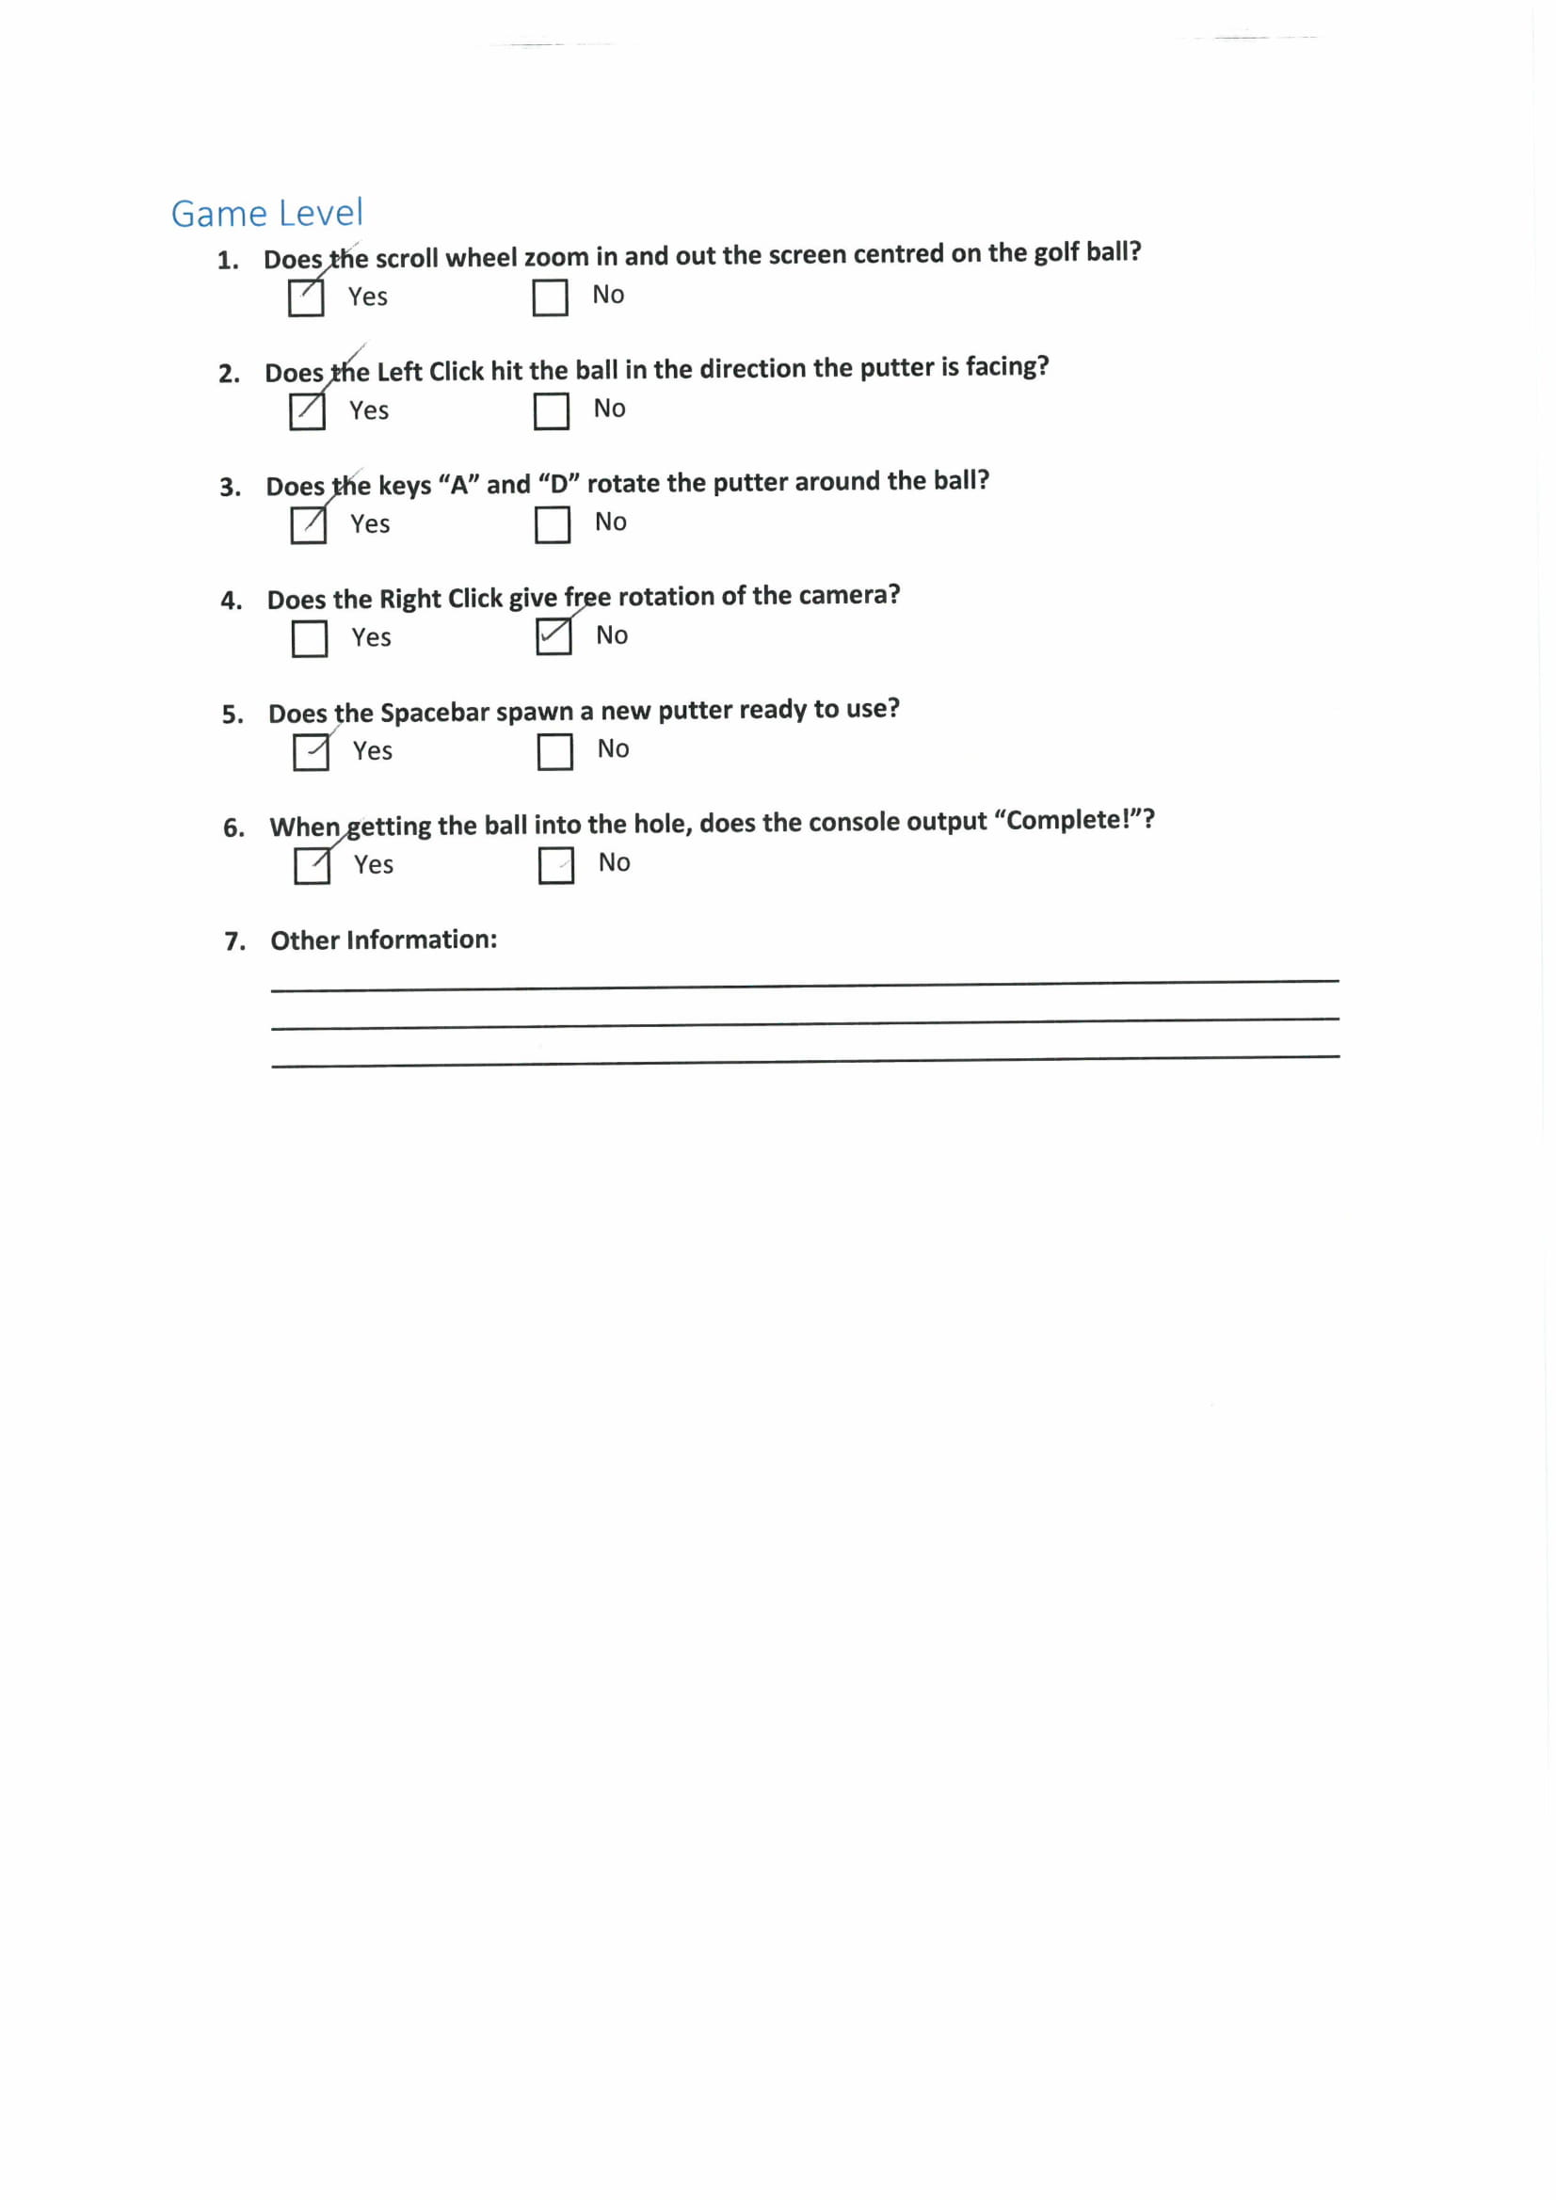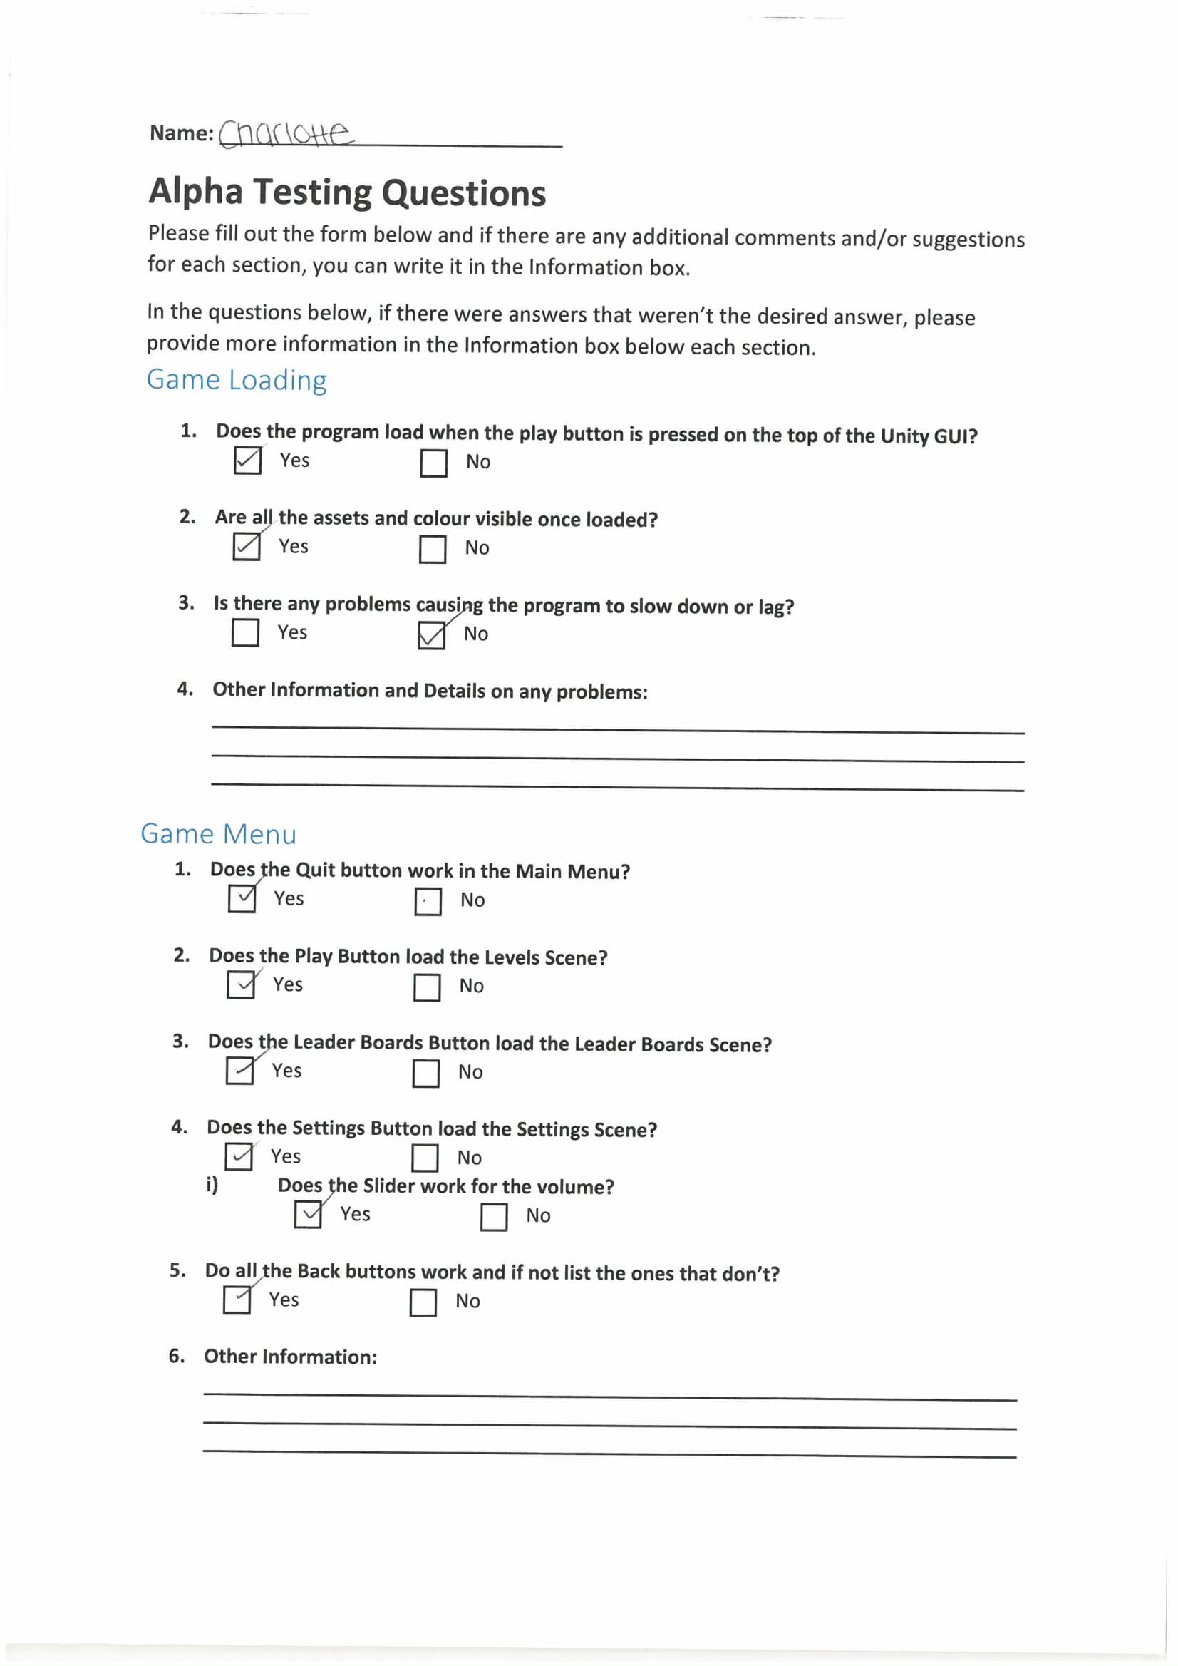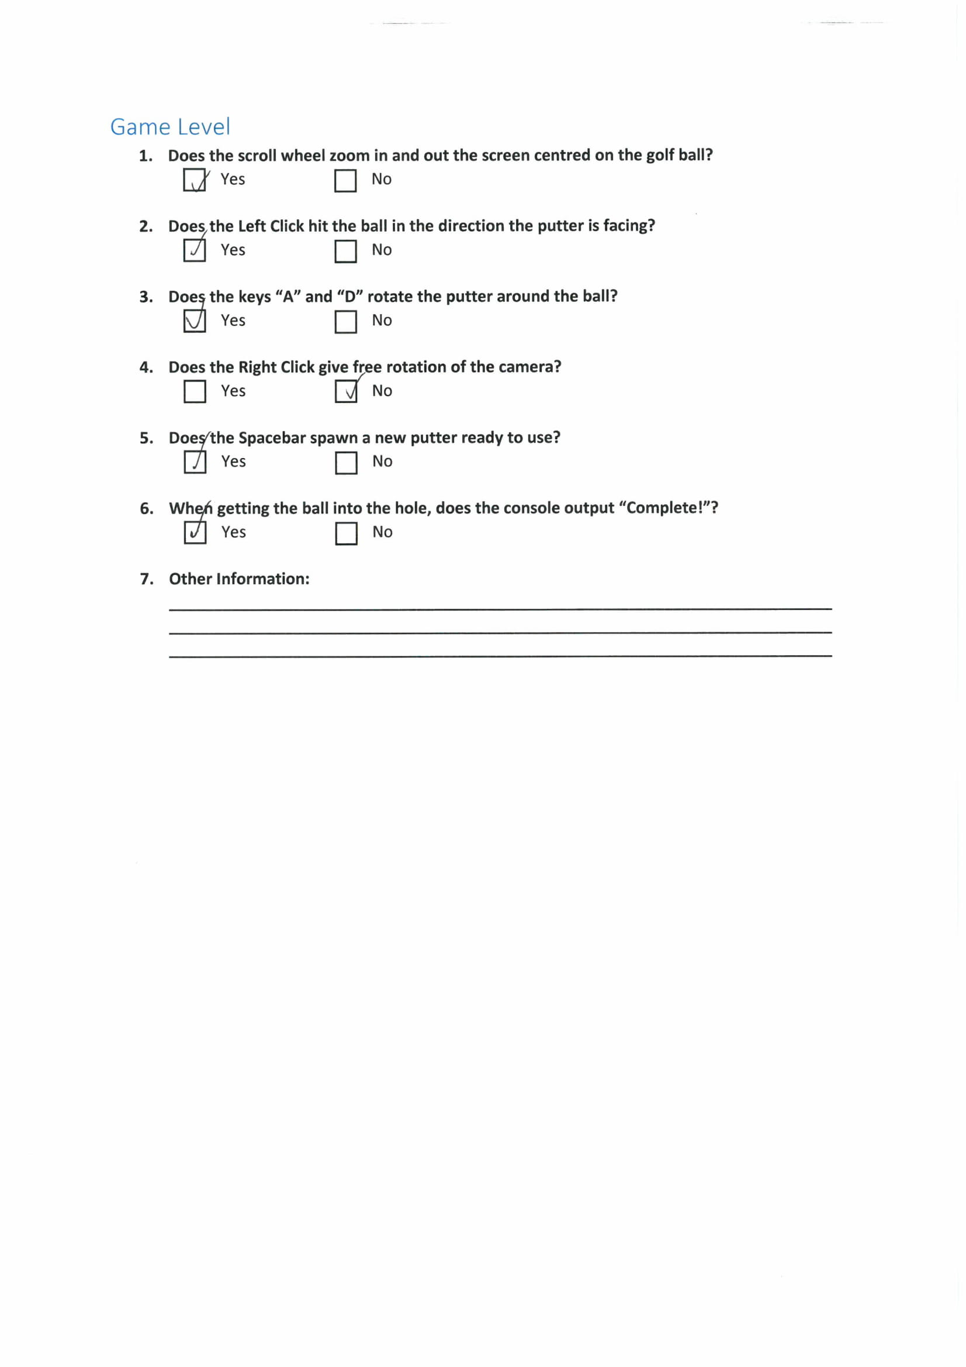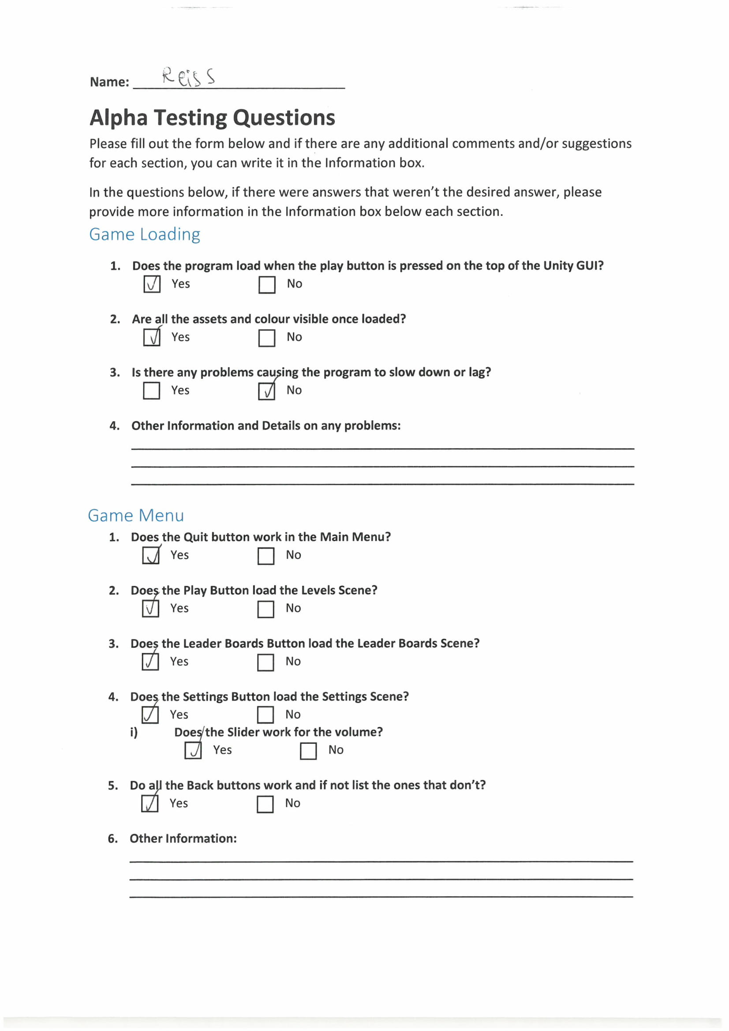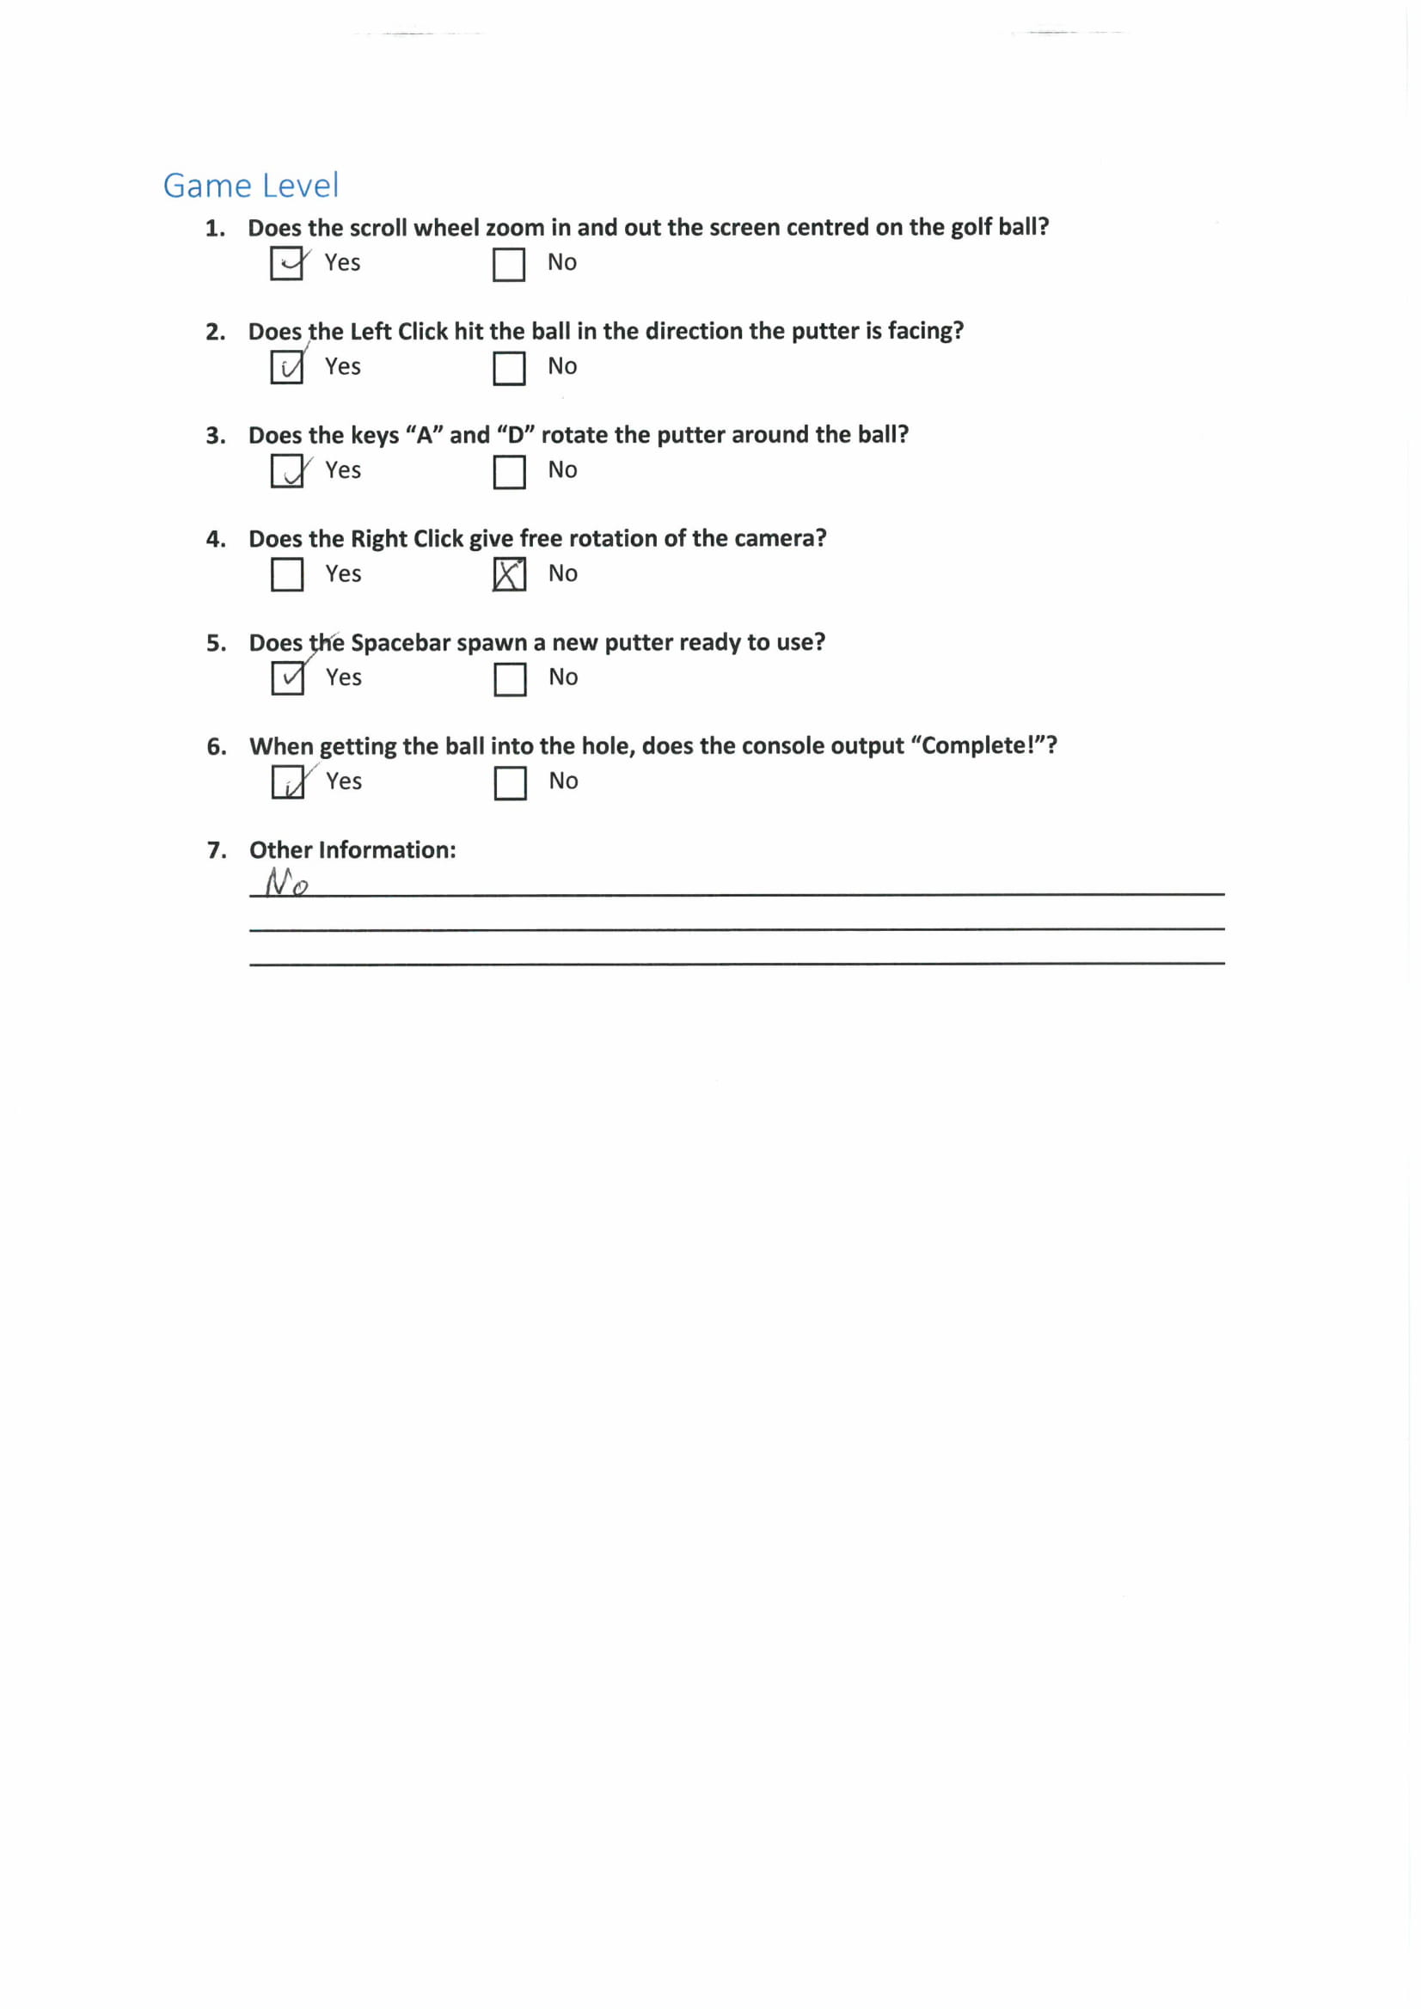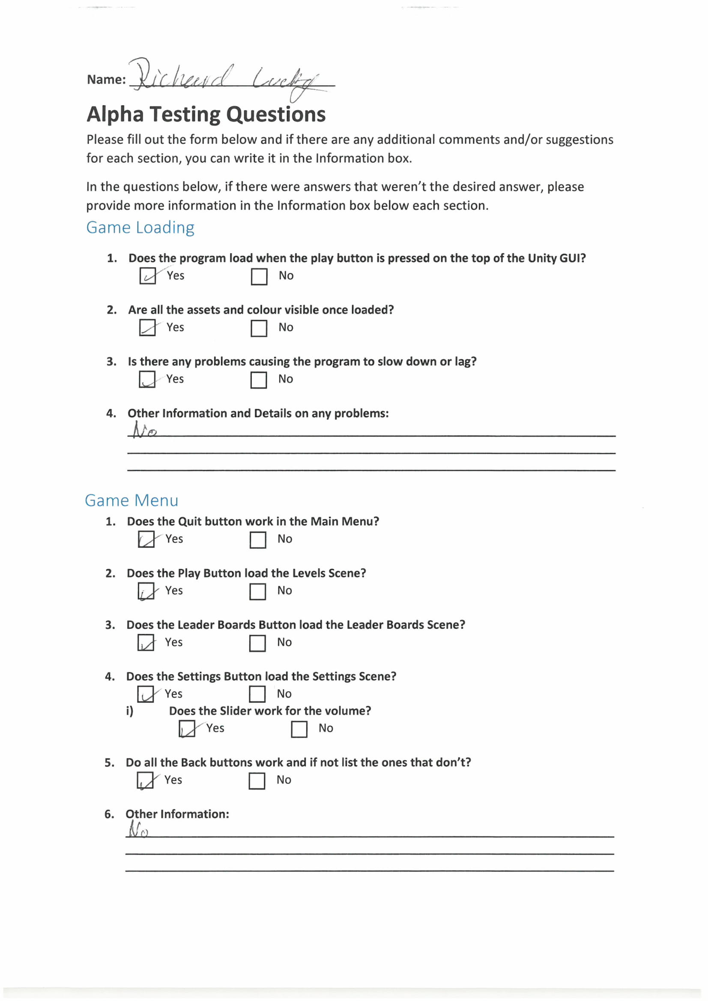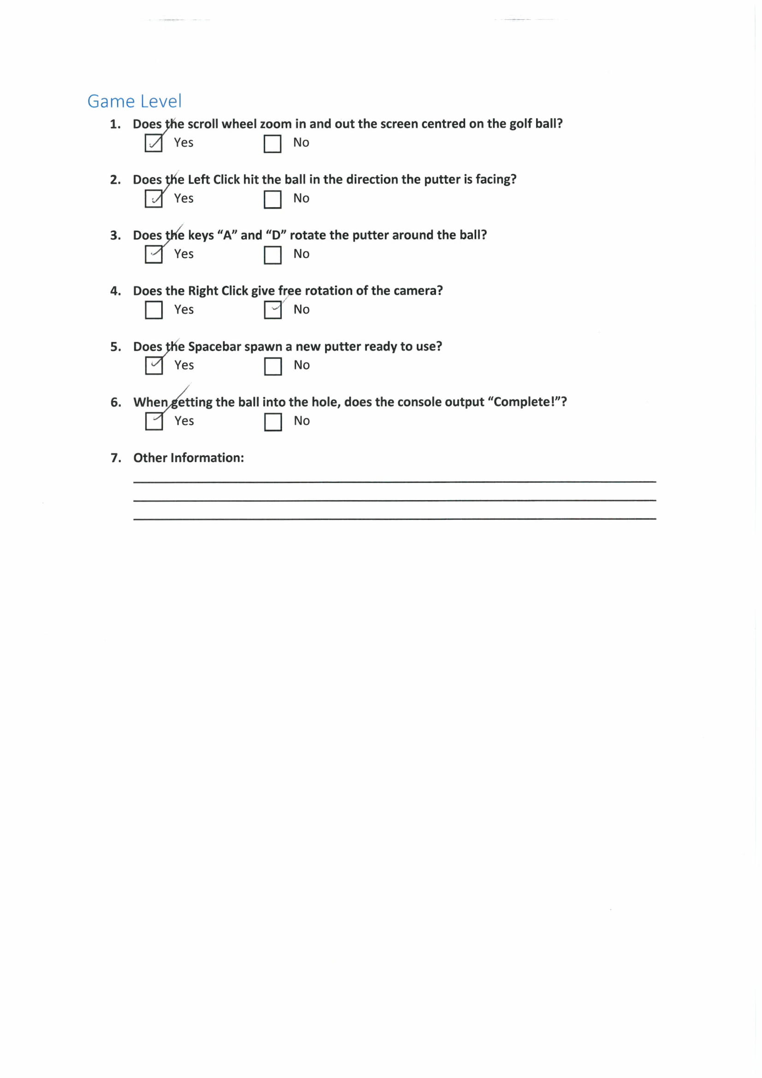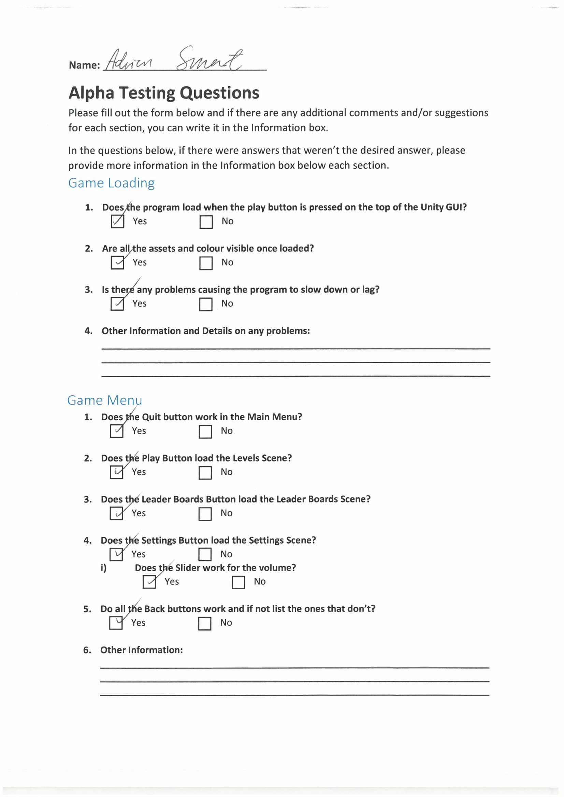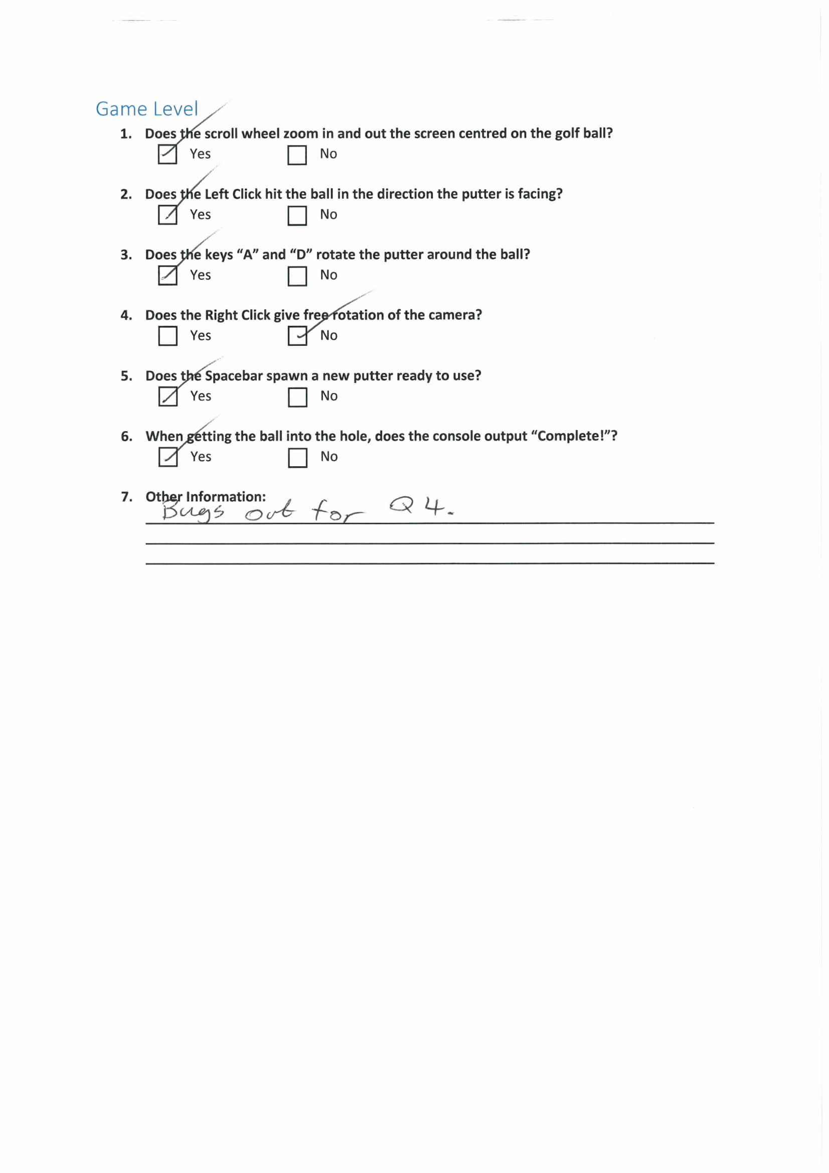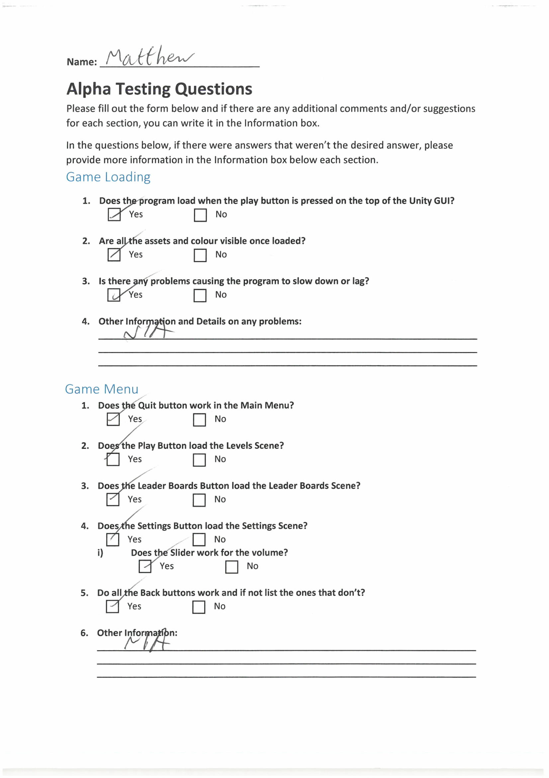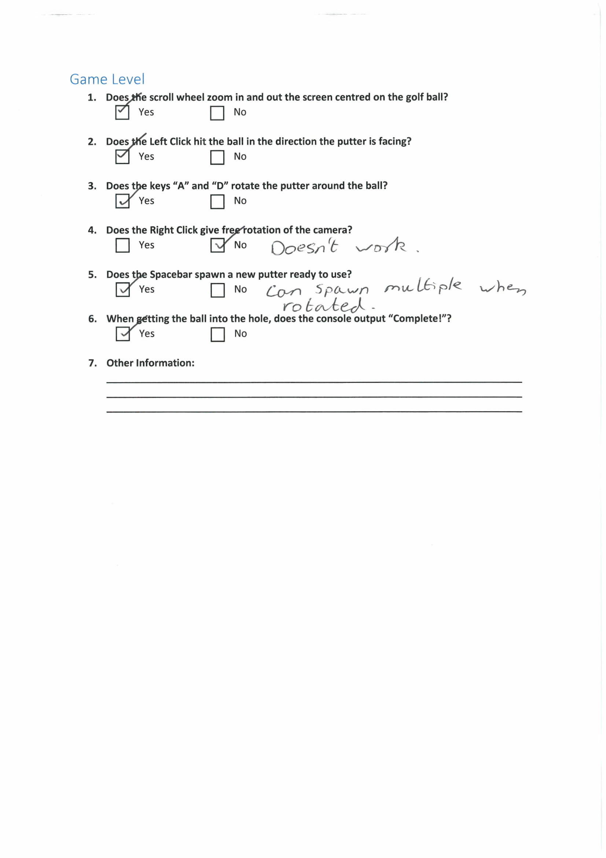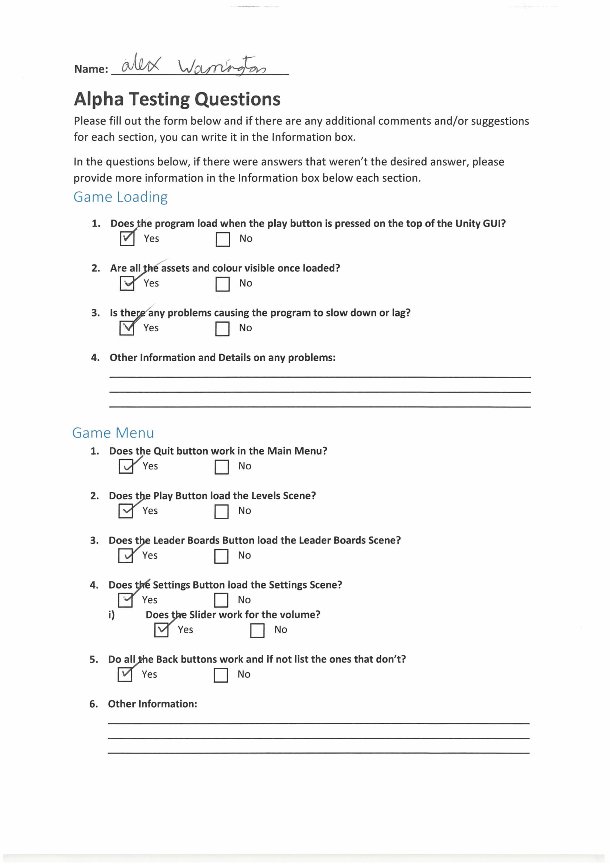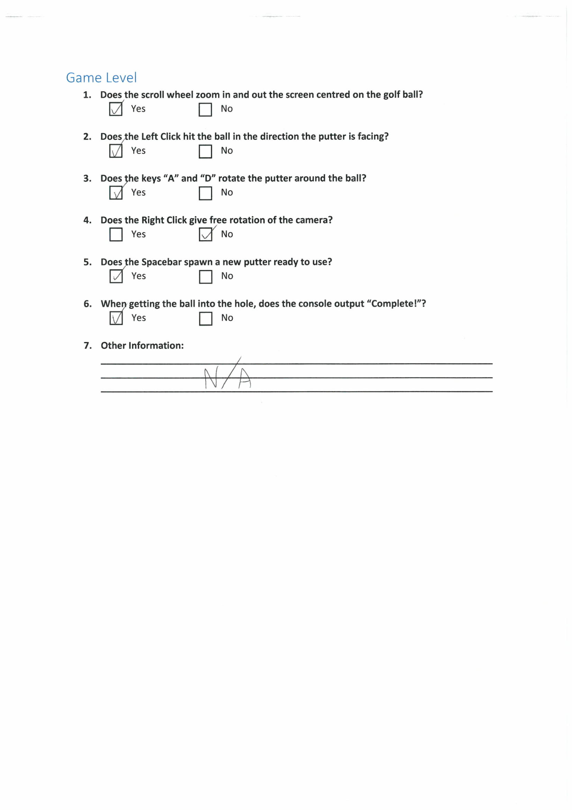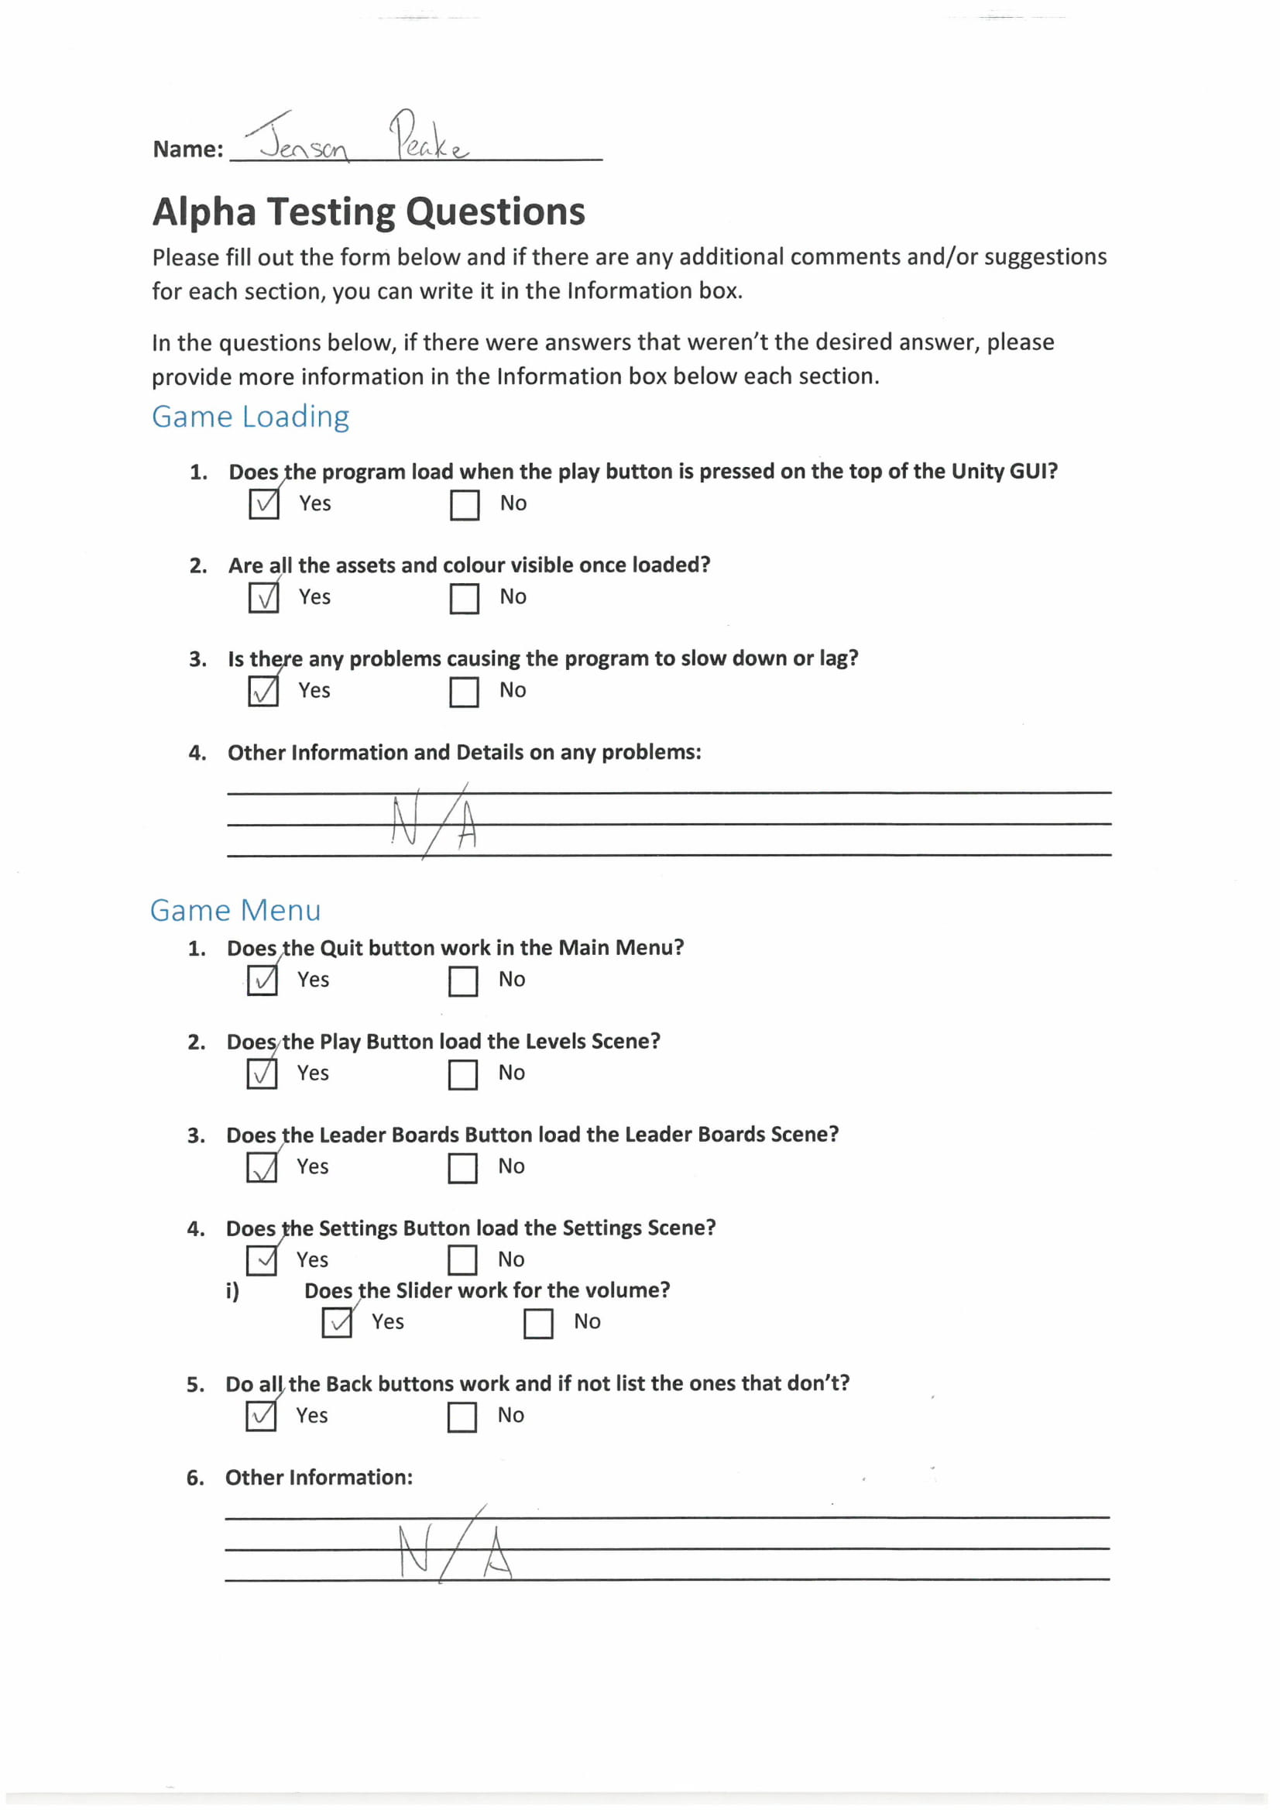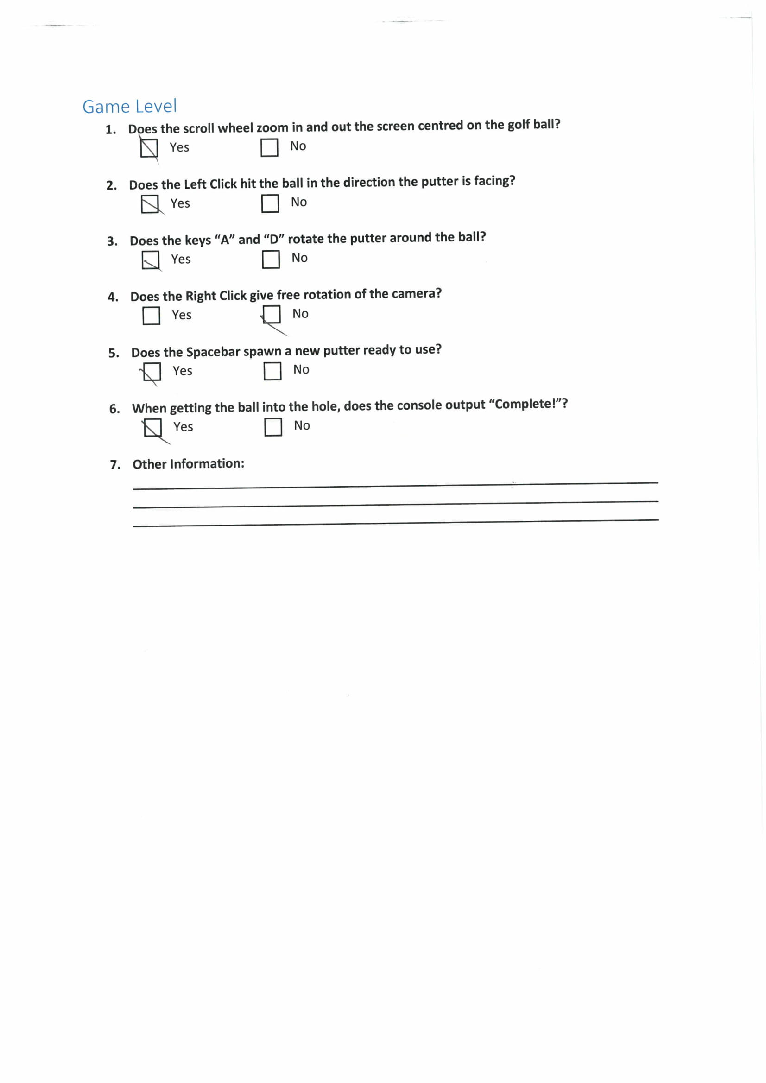

    **Beta Questionnaire**

    **Does the program load correctly?**

    Yes/No

    **Is it easy to navigate through the menu system?**

    Yes/No

    **Was the resolution of 1920x1080 suitable for this game?**

    Yes/No

    **Do you find the controls for the game suitable and easy to use?**

    Yes/no

    **Are the golf mechanics easy to use?**

    Yes/No

    **When answering the question in the quiz, is feedback correctly given?**

    Yes/No

    **Does the leaderboards show your name when you have played through the game and quiz?**

    Yes/No

    **If you are colour blind, was it easy to use and understand the program?**

    Yes/No

    **Are you confident with the use of Friction and SUVAT equations?**

    Great / Good / Alright / Needs improvement / Bad

    **Do you revise school work, if so, how many hours a week?**

    Less than 2 / 2-5 / 5-8 / 8-10 / More than 10

    **Do you actively play Computer Games, if so, how many hours a week?**

    Less than 12 / 12-18 / 18-24 / 24-30 / More than 30

    